**Micro:bit Car**

|  |  |  |  |
| --- | --- | --- | --- |
| **Programme:** | Micro:bit Car | **Level:** | Primary 4 |
|  |  |  |  |
| **Theme / Challenge Statement:** | Create a simple micro:bit car  **Summary**  This is a programme designed for our P4 high progress learners. Our students are tasked to build a micro:bit car. The theme of car was chosen as it is a familiar concept to the students.  Prior to this programme, they have already gone through an introductory programme on how to code a micro:bit. This programme serves as an extension of their knowledge in coding and to give them the opportunity to create more complex prototypes such as a car. |  |  |

|  |
| --- |
|  |

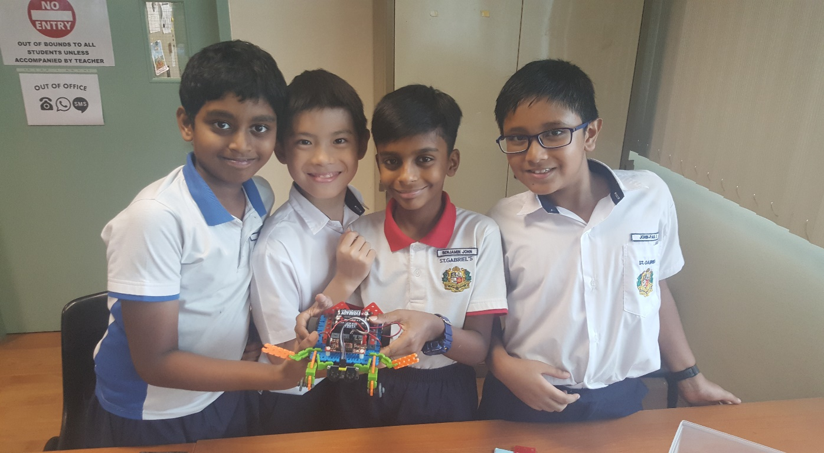

|  |  |
| --- | --- |
| **Prior Knowledge:** | Students should already know:  1. How to code a micro:bit |
| **Learning Objectives:** | By the end of the lesson, students should be able to:   1. programme a DC motor 2. assemble a simple robotic vehicle and connect its components. 3. think critically when facing a problem and explore ideas 4. demonstrate the efficacy and validity of their solution in meeting the needs of the problem identified. |

|  |  |  |  |
| --- | --- | --- | --- |
| **Time** | **Teacher Activities** | **Purpose** | **Resources Needed** |
| **Introduction/Pre-activity** | | | |
| Day 1  1 hour | Understanding  how the radio  function works  Program the micro:bit to use the radio  function to send numbers to another  micro:bit  Program the micro:bit to use the radio  function to display on another micro:bit  different icons when different buttons are  pressed | Students to learn how can a servo  motor be used as a form of input and  output.  Students to learn how to program a  servo motor to demonstrate logical  reasoning using an “if else” statement to do conditional checks and then perform the necessary action. | PowerPoint Slides  Student’s Booklet  Programming Tool  1 × Microcontroller  1 × Breakout Board |
| **Lesson development/Main activities** | | | |
| Day 2  1 hour | Theory:  How does a DC motor work  What is randomness and how it is used  Practical:  Program the DC motor to rotate clockwise and counter-clockwise  Set up and program a DC motor with a  number wheel to rotate with random  duration and speeds. | Students to give sequential instructions to program a DC Motor.  Students to program a sequence of rotation with repetition using  functions and conditional loops. | PowerPoint Slides Student’s Booklet Programming Tool  1 × Microcontroller  1 × Breakout Board  1 × DC motor |
| Day 3  1 hour | Assemble the micro:bit car  Connect the components. | Students to build a car with the required components and materials provided. | 1 × Microcontroller  1 × Breakout Board  2 × DC motor  1 × Frame Pack |
| Day 4  1 hour | Program the micro:bit car to move forward  and then backwards at low speed for  different time duration.  Program the micro:bit car to turn right at  different angles.  i. 90  ii. 180  iii. 270  iv. 360 | Students to learn about the DC motor as an output and how to control the speed and direction of  the DC motor. | 1 × Microcontroller  1 × DC Motor  1 × DC Motor  breakout board |
| Day 5  1 hour | Understanding  problem & exploring  solutions  Brainstorming &  solution design / prototype matrix  Problem scoping using systematic  methodologies and concept generation with case studies and step by step application | Students learn hands on application of design thinking fundamentals  and processes towards solving real world problems. | Powerpoint Slides  Student’s Booklet |
| Day 6 & 7  2 hours | Hands on building/prototyping of solutions including coding.  User testing of prototype and rework | Students to learn how to design and  build the solution according to the key  characteristics.  Students to write a simple program and code the solution behaviour  using simple forms of inputs and outputs.  Students to work in groups to accomplish the project goals. | Programming Tool  Microcontroller Kit  Student’s Booklet |
| **Closure and consolidation/Post-activity** | | | |
| Day 8  1 hour | Final preparation by students and teams  Presentation | Students to demonstrate the efficacy and validity of their solution in  meeting the needs of the problem identified.  Students to present their solution using essential elements of effective design communication. | Prototype  Presentation  Slides |

|  |  |  |  |
| --- | --- | --- | --- |
| **Project created by students** | | | |
| Project 1 | Students are taught how to programme the following variables of the car:   * Speed * Duration of movement * Direction   Challenge: Students are given a specific route that their car will need to take, as well as its final destination. They will work in groups to determine the codes required for the car to complete the designated route. |  |  |

Please send this template, together with any additional resources, e.g. Powerpoint slides, worksheets and .hex file, to: [digital_maker@imda.gov.sg](mailto:digital_maker@imda.gov.sg).

|  |
| --- |
| **Contributed by:**  Name of School: St Gabriel’s Primary School  Name of Teacher (Optional):  Date: 6th April 2018 |