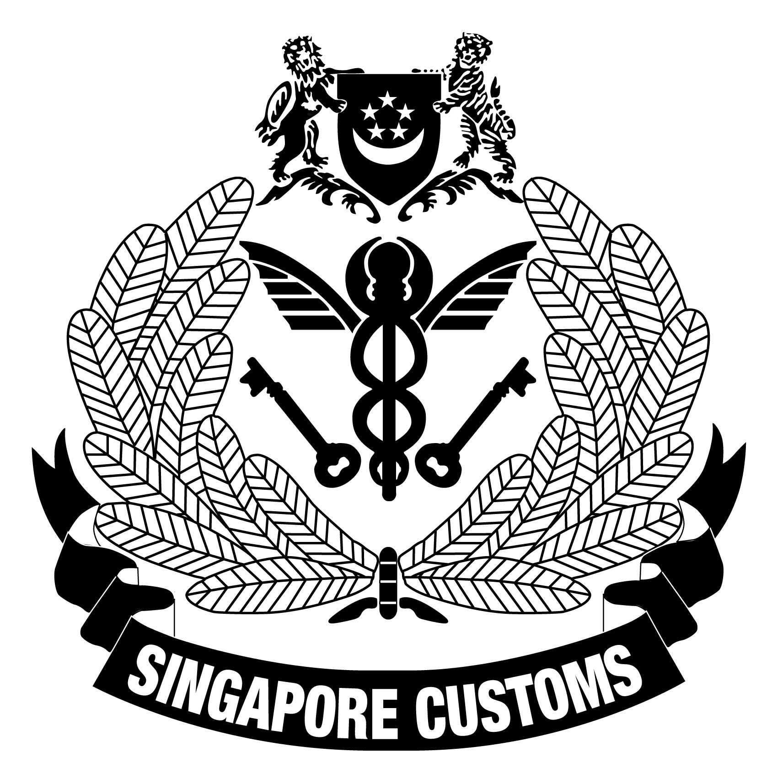 | Singapore Customs  55 Newton Road #07-01  Revenue House  Singapore 307987  Tel No. : 6355 2000  Email : customs_roo@customs.gov.sg  Form reference : SC-A-006 (Ver 11 – 04/19)

MANUFACTURER’S APPLICATION FORM
This form may take you 10 minutes to fill in.

You will need the following information to fill in the form:
- Company’s details;
- Production details; and
- Type(s) of authorised Certificate of Origin (CO) you wish to apply.

Note:
- Please fill in the application form only if you wish to apply for CO with Singapore Customs.
- Please fill in all fields. Indicate “NA” where not applicable.
- Please check () where applicable.
- Please complete the application form and submit it together with the relevant supporting documents to Singapore Customs via email.
- Singapore Customs will contact you within 7 working days upon receipt of the completed application form for a follow-up or to arrange for a factory visit, if required.
SECTION A PURPOSE OF APPLICATION
- Please specify the purpose of this application. (Please select only one box.)

New Application - For companies who are not registered as a Manufacturer with Singapore Customs

New Product Line(s) - For registered Manufacturer who wish to include other products previously not registered
SECTION B APPLICANT’S DETAILS
- Company Name: |  | - Unique Entity Number (UEN):
- Factory Address:

- Name of Contact Person: |  | - Designation:
- Tel No. & Ext No. (if any):

- Email:

SECTION C PRODUCTION DETAILS
- No. of Factory Employees:

- Item(s) Manufactured which you wish to register with Singapore Customs for the purpose of applying for CO
Item Description | HS Heading |  | Average Monthly  Production. (Quantity)
- Main Machinery(ies) Installed for Manufacturing of the Item(s) Specified in Box 10 |  |  | No. of Units
- Description of the manufacturing process that the item underwent, making reference to materials and/or components used at each stage of the manufacturing process and a description of each stage of the process
(You may wish to attach a detailed production flow chart for illustration purpose)

SECTION D TYPES OF AUTHORISED CO SCHEME
- Please indicate the type(s) of CO you intend to apply for the item(s) specified in Box 10:
ASEAN Free Trade Area – ASEAN Trade In Goods Agreement (ATIGA) Form D
ASEAN-Australia-New Zealand Free Trade Area (AANZFTA) – Form AANZ
ASEAN-China Free Trade Area (ACFTA) – Form E
ASEAN-India Free Trade Area (AIFTA) – Form AI
ASEAN-Japan Comprehensive Economic Partnership (AJCEP) – Form AJ
ASEAN-Korea Free Trade Area (AKFTA) – Form AK
Gulf Corporation Council-Singapore Free Trade Agreement (GSFTA) – Preferential CO (PCO)
China-Singapore Free Trade Agreement (CSFTA) – PCO
India-Singapore Comprehensive Economic Cooperation Agreement (CECA) – PCO
Japan-Singapore Economic Partnership Agreement (JSEPA) – PCO
Korea Singapore Free Trade Agreement (KSFTA) - PCO
Peru-Singapore Free Trade Agreement (PeSFTA) - PCO
Singapore-Jordan Free Trade Agreement (SJFTA) – PCO
Sri Lanka-Singapore Free Trade Agreement (SLSFTA) - PCO
US-Singapore Free Trade Agreement (USSFTA) – Certificate of Eligibility (for textile goods only)
Generalised System of Preferences (GSP) of the Republic of Belarus, Republic of Kazakhstan and Russian Federation – Form A
Global System of Trade Preferences Scheme (GSTP) – GSTP CO
Ordinary Certificate of Origin/ Processing

SECTION E SUBMISSION OF SUPPORTING DOCUMENTS
- Please submit the relevant supporting document(s) to Singapore Customs together with this application form and indicate below, the supporting document(s) submitted.

For the item(s) manufactured specified in Box 10: (Please indicate as applicable)

  - Full Ingredients/ Components/ Composition List (Required for all applications)
  - Product Specification Sheet
  - Technical Data Sheet
  - Material Safety Data Sheet (MSDS) /Safety Data Sheet (SDS)
  - Product Brochure/ Catalogue
  - Others (Please specify):

Depending on the type of manufacturing activity conducted, please submit the supporting documents to Singapore Customs as part of the application. Please refer to Annex 1 for the list of supporting documents.
SECTION F OUTREACH SESSION – APPLICABLE ONLY IF YOU HAVE TICKED “NEW APPLICATION’ UNDER SECTION A
- Upon approval of your application, the applicant is required to attend an outreach session on Free Trade Agreements and Preparation of Manufacturing Cost Statement (MCS). Please provide the following information of the participant.
(We encourage the person preparing the MCS to attend the outreach session.)
Name of Participant
Designation
Telephone No.
Email address
Note: We will notify you of the date of outreach in due course.

SECTION G DECLARATION AND UNDERTAKING
- I hereby certify and undertake that:

- The information given above is true in every aspect;
- As a condition precedent to this registration, I will keep and maintain up-to-date accurate books and records of the following:

  - Raw Materials Purchase Records
  - Raw Materials Consumption/Stock Records
  - Production Records
  - Receipted Wage Record for Workers
  - Sales & Stock of Finished Goods Records
  - Cash Book
  - Ledger Accounts/ Accounting Records
for such period of time as may be required under the various CO Schemes, e.g.
Types of CO Schemes | Retention Period (from date of CO)
AIFTA, CECA & Ordinary CO | Minimum 2 years
ACFTA, AFTA, AKFTA, AJCEP, AANZFTA, CSFTA, JSEPA, SJFTA & SLSFTA | Minimum 3 years
GSFTA | Minimum 2.5 years
PeSFTA | Minimum 4 years
KSFTA | Minimum 5 years

- I will extend the fullest co-operation to Singapore Customs if I am required to produce these books and records for verification;
- I will inform Singapore Customs immediately of any changes in the particulars in this application form;
- I will file cost statements for the export of my items under the relevant CO schemes on a frequency as required for the application of COs; and
- I am aware that the penalty for making a false declaration in respect of any type of CO issued is a fine not exceeding S$100,000, imprisonment for a term not exceeding 2 years, or both.

- Name of Authorised Personnel: | - Designation:
- Contact No.: | - Fax No (Optional).:
- Email: | - Date (dd/mm/yyyy):
(This is an electronically submitted declaration. No signature is required)

Annex 1

(*This list is non-exhaustive. During the application process, additional documents may be requested.)

Type of Manufacturing/Production | Licence / Supporting Documents from Respective Competent Authorities (CA)
A factory (under the Workplace Safety and Health Act) | Notification/registration with MOM
Food establishment for manufacturing, processing, preparation or packing of food for the purpose of distribution | Licence to operate from AVA/SFA
To manufacture and process animal feed | Licence to manufacture and process animal feed from AVA
Local manufacturing facilities engaged in the manufacture or assembly of therapeutic products, Chinese Proprietary Medicines (CPM)  Manufacturers of medical devices  Manufacturers and dealers of active pharmaceutical ingredients, CPM and cosmetic products who has sought certification from HSA for the export of their products | Licence with HSA; manufacturers are required to comply with the relevant legislative and regulatory requirements and Good Manufacturing Practice (GMP) standard  - Manufacturer’s Licence for Therapeutic Products  - Manufacturer’s Licence for Chinese Proprietary Medicines  - Licence to Manufacture Controlled Drugs  Licence under the Health Products Act (HPA), in addition to documents showing product registration  Good Manufacturing Practice Certificate for Therapeutic Product/Medicinal Product/Active Pharmaceutical Ingredient/Cosmetic Product
Manufacture of Chemical Products | Licence from relevant CAs (e.g. SCDF, NEA)

The description of products should be generic and sufficient for the product to be identified.
HS Heading refers to the first 4 digits of the HS Code.
Item as indicated in Box 10 of the Manufacturer’s Application Form.

