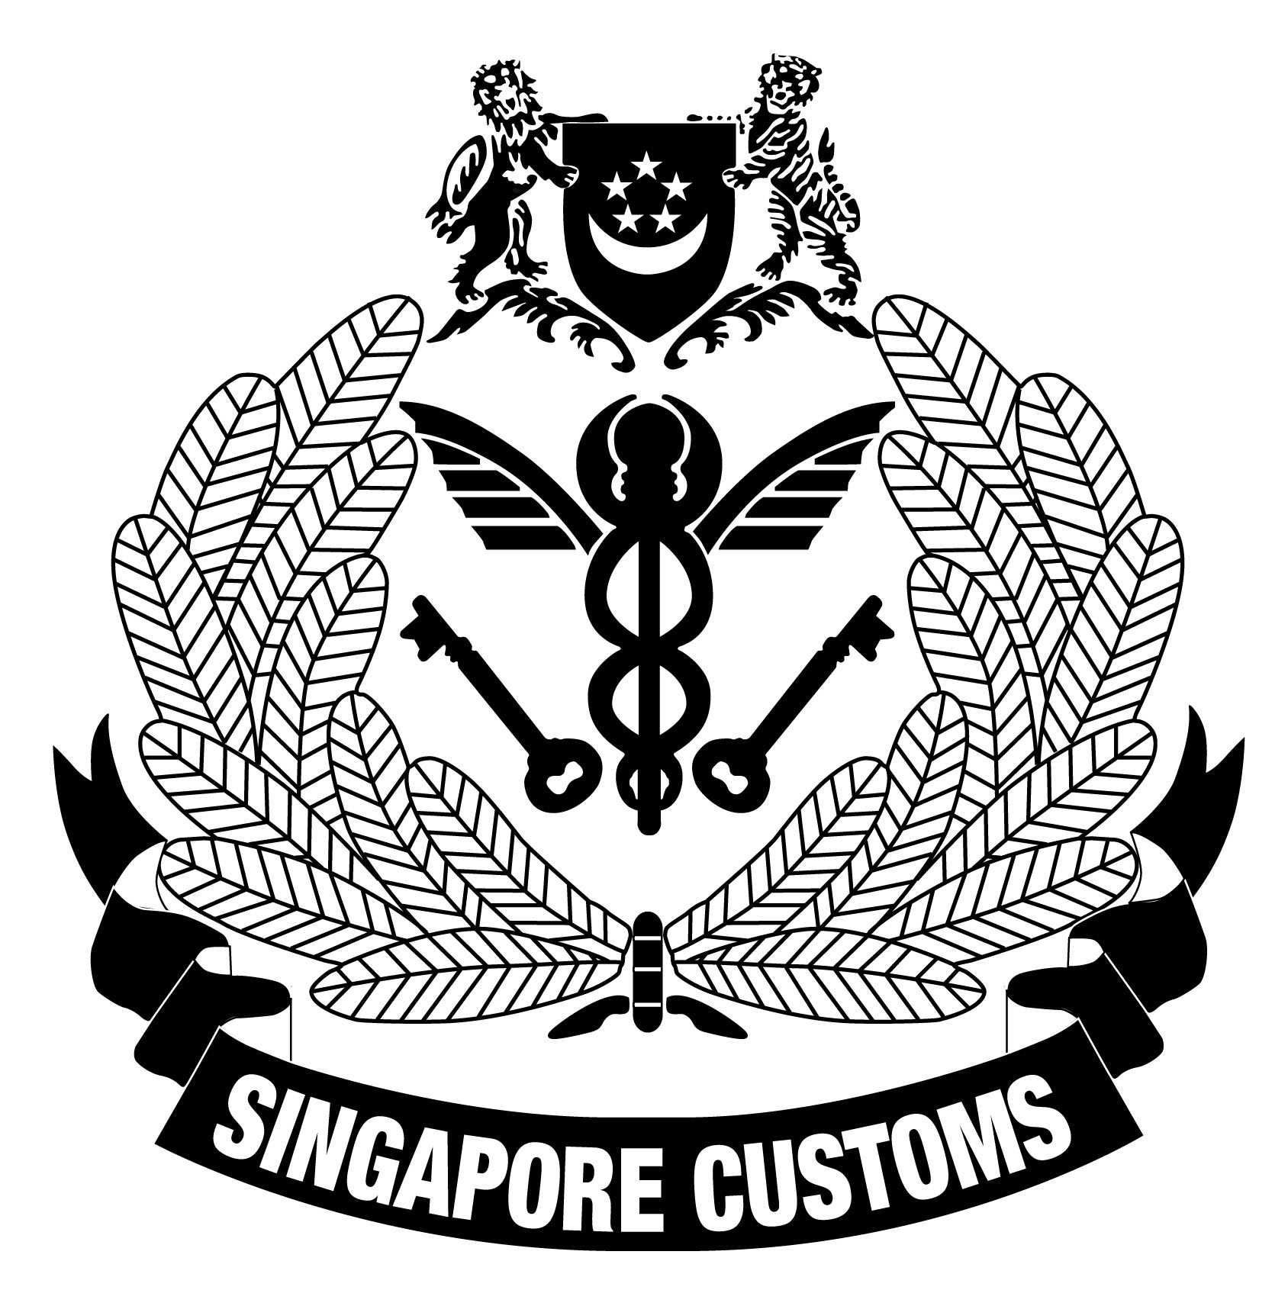 | Singapore Customs,  Schemes & Engagement Branch  55 Newton Road #07-01,  Revenue House  Singapore 307987  Tel No. : 6251 3027  Email: customs_schemes@customs.gov.sg

AUTHORISATION OF DECLARING AGENT(S) FOR LICENSED PREMISES

This form may take you 2 minutes to fill in.
You will need the following information to fill in the form:
- Licence number of applicant
- Contact details
- Entity Identifier/UEN of declaring agent
SECTION A PARTICULARS OF APPLICANT
Name of Company/Firm:
Licence No:
Contact Person: |  |  |  |  |  |  |  | Tel No:
Fax No:
SECTION B LIST OF DECLARING AGENTS
Important Note
- The declaring agent(s) must be registered with Singapore Customs for submission of Customs declarations.
Name of Company/Firm:
Entity Identifier/UEN:
Name of Company/Firm:
Entity Identifier/UEN:
SECTION C DECLARATION
(To be signed by the licensee or his staff not below the appointment of a warehouse manager)
I hereby declare that all information given in this form is true and correct. I undertake to inform Customs immediately of any changes to the particulars in this form.
Signature:

Name:
Designation:
Date:

