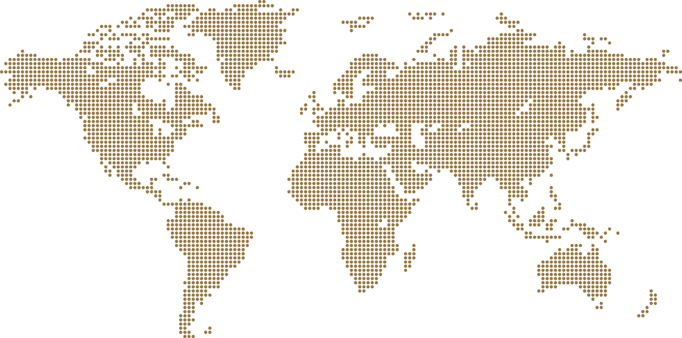****

**STAGE B SUBMISSION REPORT**

1. Your city must be nominated for Stage A before you proceed with Stage B.
2. More info on Stage A: [www.leekuanyewworldcityprize.gov.sg/stage-a](http://www.leekuanyewworldcityprize.gov.sg/stage-a)
3. More info on Stage B: [www.leekuanyewworldcityprize.gov.sg/stage-b](http://www.leekuanyewworldcityprize.gov.sg/stage-b)
4. There are three (3) sections to this report:
5. **City portfolio**: Brief information on the city
6. **Master Plan or Strategy**: Brief information on the overall master plan or strategy for the city
7. **Three (3) demonstration projects**: Information on three (3) demonstration projects to illustrate the success of the overall Master Plan or Strategy
8. Please complete all parts of this report in English. More info on evaluation criteria: [www.leekuanyewworldcityprize.gov.sg/evaluations/#judging-criteria](http://www.leekuanyewworldcityprize.gov.sg/evaluations/#judging-criteria)

# Contents Page

|  |  |  |  |
| --- | --- | --- | --- |
| 1 | **Section A** | City Portfolio | | Click here |
| 2 | **Section B** | Overall Master Plan or Strategy | | Click here |
| 3 | **Section C** | Demonstration Projects | Demonstration Project 1 | Click here |
| Demonstration Project 2 | Click here |
| Demonstration Project 3 | Click here |
| 4 | **Annex A** | Demonstration Project Types | | Click here |

# Section A | City Portfolio

Background on city

|  |  |  |
| --- | --- | --- |
| 1 | **City** |  |
| 2 | **Province/state/region** |  |
| 3 | **Country** |  |
| 4 | **Mayor or Governor** |  |
| 5 | **Term in office** |  |

1. **Please insert a map of the city**, ideally outlining the area under the Mayor’s or Governor’s jurisdiction.

Image

Leadership and governance

1. **What is the governance structure of the city** (e.g., mayor-council, commission, city manager)? You may wish to include an organisation chart to illustrate.

Answer

1. **What roles did the city leaders (past and present) play to transform the city?**

Answer

1. **Who are the key organisations and stakeholders involved in the city’s transformation?**

Answer

# Section B | Overall Master Plan or Strategy

1. Background information

|  |  |  |
| --- | --- | --- |
| 1 | **Name of Master Plan or Strategy** |  |
| 2 | **When was the Master Plan or Strategy implemented?** |  |
| 3 | **Effective period** |  |
| 4 | **Vision of Master Plan or Strategy** |  |
| 5 | **Link to the Master Plan or Strategy document online** (if available) |  |

1. Key strategies
2. **Describe up to three key strategies of the Master Plan or Strategy.**

Answer

1. **What are some new ideas that were implemented under the Master Plan or Strategy?**

Answer

1. Integration of plans
2. **Is the Master Plan or Strategy integrated with the region or neighbouring cities? If so, how?**

Answer

1. Impacts
2. **How has the Master Plan or Strategy impacted the city?** (e.g., in the areas of economy, housing, sustainable transportation, environment, quality of life, etc.)

Answer

1. Sustainability of the transformation
2. **How does the city ensure that the plans will continue despite leadership changes?**

Answer

1. Changing demographics
2. **How does your city address ageing population?**

Answer

1. **Briefly describe up to three key strategies that your city implemented or intends to implement to improve quality of life**, especially for vulnerable groups (e.g., migrants, low-income residents, minorities, etc.).

Answer

1. Climate change
2. **Briefly describe up to three key strategies that your city implemented or intends to implement to mitigate the effects of climate change.**

Answer

# Section C | Demonstration Project 1

1. Background information

|  |  |  |
| --- | --- | --- |
| 1 | **Project name** |  |
| 2 | **Type of project**  (Refer to Annex A) |  |
| 3 | **Size or scale**  (if applicable) |  |
| 4 | **Location** |  |
| 5 | **Year of completion** |  |
| 6 | **Link to project info online** (if available) |  |

1. Objectives
2. **What are the objectives of the project?** (i.e., what issues did the project seek to address?)

Answer

1. Key strategies
2. **What are the key strategies or actions taken?** (i.e., how did the city implement the project?)

Answer

1. **What are some new ideas implemented?**

Answer

1. Impacts
2. **What are the impacts of the project?** (e.g., to the local community and/or the urban environment)

Answer

# Demonstration Project 2

1. Background information

|  |  |  |
| --- | --- | --- |
| 1 | **Project name** |  |
| 2 | **Type of project**  (Refer to Annex A) |  |
| 3 | **Size or scale**  (if applicable) |  |
| 4 | **Location** |  |
| 5 | **Year of completion** |  |
| 6 | **Link to project info online** (if available) |  |

1. Objectives
2. **What are the objectives of the project?** (i.e., what issues did the project seek to address?)

Answer

1. Key strategies
2. **What are the key strategies or actions taken?** (i.e., how did the city implement the project?)

Answer

1. **What are some new ideas implemented?**

Answer

1. Impacts
2. **What are the impacts of the project, such as to the local community and/or the urban environment?**

Answer

# Demonstration project 3

1. Background information

|  |  |  |
| --- | --- | --- |
| 1 | **Project name** |  |
| 2 | **Type of project**  (Refer to Annex A) |  |
| 3 | **Size or scale**  (if applicable) |  |
| 4 | **Location** |  |
| 5 | **Year of completion** |  |
| 6 | **Link to project info online** (if available) |  |

1. Objectives
2. **What are the objectives of the project?** (i.e., what issues did the project seek to address?)

Answer

1. Key strategies
2. **What are the key strategies or actions taken?** (i.e., how did the city implement the project?)

Answer

1. **What are some new ideas implemented?**

Answer

1. Impacts
2. **What are the impacts of the project, such as to the local community and/or the urban environment?**

Answer

# Annex A | Demonstration Project Types (Non-exhaustive)

|  |  |  |  |
| --- | --- | --- | --- |
|  | Category | Types | |
| 1 | **Governance** | Governance re-structuring | Public services/e-governance |
| Participatory planning processes | Public-private partnerships |
| 2 | **Urban regeneration** | Brownfield redevelopment | Conservation of heritage |
| Public spaces development |  |
| 3 | **Adapting to climate change** | Energy transition/low carbon | Flood protection |
| Storm-water management | Disaster mitigation |
| 4 | **Environmental projects** | Urban greenery/ecology | City beautification |
| Urban agriculture | Water management |
| Waste management |  |
| 5 | **Economic development initiatives** | Industry development | Regional or international events |
| Tourism development |  |
| 6 | **Sustainable transport** | Transport infrastructure | Shared mobility |
| Electric vehicles | Traffic/transport management |
| Urban logistics |  |
| 7 | **Social equity** | Affordable housing | Social integration initiatives |
| Universal design | Shared spaces |
| 8 | **Smart city initiatives** | Smart technology | Big data |
| 9 | **Others** | COVID-19 measures | Others |

# 

# Directory

**Prize Secretary** Ms Yap Lay Bee

**Mailing address** c/o Urban Redevelopment Authority

45 Maxwell Road

The URA Centre, Tower, #13-01

Singapore 069118

**Email** [leekuanyew_worldcityprize@ura.gov.sg](mailto:leekuanyew_worldcityprize@ura.gov.sg)

**Website** [www.leekuanyewworldcityprize.gov.sg](https://www.leekuanyewworldcityprize.gov.sg/)

**YouTube** [@leekuanyewworldcityprize](https://www.youtube.com/@leekuanyewworldcityprize)

*All Rights Reserved. Copyright 2023 © Urban Redevelopment Authority Singapore. No parts of this document may be reproduced or circulated to unrelated third parties without prior permission from the Lee Kuan Yew World City Prize Secretariat*