NETWORK PROGRAMMING LAB

LAB ASSIGNMENT 1
(CSX - 354)

COMPUTER SCIENCE AND ENGINEERING



DEPARTMENT OF COMPUTER SCIENCE AND ENGINEERING
Dr. B R AMBEDKAR NATIONAL INSTITUTE OF TECHNOLOGY
JALANDHAR – 144011, PUNJAB (INDIA)

Submitted To: Submitted By:
Mr Manoj Kumar Aman Garg
Asst. Professor 13103050
Department of CSE 6th Semester

INDEX
S.no | Objective | Page | Signature
1. | TCP iterative client and server application to reverse given output | 3
2. | Client Server communication using TCP | 6
3. | TCP Sockets Date Time Server | 10
4. | TCP Client and Server application to transfer a file. | 14
5. | Creation of one way pipe in a single process | 18

LAB : 1
TCP Application to Reverse a given String (JAVA)
Description:
Sockets provide the communication mechanism between two computers using TCP. A client program creates a socket on its end of the communication and attempts to connect that socket to a server.
When the connection is made, the server creates a socket object on its end of the communication. The client and server can now communicate by writing to and reading from the socket.
The java.net.Socket class represents a socket, and the java.net.ServerSocket class provides a mechanism for the server program to listen for clients and establish connections with them.
The server instantiates a ServerSocket object, denoting which port number communication is to occur on.
The server invokes the accept() method of the ServerSocket class. This method waits until a client connects to the server on the given port.
After the server is waiting, a client instantiates a Socket object, specifying the server name and port number to connect to.
The constructor of the Socket class attempts to connect the client to the specified server and port number. If communication is established, the client now has a Socket object capable of communicating with the server.
On the server side, the accept() method returns a reference to a new socket on the server that is connected to the client's socket.
After the connections are established, communication can occur using I/O streams. Each socket has both an OutputStream and an InputStream. The client's OutputStream is connected to the server's InputStream, and the client's InputStream is connected to the server's OutputStream.

Program (Server Side):
// Server program to receive a string from client and send it's reverse
import java.util.*;
import java.io.*;
import java.net.*;
class simpleServer{
public static void main(String[] args) {
String clientString, outString;
try{
ServerSocket serSock = new ServerSocket(25000);
while (true){
Socket conn = serSock.accept();
BufferedReader inFromClient = new BufferedReader(new InputStreamReader(conn.getInputStream()));
DataOutputStream outToClient = new DataOutputStream(conn.getOutputStream());
clientString = inFromClient.readLine();
System.out.println("New message from client : "+ clientString);
StringBuilder sb = new StringBuilder(clientString);
outString = sb.reverse().toString();
System.out.println("Sending reverse to client: "+ outString);
outToClient.writeBytes(outString);
conn.close();
}
}
catch (IOException e){
System.out.println("I/O Exception caught at server"); }
}
}
Program (Client Side):
import java.util.*;
import java.io.*;
import java.net.*;
class simpleClient {
public static void main(String[] args) throws IOException{
String sentence;
try{
System.out.print("Enter string for server: ");
BufferedReader in = new BufferedReader(new InputStreamReader(System.in));
sentence = in.readLine();

Socket clientSock = new Socket("localhost",25000);
DataOutputStream outToServer = new DataOutputStream(clientSock.getOutputStream());
BufferedReader inFromServer = new BufferedReader(new InputStreamReader(clientSock.getInputStream()));
outToServer.writeBytes(sentence + "\n");
String reversedSent = inFromServer.readLine();
System.out.println("Received from server : " + reversedSent);
clientSock.close();
}
catch (IOException e){
System.out.println("IO Exception caught at client"); } }
}
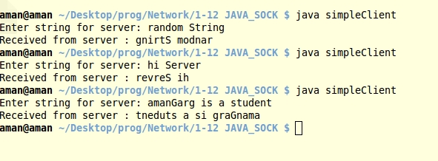
OUTPUT:

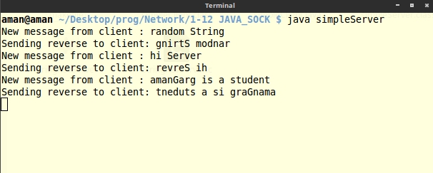

LAB : 2
Client Server Communication using TCP (C)
Description:
Most interprocess communication uses the client server model. These terms refer to the two processes which will be communicating with each other. One of the two processes, the client, connects to the other process, the server, typically to make a request for information. Notice that the client needs to know of the existence of and the address of the server, but the server does not need to know the address of (or even the existence of) the client prior to the connection being established. Notice also that once a connection is established, both sides can send and receive information. The system calls for establishing a connection are somewhat different for the client and the server, but both involve the basic construct of a socket. The two processes each establish their own socket.
The steps involved in establishing a socket on the client side are as follows:
- Create a socket with the socket() system call
- Connect the socket to the address of the server using the connect() system call
  - Send and receive data. There are a number of ways to do this, but the simplest is to use the read() and write()system calls.
The steps involved in establishing a socket on the server side are as follows:
- Create a socket with the socket() system call
- Bind the socket to an address using the bind() system call. For a server socket on the Internet, an address consists of a port number on the host machine.
- Listen for connections with the listen() system call
- Accept a connection with the accept() system call. This call typically blocks until a client connects with the server.
- Send and receive data
Program (Server Side):

#include <sys/socket.h>
#include <netinet/in.h>
#include <arpa/inet.h>
#include <stdio.h>
#include <stdlib.h>
#include <unistd.h>
#include <errno.h>
#include <string.h>
#include <strings.h>
#include <sys/types.h>
#include <time.h>
#include <stdbool.h>

#define MAX 1024
#define PORT 25000
#define MAX_BACKLOG 10

int main(){
// fd for server side and one fd for the client side
int listenfd = 0, connfd = 0;

// A socket address structure to hold in the socket
struct sockaddr_in serv_addr = {0};

// Strings to manipulate incoming and outgoing data
char recvBuff[MAX] = {' '};

// Creates a socket i.e file descriptor within the process table
listenfd = socket(AF_INET, SOCK_STREAM, 0);

// initialise members of the socket's address structure
serv_addr.sin_family = AF_INET;
serv_addr.sin_addr.s_addr = htonl(INADDR_ANY);
serv_addr.sin_port = htons(PORT);

// Assign protocol to a socket :=
bind(listenfd, (struct sockaddr *)&serv_addr, sizeof(serv_addr));

// listen for incoming connections with a specified backlog queue
listen(listenfd, MAX_BACKLOG);

while(true){
// accept incoming client connections to the given socket
connfd = accept(listenfd, (struct sockaddr*)NULL, NULL);

// Read the message from the socket into a string
int readChar = read(connfd, recvBuff, MAX);

printf("\n New Client Connected with message: \n");
for (int i = 0 ; i < readChar; i++)
printf("%c",recvBuff[i]);

close(connfd);
sleep(1);
}
}

Program (Client Side):

#include <sys/socket.h>
#include <sys/types.h>
#include <netinet/in.h>
#include <netdb.h>
#include <stdio.h>
#include <string.h>
#include <stdlib.h>
#include <unistd.h>
#include <arpa/inet.h>
#define localhost "127.70.0.10"
#define MAX 1024
#define PORT 25000

int main(){
// Set up client sockets, character buffers
int sockfd = 0, n = 0;
char sendBuff[MAX] = {' '};

// A socket address structure to hold in the socket
struct sockaddr_in serv_addr = {0};

// mention domain, stream/datagram and default protocol
sockfd = socket(AF_INET, SOCK_STREAM, 0);

if(sockfd < 0){
perror("\n Error : Could not create socket \n");
return 1;
}
// initialise members of the socket's address structure
serv_addr.sin_family = AF_INET;
serv_addr.sin_port = htons(PORT);

if( connect(sockfd, (struct sockaddr *)&serv_addr, sizeof(serv_addr)) < 0){
printf("\n Error : Connect Failed \n");
return 1;
}
// Read from input and write to socket
fprintf(stdout, "\n Enter the string to send to server: ");
fgets(sendBuff, MAX, stdin);
printf("\n Writing to server socket: %s", sendBuff);
n = write(sockfd, sendBuff, strlen(sendBuff)) ;
printf("\n");
return 0;
}
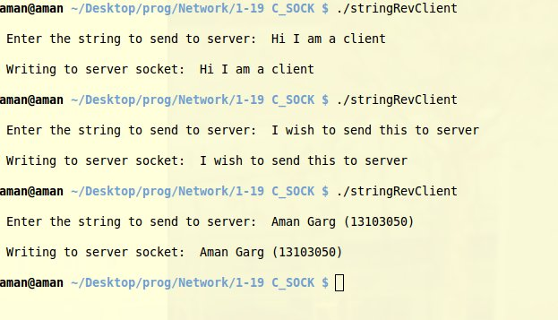
OUTPUT:

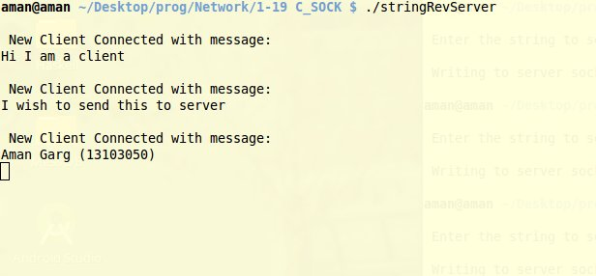

LAB : 3
TCP Sockets Date Time Server (C)
Description:
Sockets enable us to communicate between the client and the server. The client program here, requests the current time from the server using a TCP connection. This can be done by making use of the ctime() defined in <time.h>. This program is equivalent to calling the Timer Server defined at port 13.
Program (Server Side):

#include <sys/socket.h>
#include <netinet/in.h>
#include <arpa/inet.h>
#include <stdio.h>
#include <stdlib.h>
#include <unistd.h>
#include <errno.h>
#include <string.h>
#include <strings.h>
#include <sys/types.h>
#include <time.h>
#include <stdbool.h>

#define MAX 1024
#define PORT 25000
#define MAX_BACKLOG 10

int main(){
// fd for server side and one fd for the client side
int listenfd = 0, connfd = 0;

// A socket address structure to hold in the socket
struct sockaddr_in serv_addr = {0};

// Strings to manipulate incoming and outgoing data
char sendBuff[MAX] = {' '};

// Creates a socket i.e file descriptor within the process table
listenfd = socket(AF_INET, SOCK_STREAM, 0);

// initialise members of the socket's address structure
serv_addr.sin_family = AF_INET;
serv_addr.sin_addr.s_addr = htonl(INADDR_ANY);
serv_addr.sin_port = htons(PORT);

// Assign protocol to a socket :=
bind(listenfd, (struct sockaddr *)&serv_addr, sizeof(serv_addr));

// listen for incoming connections with a specified backlog queue
listen(listenfd, MAX_BACKLOG);

time_t new_time = time(NULL);

while(true){
// accept incoming client connections to the given socket
connfd = accept(listenfd, (struct sockaddr*)NULL, NULL);

// Read the message from the socket into a string
snprintf(sendBuff, MAX, "%s", ctime(&new_time) );

printf("\n Client connected. Sending Time : %s\n", sendBuff);
write(connfd, sendBuff, strlen(sendBuff));

close(connfd);
sleep(1);
}
}

Program (Client Side):

#include <sys/socket.h>
#include <sys/types.h>
#include <netinet/in.h>
#include <netdb.h>
#include <stdio.h>
#include <string.h>
#include <stdlib.h>
#include <unistd.h>
#include <arpa/inet.h>

#define localhost "127.70.0.10"
#define MAX 1024
#define PORT 25000

int main(){
// Set up client sockets, character buffers
int sockfd = 0, n = 0;

//Set up a string to hold the incoming response
char recvBuff[MAX] = {' '};

// A socket address structure to hold in the socket
struct sockaddr_in serv_addr = {0};

// mention domain, stream/datagram and default protocol
sockfd = socket(AF_INET, SOCK_STREAM, 0);

if(sockfd < 0){
perror("\n Error : Could not create socket \n");
return 1;
}

// initialise members of the socket's address structure
serv_addr.sin_family = AF_INET;
serv_addr.sin_port = htons(PORT);

// Read from input and write to socket
fprintf(stdout, "\n Requesting current time from server: \n\t");

if(inet_pton(AF_INET, localhost, &serv_addr.sin_addr)<=0){
printf("\n inet_pton error occured\n");
return 1;
}

if( connect(sockfd, (struct sockaddr *)&serv_addr, sizeof(serv_addr)) < 0){
printf("\n Error : Connect Failed \n");
return 1;
}

n = read(sockfd, recvBuff, MAX);
for(int i = 0; i < n; i ++)
printf("%c", recvBuff[i]);

printf("\n");
close(sockfd);
return 0;
}
OUTPUT:

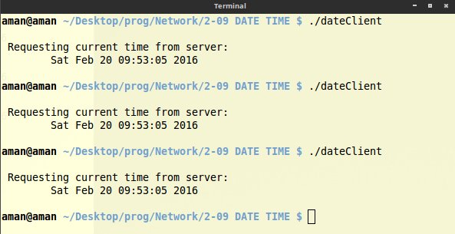
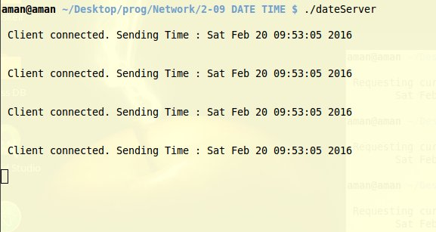

LAB : 4
TCP Application to Transfer a file using Sockets
Description:
Sockets enable us to communicate between the client and the server. The client program here, requests a file from the server using a TCP connection. Server has an input file called “inputServer”. As soon as, a client connects, it sends the file stored in an array to the client. The client reads the information received from the socket, stores it in another array and writes that to a file called “serverOutput”. The program also depicts the IP addresses involved during the transfer.
Program (Server Side):

#include <stdio.h>
#include <stdlib.h>
#include <unistd.h>
#include <sys/socket.h>
#include <netinet/in.h>
#include <arpa/inet.h>
#include <errno.h>
#include <string.h>
#include <strings.h>
#include <sys/types.h>
#include <stdbool.h>
#include <assert.h>

#define MAX 1024
#define PORT 25000
#define MAX_BACKLOG 10
#define SERVER_INPUT_FILE "inputServer"

// Send a given input file to every client that wishes to connect

int main(){
// Create a fd for server and one for client
int sockFd = 0, clientFd = 0, readChar;

// A socket address structure to hold in the socket
struct sockaddr_in serv_addr = {0};

// String to hold input file line by line for client
char sendBuff[MAX];

// Creates a TCP socket i.e file descriptor within the process table
sockFd = socket(AF_INET, SOCK_STREAM, 0);

// initialise members of the socket's address structure
serv_addr.sin_family = AF_INET;
serv_addr.sin_addr.s_addr = htonl(INADDR_ANY);
serv_addr.sin_port = htons(PORT);

// Assign protocol to a socket :=
bind(sockFd, (struct sockaddr *)&serv_addr, sizeof(serv_addr));

// listen for incoming connections with a specified backlog queue
listen(sockFd, MAX_BACKLOG);

// read input from file once
FILE *fp = fopen(SERVER_INPUT_FILE, "r");
assert (fp);
while (!feof(fp))
readChar = fread(sendBuff, 1, MAX, fp);

fclose(fp);

while(true){
// Socket address structure to hold the client socket
struct sockaddr_in addr;
socklen_t addr_size = sizeof(struct sockaddr_in);

// accept incoming client connections to the given socket descriptor clientFd
clientFd = accept(sockFd, (struct sockaddr *)&addr, &addr_size);
fprintf(stdout, "\nA new client has connected. Sending file\n");
fprintf(stdout, "IP Address: %s\n", inet_ntoa(addr.sin_addr) );

write(clientFd, sendBuff, readChar);
close(clientFd);
sleep(1);
}

return 0;
}

Program (Client Side):

#include <stdio.h>
#include <stdlib.h>
#include <unistd.h>
#include <sys/socket.h>
#include <netinet/in.h>
#include <arpa/inet.h>
#include <errno.h>
#include <string.h>
#include <strings.h>
#include <sys/types.h>
#define localhost "127.0.0.10"
#define outputFile "ServerOutput"
#define MAX 1024
#define PORT 25000
// Connect to the server at the given location and create a file mentioning its inputs

int main(){
// Set up client sockets, character buffers
int sockFd = 0, n = 0;
char recvBuff[MAX] = {' '};

// A socket address structure to hold in the socket
struct sockaddr_in serv_addr = {0};

// Create TCP Socket: mention domain, stream/datagram and default protocol
sockFd = socket(AF_INET, SOCK_STREAM, 0);

if(sockFd < 0){
perror("\n Error : Could not create socket \n");
return 1;
}

// initialise members of the socket's address structure
serv_addr.sin_family = AF_INET;
serv_addr.sin_port = htons(PORT);

if( connect(sockFd, (struct sockaddr *)&serv_addr, sizeof(serv_addr)) < 0){
printf("\n Error : Connect Failed \n");
return 1;
}

// Read from input and write to socket
fprintf(stdout, "\n Storing file received from server: %s \n\n", inet_ntoa(serv_addr.sin_addr));

FILE * fp = fopen(outputFile, "w");
assert(fp);

// Read message from server
n = read(sockFd, recvBuff, MAX);
// Write the message received from server onto file
fwrite(recvBuff, 1, n, fp);

// Also display file contents
write(0, recvBuff, n);

fclose(fp);
return 0;
}

OUTPUT:
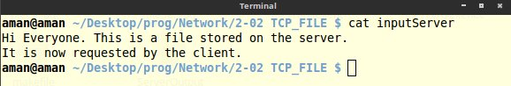

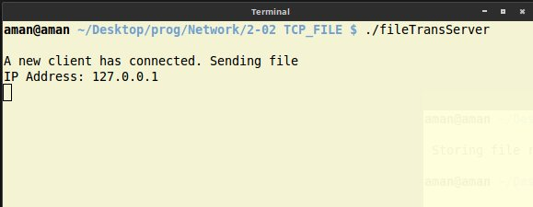

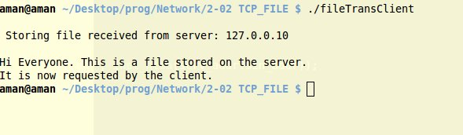

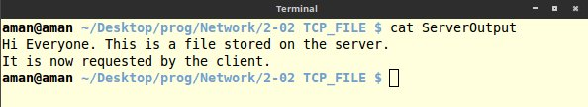

LAB : 5
One way pipe for inter process communication
Description:
Pipes provide a medium for flow of data. A pipe can be explicitly created in Unix using the pipe system call. Two file descriptors are returned, namely fd[0] and fd[1], and they are both open for reading and writing. A read from fd[0] accesses the data written to fd[1] on a first-in-first-out (FIFO) basis and a read from fd[1] accesses the data written to fd[0] also on a FIFO basis.
A regular pipe can only connect two related processes. It is created by a process and will vanish when the last process closes it.
A named pipe, also called a FIFO for its behavior, can be used to connect two unrelated processes and exists independently of the processes; meaning it can exist even if no one is using it. A FIFO is created using the mkfifo() library function.

Program :
#include <stdio.h>
#include <stdlib.h>
#include <string.h>
#include <unistd.h>
#include <sys/types.h>
#define MAX 100

int main(void){
int fd[2], readChar;
pid_t childPid;
char message[] = "A message transferred using pipes";
char pid[100];
char readbuffer[MAX] = {' '};

pipe(fd);

switch(childPid = fork()){
case -1:
perror("fork error");
exit(1);
break;

case 0:
/* Child process closes the read end of the pipe */
close(fd[0]);

/* Send message through the write end of the pipe */
sprintf(pid, " PID: (%d) ", getpid());
write(fd[1], strcat(message, pid), (strlen(message) + 1));
exit(0);
break;

default:
/* Parent process closes the write end of the pipe */
close(fd[1]);

/* Read from the pipe */
readChar = read(fd[0], readbuffer, sizeof(readbuffer));
printf("\nReceived (%d) message from child: \n\t%s\n\n", getpid(), readbuffer);

}

return 0;
}

OUTPUT:

