INDEX

S. No. | OBJECTIVE | Page No. | Sign
 | Introduction to NS2 | 2
 | Unicasting using 2 UDP connections | 4
 | Implementing Topology using 1 UDP and 2 TCP connections | 7
 | Implementing Ring Topology using UDP and TCP connections | 11
 | Program to implement Caesar Cipher | 15
 | Program to implement Play Fair Cipher | 17
 | Unicasting in a LAN using TCP and UDP connections | 22
 | Multicasting in a wired network | 26
 | Program to implement RSA algorithm | 29

EXPERIMENT -5

AIM: To implement Caesar Cipher receiving input from a file.

Program:

#include <bits/stdc++.h>
using namespace std;
static int substitution_index;

char encrypt(char c){

if (isdigit(c))
return (c -'0' +substitution_index)%10 + '0';

else if (isupper(c))
return char((65 + (int(c) - 65 +substitution_index)%26 ));

else return char((97 + (int(c) - 97 +substitution_index)%26 ));

}

void solve(vector<char> & input){
vector<char>:: iterator it = input.begin();
vector<char> output;

cout<<"\n The Decrypted Message: ";

for(;it!=input.end();it++){
cout<<*it;

if (isalnum(*it))
output.push_back(encrypt(*it));
else
output.push_back(*it);
}

vector<char>:: iterator ot = output.begin();
cout<<"\n The Encrypted Message: ";
for(;ot!=output.end();ot++)
cout<<*ot;

}

int main(){

substitution_index=3;

ifstream inf("input.txt");
char c;
vector<char>input;

while((c=inf.get())!=EOF)
input.push_back(c);

inf.close();
solve(input);
cout<<endl;

return 0;
}

OUTPUT:

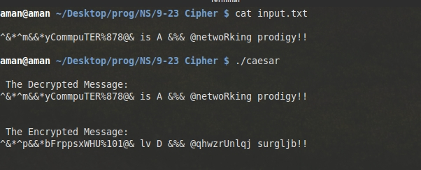

EXPERIMENT -6

AIM: Implement Playfair Cipher receiving input from a file and key string for the matrix from the user.

Program:

#include <bits/stdc++.h>
using namespace std;

static int substitution_index;
char *mat[8];

void build_matrix(string &s1,char ** mat){

for(int i=0 ; i<8; i++)
mat[i]= new char[8];

for(int i=0; i<8; i++)
for(int j=0; j<8; j++)
mat[i][j]='!';

set<char> unique;
for(int i=0; i<s1.size(); i++)
unique.insert(s1[i]);

set<char>::iterator sit=unique.begin();
int last_row,last_col;
bool over=false;

for(int i=0; i<8; i++){
for(int j=0; j<8; j++)
if (sit!=unique.end()){

mat[i][j]=*sit;
sit++;
}
else{
last_col=j;
last_row=i;
over=true;
break;
}
if (over)break;
}

vector<char>not_added_lower;
for(char x='a'; x<='z'; x++)
if (find(unique.begin(), unique.end(),x)==unique.end())
not_added_lower.push_back(x);

for(int i=0; i<not_added_lower.size(); i++){

if ((last_col)%8==0){
last_row+=1;
last_col=0;
mat[last_row][last_col++]=not_added_lower[i];
}
else mat[last_row][last_col++]=not_added_lower[i];

}

vector<char>not_added_upper;
for(char x='A'; x<='Z'; x++)
if (find(unique.begin(), unique.end(),x)==unique.end())
not_added_upper.push_back(x);

for(int i=0; i<not_added_upper.size(); i++){
if ((last_col)%8==0){
last_row+=1;
last_col=0;
mat[last_row][last_col++]=not_added_upper[i];
}
else mat[last_row][last_col++]=not_added_upper[i];
}

for (int i=0; i<10; i++){
if ((last_col)%8==0){
last_row+=1;
last_col=0;
mat[last_row][last_col++]=i+'0';
}
else mat[last_row][last_col++]=i+'0';
}

cout<<"\n";
for(int i=0; i<8; i++){
for(int j=0; j<8; j++)
cout<<" "<<mat[i][j];
cout<<endl;
}
}

char encrypt(char a,char b,vector<char>& output){

int x1,x2,y1,y2;

for(int i=0; i<8; i++)
for(int j=0; j<8; j++)
if (mat[i][j]==a){
x1=i;
y1=j;
break;
}

for(int i=0; i<8; i++)
for(int j=0; j<8; j++)
if (mat[i][j]==b){
x2=i;
y2=j;
break;
}

if (x1==x2){
output.push_back(mat[x1][(y1+1)%8]);
output.push_back(mat[x2][(y2+1)%8]);
output.push_back(' ');
}

else if (y1==y2){
output.push_back(mat[(x1+1)%8][y1]);
output.push_back(mat[(x2+1)%8][y2]);
output.push_back(' ');
}

else{
output.push_back(mat[x2][y1]);
output.push_back(mat[x1][y2]);
output.push_back(' ');
}
}

void solve(vector<char> & input_1,vector<char> & input_2){

vector<char>:: iterator it = input_1.begin();
vector<char>:: iterator it2 = input_2.begin();
vector<char> output;

cout<<"\n The Decrypted Message: ";

for(;it!=input_1.end();it++,it2++){
cout<<*it<<*it2<<" ";
encrypt(*it,*it2,output);
}

vector<char>:: iterator ot = output.begin();
cout<<"\n The Encrypted Message: ";
for(;ot!=output.end();ot++)
cout<<*ot;
}

int main(){

string s1;
cout<<"\n Enter key string for the matrix: ";
cin >> s1;

build_matrix(s1,mat);

ifstream inf("input.txt");
char c,i1,i2;
vector<char>input_1;
vector<char>input_2;

while((c=inf.get())!=EOF){

if(!isalnum(c))
continue;

i1=c;
i2=inf.get();

while(!isalnum(i2))
i2=inf.get();

if(i1==i2){
input_1.push_back(c);
input_2.push_back('!');
input_2.push_back(c);
input_1.push_back('!');
}
else{
input_1.push_back(i1);
input_2.push_back(i2);
}

}

inf.close();
solve(input_1,input_2);
cout<<endl<<endl;

return 0;
}

OUTPUT:

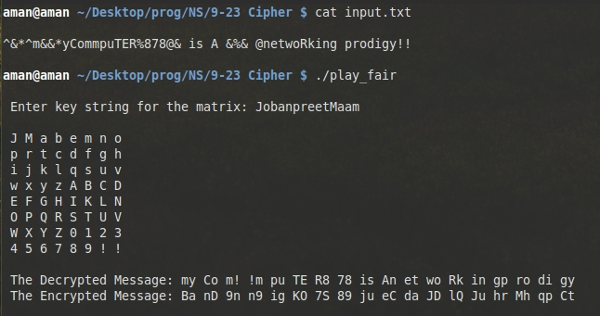

EXPERIMENT - 7

AIM: To implement unicasting in a LAN using TCP and UDP connections.

Scenario: A local area network of three nodes is connected to multiple nodes and the
analysis of the network is made on the variation of congestion window of TCP
agents.

Tcl Program:

set ns [new Simulator]
set nt [open democong.tr w]
$ns trace-all $nt
set nf [open namfile1.nam w]
$ns namtrace-all $nf
set out [open congestion.xg w]
#creating nodes
set s0 [$ns node]
set s1 [$ns node]
set s2 [$ns node]
set s3 [$ns node]
set s4 [$ns node]
set s5 [$ns node]
set lan [$ns newLan "$s3 $s4 $s5" 0.5Mb 40ms LL MAC/Csma/Cd Channel]
#creating link
#puts "hello"
$ns duplex-link $s0 $s2 3Mbps 20ms DropTail
$ns queue-limit $s0 $s2 5
$ns duplex-link-op $s0 $s2 orient right-down
$ns simplex-link $s1 $s2 1.5Mbps 20ms DropTail
$ns queue-limit $s1 $s2 7
$ns simplex-link-op $s1 $s2 orient right-up
$ns duplex-link $s2 $s3 2Mbps 20ms DropTail
$ns queue-limit $s2 $s3 5
$ns duplex-link-op $s2 $s3 orient right
#creating agents
set n0 [new Agent/TCP]
$ns attach-agent $s0 $n0
set n1 [new Agent/UDP]
$ns attach-agent $s1 $n1
set destudp [new Agent/Null]
$ns attach-agent $s5 $destudp
set desttcp [new Agent/TCPSink]
$ns attach-agent $s5 $desttcp
#setting Traffic
set traffic1 [new Application/Traffic/CBR]
$traffic1 attach-agent $n1
$traffic1 set packetSize_ 50B
$traffic1 set interval_ 3ms
set traffic2 [new Application/FTP]
$traffic2 attach-agent $n0
$traffic2 set packetSize_ 50B
$traffic2 set interval_ 1ms
#creating connect
$ns connect $n0 $desttcp
$ns connect $n1 $destudp
#creating LAN
$n0 set window_ 15
proc plotwindow {n0 out} {
global ns
set now1 [$ns now]
set cwnd1 [$n0 set cwnd_]
puts $out "$now1 $cwnd1"
$ns at [expr $now1 + 0.1] "plotwindow $n0 $out"
}
proc finish { } {
global ns nf
$ns flush-trace
close $nf
exec nam namfile1.nam
exit 0
}
$ns at 0.0 "plotwindow $n0 $out"
$ns at 1.0 "$traffic1 start"
$ns at 1.0 "$traffic2 start"
$ns at 4.4 "$traffic1 stop"
$ns at 4.4 "$traffic2 stop"
$ns at 5.0 "finish"
$ns run

OUTPUT:

The snapshot of NAM file of unicasting in a LAN using TCP and UDP connections:

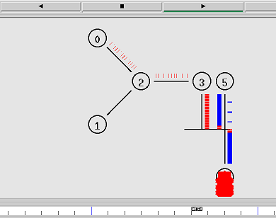

The snapshot of congestion window graph of TCP agent

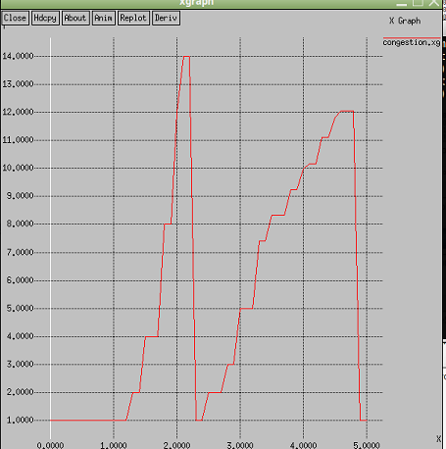

EXPERIMENT - 8

AIM: To implement multicasting in a wired network

#To implement a multicasting topology

set ns [new Simulator]
$ns multicast

set nt [open trace1.tr w]
$ns trace-all $nt

set nf [open namfile.nam w]
$ns namtrace-all $nf

proc finish { } {
global ns nf
$ns flush-trace
close $nf
exec nam namfile.nam
exit 0
}

#Initialise all nodes

for { set i 1 } { $i <7} {incr i} {
set n$i [$ns node]
}

#Give different color to source nodes
$n1 shape "square"
$n1 color Green
$n6 shape "square"
$n6 color Green

#Initialise duplex connections between all given links

$ns duplex-link $n1 $n2 2Mbps 5ms DropTail
$ns duplex-link $n1 $n4 2Mbps 5ms DropTail
$ns duplex-link $n2 $n3 2Mbps 5ms DropTail
$ns duplex-link $n4 $n3 2Mbps 5ms DropTail
$ns duplex-link $n3 $n5 2Mbps 5ms DropTail
$ns duplex-link $n5 $n6 2Mbps 5ms DropTail

$ns duplex-link-op $n1 $n2 orient left-down
$ns duplex-link-op $n1 $n4 orient right-down
$ns duplex-link-op $n2 $n3 orient left-down
$ns duplex-link-op $n4 $n3 orient right-down
$ns duplex-link-op $n3 $n5 orient right
$ns duplex-link-op $n5 $n6 orient up

#Insert sources
set src1 [new Agent/UDP]
set src2 [new Agent/UDP]
$ns attach-agent $n1 $src1
$ns attach-agent $n6 $src2

#Set groups
set group1 [Node allocaddr]
set group2 [Node allocaddr]

#Set protocol
set mproto DM
set mrthandle [$ns mrtproto $mproto]
$ns color 30 Green
$ns color 31 Red

#Set destinations
set dest1 [new Agent/Null]
set dest2 [new Agent/Null]
$src1 set dst_addr_ $group1
$src2 set dst_addr_ $group2

#Initiate traffic from the two sources
set traffic1 [new Application/Traffic/CBR]
$traffic1 attach-agent $src1
$traffic1 set packetSize_ 150B
$traffic1 set interval_ 1ms

set traffic2 [new Application/Traffic/CBR]
$traffic2 attach-agent $src2
$traffic2 set packetSize_ 150B
$traffic2 set interval_ 1ms

#Simulate the topology
$ns at 1.0 "$traffic1 start"
$ns at 1.5 "$n2 join-group $dest1 $group1"
$ns at 5.0 "$n4 join-group $dest1 $group1"
$ns at 5.0 "$n3 join-group $dest1 $group1"
$ns at 7.0 "$traffic1 stop"
$ns at 8.0 "$traffic2 start"
$ns at 9.0 "$n5 join-group $dest2 $group2"
$ns at 15.0 "$traffic2 stop"
$ns at 16.0 "finish"
$ns run

OUTPUT:

The snapshot of NAM file of multicasting in wired network:

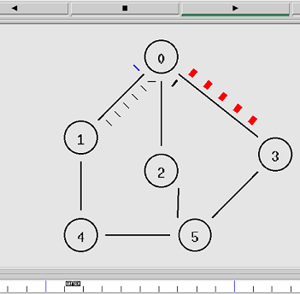

EXPERIMENT - 9

AIM: Program to implement RSA cryptography algorithm.

Program:

#include <bits/stdc++.h>
using namespace std;

typedef long long int llu;

llu power_exp(llu a,llu p,llu MOD)
{
llu RES = 1;
llu B = (llu) a;
while(p > 0)
{
if(p%2 == 1) RES = (RES*B)%MOD;
B = (B*B)%MOD;
p = p/2;
}
llu res = (llu) RES;
return res;
}

llu compute_d(llu e, llu z){

llu d = 1;
bool count= true;

while(count){
d+=1;
if ((e*d) % z == 1)
count=false;
}
return d;
}

bool isCoprime(llu &a, llu &b){
set<llu>factor_a;

for(llu i = 1 ; i<=sqrt(a); i++)
if (a % i == 0){
factor_a.insert(i);
factor_a.insert(a/i);
}

set<llu> :: iterator si = factor_a.begin();
for(; si!=factor_a.end(); si++)
if (b % *si ==0 && *si != 1)
return false;
return true;
}

inline llu encrypt(llu input, llu e , llu n){
llu enc = power_exp(input, e, n);
cout<<"\n Encrypted "<<input<<" as "<<enc;
return enc;
}

inline llu decrypt(llu cipher, llu d, llu n){
llu dec = power_exp(cipher, d, n);
cout<<"\n Decrypted "<<cipher<<" as "<<dec;
}

int main(){

llu a,b,e = 1;
llu input;

cout <<"\nEnter two space separated lluegers: "; cin >> a >> b;
assert (isCoprime(a,b));

llu n = a*b , z = (a-1) * (b-1);
cout <<"\n N: "<< n;
cout <<"\n Z: " << z;

while(++e){
if(e<z){
if(gcd(z,e)==1)
break;
}
else{
if(gcd(e,z)==1)
break;
}
}

llu d = compute_d(e,z);
cout <<"\n E: " << e;
cout <<"\n D: " << d;

cout << "\n\n Public Key: (" << e << "," << n << ")";
cout << "\n Private Key: (" << d << "," << n << ")"<<endl;

while(true){
cout<<"\n\n Enter confidential text : "; cin>>input;
llu enc = encrypt(input, e, n);
decrypt(enc, d, n);
}
return 0;
}

OUTPUT:

