Experiment – 18

To configure and set up the DNS Server

Domain Name Service (DNS) is an internet service that maps IP addresses to fully qualified domain names (FQDN) and vice versa.
BIND stands for Berkley Internet Naming Daemon. BIND is the most common program used for maintaining a name server on Linux.
In this tutorial, we will explain how to install and configure a DNS server.
The DNS chosen is on “10.42.0.83”.

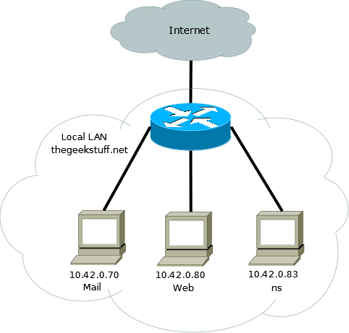

1). Install Bind
$ sudo apt-get install bind9
All the DNS configurations are stored under /etc/bind directory. The primary configuration is /etc/bind/named.conf which will include other needed files. The file named /etc/bind/db.root describes the root nameservers in the world.

2). Configure Cache NameServer
The job of a DNS caching server is to query other DNS servers and cache the response. Next time when the same query is given, it will provide the response from the cache. The cache will be updated periodically. To configure a Cache NameServer , add your ISP (Internet Service Provider)’s DNS server or any OpenDNS server to the file /etc/bind/named.conf.options
Forwarders {
8.8.8.8; 8.8.4.4;
};
After the above change, restart the DNS server.
$ sudo service bind9 restart

3) Test the Cache NameServer

$ dig ubuntu.com

4) Build the Forward Resolution for Primary/Master NameServer
Now we will add the details which is necessary for forward resolution into /etc/bind/db.dns_stuff.net.
$ sudo cp /etc/bind/db.local /etc/bind/db.dns_stuff.net
Next, edit the /etc/bind/db.dns_stuff.net and replace the following.
$TTL 604800
@ IN SOA ns.dns_stuff.net. lak.localhost. (
1024 ; Serial
604800 ; Refresh
86400 ; Retry
2419200 ; Expire
604800 ) ; Negative Cache TTL
;

5) Build the Reverse Resolution for Primary/Master NameServer

$ sudo cp /etc/bind/db.127 /etc/bind/db.10
$ sudo service bind9 restart

6) Test the DNS server
On web.dns_stuff.net server, add the following to /etc/resolv.conf
nameserver 10.42.0.83
$ ping mail.dns_stuff.net

