Experiment – 17

To configure the Samba Server to share files

1) To get Samba open terminal and run:

sudo apt-get install samba

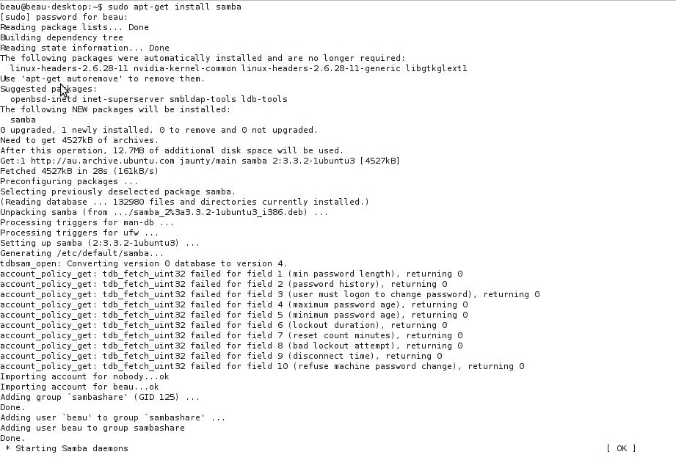

2) To open and edit Samba's configuration file.
sudo gedit /etc/samba/smb.conf
3) Change WORKGROUP to any workgroup name.
Add netbios name = server and replace server with servers name
4) Scroll down to Share Definitions in the .conf file. Change yes next to read-only to no if you want to be able to write to that drive
5) If you want to add more drives just repeat those options e.g.
[public]
comment = Data
path = /export
force user = thermoelectric
force group = users
read only = No
Path is where that shared drive is located.

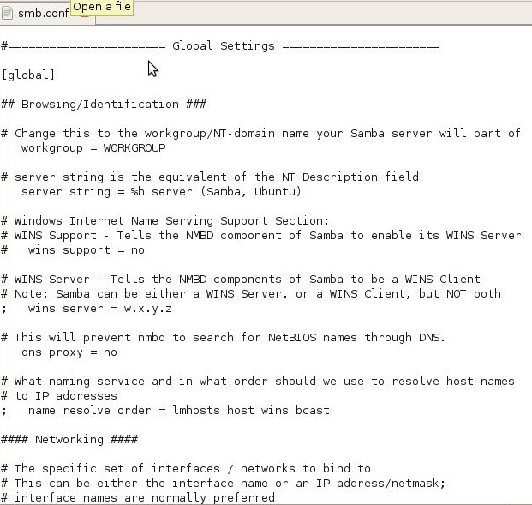

6) Add users to Ubuntu by typing this into terminal e.g
sudo useradd -c "Thermoelectric Rules" -m -g users -p password Thermoelectric
7) You replace password with that users password. You replace Thermoelectric Rules with your real name. You replace Thermoelectric with your user name.
8) Repeat that until you have made a account for all of your users
9) Then add the users to Samba by typing this into terminal e.g
sudo smbpasswd -a Thermoelectric
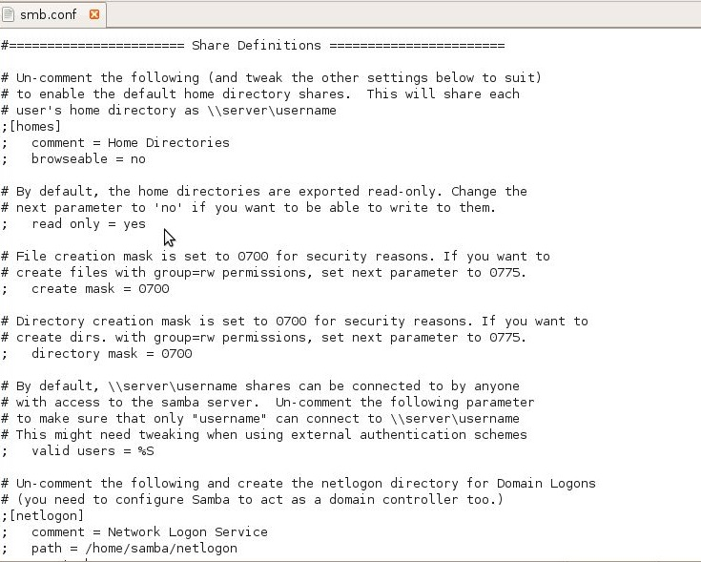

10) Start Samba by executing this in terminal
sudo nmbd; smbd;
11) Configure the /export directory:
sudo mkdir /export
sudo chown Thermoelectric.users /export
sudo chmod u=rwx,g=rwx,o-rwx /export
12) Check that Samba is running correctly:
sudo smbclient -L localhost -U%
13) Connect to SERVER (netbios name) as Thermoelectric (your user name):
sudo smbclient //SERVER/Thermoelectric -UThermoelectric%password

