COMPUTER GRAPHICS LABORATORY

LAB PRACTICALS RECORD
(CSX - 331)



DEPARTMENT OF COMPUTER SCIENCE AND ENGINEERING

Dr. B R AMBEDKAR NATIONAL INSTITUTE OF TECHNOLOGY
JALANDHAR – 144011, PUNJAB (INDIA)
July – December 2015

Submitted To: Submitted by:
Ms Jagriti Aman Garg
Assistant Professor , 13103050
Dept. Of CSE 6th Semester
NIT Jalandhar Group G-3

INDEX

S. No. | Title | Page | Sign
1. | Program to implement various functions of graphics | 3
2. | Program to draw a line using direct method | 5
3. | Program to implement Digital Differential Analyzer | 7
4. | Program to draw a line using Bresenham's Line algorithm | 11
5. | Program to implement the polar co-ordinates method to draw circle | 15
6. | Program to implement mid point circle algorithm | 17
7. | Program to draw ellipse using Bresenham's algorithm | 20
8. | Program to perform 2D transformations : translation, rotation, scaling, shearing | 24
9. | Program to implement composite transformations | 30
10. | Program to implement Cohen Sutherland Algorithm | 38
11. | Programming to implement Liang Barsky line clipping algorithm | 44
12. | Program to draw cubic Bézier curves | 48
13. | Program to demonstrate simple animation.

Programming Environment:

OS: Linux Mint 17.3  Compiler: clang++ -std=c++14 | Editor: Atom Text Editor  Programming Language: C++

1. | Write a program to implement various functions of graphics

Description:
The first line to look at is: graphics.h. This file contains definitions and explanation of all the graphic functions and constants. In graphics, we have two modes: text mode and graphic mode. In text mode, it is possibe to display or capture only text in terms of ASCII.
But in graphics mode, any type of figure can be displayed, captured and animated. To switch from text mode to graphic mode,we have function called as ” initgraph ” .
initgraph
: This function initializes the graphic mode. It selects the best resolution and direct that value to mode in variable gm.The two int variables gd, gm are graphic driver and graphic mode respectively. The gm handles value that tells us which resolution and monitor we are using. The gd specifies the graphic driver to be used.
In our program we have gd=DETECT means we have passed the highest possible value available for the detected driver. If you don’t want that value then you have to assign the constant value for gd and gm. The ” &” symbol is used for initgraph to pass address of the constants.
closegraph( ) :
The closegraph() switches back the screen from graphics mode to text mode. If you don’t use this function then you may have undesirable effects.

Program:

#include <graphics.h>
#include <stdio.h>

int main(){

int graphDriver = DETECT,graphMode;
initgraph(&graphDriver, &graphMode, NULL);

fprintf(stdout,"MAX : (%d, %d)\n",getmaxx(), getmaxy() );

// Creating a rectangular loop around the borders of concentric width 20
for (int i = 1; i < 10; i++)
rectangle(10*i, getmaxy() - 10*i, getmaxx() - 10*i, 10*i);

delay(100000);
closegraph();
return 0;
}

OUTPUT:

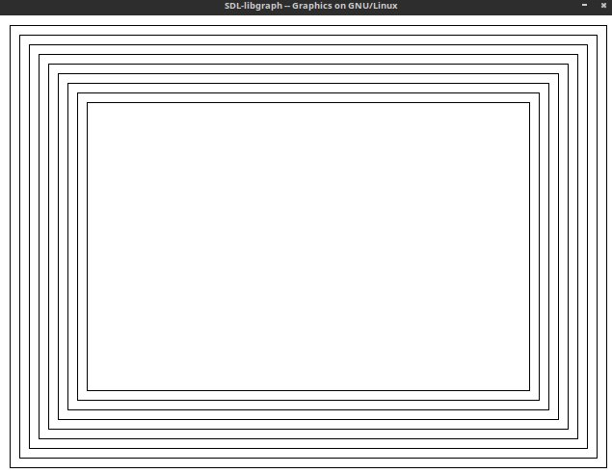
2. | Write a program to draw a line using Direct Method

Description:
The equation of a straight line is given by: y=m.x+b
Algorithm: Direct Method Algorithm
1. Start at the pixel for the left-hand endpoint x1
2. Step along the pixels horizontally until we reach the right-hand end of the line, xr
3. For each pixel compute the corresponding y value
4. Round this value to the nearest integer to select the nearest pixel

The algorithm performs a floating-point multiplication for every step in x. This method therefore requires an enormous number of floating-point multiplications, and is therefore expensive.

Program:

#include <graphics.h>
#include <stdio.h>
#include <assert.h>
#define coordinateFile "coordinates"
FILE * fp;

void directDrawLine(int x1, int y1, int x2, int y2){
int dx = x2 - x1, dy = y2 - y1;
float m = (dy * 1.)/dx; //slope
float c = y1 - m*x1;
int x = x1, y = y1;
if (x2 < x1) x = x2, y = y2;

for( int i = 0; i < abs(dx); i++){
fprintf(stdout, "Plotting points (%d, %d) m: %.2f\n",x, y, m);
putpixel(x, getmaxy() - y, BLACK);
if (m <= 1.0){
x = x + 1;
y = m*x + c;
}
else {
y = y + 1;
x = (y - c)/m;
}
}
}

int main(){
int x1, x2, y1, y2;
fp = fopen(coordinateFile, "r");
assert(fp);

int graphDriver = DETECT,graphMode;
initgraph(&graphDriver, &graphMode, NULL);

while (!feof(fp)){
fscanf(fp, "%d %d %d %d", &x1, &y1, &x2, &y2);
directDrawLine(x1, y1, x2, y2);
}

fclose(fp);
fprintf(stdout,"MAX : (%d, %d)\n",getmaxx(), getmaxy() );
delay(10000);
closegraph();
return 0;
}

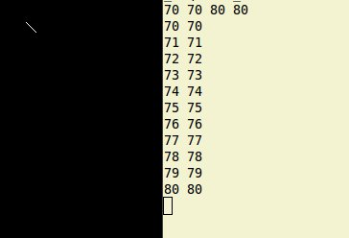
OUTPUT:

3. | Write a program to implement Digital Differential Analyzer (DDA) .
Digital Differential Analyzer (DDA) algorithm is the simple line generation algorithm which is explained step by step here.
1) Get the input of two end points (X0,Y0)(X0,Y0) and (X1,Y1)(X1,Y1).
2) Calculate the difference between two end points.
dx = X1 - X0
dy = Y1 - Y0

3) Based on the calculated difference in step-2, you need to identify the number of steps to put pixel. If dx > dy, then you need more steps in x coordinate; otherwise in y coordinate.
if (dx > dy)
Steps = absolute(dx);
else
Steps = absolute(dy);

4) Calculate the increment in x coordinate and y coordinate.
Xincrement = dx / (float) steps;
Yincrement = dy / (float) steps;

5) Put the pixel by successfully incrementing x and y coordinates accordingly and complete the drawing of the line.
for(int v=0; v < Steps; v++)
{
x = x + Xincrement;
y = y + Yincrement;
putpixel(x,y);
}

Program:

#include <graphics.h>
#include <bits/stdc++.h>
using namespace std;

typedef struct point{
int x, y;
point(){}
point(int x1, int y1){
x = x1;
y = y1;
}
friend ostream & operator<<(ostream &c, point &a){
c << "(" << a.x <<"," << a.y <<") ";
return c;
}
bool operator<(point b){
if (x == b.x && y < b.y)
return true;
if (y == b.y && x < b.x)
return true;
if (x < b.x && y < b.y)
return true;
else return false;
}
bool operator==(point b){
return (x == b.x && y == b.y)?true:false;
}
}point;

typedef vector<pair<point , point> > lines;

void plotLine(point a, point b){
// Given a pair of end points a and b, draw a line segment
int dx = b.x - a.x, dy = b.y - a.y;
float m;
if (dx == 0)
m = INT_MAX * 1.;
else m = (dy * 1.)/dx; //slope
float c = a.y - m * a.x; //y intercept

point start(a.x, a.y); // Start plotting from first point and repeat for dx times
point end(b.x, b.y);
if (b < a){
start = point(b.x, b.y);
end = point(a.x, a.y);
cout <<"Point b is small. Start with small\n";
}

while(true){
putpixel(start.x, getmaxy() - start.y, GREEN);
// cout << " Plotting : "<<start<<endl;
if (start == end) break;

// Move according to values
if (m == INT_MAX *1.){
start.y += 1;
}
else if (m <= 1.0){
start.x += 1;
start.y = m * start.x + c;
}
else{
start.y += 1;
start.x = (start.y - c)/m;
}
}
}

int main(){
// Initialise graphic drivers and graphModes;
int graphMode, graphDriver = DETECT;
int x1, x2, y1, y2;
initgraph(&graphDriver, &graphMode, NULL);

// read coordinates from a file
ifstream inf ("coordinates");
lines newLines;

while (!inf.eof()){
inf >> x1 >> y1 >> x2 >> y2 ;
newLines.push_back(make_pair(point(x1, y1), point(x2, y2) ) );
}
inf.close();

for (auto a : newLines){
cout <<"\nPlotting line "<<a.first<<" -> "<<a.second<<endl;
plotLine(a.first, a.second);
}

delay(100000);
closegraph();

return 0;
}

OUTPUT:
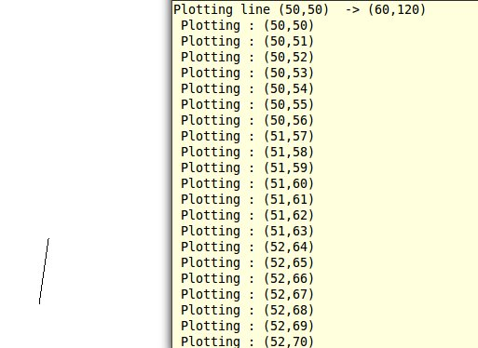

4. | Write a program to implement the Bresenham’s Line Algorithm
The Bresenham algorithm is another incremental scan conversion algorithm. The big advantage of this algorithm is that, it uses only integer calculations. Moving across the x axis in unit intervals and at each step choose between two different y coordinates.

1) Input the two end-points of line, storing the left end-point in (x0,y0)(x0,y0).
2) Plot the point (x0,y0)(x0,y0).
3) Calculate the constants dx, dy, 2dy, and (2dy – 2dx) and get the first value for the decision parameter as => p0=2dy−dxp0=2dy−dx
4) At each xk along the line, starting at k = 0, perform the following test −
If pkpk < 0, the next point to plot is (xk+1,yk)(xk+1,yk) and pk+1=pk+2dypk+1=pk+2dy
Otherwise,
pk+1=pk+2dy−2dxpk+1=pk+2dy−2dx

5) Repeat step 4 (dx – 1) times.
PROGRAM:

#include <graphics.h>
#include <bits/stdc++.h>
using namespace std;

typedef struct point{
int x, y;
point(){}
point(int x1, int y1){
x = x1;
y = y1;
}

bool operator<(point b){
if (x < b.x)
return true;
else return false;
}
}point;

typedef vector<pair<point , point> > lines;

void plotLine(point a, point b){
// Given a pair of end points a and b, draw a line segment
int dx = b.x - a.x, dy = b.y - a.y;
float m;
if (dx == 0)
m = INFINITY;
else m = (dy * 1.)/dx; //slope

point start(a.x, a.y); // Start plotting from first point and repeat for dx times
point end(b.x, b.y);

int p = 2 * dy - dx ;
int k = 0, yk;
cout <<" \n M: "<<m;

cout <<"K\tPk\t(x, y):\n";

// M = infinity
if (m == INFINITY){
cout <<"\nm = INF\n";
while(start.y != end.y){
cout <<k <<"\t" << p <<"\t" << start << endl;
start.y += 1;
putpixel(start.x, getmaxy() - start.y, GREEN);
continue;
}
}
// For 0 < m < 1, normal algo
if (m >= 0 && m <= 1){
cout <<"\n0 <= m <= 1\n";
if (b.x < a.x){
start = point(b.x, b.y);
end = point(a.x, a.y);
}
yk = start.y;

while (start.x <= end.x){
cout <<k <<"\t" << p <<"\t" << start << endl;
if (start == end) break;
start.x += 1;
start.y = (p > 0) ? start.y + 1: start.y;

putpixel(start.x, getmaxy() - start.y, BLACK);
p += 2 *(end.y - start.y) + 2 *(end.x - start.x) *(yk - start.y);
k ++;
yk = start.y;
}
}
// For m > 1, interchange role of x and y
if (m > 1){
cout <<"\nm > 1\n";
if (b < a){
start = point(b.x, b.y);
end = point(a.x, a.y);
}

yk = start.x;
while (start.y <= end.y){
cout <<k <<"\t" << p <<"\t" << start << endl;

if (start == end) break;
start.y += 1;
start.x = (p > 0) ? start.x + 1: start.x;

putpixel(start.x, getmaxy() - start.y, BLACK);
p += 2 *(end.x - start.x) + 2 *(end.y - start.y) *(yk - start.x);
k ++;
yk = start.x;
}

}
}

int main(){
int graphMode, graphDriver = DETECT;
int x1, x2, y1, y2;
initgraph(&graphDriver, &graphMode, NULL);

ifstream inf ("coordinates");

inf >> x1 >> y1 >> x2 >> y2 ;
pair<point, point> a = make_pair(point(x1, y1), point(x2, y2));
cout <<"\nPlotting line "<<a.first<<" -> "<<a.second<<endl;
plotLine(a.first, a.second);
inf.close();

closegraph();
return 0;
}

OUTPUT:

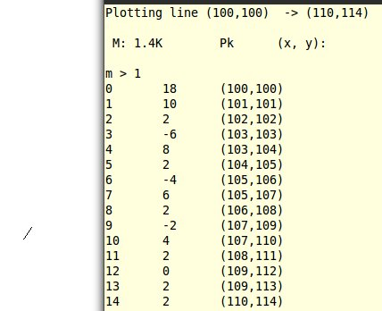

5. | Program to implement the polar co-ordinates method to draw circle

Description:
This algorithm is based on the parametric form of the circle equation.
x = h + r cosθ
y = k + r sinθ
where r is the radius of the circle, and h,k are the coordinates of the center.
What these equation do is generate the x,y coordinates of a point on the circle given an angle θ (theta). The algorithm starts with theta at zero, and then loops adding an increment to theta each time round the loop. It draws straight line segments between these successive points on the circle. The circle is thus drawn as a series of straight lines. If the increment is small enough, the result looks like a circle to the eye.

Program:

#include<iostream>
#include<graphics.h>
#include<math.h>
using namespace std;

int main(){
int gd=DETECT,gm,i;
initgraph(&gd,&gm,NULL);
int xc,yc,r;
float xi,yi,xf,yf;
float theta;
setcolor(4);
cout<<"Enter (xc,yc) and radius";
cin>>xc>>yc>>r;

while(theta<=6.294){
putpixel(xf,yf,BLUE);
theta=theta+0.01;
xf=xc+ (r*cos(theta));
yf=yc+ (r*sin(theta));
}
delay(20000);
return 0;
}

Output:

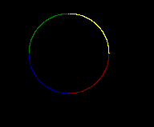

6. | Write a program to implement the midpoint circle algorithm.

Description:
We cannot display a continuous arc on the raster display. Instead, we have to choose the nearest pixel position to complete the arc. We have put the pixel at (X, Y) location and now need to decide where to put the next pixel − at (X+1, Y) or at (X+1, Y-1). The algorithm is:
1.Input radius r and circle center (xc,yc)(xc,yc) and obtain the first point on the circumference of the circle centered on the origin as (x0,y0) = (0,r)
2.Calculate the initial value of decision parameter as : P0 = 5/4 – r
3.At each XK position starting at K=0, perform the following test :
->If PK < 0 then next point on circle (0,0) is (XK+1,YK) and PK+1 = PK + 2XK+1 + 1
->Else PK+1 = PK + 2XK+1 + 1 – 2YK+1
where, 2XK+1 = 2XK+2 and 2YK+1 = 2YK-2.
4.Determine the symmetry points in other seven octants.
5. Move each calculate pixel position (X, Y) onto the circular path centered on (XC,YC) and plot the coordinate values.
X = X + XC, Y = Y + YC
6. Repeat step-3 through 5 until X >= Y.

Program:

#include <graphics.h>
#include <bits/stdc++.h>
using namespace std;

typedef struct point{
int x, y, origX, origY;
point(){}
point(int x1, int y1){
origX = x = x1;
origY = y = y1;
}
}point;

typedef vector< pair<point, int> > circles;

void circlePlotPoints(point center, point start, int r){
int h = center.x, k = center.y;
int x = start.x, y = start.y;
putpixel(h + x, getmaxy() - (k + y), BLACK);
putpixel(h + x, getmaxy() - (k - y), BLACK);
putpixel(h - x, getmaxy() - (k + y), BLACK);
putpixel(h - x, getmaxy() - (k - y), BLACK);
putpixel(h + y, getmaxy() - (k + x), BLACK);
putpixel(h + y, getmaxy() - (k - x), BLACK);
putpixel(h - y, getmaxy() - (k + x), BLACK);
putpixel(h - y, getmaxy() - (k - x), BLACK);
}

void circleMidPoint(point center, int r){
point start(0, r);
int p = 1 - r;
putpixel(center.x, getmaxy() - center.y, LIGHTMAGENTA);

while (start.x < start.y){
cout <<"Plotting point: "<<start << " and P: "<< p << endl;
circlePlotPoints(center, start, r);
start.x += 1;
if (p < 0)
p += 2 * start.x + 1;
else{
start.y -= 1;
p += 2 * (start.x - start.y) + 1;
}
}
}

int main(){
// Initialise graphic drivers and graphModes;
int graphMode, graphDriver = DETECT;
int x, y , r;
initgraph(&graphDriver, &graphMode, NULL);
ifstream inf ("coordinates");
circles newCircles;

inf >> x >> y >> r;
newCircles.push_back(make_pair(point(x, y), r ) );

inf.close();
circles :: iterator it;

for (it = newCircles.begin(); it != newCircles.end(); it++){
cout <<"\nPlotting circle "<<it -> first<<" with radius -> "<<it -> second<<"\n\n";
circleMidPoint(it -> first, it -> second);
}

delay(100000);
closegraph();

return 0;
}

OUTPUT:
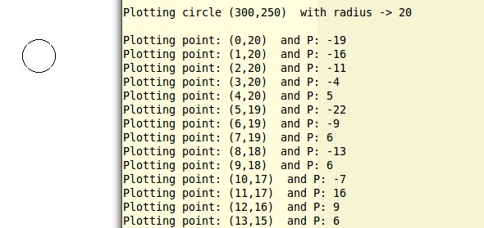

7. | Write a program to implement the ellipse using Bresenham algorithm.

The theory for drawing Ellipse with Bresenham algorithm is same as that of Circle drawing. But the difference is that the Ellipse is divided into two regions because it has two radii. The regions are separated from each other at a point where the slope of the tangent line is –1. So we need to draw 2 regions in first quadrant and draw in other quadrant symmetrically.
1.Use symmetry of ellipse.
2.Divide the quadrant into two regions, the boundary of two regions is the point at which the curve has a slope of -1.
3.Process by taking unit steps in the x direction to the point P, then taking unit steps in the y direction.
4.Apply algorithm for both the sections as done in the circle bresenham.
Obtain the formula by putting the following values in the equation of ellipse:
p1k = f (xk+1, yk – ½) p2k = f (xk+½, yk – 1)
where f(x,y)= (x^2/a^2)+(y^2/b^2)-1

Program:

#include <graphics.h>
#include <bits/stdc++.h>
using namespace std;

typedef struct point{
int x, y, origX, origY;
point(){}
point(int x1, int y1){
origX = x = x1;
origY = y = y1;
}
}point;

typedef vector< pair<point, point> > ellipses;
// First pair represents the origin and next gives a, b

void drawEllipse(point center, point start){
int h = center.x, k = center.y;
int x = start.x, y = start.y;
putpixel(h + x, getmaxy() - (k + y), BLUE);
putpixel(h + x, getmaxy() - (k - y), BLUE);
putpixel(h - x, getmaxy() - (k + y), BLUE);
putpixel(h - x, getmaxy() - (k - y), BLUE);
}

void ellipseBresen(point origin, point para){
int a = para.x, b = para.y;
// int xA = origin.x, yA = origin.y;
// ellipse(xA, yA, 0, 360, b, a);
int a2 = a *a, b2 = b *b;
int x = 0, y = b;
float d = b2 - (a2 * b) + a2/4.;

// REGION I

while (b2*x <= a2*y){
point zy = point(x, y);
cout << "\nREG I: "<< zy << "\td: " << d;
drawEllipse(origin, zy);
x ++;
if (d > 0){
y--;
d += 2.0 * b2 * x + b2 - 2.0 * a2 * y;
}
else d += b2 + 2.0 * b2 * x;
}

// REGION II

x = a, y = 0;
d = a2 + 2.0 * b2 * a + b2/4.;

while (a2*y <= b2*x){
point zy = point(x, y);
cout << "\nREG II: "<< zy << "\td: " << d;
drawEllipse(origin, zy);
y++;
if (d > 0)
d += a2 - 2.0 * a2 *y;

else{
x--;
d += 2.0 * b2 *x - 2.0 *a2 *y +a2;
}
}
}

int main(){

int graphMode, graphDriver = DETECT;
int x, y , a, b;
initgraph(&graphDriver, &graphMode, NULL);

// read coordinates from a file
ifstream inf ("coordinates");
ellipses newEllipse;

while (!inf.eof()){
inf >> x >> y >> a >> b;
newEllipse.push_back(make_pair(point(x, y), point(a, b) ) );
}
inf.close();
ellipses :: iterator it;

for (it = newEllipse.begin(); it != newEllipse.end(); it++){
cout <<"\nPlotting ellipse "<<it -> first<<" with a, b-> "<<it -> second<<"\n\n";
ellipseBresen(it -> first, it -> second);
}

delay(100000);
closegraph();
return 0;
}

OUTPUT:

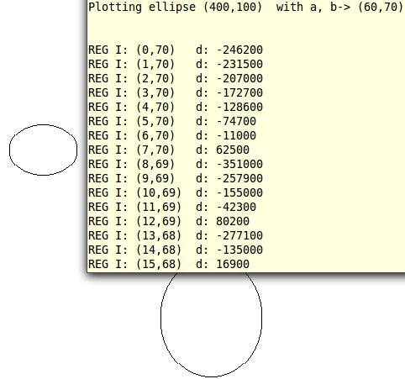

'

8. | Write a program to perform 2D transformations such as translation, rotation, scaling, reflection and shearing.

Description:
Fundamental to all computer graphics system is the ability to simulate the manipulation of objects in space. This simulated spatial manipulation is referred to as transformation.The need for transformation arises when several objects, each of which is independently defined in its own co-ordinate system, need to properly positioned into a common scene in a master co-ordinate system. Transformations are also relevant in other areas of image synthesis process. The algorithm for its implementation is as follows:

1.Start the program.
2.Input the object coordinates
3.For Translation:
a) Enter the translation factors tx and ty.
b) Move the original coordinate position (x,y) to a new position (x1,y1).ie. x=x+x1, y=y+y1.
c) Display the object after translation.
4.For Rotation:
a) Enter the radian for rotation angle θ.
b) Rotate a point at position (x,y) through an angle θ about the origin:
x1=xcos θ - ysin θ y1=ycos θ + xsin θ.
c) Display the object after rotation.
5.For Scaling:
a) Input the scaled factors sx and sy.
b) The transformed coordinates (x1,y1) , x1=x.sx and y1=y.sy.
c) Display the object after scaling
6.For Shearing:
a) Input the shearing factors shx and shy.
b) Shearing related to x axis : Transform coordinates x1=x+shx*y and y1=y.
c) Shearing related to y axis : Transform coordinates x1=x and y1=y+shy*x.
d) Input the xref and yref values.
e) X axis shear related to the reference line y-yref is x1=x+shx(y-yref) and y1=y.
f) Y axis shear related to the reference line x=xref is x1=x
g) Display the object after shearing
8.Stop the Program.

Program:

#include <bits/stdc++.h>
#include <graphics.h>
using namespace std;

/* A program to perform 2d transformations on a figure from a file
Line 1: Coordinations of the given figure
Line 2: Translation of figure in three direction x, y, z
Line 3: Rotation of triangle in three directions x, y, x
Line 4: Scaling of triangle in x and y directions;
*/
typedef struct point{
int x, y;
point(){};
point(int a, int b){
x = a;
y = b;
}
}point;

typedef struct translation{
int x, y;
translation(){}
}translation;

typedef struct rotation{
int angle, fixedX, fixedY;
}rotation;

typedef struct scale{
float x, y;
int fixedX, fixedY;
}scale;

typedef struct shear{
float val;
int shX, shY, axis;
}shear;

void plotTriangle(point a, point b, point c){
//Given three coordinates plot the triangle resulting from them
line(a.x, a.y, b.x, b.y);
line(a.x, a.y, c.x, c.y);
line(b.x, b.y, c.x, c.y);
}

point translatePoint(point a, translation t){
return point(a.x + t.x, a.y + t.y);
}

point scalePoint(point a, scale s){
return point(a.x * s.x + s.fixedY * (1 - s.x), a.y * s.y + s.fixedX*(1 - s.y));
}

point rotatePoint(point a, rotation r){
r.angle = (M_PI * r.angle)/180;
double x = r.fixedX + (a.x - r.fixedX)* cos(r.angle) - (a.y - r.fixedY) * sin(r.angle);
double y = r.fixedY + (a.y - r.fixedY)* sin(r.angle) - (a.y - r.fixedY) * cos(r.angle);
return point(x + a.x, y + a.y);
}

point applyShear(point a, shear h){
if (h.axis == 1)
return point(a.x + h.val * (a.y - h.shY), a.y);
else
return point(a.x, a.y + h.val * (a.x - h.shX));
}

int main(){
int graphMode, graphDriver = DETECT;

point a, b, c;
translation t;
rotation r;
scale s;
shear h;

cout << "\n Enter coordinates of triangle: ";
cin >> a.x >> a.y >> b.x >> b.y >> c.x >> c.y;

cout << "\n Enter translation in x and y axis: ";
cin >> t.x >> t.y;

cout << "\n Enter angle of rotation as well as point: ";
cin >> r.angle >> r.fixedX >> r.fixedY;

cout << "\n Enter scaling factor in x and y and a point: ";
cin >> s.x >> s.y >> s.fixedX >> s.fixedY ;

cout << "\n Enter shear value, point and axis (x = 1 | y = 0): ";
cin >> h.val >> h.shX >> h.shY >> h.axis;

initgraph(&graphDriver, &graphMode, NULL);

// Plot initial triangle
plotTriangle(a, b, c);

// Translate the triangle
point transA = translatePoint(a, t);
point transB = translatePoint(b, t);
point transC = translatePoint(c, t);

//Rotate the triangle
point rotA = rotatePoint(a, r);
point rotB = rotatePoint(b, r);
point rotC = rotatePoint(c, r);

printf("\n\n\tROTATED TRIANGLE\n");
plotTriangle(a, b, c);
plotTriangle(rotA, rotB, rotC);

//Scale the triangle
point scaleA = scalePoint(a, s);
point scaleB = scalePoint(b, s);
point scaleC = scalePoint(c, s);

printf("\n\n\tSCALED TRIANGLE\n");
plotTriangle(a, b, c);
plotTrianglescaleA, scaleB, scaleC);

//Shear the triangle
point shearA = applyShear(a, h);
point shearB = applyShear(b, h);
point shearC = applyShear(c, h);

printf("\n\n\tSHEARED TRIANGLE\n");
plotTriangle(a, b, c);
plotTriangle(shearA, shearB, shearC);

delay(10000);
closegraph();
return 0;
}

OUTPUT:

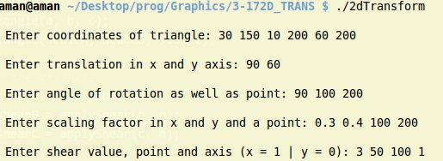

TRANSLATION:

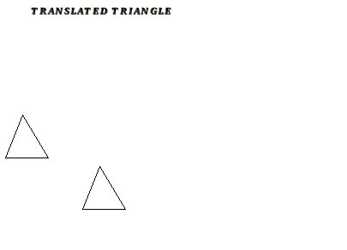

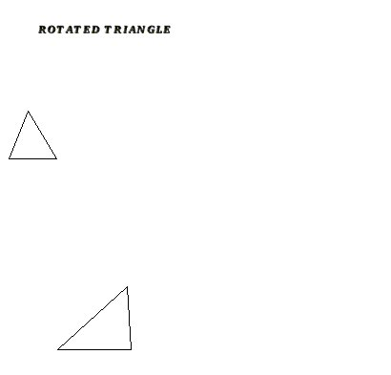
ROTATION:

SCALING:
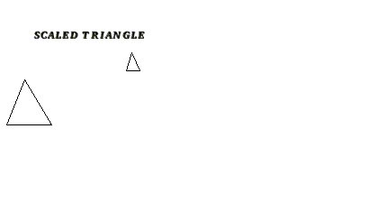

SHEARING:

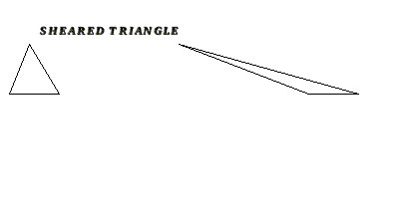

9. | Write a program to implement composite transformations
Description:
Transformations are used to transform one set of coordinates into the other. The various types of transformations are translation, rotation, scaling, shear, reflection etc. Using homogeneous transformation matrices we can transform P into P’ as follows.

Where P is the vector containing original coordinates and P’ is the vector containing transformed set of coordinates

Program:
#include<bits/stdc++.h>
#include<graphics.h>
using namespace std;
const double pi = 3.1415;

vector< vector<double> > mul(vector< vector<double> >& a, vector< vector<double> >& b){
vector< vector<double> > ans;
int n = a[0].size();
int p = b.size();
int q = b[0].size();
assert(n==p);
for(int i = 0; i<n; i++)
{
vector<double> r;
for(int j =0; j<q; j++)
{
double num = 0;
for(int k = 0; k<p; k++)
num += a[i][k]*b[k][j];
r.push_back(num);
}
ans.push_back(r);
}
return ans;
}
vector< vector<double> > make_P(int x, int y)
{
vector<double> p,q,r;
vector< vector<double> > ans;
p.push_back(x);
q.push_back(y);
r.push_back(1);
ans.push_back(p);
ans.push_back(q);
ans.push_back(r);
return ans;
}
vector< vector<double> > make_T(){
vector< vector<double> > T(3);
T[0].resize(3);
T[1].resize(3);
T[2].resize(3);
for(int i = 0; i<3; i++)
for(int j = 0; j<3; j++)
T[i][j] = 0;
T[0][0] = 1;
T[1][1] = 1;
T[2][2] = 1;
return T;
}
vector< vector<double> > rotateComposite(int x, int y, double xr, double yr, double theta){
vector< vector<double> > P = make_P(x,y);
vector< vector<double> > T = make_T();
double c = cos(theta*pi/180.0);
double s = sin(theta*pi/180.0);
T[0][0] = c;
T[0][1] = -s;
T[0][2] = xr*(1-c) + yr*s;
T[1][0] = s;
T[1][1] = c;
T[1][2] = yr*(1-c) - xr*s;
return mul(T,P);
}

vector< vector<double> > scaleComposite(int x, int y, double xr, double yr,double sx, double sy){
vector< vector<double> > P = make_P(x,y);
vector< vector<double> > T = make_T();
T[0][0] = sx;
T[0][2] = xr*(1-sx);
T[1][1] = sy;
T[1][2] = yr*(1-sy);
return mul(T,P);
}
vector< vector<double> > shear(int x, int y, double xr, double yr,double hx,double hy){
vector< vector<double> > P = make_P(x,y);
vector< vector<double> > T = make_T();
T[0][0] = 1;
T[0][1] = hx;
T[0][2] = -hx*yr;
T[1][0] = hy;
T[1][1] = 1;
T[1][2] = -hy*xr;
return mul(T,P);
}

vector< vector<double> > reflectX(int x, int y, double yr){
vector< vector<double> > P = make_P(x,y);
vector< vector<double> > T = make_T();
T[0][0] = 1;
T[1][1] = -1;
T[1][2] = 2*yr;
return mul(T,P);
}
vector< vector<double> > reflectY(int x, int y, double xr){
vector< vector<double> > P = make_P(x,y);
vector< vector<double> > T = make_T();
T[0][0] = -1;
T[0][2] = 2*xr;
return mul(T,P);
}

int main(){
int arr[3][3]= {{1,2,3},{4,5,6},{7,8,9}};
int g = DETECT;
int d = 0;
initgraph(&g,&d," ");

int option;
while(1){
cout << "1 for composite rotation\n2 for scaling\n3 for shear\n4 for x reflection\n5for y reflection";
cin >> option;
if(option==1){
cout << "Enter xmin,ymin,xmax,ymax for the rectangle";
int x,y,x2,y2,x3,y3,x4,y4;
cin >> x >> y>> x3 >> y3;
x2 = x3;
y2 = y;
x4 = x;
y4 = y3;

cout << "Enter xr and yr and theta\n";
double xr,yr,theta;
cin >> xr >> yr >> theta;

vector< vector<double> > P_dash = rotateComposite(x,y,xr,yr,theta);
vector< vector<double> > P_dash2 = rotateComposite(x2,y2,xr,yr,theta);
vector< vector<double> > P_dash3 = rotateComposite(x3,y3,xr,yr,theta);
vector< vector<double> > P_dash4 = rotateComposite(x4,y4,xr,yr,theta);

cout << "New points are: " << P_dash[0][0] << "," << P_dash[1][0] << "\n";
cout << P_dash2[0][0] << "," << P_dash2[1][0]<< "\n";
cout << P_dash3[0][0] << "," << P_dash3[1][0] << "\n";
cout << P_dash4[0][0] << "," << P_dash4[1][0] << "\n";
int arr[10] = {P_dash[0][0],P_dash[1][0],P_dash2[0][0],P_dash2[1][0],P_dash3[0] [0],P_dash3[1][0],P_dash4[0][0],P_dash4[1][0],P_dash[0][0],P_dash[1][0]};
rectangle(x,y,x3,y3);
drawpoly(5,arr);
delay(1000);
}
else if(option==2){
cout << "Enter xmin,ymin,xmax,ymax for the rectangle";
int x,y,x2,y2,x3,y3,x4,y4;
cin >> x >> y>> x3 >> y3;
x2 = x3;
y2 = y;
x4 = x;
y4 = y3;
cout << "Enter xr and yr and sx and sy\n";
double xr,yr,sx,sy;
cin >> xr >> yr >> sx >> sy;
vector< vector<double> > P_dash = scaleComposite(x,y,xr,yr,sx,sy);
vector< vector<double> > P_dash2 = scaleComposite(x2,y2,xr,yr,sx,sy);
vector< vector<double> > P_dash3 = scaleComposite(x3,y3,xr,yr,sx,sy);
vector< vector<double> > P_dash4 = scaleComposite(x4,y4,xr,yr,sx,sy);
cout << "New points are: " << P_dash[0][0] << "," << P_dash[1][0] << "\n";
cout << P_dash2[0][0] << "," << P_dash2[1][0]<< "\n";
cout << P_dash3[0][0] << "," << P_dash3[1][0] << "\n";
cout << P_dash4[0][0] << "," << P_dash4[1][0] << "\n";
int arr[10] = {P_dash[0][0],P_dash[1][0],P_dash2[0][0],P_dash2[1][0],P_dash3[0][0],P_dash3[1][0],P_dash4[0][0],P_dash4[1][0],P_dash[0][0],P_dash[1][0]};
rectangle(x,y,x3,y3);
drawpoly(5,arr);
delay(1000);
}
else if(option==3){
cout << "Enter xmin,ymin,xmax,ymax for the rectangle";
int x,y,x2,y2,x3,y3,x4,y4;
cin >> x >> y>> x3 >> y3;
x2 = x3;
y2 = y;
x4 = x;
y4 = y3;
cout << "Enter xr and yr and shx and shy\n";
double xr,yr,sx,sy;
cin >> xr >> yr >> sx >> sy;

vector< vector<double> > P_dash = shear(x,y,xr,yr,sx,sy);
vector< vector<double> > P_dash2 = shear(x2,y2,xr,yr,sx,sy);
vector< vector<double> > P_dash3 = shear(x3,y3,xr,yr,sx,sy);
vector< vector<double> > P_dash4 = shear(x4,y4,xr,yr,sx,sy);
cout << "New points are: " << P_dash[0][0] << "," << P_dash[1][0] << "\n";

cout << P_dash2[0][0] << "," << P_dash2[1][0]<< "\n";
cout << P_dash3[0][0] << "," << P_dash3[1][0] << "\n";
cout << P_dash4[0][0] << "," << P_dash4[1][0] << "\n";
int arr[10] = {P_dash[0][0],P_dash[1][0],P_dash2[0][0],P_dash2[1][0],P_dash3[0][0],P_dash3[1][0],P_dash4[0][0],P_dash4[1][0],P_dash[0][0],P_dash[1][0]};
rectangle(x,y,x3,y3);
drawpoly(5,arr);
delay(1000);
}
else if(option==4)
{
cout << "Enter xmin,ymin,xmax,ymax for the rectangle";
int x,y,x2,y2,x3,y3,x4,y4;
cin >> x >> y>> x3 >> y3;
x2 = x3;
y2 = y;
x4 = x;
y4 = y3;
double yr;
cout << "Enter yr for reflection\n";
cin >> yr;
vector< vector<double> > P_dash = reflectX(x,y,yr);
vector< vector<double> > P_dash2 = reflectX(x2,y2,yr);
vector< vector<double> > P_dash3 = reflectX(x3,y3,yr);
vector< vector<double> > P_dash4 = reflectX(x4,y4,yr);
cout << "New points are: " << P_dash[0][0] << "," << P_dash[1][0] << "\n";
cout << P_dash2[0][0] << "," << P_dash2[1][0]<< "\n";
cout << P_dash3[0][0] << "," << P_dash3[1][0] << "\n";
cout << P_dash4[0][0] << "," << P_dash4[1][0] << "\n";
int arr[10] = {P_dash[0][0],P_dash[1][0],P_dash2[0][0],P_dash2[1][0],P_dash3[0][0],P_dash3[1][0],P_dash4[0][0],P_dash4[1][0],P_dash[0][0],P_dash[1][0]};
rectangle(x,y,x3,y3);
drawpoly(5,arr);
delay(1000);
}
else if(option==5)
{
cout << "Enter xmin,ymin,xmax,ymax for the rectangle";
cin >> x >> y>> x3 >> y3;
double xr;
cout << "Enter xr for reflection\n";
cin >> xr;
vector< vector<double> > P_dash = reflectY(x,y,xr);
vector< vector<double> > P_dash2 = reflectY(x2,y2,xr);
vector< vector<double> > P_dash3 = reflectY(x3,y3,xr);
vector< vector<double> > P_dash4 = reflectY(x4,y4,xr);

cout << "New points are: " << P_dash[0][0] << "," << P_dash[1][0] << "\n";
cout << P_dash2[0][0] << "," << P_dash2[1][0]<< "\n";
cout << P_dash3[0][0] << "," << P_dash3[1][0] << "\n";
cout << P_dash4[0][0] << "," << P_dash4[1][0] << "\n";

int arr[10] = {P_dash[0][0],P_dash[1][0],P_dash2[0][0],P_dash2[1][0],P_dash3[0] [0],P_dash3[1][0],P_dash4[0][0],P_dash4[1][0],P_dash[0][0],P_dash[1][0]};
rectangle(x,y,x3,y3);
drawpoly(5,arr);
delay(1000);
}
}
}

OUTPUT:

A: Composite Rotation about a point:

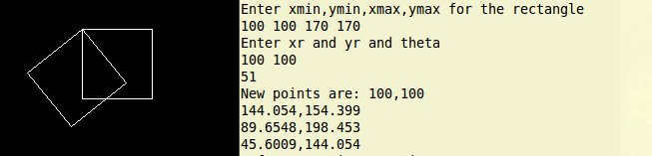

A: Composite scaling about a point:

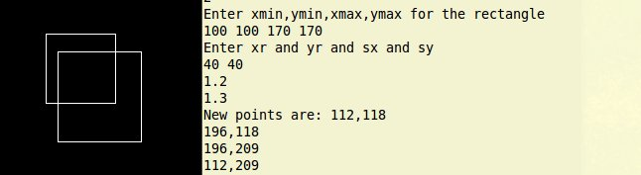

10. | Write a program to clip a line using Cohen Sutherland Algorithm

Description:
The Cohen–Sutherland algorithm is a computer graphics algorithm used for line clipping. The algorithm divides a two-dimensional space into 9 regions (or a three-dimensional space into 27 regions), and then efficiently determines the lines and portions of lines that are visible in the center region of interest (the viewport).
The algorithm includes, excludes or partially includes the line based on where:
- Both endpoints are in the viewport region (bitwise OR of endpoints == 0): trivial accept.
- Both endpoints share at least one non-visible region which implies that the line does not cross the visible region. (bitwise AND of endpoints != 0): trivial reject.
- Both endpoints are in different regions: In case of this nontrivial situation the algorithm finds one of the two points that is outside the viewport region (there will be at least one point outside). The intersection of the outpoint and extended viewport border is then calculated (i.e. with the parametric equation for the line) and this new point replaces the outpoint. The algorithm repeats until a trivial accept or reject occurs.

Program:
#include <bits/stdc++.h>
#include <graphics.h>
#define bitCode int
using namespace std;

/* Algorithm for line clipping using cohen sutherland algorithm.Clip a line l given boundary b*/

//Set Positions to mark a point as inside or outside
#define INSIDE 0 //0000
#define LEFT 1 //0001
#define RIGHT 2 //0010
#define BOTTOM 4 //0100
#define TOP 8 //1000

typedef struct Boundary{
int x_min, x_max, y_min, y_max;
}Boundary;

typedef struct Point{
int x, y;
Point (){}
Point(int a, int b) : x(a), y(b){}
}Point;

typedef struct Line{
Point A, B;
string lineStatus(){
return "(" + to_string(A.x) + "," + to_string(A.y) + ") to (" + to_string(B.x) + "," + to_string(B.y) + ")\n";
}
}Line;

int getBitCode(Point p, Boundary &b){
//Compute bitcodes for the given point depending on where the point lies wrt boundary
int curBit = INSIDE;

if (p.x < b.x_min)
curBit |= LEFT;
if (p.x > b.x_max)
curBit |= RIGHT;
if (p.y < b.y_min)
curBit |= BOTTOM;
if (p.y > b.y_max)
curBit |= TOP;

return curBit;
}

void showClipping_Line(Line &l, Boundary &b, string &message){
rectangle(b.x_min, b.y_max, b.x_max, b.x_min);
line(l.A.x, l.A.y, l.B.x, l.B.y);
printf("\t %s ", message.c_str());
sleep(2);
cleardevice();
}

void cohenSuther_clipping(Boundary &b, Line &l){
//Compute bitcodes of two points of the given line and take decisions accordigly
cout << "\n Initial line : " << l;

string message = " INITIAL LINE " + l.lineStatus();
showClipping_Line(l, b, message);

bitCode bitA = getBitCode(l.A, b);
bitCode bitB = getBitCode(l.B, b);
cout << "\n BitA: " << bitA;
cout << "\n BitB: " << bitB;

bool accept = false;
while (true){
cout << "\n\n Current Line : " << l;
if (!(bitA | bitB)){ //line is completely inside
message = " Line is completely inside ";
accept = true;
break;
}

if (bitA & bitB){ //line lies outside the boundary
message = " Line is completely outside ";
accept = false;
break;
}

//Now line has some intersection with the boundary. Either one or both points
//maybe outside. Clip the line from outside to the intersection
message = " Some part of line is inside ";

Point intersection;
double slope = (l.B.y - l.A.y * 1.0)/( l.B.x - l.A.x);
bitCode anyOuterPoint = bitA ? bitA : bitB; //Any point which is outside

if (anyOuterPoint & TOP){ //then point is above boundary
intersection.y = b.y_max;
intersection.x = l.A.x + (intersection.y - l.A.y)/slope;
}

else if (anyOuterPoint & BOTTOM){ //point is below boundary
intersection.y = b.y_min;
intersection.x = l.A.x + (intersection.y - l.A.y)/slope;
}

else if (anyOuterPoint & LEFT){ //point is left to the boundary
intersection.x = b.x_min;
intersection.y = l.A.y + slope*(intersection.x - l.A.x);
}

else if (anyOuterPoint & RIGHT){ //point is right to the boundary
intersection.x = b.x_max;
intersection.y = l.A.y + slope*(intersection.x - l.A.x);
}

// Now we move outside point to intersection point to clip
// and get ready for next pass.
if (anyOuterPoint == bitA){
l.A.x = intersection.x;
l.A.y = intersection.y;
bitA = getBitCode(l.A, b);
}
else{
l.B.x = intersection.x;
l.B.y = intersection.y;
bitB = getBitCode(l.B, b);
}
cout << " New line: " << l;
message.append(l.lineStatus());
showClipping_Line(l, b, message);
}

if (accept){
cout << "\n The line is accepted";
message.append(" Final Clipping " + l.lineStatus());
showClipping_Line(l, b, message);
}
}

int main(){
Boundary b = {100, 300, 100, 400};
Line l = {Point(50, 200), Point(450, 100)};

/*Graph initialisations*/
int graphMode, graphDriver = DETECT;
initgraph(&graphDriver, &graphMode, NULL);
setbkcolor(WHITE);
setcolor(BLACK);
setfontcolor(BLACK);
/**/

cohenSuther_clipping(b, l);

delay(100000);
closegraph();

return 0;
}

OUTPUT:

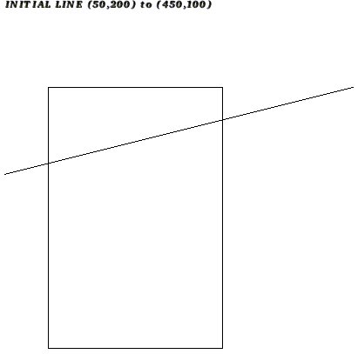
1)

2) 3)
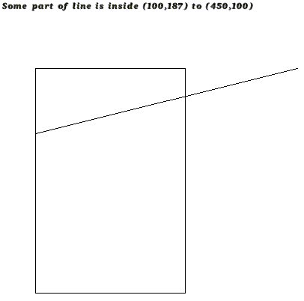
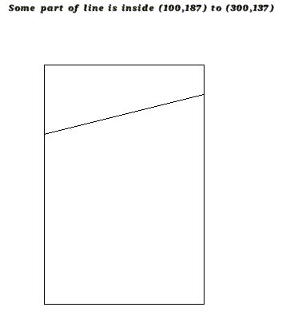

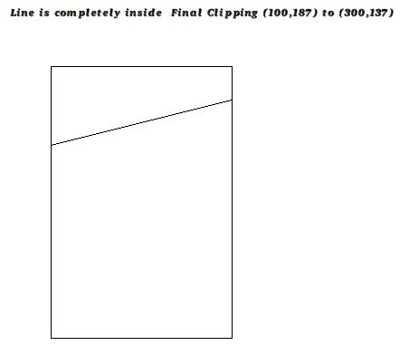
4)

11. | Write a program to clip a line using Liang Barsky Algorithm

Description:
In computer graphics, the Liang–Barsky algorithm (named after You-Dong Liang and Brian A. Barsky) is a line clipping algorithm. The Liang–Barsky algorithm uses the parametric equation of a line and inequalities describing the range of the clipping window to determine the intersections between the line and the clipping window. With these intersections it knows which portion of the line should be drawn. This algorithm is significantly more efficient than Cohen–Sutherland.The idea of the Liang-Barsky clipping algorithm is to do as much testing as possible before computing line intersections.
Program:

#include <bits/stdc++.h>
#include <graphics.h>
using namespace std;

/* Algorithm for line clipping using Liang-Barsky algorithm. Clip a line l given a boundary b*/

typedef struct Boundary{
int x_min, x_max, y_min, y_max;
}Boundary;

typedef struct Point{
int x, y;
Point (){}
Point(int a, int b) : x(a), y(b){}
}Point;

typedef struct Line{
Point A, B;
string lineStatus(){
return "(" + to_string(A.x) + "," + to_string(A.y) + ") to (" + to_string(B.x) + "," + to_string(B.y) + ")\n";
}
}Line;

void liangBarsky_clipping(Boundary &b, Line &l){
//Perform liang Barsky clipping for the given line and boundary
rectangle(b.x_min, b.y_max, b.x_max, b.x_min);
line(l.A.x, l.A.y, l.B.x, l.B.y);
sleep(2);
/*
A) Parametric line equation for (x1, x2) and (y1, y2) as f(t)
x(t) = x1 + t(x2 - x1) and y(t) = y1 + t(y2 - y1)
b.xmin <= x <= b.xmax and b.ymin <= y <= b.ymax
b.xmin <= x1 + t(dx) <= b.xmax
b.ymin <= y1 + t(dy) <= b.ymax
OR
-t(dx) <= x1 - b.xmin
t(dx) <= b.xmax - x1
-t(dy) <= y1 - b.ymin
t(dy) <= b.ymax - y1

t(p(k)) <= q(k) where k = 1, 2, 3, 4.. Rearranging,
p1 = -dx, q1 = x1 - b.xmin
p2 = dx , q2 = b.xmax - x1
p3 = -dy, q3 = y1 - b.ymin
p4 = dy, q4 = b.ymax - y1

B) Assign t1 = 0, t2 = 1
if p(k) (i.e dx or dy) == 0: then line is || to boundary
if q(k) < 0, discard line as it is outside
if p(k) != 0:
if p(k) < 0: partially in. Find st1rting point t1 = max(0, q(k)/p(k))
else: Find t2 (ending point) = min(1, q(k)/p(k))
if t1 > t2: reject
else: find new set of (x, y)
x = x1 + t(dx) and y = y1 + t(dy)
*/
int dx = l.B.x - l.A.x, dy = l.B.y - l.A.y;
vector<int> P {-dx, dx, -dy, dy};
vector<int> Q {l.A.x - b.x_min, b.x_max - l.A.x, l.A.y - b.y_min, b.y_max - l.A.y};

for (int i = 0; i < P.size(); i++)
cout << "\n P["<<i<<"] : " << P[i] << " and Q["<<i<<"] : " << Q[i] << " Q/P: " << (Q[i] * 1.0)/P[i];
cout << endl;

float t1 = 0.0, t2 = 1.0;
for (int k = 0; k < P.size(); k++){
if (P[k] == 0 && Q[k] < 0){
cout << "\n Line is outside of clipping window. Rejecting Line\n";
return;
}
if (P[k] < 0)
t1 = max(t1, (Q[k] * 1.0)/P[k]);
else
t2 = min(t2, (Q[k] * 1.0)/P[k]);
}
cout << "\n t1: " << t1 << endl;
cout << "\n t2: " << t2 << endl;

if (t1 > t2){ //reject line
cout << "\n Line is completely outside the window. Rejecting line";
return;
}

Point newA(l.A.x + t1 * dx, l.A.y + t1 * dy);
Point newB(l.A.x + t2 * dx, l.A.y + t2 * dy);
Line clippedLine = {newA, newB};

fprintf(stdout, "\n New x1: (%d, %d)", newA.x, newA.y);
fprintf(stdout, "\n New x2: (%d, %d)", newB.x, newB.y);
fprintf(stdout, "\n Clipped line: %s" ,clippedLine.lineStatus().c_str());

cleardevice();
rectangle(b.x_min, b.y_max, b.x_max, b.x_min);
line(clippedLine.A.x, clippedLine.A.y, clippedLine.B.x, clippedLine.B.y);
cout << "\n CLIPPING FINISHED";
}

int main(){
Boundary b = {100, 250, 100, 300};
Line l = {Point(50, 200), Point(350, 300)};

/*Graph initialisations*/
int graphMode, graphDriver = DETECT;
initgraph(&graphDriver, &graphMode, NULL);
setbkcolor(WHITE);
setcolor(BLACK);
/**/

liangBarsky_clipping(b, l);
delay(100000);
closegraph();
return 0;
}

OUTPUT:

A: BEFORE CLIPPING

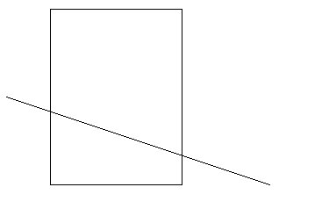

B: AFTER CLIPPING

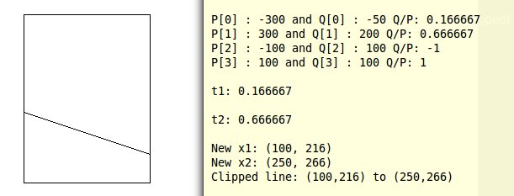

12. | Write a program to draw cubic Bezier curves

Description:
A Bézier curve is a parametric curve frequently used in computer graphics and related fields. Generalizations of Bézier curves to higher dimensions are called Bézier surfaces, of which the Bézier triangle is a special case. In vector graphics, Bézier curves are used to model smooth curves that can be scaled indefinitely. "Paths", as they are commonly referred to in image manipulation programs, are combinations of linked Bézier curves. Paths are not bound by the limits of rasterized images and are intuitive to modify.
Some terminology is associated with these parametric curves. We have
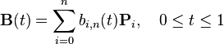
where the polynomials
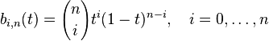

Program:

OUTPUT:

13. | Write a program to demonstrate simple animation.

Description:
Animation is the process of making the illusion of motion and change by means of the rapid display of a sequence of static images that minimally differ from each other. The illusion—as in motion pictures in general—is thought to rely on the phi phenomenon. Animators are artists who specialize in the creation of animation.

Animation can be recorded with either analogue media, a flip book, motion picture film, video tape, digital media, including formats with animated GIF, Flash animation and digital video. To display animation, a digital camera, computer, or projector are used along with new technologies that are produced.

Animation creation methods include the traditional animation creation method and those involving stop motion animation of two and three-dimensional objects, paper cutouts, puppets and clay figures. Images are displayed in a rapid succession, usually 24, 25, 30, or 60 frames per second.

Program:

OUTPUT:

