PROGRAM 1
STEGANOGRAPHY
Description:
Steganography is the practice of concealing a file, message, image, or video within another file, message, image, or video. The advantage of steganography over cryptography alone is that the intended secret message does not attract attention to itself as an object of scrutiny. Plainly visible encrypted messages—no matter how unbreakable—arouse interest, and may in themselves be incriminating in countries where encryption is illegal. Thus, whereas cryptography is the practice of protecting the contents of a message alone, steganography is concerned with concealing the fact that a secret message is being sent, as well as concealing the contents of the message.
In this program, an input file is prepared which serves as the carrier for hiding the data. The program then asks for the string to be hidden in the file. The input string is converted into binary and its representation is stored. Then the input file is modified to create a new updated input file which is the same file except that a space denotes a '0' and a double space denotes a '1'. This updated input is sent. At the receiving end, same rules are applied to create the binary representation from the updated file. Thus, the original message is reconstructed.

Program:

#include <stdio.h>
#include <stdlib.h>
#include <string.h>
#include <math.h>
#include <assert.h>
#include <ctype.h>

static int byteSize;
#define MAX 1000
#define BITS_CHAR 8
#define input_file "input.txt"
#define crypt_file "updated_input.txt"

// A program to hide the input message from the string to a new file.

void getBinary(char * inp, int * binary){
for (int i = 0; i < strlen(inp); i++) {
int ascii = (int) inp [i];
int counter = BITS_CHAR * (i + 1) - 1;
while (ascii) {
binary[counter] = ascii % 2;
ascii /= 2;
counter -= 1;
}
}
}

void readAndCrypt(int * binary){
// Creates a crypted file from the given input that contain our message
// Here, we denote a binary 0 with a single space and 1 with two spaces.
char myLine[MAX] = {' '};
FILE * fp = fopen(input_file, "r");
FILE* fout = fopen(crypt_file, "w");

int charRead = fread(myLine, sizeof(char), MAX, fp);
int arrayCounter = 0, i = 0;

while (i < charRead && arrayCounter < byteSize) {
if (isspace((int)myLine[i]) && binary[arrayCounter] == 0) {
// printf("\nWriting single at %d", i);
fwrite(&myLine[i], sizeof(char), 1, fout);
arrayCounter += 1;
}
else if (isspace((int)myLine[i]) && binary[arrayCounter] == 1) {
// printf("\nWriting double at %d", i);
fwrite(&myLine[i], sizeof(char), 1, fout);
fwrite(&myLine[i], sizeof(char), 1, fout);
arrayCounter += 1;
}

else fwrite(&myLine[i], sizeof(char), 1, fout);
i++;
}

fclose(fp);
fclose(fout);
}

void readAndDecrypt(){
// Decrypts information from the updated input file used as a stegnograph
// Converts the result back into the value we want
FILE* fout = fopen(crypt_file, "r");
assert(fout);

char myLine[MAX] = {' '};
int charRead = fread(myLine, sizeof(char), MAX, fout), i = 0;
int final [MAX] = {0}, finalCounter = 0, ans = 0;

while (i < charRead && finalCounter < byteSize) {

if (isspace((int) myLine[i]) ) {
if ((i + 1) < charRead && isspace((int)myLine[i + 1])) {
// printf("\nReading double at %d", i);
final[finalCounter] = 1;
i++;
}
else {
// printf("\nReading single at %d", i);
final[finalCounter] = 0;
}
finalCounter += 1;
}
i++;
}

char decrypt[MAX] = {' '};
printf("\n\nReceived the message: \t");

for (int i = 0; i < byteSize; i++) {
if (final [i] == 1)
ans += pow(2, BITS_CHAR - 1 - (i % BITS_CHAR));

if (i > 0 && (i + 1) % BITS_CHAR == 0) {
char sm [2] = {(char) ans,'\0'};
strcat(decrypt, sm);
ans = 0;
}
}
printf("%s\n",decrypt);
}

int main(){
char user_input[MAX];

// Ask user for a text to encrypt

printf("\nEnter a string to encrypt\t");
fgets(user_input, MAX, stdin);
// fscanf(stdin, "%s[^\n]",user_input );
byteSize = strlen(user_input)* BITS_CHAR;

int binary[MAX] = {0};
getBinary(user_input, binary);

//read carrier file and crypt it into a new file
readAndCrypt(binary);

// read crypt file and print output
readAndDecrypt();
return 0;
}

OUTPUT:

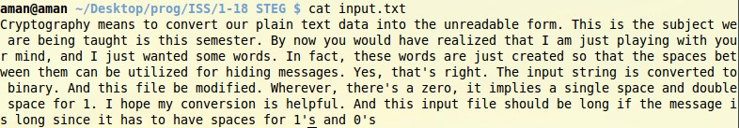

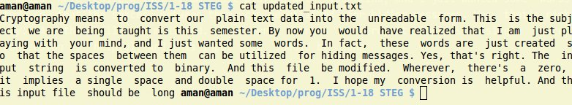

PROGRAM 2
Play Fair CIPHER
Description:
The technique encrypts pairs of letters (digraphs), instead of single letters as in the simple substitution cipher. The Play Fair is thus significantly harder to break since the frequency analysis used for simple substitution ciphers does not work with it. Frequency analysis can still be undertaken, but on the 600 possible digraphs rather than the 26 possible monographs.
The Play Fair cipher uses a 5 by 5 table containing a key word or phrase. Memorization of the keyword and 4 simple rules was all that was required to create the 5 by 5 table and use the cipher.
To generate the key table, one would first fill in the spaces in the table with the letters of the keyword (dropping any duplicate letters), then fill the remaining spaces with the rest of the letters of the alphabet in order (usually putting both "i" and "j" in the same space). The key can be written in the top rows of the table, from left to right, or in some other pattern, such as a spiral beginning in the upper-left-hand corner and ending in the centre. The keyword together with the conventions for filling in the 5 by 5 table constitute the cipher key.
To encrypt a message, one would break the message into digraphs (groups of 2 letters) such that, for example, "hello" becomes "he lx lo", and map them out on the key table. If needed, append a "x" to complete the final digraph. The two letters of the digraph are considered as the opposite corners of a rectangle in the key table. Note the relative position of the corners of this rectangle. Then apply the following 4 rules, in order, to each pair of letters in the plain text.
- If both letters are the same (or only one letter is left), add an "x" after the first letter. Encrypt the new pair and continue.
- If the letters appear on the same row of your table, replace them with the letters to their immediate right respectively.
- If the letters appear on the same column of your table, replace them with the letters immediately below respectively.
- If the letters are not on the same row or column, replace them with the letters on the same row respectively but at the other pair of corners of the rectangle defined by the original pair.

Program:
#include <bits/stdc++.h>
#include <iostream>
using namespace std;

#define MAT_SIZE 5 //5 * 5 matrix
#define inputFile "input.txt"
char * mat[MAT_SIZE];

static char i_j;

// A program to implement Play Fair cipher encryption on a string that is read from a file

void build_matrix(string &str, char ** mat){
// Builds a square matrix of size MAT_SIZE using the input string
for(int i = 0 ; i<MAT_SIZE; i++)
mat[i]= new char[MAT_SIZE];

for(int i = 0; i<MAT_SIZE; i++)
for(int j = 0; j<MAT_SIZE; j++)
mat[i][j] = '!';

set<char> unique;
for(int i = 0; i<str.size(); i++)
unique.insert(str[i]);

set<char>::iterator sit = unique.begin();
int last_row, last_col;
bool over = false;

for(int i = 0; i<MAT_SIZE; i++){
for(int j = 0; j<MAT_SIZE; j++)
if (sit != unique.end()){
mat[i][j] = *sit;
sit++;
}
else{
last_col = j;
last_row = i;
over = true;
break;
}
if (over)break;
}

vector<char>not_added_lower;
for(char x = 'a'; x <= 'z'; x++){
// Take special case for i = j
if (x == 'i'){
if (find(unique.begin(), unique.end(), 'j') == unique.end()){
not_added_lower.push_back('i');
i_j = 'i';
unique.insert('i');
}
}
else if (x == 'j'){
if (find(unique.begin(), unique.end(), 'i') == unique.end()){
not_added_lower.push_back('j');
i_j = 'j';
unique.insert('j');
}
}
else if (find(unique.begin(), unique.end(), x) == unique.end())
not_added_lower.push_back(x);
}
}

void encrypt(char a, char b, vector<char>& outputA, vector<char>& outputB){
// Given two characters a and b of a digraph, encrypt them according to the matrix
int x1, x2, y1, y2;

for(int i = 0; i<MAT_SIZE; i++)
for(int j = 0; j<MAT_SIZE; j++)
if (mat[i][j] == a){
x1 = i;
y1 = j;
break;
}

for(int i = 0; i<MAT_SIZE; i++)
for(int j = 0; j<MAT_SIZE; j++)
if (mat[i][j] == b){
x2 = i;
y2 = j;
break;
}

if (x1 == x2){
outputA.push_back(mat[x1][(y1+1) % MAT_SIZE]);
outputB.push_back(mat[x2][(y2+1) % MAT_SIZE]);
}

else if (y1 == y2){
outputA.push_back(mat[(x1+1) % MAT_SIZE][y1]);
outputB.push_back(mat[(x2+1) % MAT_SIZE][y2]);
}

else{
outputA.push_back(mat[x2][y1]);
outputB.push_back(mat[x1][y2]);
}
}

void decrypt(char a, char b, vector<char>& inputA, vector<char>& inputB){
// Given two characters a and b of a digraph, decrypt them according to the matrix
int x1, x2, y1, y2;

for(int i = 0; i < MAT_SIZE; i++)
for(int j = 0; j < MAT_SIZE; j++)
if (mat[i][j] == a){
x1 = i;
y1 = j;
break;
}

for(int i = 0; i < MAT_SIZE; i++)
for(int j = 0; j < MAT_SIZE; j++)
if (mat[i][j] == b){
x2 = i;
y2 = j;
break;
}
if (x1 == x2){
inputA.push_back(mat[x1][(y1 - 1) % MAT_SIZE]);
inputB.push_back(mat[x2][(y2 - 1) % MAT_SIZE]);
}

else if (y1 == y2){
inputA.push_back(mat[(x1 - 1) % MAT_SIZE][y1]);
inputB.push_back(mat[(x2 - 1) % MAT_SIZE][y2]);
}

else{
inputA.push_back(mat[x2][y1]);
inputB.push_back(mat[x1][y2]);
}

}

void solve(vector<char> & inputA, vector<char> & inputB){
// Given the digraph, encrypts it according to the Play Fair matrix
vector<char>:: iterator it = inputA.begin();
vector<char>:: iterator it2 = inputB.begin();
vector<char> outputA, reoutA;
vector<char> outputB, reoutB;

inputA.pop_back();
inputB.pop_back();

cout << "\n The Digraph Message: ";

for(;it != inputA.end();it++, it2++){
cout << *it << *it2 << " ";
encrypt(*it, *it2, outputA, outputB);
}

cout << "\n The Encrypt Message: ";
for(int i = 0; i < outputA.size(); i ++){
cout << outputA[i] << outputB[i] << " ";
}

cout << "\n The Decrypt Message: ";
for(int i = 0; i < outputA.size(); i ++)
decrypt(outputA[i], outputB[i], reoutA, reoutB);

it = reoutA.begin();
it2 = reoutB.begin();
for(;it != reoutA.end(); it++, it2++)
cout << *it << *it2 << " ";
}

void consoleInput(vector<char> & inputA, vector<char> &inputB){
// Reads input string from a file and prepares the digraph
ifstream inf(inputFile);
char c, i1, i2;
while((c = inf.get())!= EOF){

if(!isalnum(c))
continue;
i1 = c;
i2 = inf.get();
while(!isalnum(i2) && i2 != EOF)
i2 = inf.get();

if(i1 == i2){
inputA.push_back(i1);
inputB.push_back('x');
inputA.push_back(i2);
i2 = inf.get();
while(!isalnum(i2) && i2 != EOF)
i2 = inf.get();
inputB.push_back(i2);
}
else{
inputA.push_back(i1);
if (i2 == EOF)
inputB.push_back('x');
else inputB.push_back(i2);
}
}
inf.close();
}

int main(){
string str;
cout << "\n Enter key string for the matrix: ";
cin >> str;
build_matrix(str, mat);

vector <char> inputA;
vector <char> inputB;
consoleInput(inputA, inputB);
solve(inputA, inputB);
return 0;
}

OUTPUT:

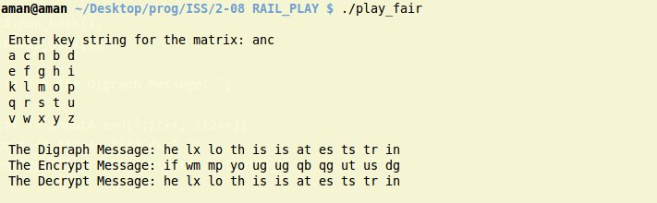

PROGRAM 3
RAIL FENCE CIPHER
Description:
Rail Fence Cipher (also called a zigzag cipher) generally refers to a form of transposition cipher. It derives its name from the way in which it is encoded. In the rail fence cipher, the plain text is written downwards and diagonally on successive "rails" of an imaginary fence, then moving up when we reach the bottom rail. When we reach the top rail, the message is written downwards again until the whole plaintext is written out. The message is then read off in rows. For example, if we have 3 "rails" and a message of 'WE ARE DISCOVERED. FLEE AT ONCE', the cipher text is
W . . . E . . . C . . . R . . . L . . . T . . . E
. E . R . D . S . O . E . E . F . E . A . O . C .
. . A . . . I . . . V . . . D . . . E . . . N . .
Then reads off to get the ciphertext:
WECRL TEERD SOEEF EAOCA IVDEN

Program:
#include <bits/stdc++.h>
using namespace std;

int numRails;
string userStr;
vector<char> rail;

void display(vector<char> &rail){
cout <<"\n Rail: ";
for (auto a : rail)
cout << a << " ";
cout << endl;
}

void encrypt(){
//encrypts the text with the given number of rails
rail.resize(0);
int starter, gap;
cout <<"\n********ENCRYPTION**********\n";

for (int railNum = 0; railNum < numRails; railNum++){
if (railNum == 0 || railNum == numRails -1){
starter = railNum;
gap = 2 * (numRails -1);
rail.push_back(userStr[starter]);

starter += gap;
while (starter < userStr.size()){
rail.push_back(userStr[starter]);
starter += gap;
}
}

else{
bool isOdd = true;
starter = railNum;
int railBelow, railAbove;
while (starter < userStr.size()){
rail.push_back(userStr[starter]);

if (isOdd){ //do odd first
isOdd = false;
railBelow = numRails - railNum -1;
gap = 2 * railBelow;
}
else{
railAbove = railNum;
gap = 2 * railAbove;
isOdd = true;
}
starter += gap;
}
}
display(rail);
}
}

void decrypt(){
//deccrypts the rails to the original message
vector<char> deRail(rail.size(),'-');
int i = 0, starter, gap, j;
cout <<"\n********DECRYPTION**********\n";

for (int iter = 0; iter < numRails; iter++){
if (iter == 0 || iter == numRails -1){
starter = iter;
deRail[starter] = rail[i ++];
gap = 2 * (numRails -1);
starter += gap;

while(starter < rail.size()){
deRail[starter] = rail[i ++];
starter += gap;
}
}
else{
bool isOdd = true;
starter = iter;

while (starter < deRail.size()){
if (isOdd){
gap = 2 * (numRails - iter -1);
deRail[starter] = rail[i++];
isOdd = false;
starter += gap;
}
else{
isOdd = true;
deRail[starter] = rail[i++];
gap = 2 * iter;
starter += gap;
}
}
}
display(deRail);
}

}

int main(){

cout <<" Enter String: ";
cin >> userStr;
cout <<" Enter number of rails: ";
cin >> numRails;

encrypt();

decrypt();
return 0;
}

OUTPUT:

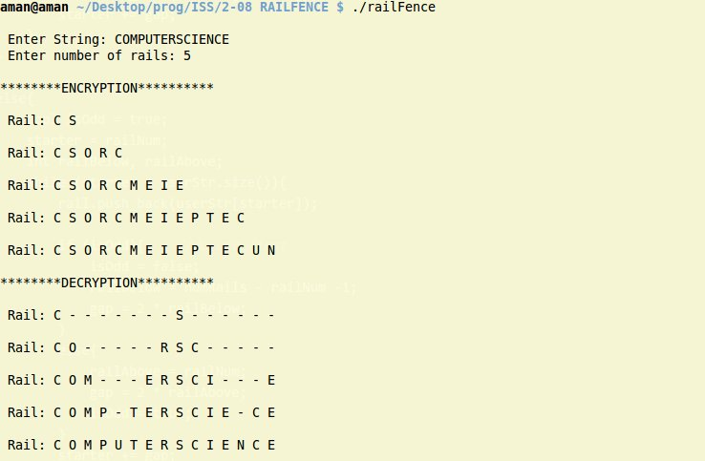

PROGRAM 4
CHINESE REMAINDER THEOREM
Description:
The Chinese remainder theorem is a result about congruences in number theory and its generalizations in abstract algebra. It was first published some time between the 3rd and 5th centuries by the Chinese mathematician Sun Tzu. In its basic form, the Chinese remainder theorem will determine a number n that, when divided by some given divisors, leaves given remainders.
The program takes as input , the number of equations n of the form x = a mod m. Then n equations follow. The prerequisite for solving these equations is that all the m's in the equations must be coprime. If they aren't, then no solution exists. Else, it does.
After storing M = m1 * m2 * m3 and so on, find divs such that M1 = M/M1 , M2 = M/M2 and so on..
For each entry in divs, find the corresponding inverses mod M. Now, final step is to find
X = a * m1 * m1^(-1) + b * m2 * m2^(-1)…
Program:
#include <bits/stdc++.h>
using namespace std;

int gcd(int a, int b){
// Given two numbers, finds GCD using Euclidean Method
if (a < b)
gcd (b, a);
if (b == 0)
return a;
return gcd(b, a%b);
}

tuple<int, int> extendedGCDUtil(int a, int b, int s1, int s2, int t1, int t2){
// Util method to find two solutions s1, t1
if (b == 0)
return make_tuple(s1, t1);
return extendedGCDUtil(b, a % b, s2, s1 - (a / b) * s2, t2, t1 - (a / b) * t2);
}

tuple<int, int> extendedGCD(int a, int b){
// Returns a pair of integers r and s such that a *r + b *s = 1
// Solutions exist only when gcd(a, b) == 1
if (gcd (a, b) != 1)
return make_tuple(0,0);
return extendedGCDUtil(a, b, 1, 0, 0, 1);
}

int main(){
int numEq, a, b, M = 1,r, s;
vector<int> nums, mods, inverses, divs;
// Ask user for n equations of the form X = a mod m1, X = b mod m2
cout <<"\n Enter n (number of equations): \t";
cin >> numEq;

for (int i = 0; i < numEq; i ++){
cout <<"\n Enter (a, b) such that X = a mod b\t ";
cin >> a >> b;
nums.push_back(a);
mods.push_back(b);
M *= b;
}
// Preliminary display
cout <<"\n Big M: " << M << endl << endl;
cout <<" Nums: "<< nums << endl;
cout <<" Mods: "<< mods << endl;

// Check if all smaller mods are coPrime
int modGCD = mods[0];
for (int i = 1; i < mods.size(); i++)
modGCD = gcd(modGCD, mods[i]);

if (modGCD != 1){
cout <<"\n Given modulii are not coprime to each other";
cout <<"\n No solution exists\n";
return -1;
}
// After storing M = m1 * m2 * m3 and so on
// Find divs such that M1 = M/M1 , M2 = M/M2 and so on..

for (auto m : mods)
divs.push_back(M / m);
cout <<" Divs: "<< divs << endl;

// For each entry in divs, find the corresponding inverses mod M
for (int i = 0; i < numEq; i++){
tie (r, s) = extendedGCD(divs[i], mods[i]);
inverses.push_back((r + mods[i]) % mods[i]);
}
cout <<" Invs: "<< inverses << endl;

// Now, final step is to find X = a * m1 * m1^(-1) + b * m2 * m2^(-1)...
int ans = 0;
for (int i = 0; i < numEq; i++)
ans = (ans + nums[i] * divs[i] * inverses[i]) % M;

cout << " Solution to these equations : "<< ans << endl;
cout <<" \n Verification: \n";
for (auto a : mods)
cout << " " << ans <<" % " << a <<" : " << ans % a << endl;
return 0;
}

OUTPUT:

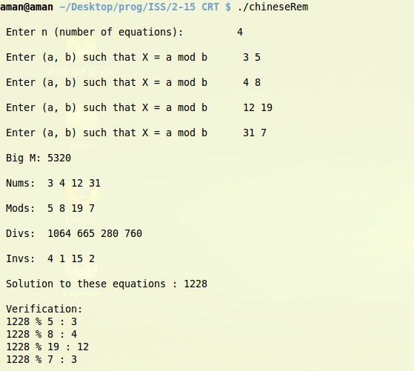

PROGRAM 5
RSA, PRIMALITY TESTING, RANDOM NO GENERATION
Description:
RSA is an algorithm used by modern computers to encrypt and decrypt messages. It is an asymmetric cryptographic algorithm. Asymmetric means that there are two different keys. This is also called public key cryptography, because one of them can be given to everyone. The other key must be kept private. It is based on the fact that finding the factors of an integer is hard (the factoring problem)
The keys for RSA can be generated as follows:

1) Choose two large prime numbers p and q
2) Calculate n = pq and the totient t = (p – 1) * (q – 1)
3) Choose an integer e such than 1 < e < t and gcd(e, t) = 1. This 'e' is the public key exponent
4) Compute d as (e inverse) mod t. This 'd' is the private key exponent.
5) Compute cipher text as C = (m ^ e) mod n using fast exponentiation
6) Compute decrypted message as M = (C ^ d) mod n

The two large prime numbers are generated randomly using a linear congruential generator (LCG) and then checked for primality using trial division uptill the square root of the number.
The LCG is defined as the following recurrence.
X(n + 1) = ( a(Xn) + c ) mod m
where X(n +1) is the next seed, a is the multiplier, c is the increment and m is the maximum range of the random number required.
X0 is the initial seed that is kept at the value of time(NULL) so that it's random at that moment
a = 1103515245
c = 12345
m = 65536 (this sequence is used by GCC to generate random values)
The random values are then checked for primality by trial division which works in O(sqrt N). This is a deterministic test. Other faster probabilistic tests such as Rabin Miller Karp can also be used.

PROGRAM:
#include <bits/stdc++.h>
#define seed rand()
typedef long long unsigned ll;
using namespace std;

ll nextSeed = 1;

int myRand() {
//generates a random number with the given seed using linear congruential generator
nextSeed = nextSeed * 1103515245 + 12345;
return ((nextSeed/65536) % 65536);
}

tuple<ll, ll> extendedGCDUtil(ll a, ll b, ll s1, ll s2, ll t1, ll t2){
// Util method to find two solutions s1, t1
if (b == 0)
return make_tuple(s1, t1);
return extendedGCDUtil(b, a % b, s2, s1 - (a / b) * s2, t2, t1 - (a / b) * t2);
}

tuple<ll, ll> extendedGCD(ll a, ll b){
// Returns a pair of llegers r and s such that a *r + b *s = 1
// Solutions exist only when gcd(a, b) == 1
// Let tie (r, s) = extendedGCD(divs[i], mods[i]); then (r + mods[i]) % mods[i] is the mod inv
if (gcd (a, b) != 1)
return make_tuple(0,0);
return extendedGCDUtil(a, b, 1, 0, 0, 1);
}

ll fastExp(ll a, ll b, ll mod){
//fast modular exponentiation of a ^ b % mod
if (b == 1)
return a % mod;
else{
if (b % 2 == 0)
return fastExp((a * a) % mod, b/2, mod) % mod;
else
return (a % mod * (fastExp(a, b -1, mod) % mod)) % mod;
}
}

bool primalityTest(ll n){
//Given a number n, tests whether it is prime or not
if (n < 3)
return n == 2;
else if (n % 2 == 0)
return false;

for (ll i = 3; i * i <= n; i++){
if (n % i == 0)
return false;
}
return true;
}

void rsaSolver(ll n1, ll n2){
//Rsa algorithm given two large prime numbers
ll msg;
cout << "\n Enter number to encode: ";
cin >> msg;

ll n = n1 * n2, phyN = (n1 - 1) * (n2 - 1);
ll e;
for (e = 2; e< phyN; e++)
if (gcd(e, phyN) == 1)
break;

ll d, s;
tie (d, s) = extendedGCD(e, phyN);
d = (d + phyN) % phyN;

ll enc = fastExp(msg, e, n);
cout << "\n The crypted message is: " << enc << endl;

ll origMsg = fastExp(enc, d, n);
cout << "\n The decrypted message is: " << origMsg << endl;
}

int main(){
ll n1 = 0, n2 = 0;
nextSeed = time(NULL);

while(true){
n1 = myRand();
if (primalityTest(n1))
break;
}

nextSeed = time(NULL);
while(true){
n2 = myRand();
if (primalityTest(n2) and n2 != n1)
break;
}

assert (gcd(n1, n2) == 1 && primalityTest(n1) && primalityTest(n2));
cout << "\n Generated Prime Random n1: " << n1 << endl;
cout << "\n Generated Prime Random n2: " << n2 << endl;
rsaSolver(n1, n2);
return 0;
}

OUTPUT:
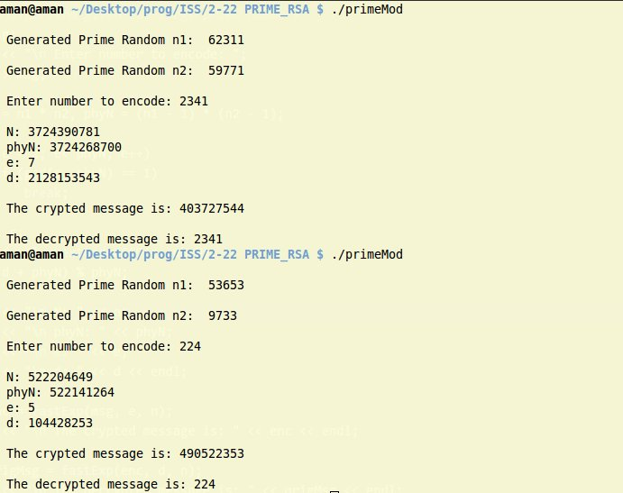

PROGRAM 6
MESSAGE DIGEST (MD5) Algorithm
Description:
The MD5 message-digest algorithm is a widely used cryptographic hash function producing a 128-bit (16-byte) hash value, typically expressed in text format as a 32-digit hexadecimal number. MD5 has been utilized in a wide variety of cryptographic applications and is also commonly used to verify data integrity. MD5 is a one-way function; it is neither encryption nor encoding. It cannot be reversed other than by brute-force attack.
MD5 processes a variable-length message into a fixed-length output of 128 bits. The input message is broken up into chunks of 512-bit blocks (sixteen 32-bit words); the message is padded so that its length is divisible by 512. The padding works as follows: first a single bit, 1, is appended to the end of the message. This is followed by as many zeros as are required to bring the length of the message up to 64 bits fewer than a multiple of 512. The remaining bits are filled up with 64 bits representing the length of the original message, modulo 264.
The main MD5 algorithm operates on a 128-bit state, divided into four 32-bit words, denoted A, B, C, and D. These are initialized to certain fixed constants. The main algorithm then uses each 512-bit message block in turn to modify the state. The processing of a message block consists of four similar stages, termed rounds; each round is composed of 16 similar operations based on a non-linear function F, modular addition, and left rotation. Figure illustrates one operation within a round. There are four possible functions F and a different one is used in each round:
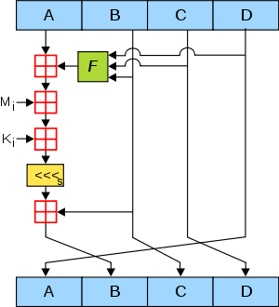
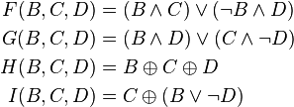
The security of the MD5 hash function is severely compromised.

PROGRAM:
#include <bits/stdc++.h>
using namespace std;
#define INPUT_FILE "input"
/* A program to generate the message digest as governed by the MD5 algorithm */

// Initialise chaining variables
uint a0, b0, c0, d0;
vector<uint> K(64); //handles constants
vector<uint> S(64); //handles shuft values

uint getPaddingLength(uint inputBits){
// Given the number of inputBits, returns the required padding bits in MD5
int paddingMust = inputBits < 512 ? 512 : 0;
return 512 - (inputBits + 64) % 512 + paddingMust;
}

string getPaddedString(uint bitCount){
// Given the number of inputBits, returns the padded string for that input
uint numZero = bitCount - 1;
int paddingMust = bitCount < 512 ? 512 : 0;
return '1' + string(numZero + paddingMust, '0');
}

uint binaryToChar(string &bin){
// Given a binary form, return the decimal expansion
uint num = 0, len = bin.size();
for (uint i = 0; i < len; i++){
if (bin[i] == '1')
num += 1 << (len - 1 - i);
}
return num;
}

string numToBinary(uint num, uint padLength){
// Given an integer, return a string denoting its binary representation padded appropriately
string binary;
while(num){
binary += (num % 2) ? "1" : "0";
num /= 2;
}
reverse(binary.begin(), binary.end());
uint padZero = padLength - binary.size();
return string(padZero, '0').append(binary);
}

uint leftRotate (uint x, uint c){
// To left rotate a number x by c bits
return (x << c) | (x >> (32 -c));
}

void setupConstants(){
// Setup K and shift array for all 64 rounds
a0 = 1732584193; //0x67452301
b0 = 4023233417; //0xefcdab89
c0 = 2562383102; //0x98badcfe
d0 = 271733878; //0x10325476

for (uint i = 0; i < 64; i++)
K[i] = uint(4294967296 * abs(sin(i + 1)));

S[0] = 7; S[1] = 12; S[2] = 17; S[3] = 22; S[4] = 7; S[5] = 12; S[6] = 17; S[7] = 22;
S[8] = 7; S[9] = 12; S[10] = 17; S[11] = 22; S[12] = 7; S[13] = 12; S[14] = 17; S[15] = 22;
S[16] = 5; S[17] = 9; S[18] = 14; S[19] = 20; S[20] = 5; S[21] = 9; S[22] = 14; S[23] = 20;
S[24] = 5; S[25] = 9; S[26] = 14; S[27] = 20; S[28] = 5; S[29] = 9; S[30] = 14; S[31] = 20;
S[32] = 4; S[33] = 11; S[34] = 16; S[35] = 23; S[36] = 4; S[37] = 11; S[38] = 16; S[39] = 23;
S[40] = 4; S[41] = 11; S[42] = 16; S[43] = 23; S[44] = 4; S[45] = 11; S[46] = 16; S[47] = 23;
S[48] = 6; S[49] = 10; S[50] = 15; S[51] = 21; S[52] = 6; S[53] = 10; S[54] = 15; S[55] = 21;
S[56] = 6; S[57] = 10; S[58] = 15; S[59] = 21; S[60] = 6; S[61] = 10; S[62] = 15; S[63] = 21;
}

void md5(vector<string> &block){
/* Given a message broken into 512 bit blocks, perform MD5 algorithm */
//Process the message in successive 512-bit chunks
setupConstants();

for (auto a : block){
cout << "\n BLOCK => " << a << endl;
// for each 512-bit chunk of message
//break chunk into sixteen 32-bit words M[j], 0 ≤ j ≤ 15
vector<uint> M(16);
string subBlock;
for (uint i = 0, j = 0; i < a.size(); i++){
subBlock += a[i];
if ((i + 1) % 32 == 0){
M[j] = binaryToChar(subBlock);
cout << "\n\t Subblock: " << subBlock << " : " << M[j];
subBlock.clear();
}
}
cout << endl;

//Initialize hash value for this chunk:
uint A = a0, B = b0, C = c0, D = d0;
uint F, G, dTemp;

//16 iterations per four major rounds = 64 rounds
for (uint i = 0; i < 64; i++){
if (i <= 15){
F = (B & C) | (~B & D);
G = i;
}
else if (i >= 16 && i <= 31){
F = (D & B) | (~D & C);
G = (5 * i + 1) % 16;
}
else if (i >= 32 && i <= 47){
F = B ^ C ^ D;
G = (3 * i + 5) % 16;
}
else if (i >= 48 && i <= 63){
F = C ^ (B | ~D);
G = (7 * i) % 16;
}
dTemp = D;
D = C;
C = B;
B = B + leftRotate(A + F + K[i] + M[G], S[i]);
A = dTemp;
}
//Add this chunk's hash to result so far:
a0 += A;
b0 += B;
c0 += C;
d0 += D;
}
// The final chaining variables are a0, b0, c0, d0 (32 bit). Convert them to hex and append
cout << "\n Final Chaining variable: \n";
cout << "\t\tA: " << a0 << ": " << hex << a0 << endl;
cout << "\t\tB: " << b0 << ": " << hex << b0 << endl;
cout << "\t\tC: " << c0 << ": " << hex << c0 << endl;
cout << "\t\tD: " << d0 << ": " << hex << d0 << endl;

stringstream md;
md << hex << a0 << hex << b0 << hex << c0 << hex << d0;
cout << "\n MD5 Digest: " << md.str() << endl << endl;
}

int main(){
// Read input file char by char and process it into 512 bit (64 bytes) inputS
// 1 char = 1 byte. So array[64] to hold one block
ifstream inf(INPUT_FILE);
char c; string inputString;

vector< string > block; //64 bytes per block
static uint byteCount = -1;
uint bitCount = 0;

while( (c = inf.get())!= EOF){
inputString += c;
byteCount += 1;
}
inputString.erase(remove(inputString.begin(), inputString.end(), '\n'));
bitCount = byteCount * 8;
cout << "\n Number of bytes in original message: " << byteCount;
cout << "\n Number of bits in original message: " << bitCount << endl;
cout << "\n Length of message to be appended: 64 bits ";
cout << "\n Number of bits to be padded : " << getPaddingLength(bitCount) << endl;

string byteTobit;
for (char c : inputString)
byteTobit += numToBinary(c, 8);

inputString = byteTobit;
cout << "\n ORIGINAL: \n" << inputString << endl;

string paddedString = getPaddedString(getPaddingLength(bitCount));
cout << "\n PADDED: \n" << paddedString << endl;
inputString += paddedString;

string lengthString = numToBinary(bitCount, 64);
inputString += lengthString;
cout << "\n LENGTH(64): \n" << lengthString << endl;
// Process non padded bytes into block
string blockString = "";

for (uint i = 0; i < inputString.size(); i++){
blockString += inputString[i];
if ((i + 1)% 512 == 0){
block.push_back(blockString);
blockString.clear();
}
}
// 64 byte = 512 bit blocks are ready
md5(block);

inf.close();
return 0;
}

OUTPUT:

