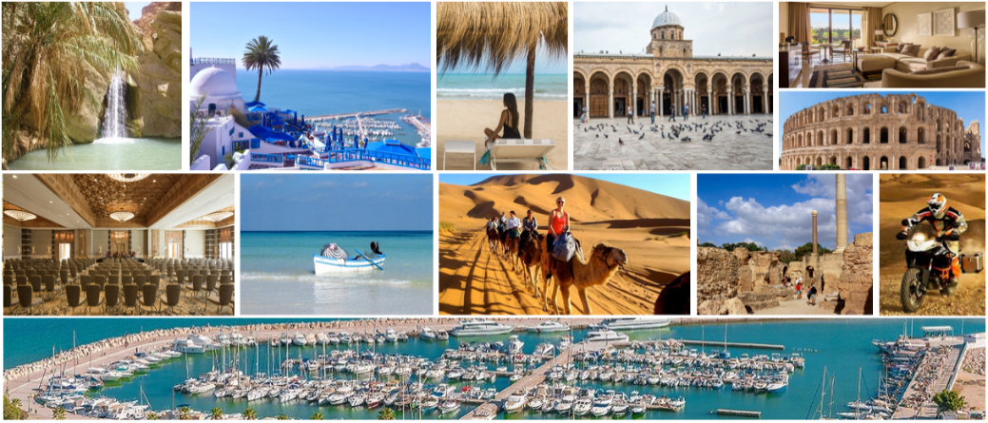

**The 27th IEEE International Symposium**

**On Real-Time Distributed Computing**

**IEEE ISORC 2024 (Hybrid Conference)**

**Carthage, Tunis, Tunisia**

**May 22-25, 2024**

<https://isorc.github.io/2024/>

**CALL FOR PARTICIPATION**

**Organizing Committee**

**General Chairs**

**Akram Hakiri**

University of Pau & Pays de l’Adour, France

**Aniruddha Gokhale**

Vanderbilt University, USA

**Mathias Pacher**

Goethe University of Frankfurt, Germany

**Program Committee Chairs**

**Hella Kaffel Ben Ayed**

University of Tunis El Manar, FST,Tunisia

**Abderrazak Jemai**

University of Carthage, INSAT,

Tunisia

**Pierre-Emmanuel Hladik**

Centrale Nantes, LS2N, France

**Steering Committee Chairs**

**Uwe Brinkschulte**

Goethe University of Frankfurt, Germany

**Robert G Pettit**

George Mason University, USA

**Local Management Chairs**

**Walid Barhoumi**

University of Carthage, Tunisia

**Slim Amri**

University of Carthage, Tunisia

**Fourati Hend**

University of Manouba, Tunisia

**Karim Houidi**

University of Tunis - El Manar, Tunisia

**Yassine Mabrouk**

CNSNT, Tunisia

**Marwa Said**

University of Tunis - El Manar, Tunisia

**Web Chair**

**Akram Hakiri**

University of Pau & Pays de l’Adour, France.

**Publicity Chairs**

**Aicha Ben Salem**

University of Carthage, Tunisia

**Maryline Laurent**

Télécom Sud Paris, Institut Polytechnique de Paris, France

**Kim, Jong-Chan**

Kookmin University, Korea

**Publication Chairs**

**Sondes Chaabane**

Polytechnic University of Hauts-de-France, Valenciennes, France

**Maroua NOUIRI**

Centrale Nantes, France.

**Finance Chair**

**Ilhem Abdelhedi**

University of Carthage, Tunisia

**Akram Hakiri**

University of Pau & Pays de l’Adour, France.

**Organizing Committee**

**Workshop chairs**

**Nedra Mellouli**

ESILV, DVRC-la Défense &

Paris 8 University, France

**Pascal Berthou**

CNRS-LAAS, University of Toulouse 3, UPS, France

**Christian Esposito**

University of Salerno, Italy

**Short Paper/Poster chairs**

**Slim Abdellatif**

INSA Toulouse, CNRS-LAAS, France

**Olfa Jemai**

University of Gabès, ISIMG Tunisia

**Tutorials chairs**

**Thierry Gayraud**

CNRS-LAAS, University of Toulouse 3, UPS, France

**Martin Schoeberl**

Technical University of Denmark, Denmark

**Eric Hutter**

Provadis School of International Management & Technology AG, Frankfurt, Germany

**Keynote chairs**

**Mohamed Faten Zhani**

University of Sousse, Tunisia

**Marcello Cinque**

University of Naples Federico II, Italy

**Industry chairs**

**Samir Ben Ahmed**

University Tunis MANAR,

Tunisia

**Stefano Russo**

University Naples Federico II, Italy

**Dissertation Digest chairs**

**Tatsuo Nakajima**

Waseda University, Japan

**Mohamed GHAZEL**

University Gustave Eiffel, Lille, France.

**Doctoral Symposium chairs**

**Sadok Ben Yahia**

Southern Denmark University, Denmark

**Peter Puschner**

TU Wien, Vienna, Austria

**Luigi De Simone**

University Naples Federico II, Italy

**IEEE ISORC 2024**

ISORC has been established as the leading event devoted to state-of-the-art research and state-of-the-practice applications in the field of real-time distributed computing. Celebrating the 27th anniversary since its foundation in 1998, ISORC continues the trend of providing an international forum for researchers and industry experts to exchange and share their experiences, ideas, latest research results on all aspects of ORC technology.

**Topics**

IEEE ISORC 2024 invites high-quality papers on all aspects of ORC technology, including, but not limited to:

* *Software Architectures for Real-Time Distributed Computing.*
* *Distributed Real-Time Image, Video, and Stream Processing.*
* *Distributed Communication for Emerging and Future Networks.*
* *Blockchain and Distributed Ledger Technology (DLT) for Distributed Computing.*
* *AI/ML, LLM, and Federated Learning for Real-Time Distributed Computing.*
* *Digital Twin for Future Networks and Emerging IoT Applications*
* *Cybersecurity, and Trust for Distributed Real-Time IoT Systems.*
* *Optimization Approaches for Distributed Real-Time Computing in The Context of IoT, Cyber Physical Systems (CPS), and Edge-Cloud Continuum.*
* *Sustainable and Green Computing Transformation in Edge-to-Cloud Continuum.*
* *Formal Verification and Model Checking for Distributed Real-Time IoT, CPS, and Cloud.*
* *Ontology-Based Knowledge Modelling for Real-Time Distributed IoT & CPS.*
* *Dependability, Fault Tolerance, and Resilience of Distributed Real-Time IoT.*
* *Big Data, Algorithms, Models, and Techniques for Real-Time Analytics.*
* *Operating Systems, Middleware, and System Software.*
* *Distributed Management, Monitoring, Performance Evaluation.*
* *Applications for IoT, CPS, Edge-Cloud, Distributed Embedded Computing.*

**Registration**

The registration categories to participate to the IEEE ISORC 2024 are:

* **Authors:**
  + IEEE Members: 950 TND (HTax)
  + Non-IEEE Members: 1000 TND (HTax)
* **Non-Author:** 
  + IEEE Members: 800 TND (HTax)
  + Non-IEEE Members: 850 TND (HTax)
* **Student non-Author:** 
  + IEEE Members: 600 TND (HTax)
  + Non-IEEE Members: 850 TND (HTax)

Venue: Mövenpick Gammarth Hotel, La Marsa

Registration includes access to all technical sessions, lunches, coffee breaks, and social activities. Accommodation is not included in the registration fee.

For purchase order (bon de commande) to IEEE Tunisia Section - MF. 1496298T (you should add 19% TVA)

For bank transfer: IEEE Tunisia Section 0830 4000 3520 0875 0782 (BIAT)

Registration deadline: April 1, 2024

**For more information**

More information about IEEE ISORC 2024, including submission guidelines, can be found at: [isorc.github.io/2024/](http://isorc.github.io/2024/)