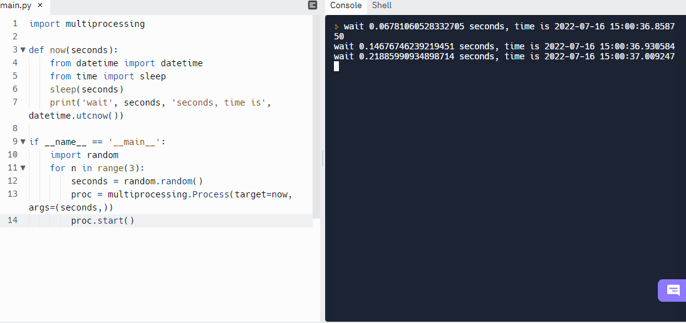

I was able to run the code in replit, not sure why it would not run on jupyter notebooks.