**CSc 3320: Systems Programming**

Fall 2021

Homework

# 1: Total points 100

Submission instructions:

1. Create a Google doc for each homework assignment submission.
2. Start your responses from page 2 of the document and copy these instructions on page 1.
3. Fill in your name, campus ID and panther # in the fields provided. If this information is missing in your document TWO POINTS WILL BE DEDUCTED per submission.
4. Keep this page 1 intact on all your submissions. If this *submissions instructions* page is missing in your submission TWO POINTS WILL BE DEDUCTED per submission.
5. Each homework will typically have 2-3 PARTS, where each PART focuses on specific topic(s).
6. Start your responses to each PART on a new page.
7. If you are being asked to write code copy the code into a separate txt file and submit that as well.
8. If you are being asked to test code or run specific commands or scripts, provide the evidence of your outputs through a screenshot and copy the same into the document.
9. Upon completion, download a .PDF version of the document and submit the same.

Full Name: Iven Souffrant

Campus ID: isouffrant1

Panther #: 002-39-7180

**PART 1**

**Answer the following questions briefly. Provide clear and succinct reasoning.**

**Points per question = 5**

1. Tell the differences between Unix and Linux. Then please list some operating systems (at least three) which belong to Unix but not Linux.

Linux is flexible while unix is not, Linux is open source and source code is available while unix is not and Linux can be installed on a wide variety of cpu hardwares and run on any processor while unix is more specific.

Ex. macOS, Solaris, and AIX

2. What is the pipe mechanism in UNIX? And show one command using pipe and explain how the pipe works in it?

They provide a one way traffic flow of data and is used to combine two or more commands.

Ex. $cat Sample | grep Apple = Apple. It was used to combine commands to get the output.

3. In a Linux system, you can issue the command **ls /** to check the sub directories under root. Please describe the meanings of directory /bin, /dev, /boot, /usr, /etc, /mnt, /sbin, /var separately. For example, you can say that /bin contains binary executable files.

/bin: contains binary executable files, /dev: contains special device files that cannot access to devices, /boot: contains files that are used in booting the operating system, /usr: where the home directories of user are placed, /etc: contains system related configuration files or sub directories, /mnt: can be empty or contain sub directory for individual devices, /sbin: standard subdirectory of root directory and contain files, /var: subdirectory of root directory and in unix that contains files where the system can write the data.

4. What is the meaning of Multitask and Multi-user in a Unix system?

Multiuser operating system enables two or more users to run programs simultaneously. Multitask operating system supports two or more processors running programs at the same time.

5. What does -rwxr-xr-x mean in terms of permissions for a file? What is the exact unix command (with the octal representation) for changing the permissions to this setting?

The user has read, write and execute permissions; the group and others can only read and execute and the octal representation is 755.

6. In class, you have learned the meaning of read, write and execute permission for regular files. However, these permissions are also applied to directories. So please describe the meaning of read, write, and execute permission for directory.

Read means that the user has permission to open a file and view the contents. Write means that the user has the right to make changes on the content. Execute means that the user to run a file that works like a command.

**Part II-a**

**Regular Expression**

**Find outcomes for each given basic/extended regular expression (maybe multiple correct answers)**

**Points per question: 2.5**

| *Example:*  *‘ab+a’* （*extended regex*）  ***Answer****: aba , abba ; Pattern : The matched string should begin and end with ‘a’ and ‘b’ occurs at least once between leading and ending ‘a’)* |
| --- |

Note: 7) to 10) are basic regexes; Note: 11) to 18) are extended regexes.

7) ‘a[ab]*a’ = ababa, aaba, aabbaa, aa

8) ‘a(bc)?’ = abc, a

9) ‘.[ind]*’ = wind, end

10) ‘[a-z]+[a-z]’ =

11) ‘[a-z] (\+[a-z])+’ = a+b+c, x+a

12) ‘a.[bc]+’ = azbc, azbcbc, acc

13) ‘a.[0-9]’ = a01

14) ‘[a-z]+[\.\?!]’ = good!, hard?

15) ‘[a-z]+[\.\?!]\s*[A-Z]’ = book. Z

16) ‘(very )+(cool )?(good|bad) weather’ = very good weather, very cool bad weather

17) ‘-?[0-9]+’ = 3312, -2231

18) ‘-?[0-9]*\.?[0-9]*’ = 3312, -2231, 0.5

**Part II-b**

**Regular Expression**

**Write down the extended regular expression for following questions. E.g. Social security number in the format of 999-99-9999. Answer: [0-9]{3}-[0-9]{2}-[0-9]{4}**

**Points per question: 5**

19) Valid URL beginning with “http://” and ending with ".edu" (e.g. http://cs.gsu.edu, http://gsu.edu)

/^(http):\/\/[\w\-_]+(\.[\w\-_]+)+([\w\-\.]*+(.edu)?

20) Non-negative integers. (e.g. 0, +1, 3320)

(([1-9][0-9])* | 0)?

21) A valid absolute pathname in Unix (e.g. /home/ylong4, /test/try.c)

([.\/]+[a-z]*)*

22) Identifiers which can be between 1 and 10 characters long, must start with a letter or an underscore. The following characters can be letters or underscores or digits. (e.g. number, _name1, isOK).

[_a-Z]{10}

23) Phone number in any of the following format: 9999999999,999-999- 9999, (999)-999-9999. (Note: all of these formats should be matched by a single regular expression)

[0-9]{10}

[0-9]{3}-[0-9]{3}-[0-9]{4}

([0-9]{3})-[0-9]{2}-[0-9]{4}

**Part III**

**Programming**

**Points per question: 15**

24. Create a file named homework_instructions.txt using VI editor and type in it all the submission instructions from page1 of this document. Save the file in a directory named *homeworks* that you would have created. Set the permissions for this file such that only you can edit the file while anybody can only read. Find and list (on the command prompt) all the statements that contain the word POINTS. Submit your answer as a description of what you did in a sequential manner (e.g. Step1 … Step 2… and so on..). Add a screenshot to your answer as a proof of evidence.

Step 1:Make directory called “homeworks” and create file called “homework_instructions.txt”

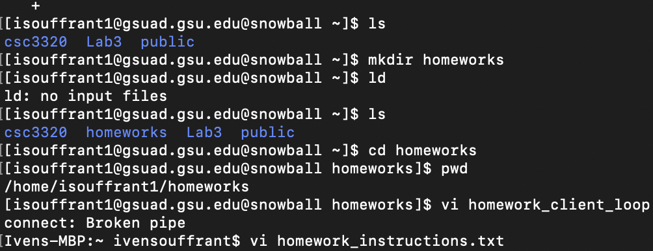

Step 2: Type in statements with the string “POINTS” in some of them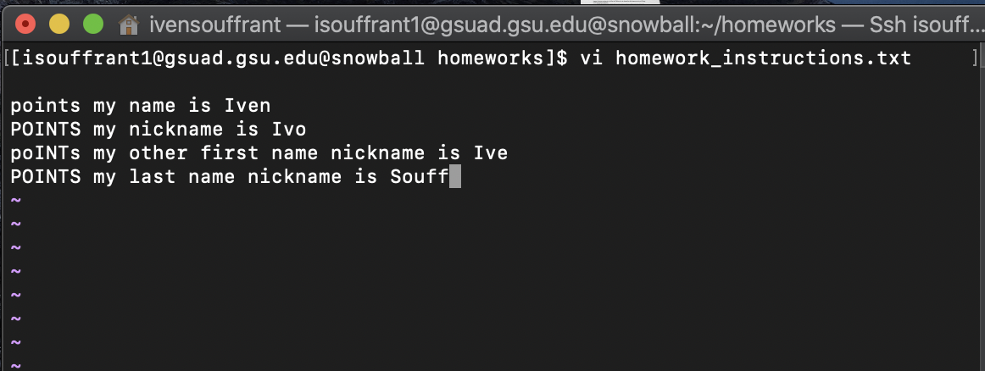

Step 3: Print only statements that has the string “POINTS” in it

Step 4: Make the file where the owner can fully read and write while other people can only read it