**CSc 3320: Systems Programming**

Fall 2021

Midterm 1: Total points = 100

Submission instructions:

1. Create a Google doc for your submission.

2. Start your responses from page 2 of the document and copy these instructions on page 1.

3. Fill in your name, campus ID and panther # in the fields provided. If this information is missing TWO POINTS WILL BE DEDUCTED.

4. Keep this page 1 intact. If this *submissions instructions* page is missing in your submission TWO POINTS WILL BE DEDUCTED.

5. Start your responses to each QUESTION on a new page.

6. If you are being asked to write code copy the code into a separate txt file and submit that as well. The code should be executable. E.g. if asked for a C program then provide myfile.c so that we can execute that script. In your answer to the specific question, provide the steps on how to execute your file (like a ReadMe).

7. If you are being asked to test code or run specific commands or scripts, provide the evidence of your outputs through a screenshot and/or screen

video-recordings and copy the same into the document.

8. Upon completion, download a .PDF version of the google doc document and submit the same along with all the supplementary files (videos, pictures, scripts etc).

9. Scripts/Code without proper comments, indentation and titles (must have the name of the program, and name & email of the programmer on top the script).

Full Name: Iven Souffrant

Campus ID: isouffrant1

Panther #: 002-39-7180

**Questions 1-5 are 20pts each**

1. (20 pts) Pick any of your 10 favourite unix commands. For each command run the *man* command and copy the text that is printed into a mandatabase.txt. Write a shell script *helpme.sh* that will ask the user to type in a command and then print the manual’s text associated with that corresponding command. If the command the user types is not in the database then the script must print

*sorry, I cannot help you*

2. (10pts each) On your computer open your favourite Wikipedia page. Copy the text from that page into a text file **myexamfile.txt** and then copy that file to a directory named **midterm** (use mkdir to create the directory if it doesn’t exist) in your snowball server home directory (use any FTP tool such as Putty or Filezilla to copy the file from your computer to the remote snowball server machine: see Lab 6).

a. Write a shell script that will find the number of statements in the text. A statement is defined as the collection of text between two periods (full-stops).

b. Update the script to present a tabular list that shows the number of words and number of letters in each statement.

3. (20pts) Design a calculator using a shell script using regular expressions. The calculator, at the minimum, must be able to process addition, subtraction, multiplication, division and modulo operations. It must also have cancel and clear features.

4. (20pts) Build a phone-book utility that allows you to access and modify an alphabetical list of names, addresses and telephone

numbers. Use utilities such as awk and sed, to maintain and edit the file of phone-book information. The user (in this case, you) must be able to read, edit, and delete the phone book contents. The permissions for the phone book database must be such that it is inaccessible to anybody other than you (the user).

5. (4 pts each) Give brief answers with examples, wherever relevant A. What is the use of a shell?

B. Is there any difference between the shell that you see on your PC versus that you see on the snowball server upon login. If yes, what are they? Provide screenshots for examples.

C. What are the elements in a computer (software and hardware) that enable the understanding and interpretation of a C program?

D. The “printf()” C command is used for printing anything on the screen. In bash we use the command “echo ”. What is the difference (if any) in terms of how the computer interprets and executes these commands?

E. What do these shell commands do? “ssh”, “scp” and “wget”. Describe briefly using an example that you have executed using the snowball server.

· Type ten lines with “man [command you want] |cat >> mandata.txt

· Then create helpme.sh file by typing vi helpme.sh and type in code from helpme_sh.doc

· Save and exit the file by clicking the “esc” button and type in “:wq” and hit enter

· To test the code type in sh helpme.sh and type a command to see if it was one that you added in or not based off the result you get back

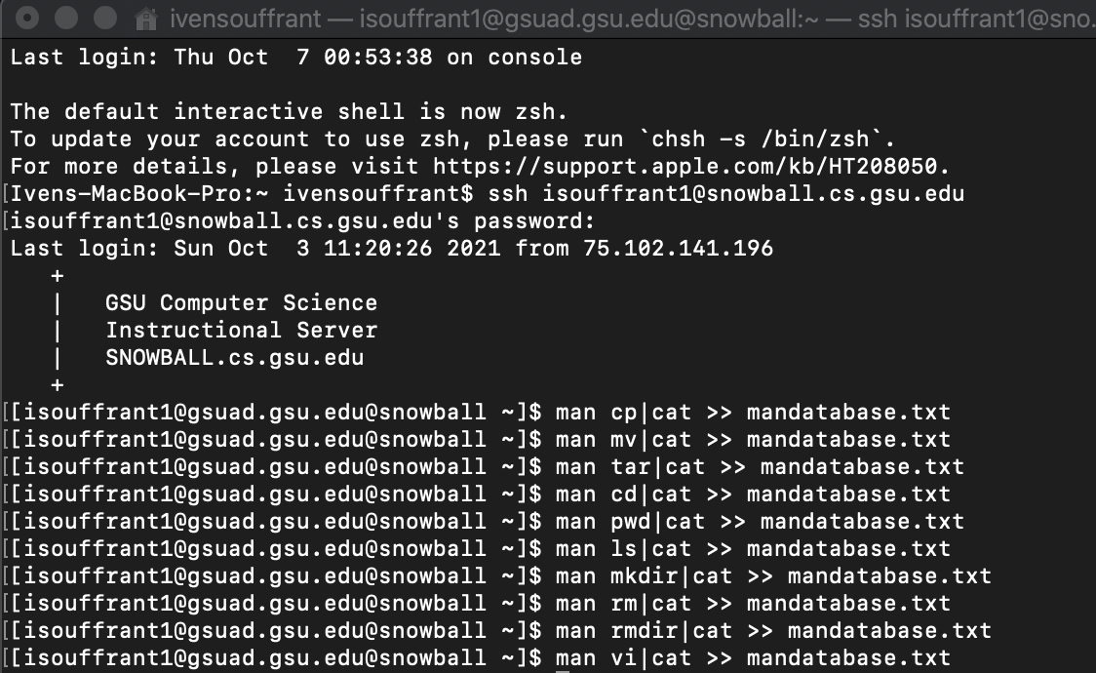

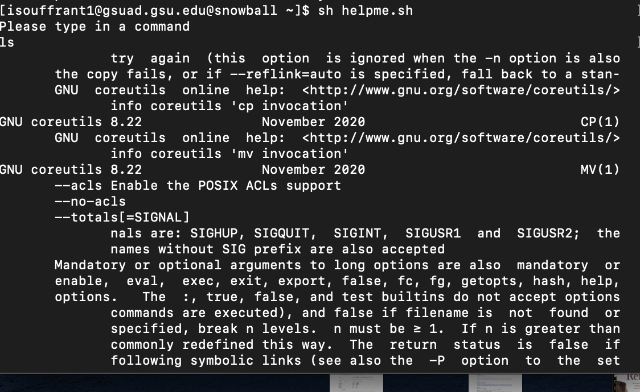



2.

* 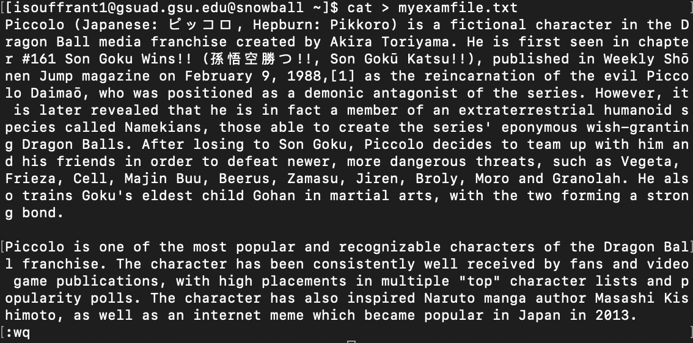
* 

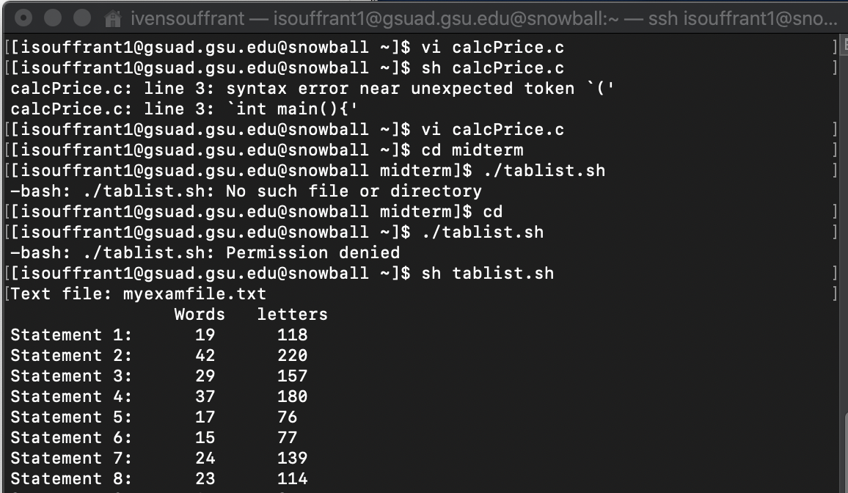

3.

* Create script shell file “vi calculator.sh”
* Enter code from “calculator_sh.doc” file
* Save and exit file by clicking the esc button and type in “:wq”
* Run code by typing in “sh calculator.sh” and type in the required input to get what you want

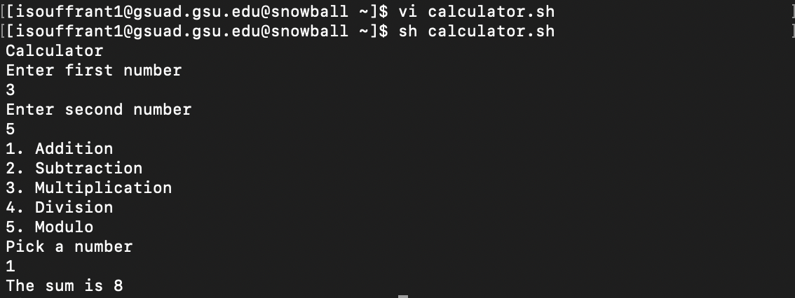

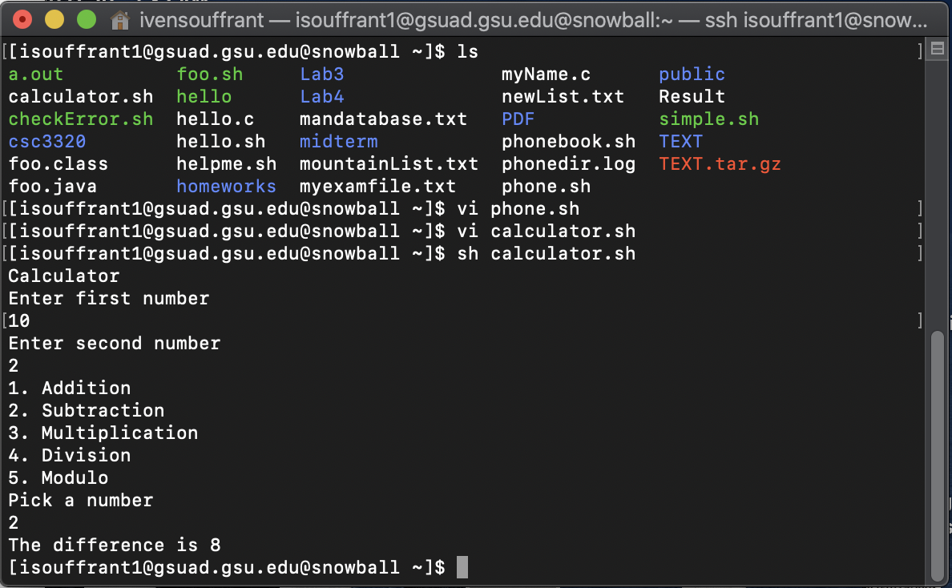

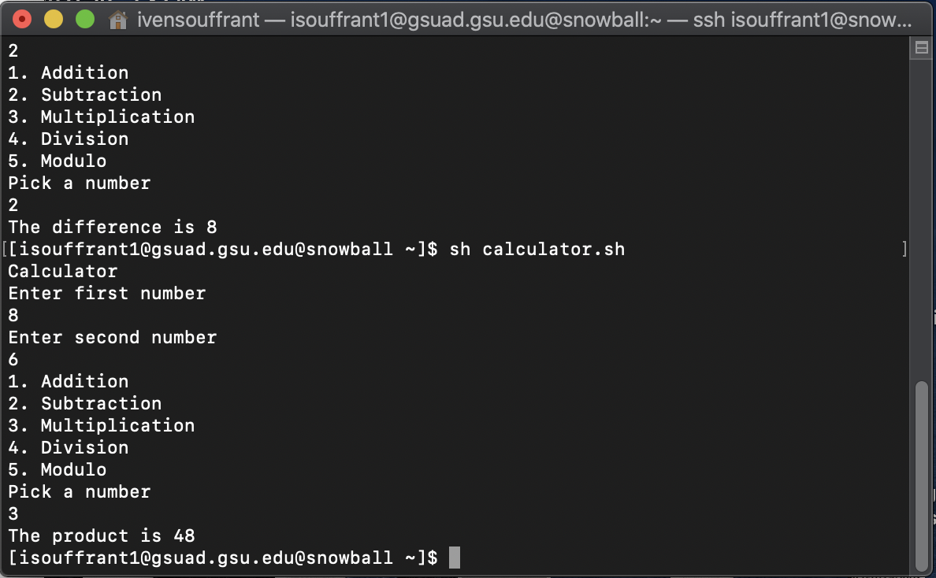

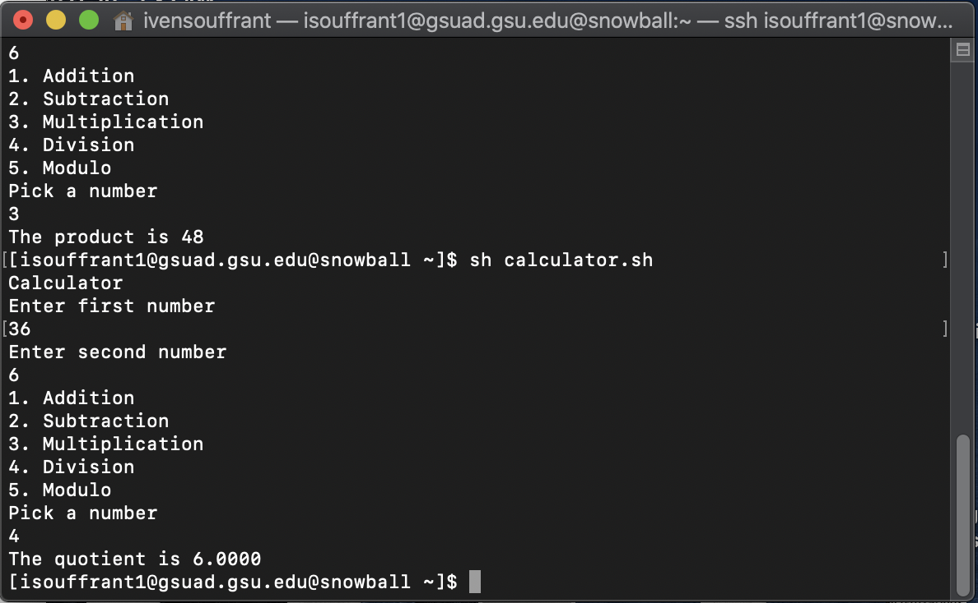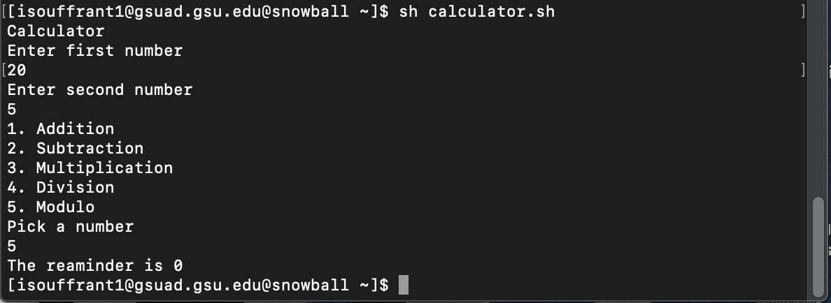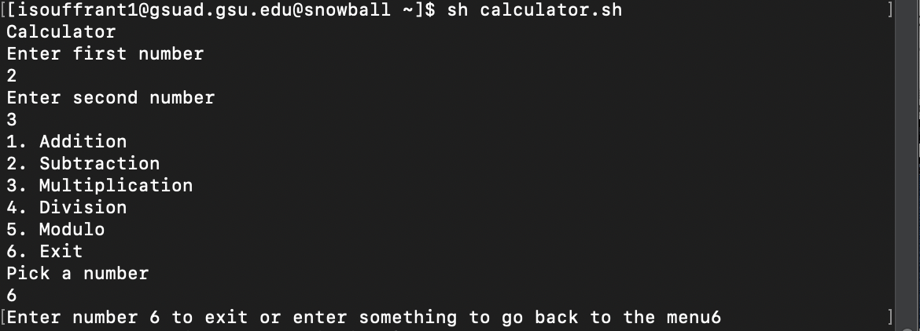

4.

* Type in sh phone.sh
* Choose a number from 1-5
* Depending on what number you have chosen you have to do specific actions

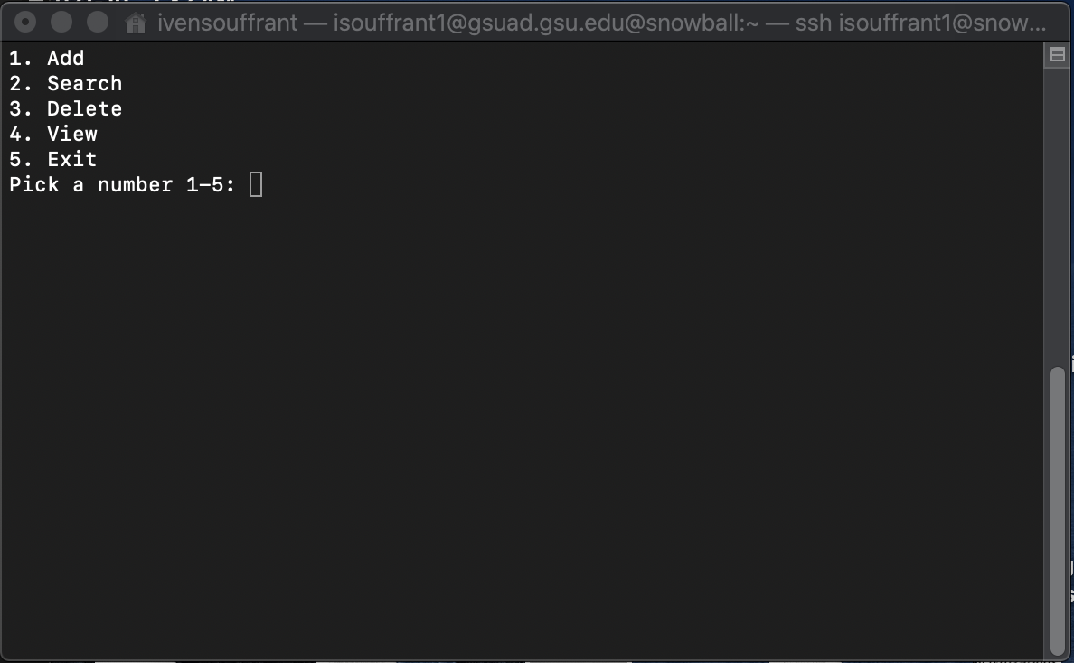

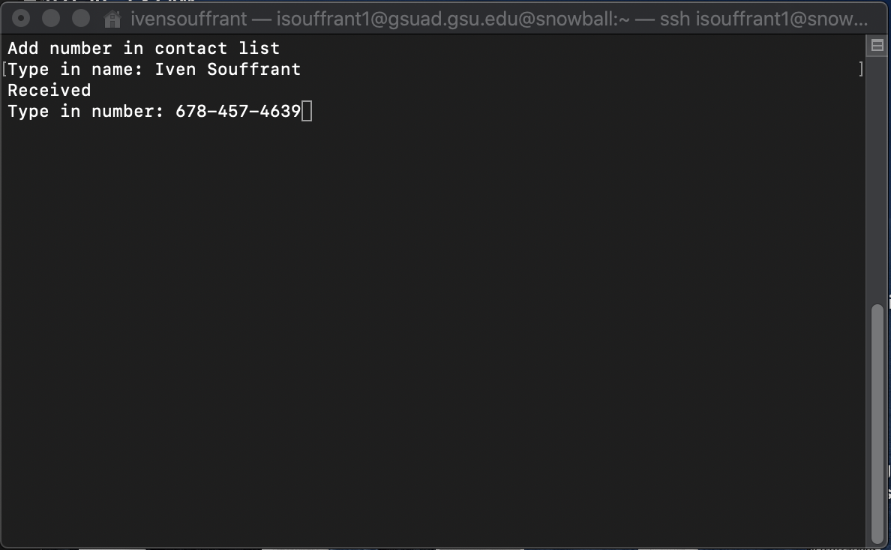

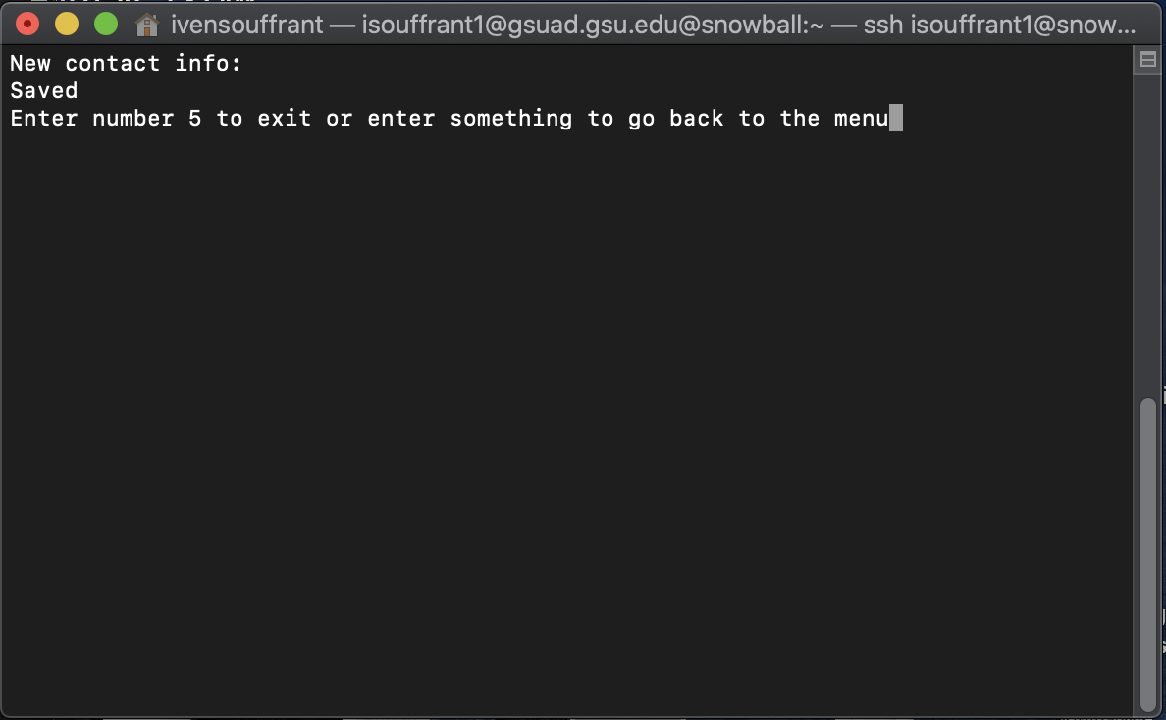

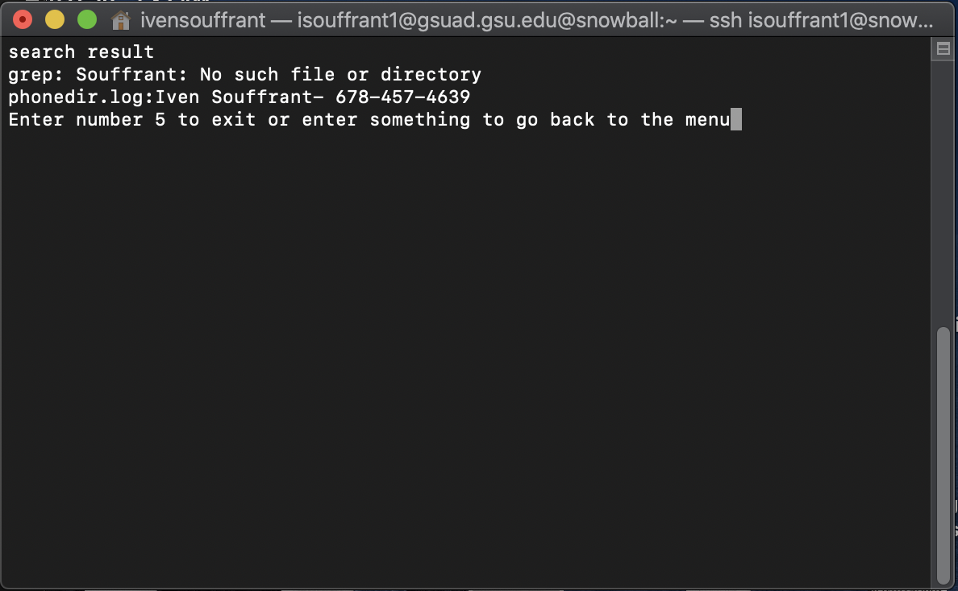

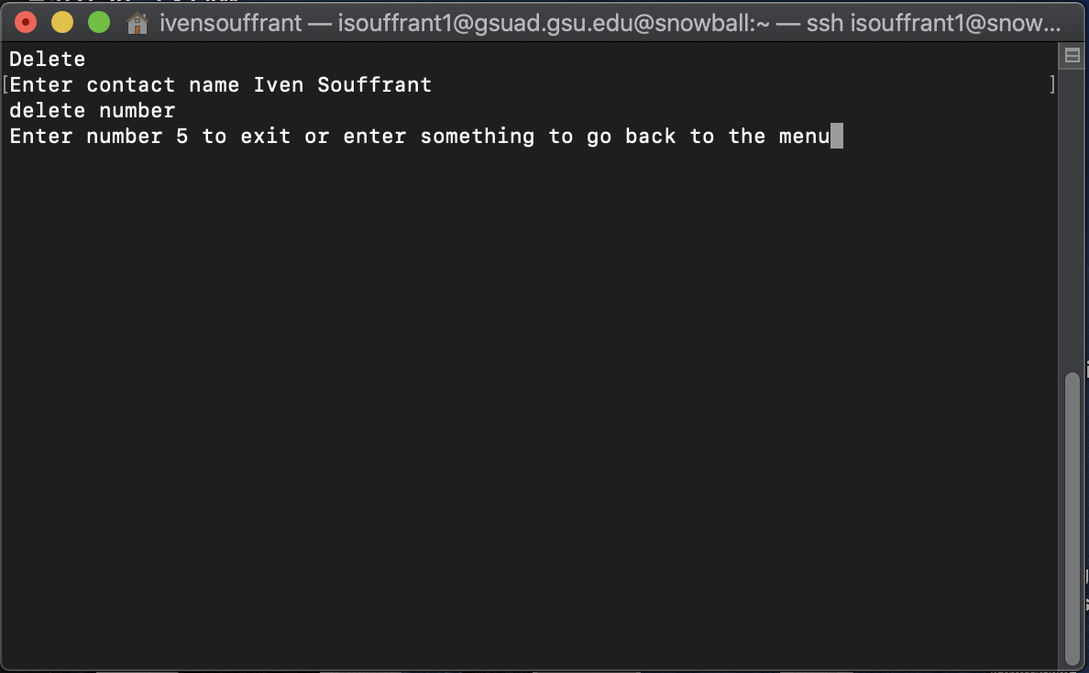

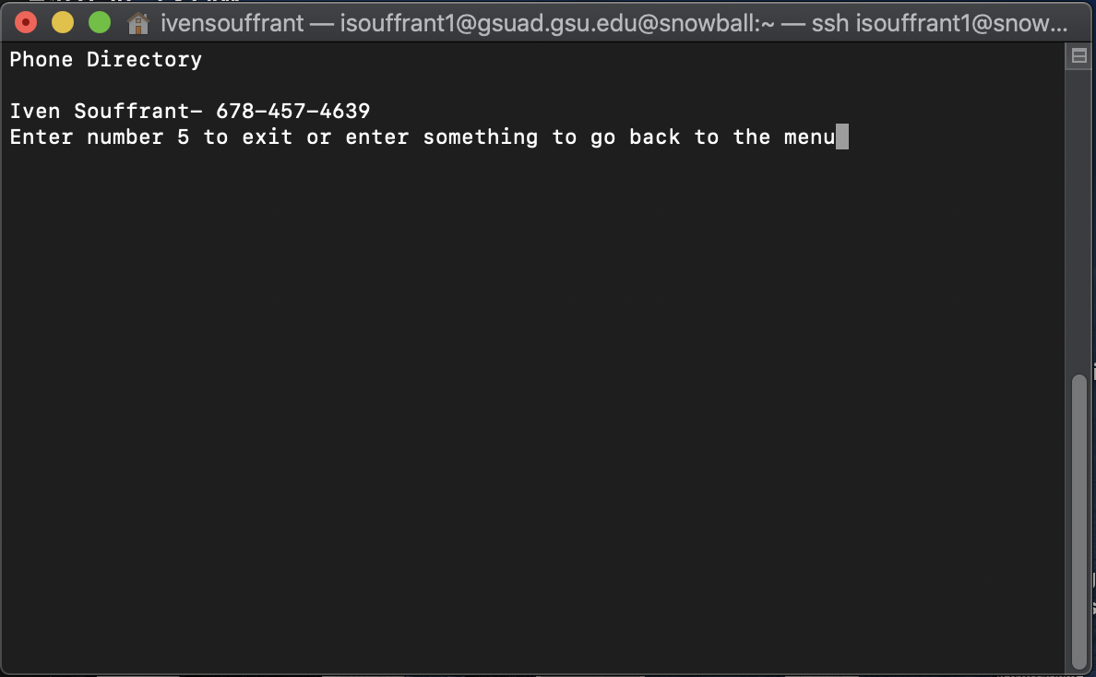

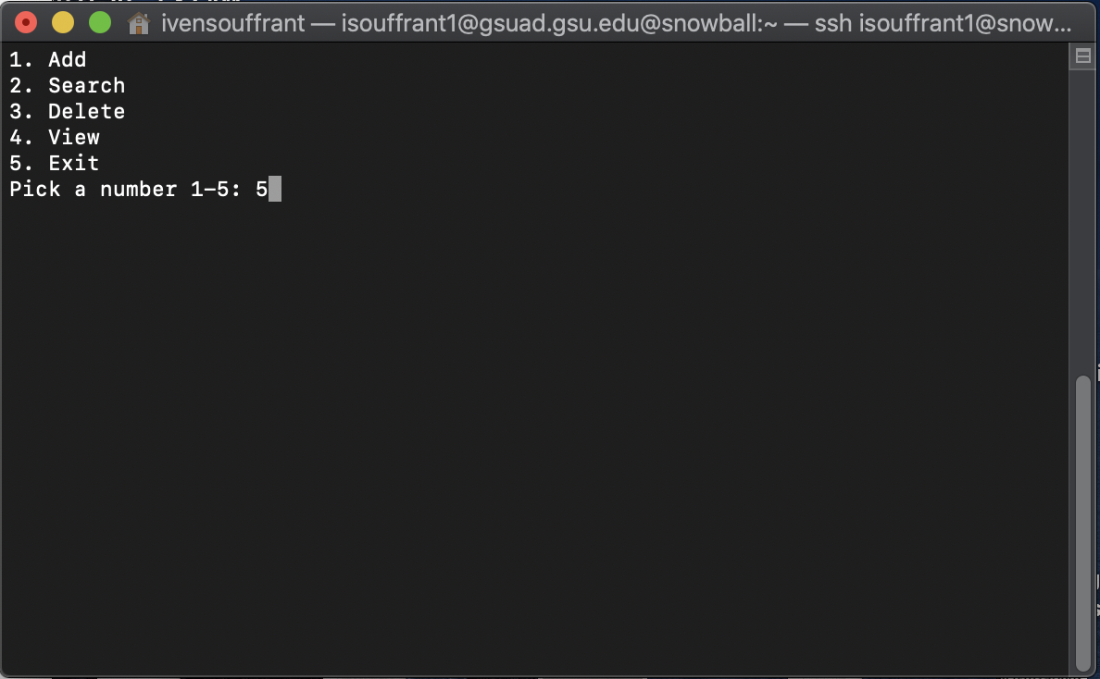

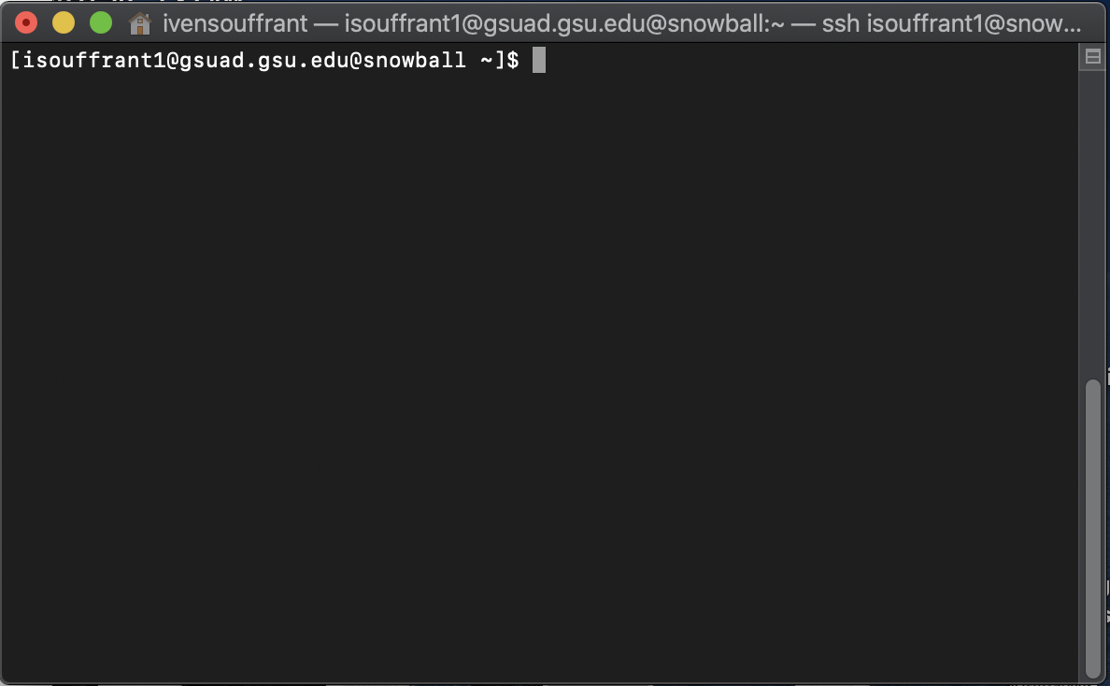

5.

1. A shell is a program whose primary purpose is to read commands and run other programs. Shell helps to interact with the system.
2. Yes you have to use the ssh to connect the snowball server while a PC does not need to do this step.

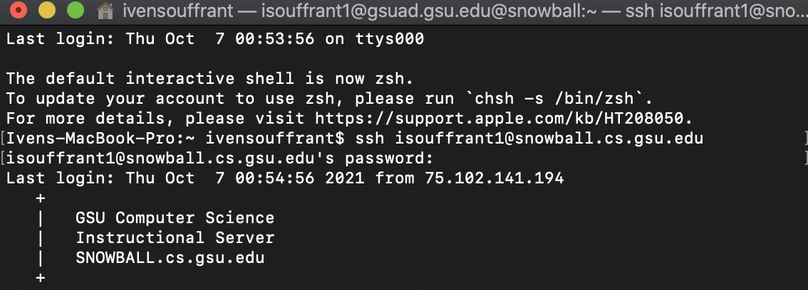

1. C programming language is a compiled language so it needs to be converted into machine code so it can be executed. The CPU translates code into machine code, instruction by instruction and executes each instruction before the interpreter moves on to translate the next instruction.
2. Both Printf and Echo are built-in commands. Echo simply dumps whatever they are passed to output and always exits with a 0 status. Printf takes it one step further and allows you to format the data before output and gives a non-zero exit status.
3. SSH: provides a secure encrypted connection between two hosts over an insecure network and example of me using this command is when I have to connect to my snowball login into the terminal

SCP: used to copy files between servers in a secure way. An example of me using this command is when I have to copy files that I made in my home directory into another directory.

WGET: helps us to download the files from the web but it is non-interactive. An example of me is when I had to download a file from a google drive in one of the labs we did.