2.

3.

4 a.

4 b.

4 c.

The -n option suppresses the default behavior of printing every line.

4 d.

sed replace 'ridge high point' with 'r.h.p.' and p flag prints all lines where replacement happened twice

6.

7.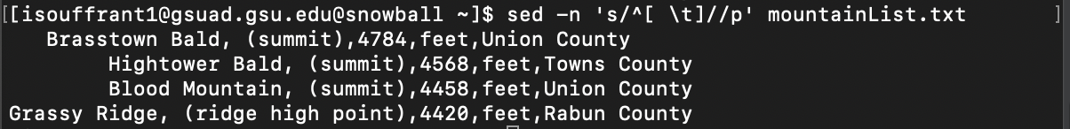

12.

14.

