Lab Section #205 |  | Name: Alexander Maguire
ID# 20396195 | Email address: amaguire@uwaterloo.ca |  | Date: 2011-01-26
Partner’s Name: Anushervon Saidmuradov | Partner’s ID# 20398978 |  | Station# 38

Executive Summary
The primary purpose of this lab is to get familiar with oscilloscopes and function generators. It also involved the importation of graphical displays from the oscilloscope into a computer. Multiple functions were generated, and run along small tests to see if actual results are to be expected, including running a function through a resistor and measuring the result.

Introduction to the Oscilloscope and Function Generator

Oscilloscope Basics

d) Using the grid
peak-to-peak voltage | 5V
Signal period | 820us

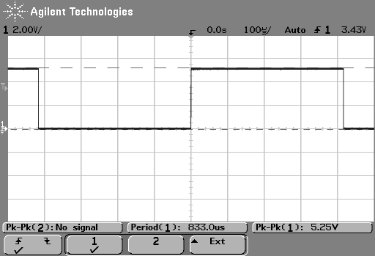
e) Using the cursors
peak-to-peak voltage | 5.125V
Signal period | 832us

f)
Min. voltage per division= 1.32V

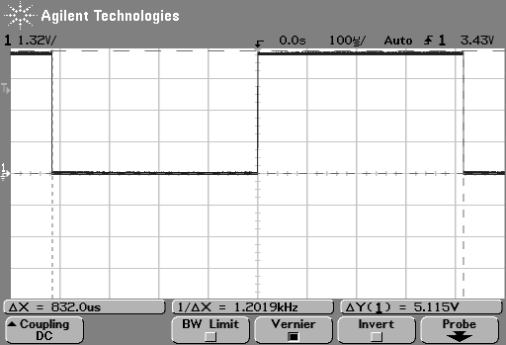
g)
Min. time per division= 86us

- The frequency of the probe is going to be 1/period = 1/820us = 1219Hz
- The frequency of the cursors is 1202Hz
The cursor is more precise than the grids.

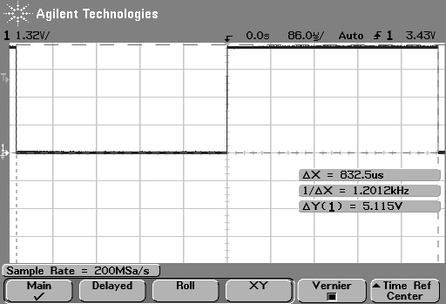Function Generator
For parts c) – f) fill the table below.

Output termination of the function generator |  | Displayed voltage on the screen of the function generator | Measured peak-to-peak voltage on the oscilloscope
50 Ohm | 50 ohm load connected | 8 Vp-p | 8.59Vp-p
 | 50 ohm load disconnected | 8Vp-p | 16.6Vp-p
Hi Z | 50 ohm load connected | 16Vp-p | 8.6Vp-p
 | 50 ohm load disconnected | 16Vp-p | 16.6Vp-p

g) 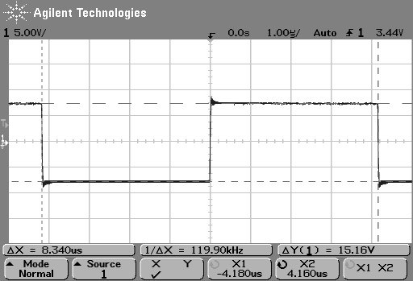

h) 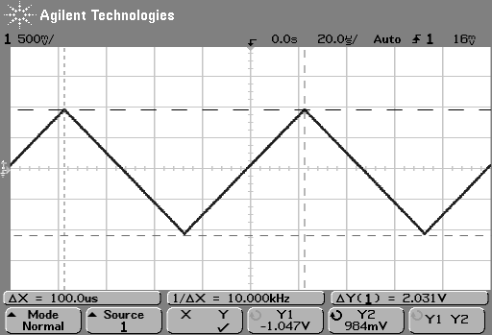
- 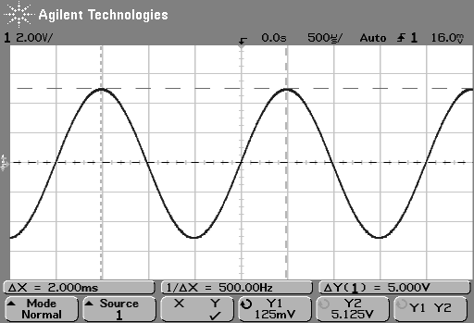

When 50Ohm setting is on, the voltage measured is the same as the voltage displayed when an equal load is connected. In Hi Z mode, the same is true only when the load is 0Ohms.

Oscilloscope Settings

Triggering

b) The phase shift seen on screen when the triggering is changed from rise edge to falling edge is 180 degrees.

c) At 2V, nothing happens. At 8V and -8V the function oscillates at a speed too fast to observe.

d) For auto triggering, we do not still see a signal on the oscilloscope screen.
For normal triggering, we do still see a signal on the oscilloscope screen.

e) Based in your observations, the function of roll is to show a real-time signal, as opposed to the regular “time locked” signal.

f) When the 1 softkey is selected the sine wave (channel 1) is triggered.
When the 2 softkey is selected the triangular wave (channel 2) is triggered.

- In part c, the tracer oscilates the function until it can intersect wit hit. Because the function is > 2V, at 2V, such an intersection can happen. At +-8V, this exceeds the amplitude of the signal, so it is oscillated (forever) trying to find an intersection.
- Based on my observations in part d), the difference between the “Auto” and “Normal” triggering modes seems to be that Auto automatically refreshes the signal, while normal holds it until it is refreshed.
- Based on my observations in part f), two waveforms can not be simultaneously triggered.

    - Channel Coupling
d) 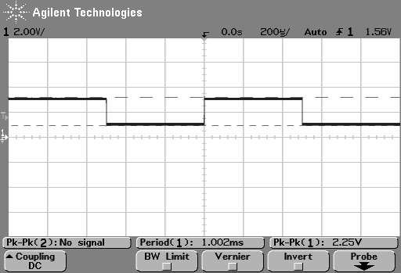

e) 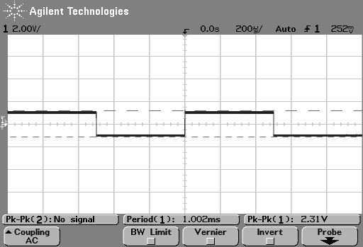

- When the oscilloscope is coupled with DC, all signal is shown. When coupled with AC, only the AC portion of a signal is shown.

    - X-Y Mode
b) 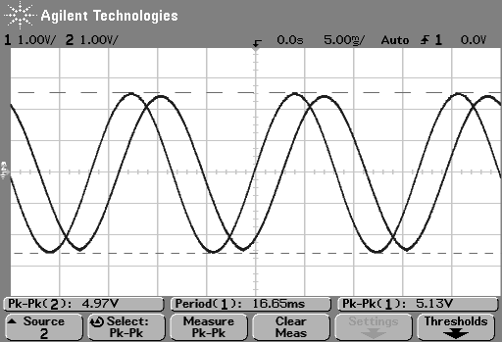
d) 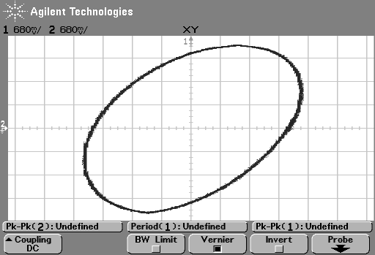

    - Measuring OFF-Ground Voltages
c) Measurements using the oscilloscope
Voltage of the signal displayed on CH1 | 10.25V
Voltage of the signal displayed on CH2 | 9.19V

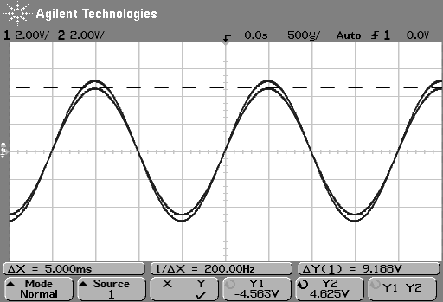
d) Measurements using DMM1
Voltage across R1 | 0.324V
Voltage across R2 | 3.197V
Voltage across R1+R2 | 3.521V

e) Voltage of the signal displayed on the oscilloscope= 1.000V

- The measurements made in d) are not what I expected. The voltage across R1 should be 5V*1kOhm/10kOhm = 0.5V. The actual measured voltage was 0.324V. The same goes for R2, but adding the two together has the expected result.
- It's not possible to directly measure the voltage across R1 with the oscilloscope because the oscilloscope has channel 1 on one end of the resistor, but the ground on a node not being the same as the other end of the resistor. You could measure R1's voltage by subtracting channel 1 from channel 2.

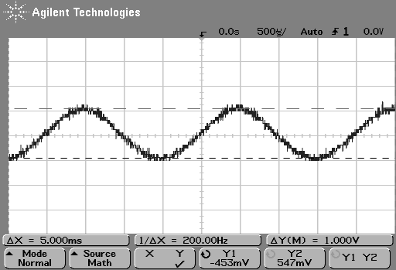

Recommendations
The primary recommendation of this lab is to be familiar with your equipment before starting. My partner and I spent a lot of overhead working against the machinery trying to set specific functions. We encountered some problems in our measuring of voltage in the circuit, all values were about 20% off. We have deduced this is related to either the oscilloscope being connected, or the measurement with the oscillloscope itself.

