1 a) -1, 0, 0, 0, 1, 0, 0, 0, 1, 0, 1, 0, 0, 1, 2, 3, 0, 0, 1
1 b) -1, 0, 0, 1, 0, 1, 0, 1, 2, 3, 4, 5, 6, 7, 8, 9, 10, 11
1 c) -1, 0, 0, 1, 0, 1, 0, 1, 2, 3, 4, 5, 6, 0, 1, 2, 3, 4
1 d) -1, 0, 0, 1, 0, 1, 0, 1, 2, 3, 4, 5, 6, 0, 1, 2, 3, 4

5 a) If a character set is uniformly frequent and its size is a power of 2, Huffman encoding can make no improvements on its representation. Since all characters are equally frequent, compressing some into fewer bits will make more characters take more bits, and thus will have a negative benefit if any.
5 b a)
1 k
1 m
1 p
1 y
2 \n
2 n
2 o
2 r
2 v
3 h
3 i
3 s
4 l
4 t
5 a
8 e
11 _

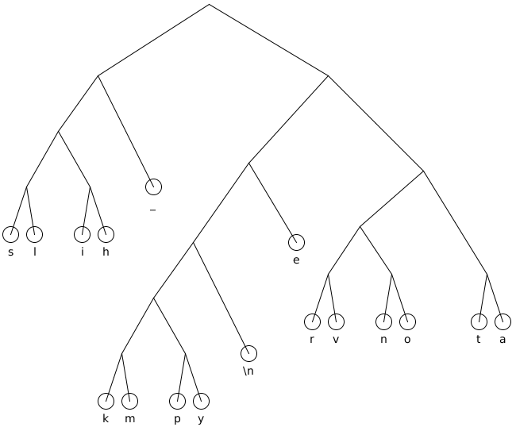
5 b b)

5 b c) 0010 01 1110 0011 0010 11010 100000 01 1110 0011 1111 1110 01 0010 01 0000 0011 1111 0001 0001 01 11010 101 1011001 101 11000 01 0000 101 101 1001 1111 01 100010 11011 101 100001 01 0001 11011 1011001 101 0001 100011 01 1111 0000 01 1111 01 1110 11000 101 101 1001

5 b d) 210bits / 280bits = 75%

