Alexander Maguire
20396195

1)
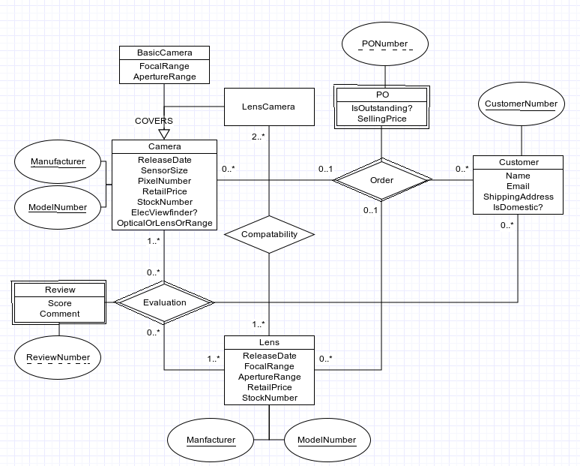
2) CREATE TABLE Cameras (
/* added cameraID to simplify primary key */
cameraID INTEGER NOT NULL,
manufacturer VARCHAR(64) NOT NULL,
model VARCHAR(32) NOT NULL,
releaseDate DATE NOT NULL,
sensorSize INTEGER NOT NULL,
retailPrice INTEGER NOT NULL,
stockNumber INTEGER NOT NULL,
hasElecViewfinder BOOLEAN NOT NULL,
opticalOrlensOrRange ENUM('OPTICAL', 'LENS', 'RANGEFINDER') NOT NULL,
PRIMARY KEY (cameraID));

CREATE TABLE BasicCameras (
cameraID INTEGER NOT NULL,
focalRange INTEGER NOT NULL,
apertureRange INTEGER NOT NULL,
PRIMARY KEY (cameraID),
FOREIGN KEY (cameraID) REFERENCES Cameras (cameraID));

CREATE TABLE compatability (
/* added compatabilityID to simplify primary key */
compatabilityID INTEGER NOT NULL,
camera INTEGER NOT NULL,
lens INTEGER NOT NULL,
PRIMARY KEY (compatabilityID),
FOREIGN KEY (camera) REFERENCES Cameras (cameraID),
FOREIGN KEY (lens) REFERENCES Lenses (lensID));

CREATE TABLE Lenses (
/* added lensID to simplify primary key */
lensID INTEGER NOT NULL
manufacturer VARCHAR(64) NOT NULL,
model VARCHAR(32) NOT NULL,
releaseDate DATE NOT NULL,
focalRange INTEGER NOT NULL,
apertureRange INTEGER NOT NULL
retailPrice INTEGER NOT NULL,
stockNumber INTEGER NOT NULL,
PRIMARY KEY (lensID));

CREATE TABLE Customers (
customerNumber INTEGER NOT NULL,
name VARCHAR(128) NOT NULL,
email VARCHAR(128) NOT NULL,
shippingAddress VARCHAR(128) NOT NULL,
isDomestic BOOLEAN NOT NULL,
PRIMARY KEY (customerNumber));

CREATE TABLE Orders (
PONumber INTEGER NOT NULL,
isOutstanding BOOLEAN NOT NULL,
sellingPrice INTEGER NOT NULL,
/* constraint: order being one camera or lens is not satisfied */
camera INTEGER,
lens INTEGER,
PRIMARY KEY (PONumber),
FOREIGN KEY (camera) REFERENCES Cameras (cameraID),
FOREIGN KEY (lens) REFERENCES Lenses (lensID));

CREATE TABLE Evaluations (
reviewNumber INTEGER NOT NULL,
customer INTEGER,
lens INTEGER,
/* constraint: review being one camera or lens is not satisfied */
camera INTEGER NOT NULL,
score INTEGER NOT NULL,
comment VARCHAR(MAX) NOT NULL,
PRIMARY KEY (reviewNumber),
FOREIGN KEY (camera) REFERENCES Cameras (cameraID),
FOREIGN KEY (lens) REFERENCES Lenses (lensID));

