Quake Runner

**Purpose:** A python script for configuring the command-line options to run Quake on Mac or Windows.

**Test Machines:**

* MacBook Air with M2 chip & Sonoma 14.6.1
* HP Envy Laptop & Windows 11 Home 23H2

**Preface:** The inspiration for this script stemmed from the launch commands needed in such applications as necros compiling GUI and Trenchbroom. Both programs are used extensively in creating custom maps and games for the original id Software Quake game, among others. To add to the inspiration was my insatiable appetite for those very same mods, downloading and trying hundreds of fan created maps/mods. While it is a simple matter to create shortcuts on Windows, the MacOS is more difficult. And even then ending up with a ton of different shortcuts wasn’t practical for either OS. This script provides a GUI to select games, maps and add command-line options without much typing or a folder full of shortcuts.

*Mac Screenshot*

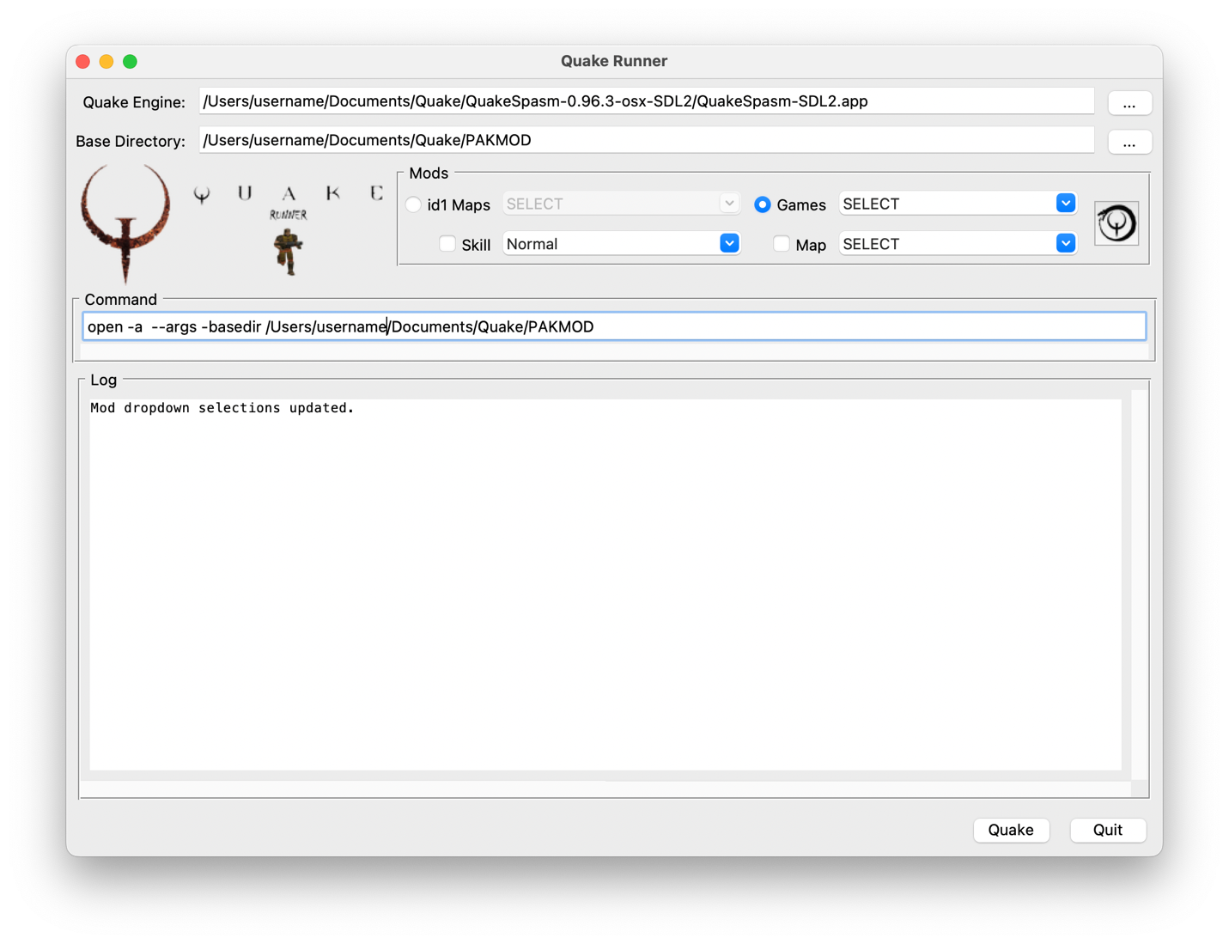

# Features & UI Description

* **Quake Engine:** Select the path to the Quake engine *.exe (Windows) or *.app (Mac). The button to the right of the text box with the three dots "..." will open the file dialog. The text box is editable, but has not affect at this time. The file dialog must be used to affect changes in the program.
* **Base Directory:** Select the path to the folder with id1 game data. The button to the right of the text box with the three dots "..." will open the folder dialog. For MacOS it is recommended that the Quake Engine folder not be used as the Base Directory due to issues with QuakeSpasm and how the MacOS operates.

*Note: An explanation is provided starting in "Basic Directory Structure (Mac or Windows)" to include running mod games and *.bsp maps.*

## Mods Section

* **id1 Maps:** A dropdown list that contains user created maps from the "maps" folder of the id1 directory.

*Note: For Mac users, as mentioned above, I have found an issue with using the Quake Engine folder as the Base Directory for the id1 folder. This is normally the default configuration for Quake, but Quake was not originally written for Mac. QuakeSpasm will launch correctly with the base game but an error occurs when attempting to locate customer maps in the “maps” folder of the id1 directory. This feature runs fine if another folder is used independent of the Quake Engine folder as will be explained later in this documentation.*

* **Games:** A drop-down list that contains the game folders in the Base Directory. The script will test each mod folder and include only those folders with "pak" or "progs" files.
* **Maps:** A drop-down list that contains the maps found in the selected game folder. The script will test and load only the files with the "bsp" extension.
* **Skill:** A drop-down list of skill levels that can be set prior to entering a map or game. The user should note that not all maps or games allow for a skill level to be set. Consult the map or game text file for clarification or set the skill then check via the Quake console by pressing “~” and then typing “skill”. Quake should respond with the current setting.
* Refresh Button: The image on the button is of an Ouroboros (snake eating its own tail) surrounding the Quake symbol. Clicking the button will refresh the id1 Maps; Games; & Maps drop-downs.

*Note: I'll often times download mods from Quaddicted then add them to my folder to try them out. The refresh button will add the new maps and mods to the list without having to restart Quake Runner.*

* **Command:** The text box just above the "Log" section. This is the assembled command based on the options selected. The text is editable so additional command line options can be entered manually such as adding mods like -quoth or -copper or combinations like -hypnotic -quoth. The user should consult the text instructions provided with the map or mod. This is a nice feature because Quake Runner will execute the command independently of the selected options. This can also be a problem with any errors that may be introduced from manually typing in the command.
* **Log** (window)**:** Provides the status of Quake Runner as options or selections change. It will also display the log output from Quake on Windows OS. A neat feature, to see what Quake was doing while the game was in session. The log contains system information as well, captured by the Quake engine like graphics and memory usage.
* **Settings** (menu option): In the main menu under "Settings" is "Save". This saves the user selections then reloads them when Quake Runner is launched.
* **Quake & Quit** (buttons)**:** Quake runs the command. The user should see the familiar Quake demo on Windows while Mac users will get the system generated start dialog.

The rest of this document explains two options for a directory structure to run Quake on Mac or Windows. As well as the command-line structure plus options.

Quake Runner has been tested with QuakeSpasm, QuakeSpasm-Spiked, vkQuake, vkQuake-RT & IronWail on Windows. For Mac, QuakeSpasm is the only modern port I've found with support for the MacOS.

## Basic Directory Structure (Mac or Windows)

Quake

|_quake_engine_port

|_quake_engine.exe or quake_engine.app

|_<other files>

|_<...>

|_<...>

|_<etc.>

|

|_id1

|_maps

|

|_pak0.pak

|_pak1.pak (Note: the Quake remastered pak0 file does not have a pak1.pak)

To run Quake the user would double click the *.exe or *.app file from the Quake engine port folder. Quake, on Windows, will detect the id1 folder and start normally. Similarly, any mod folders added to the Quake engine port folder can also be launched either via command-line, Quake console or through menu options, if your port is so equipped. IronWail is a port that does a fantastic job of this through its Quake UI.

***Note:*** *On Mac, a dialog window will appear after launching the *.app to enter in the location of the id1 data file. Below is the command-line option example for Quake to run on a Mac.*

## Mac Dialog Window Command Line Option:

*-basedir /Quake/quake_engine_port_folder*

## Directory Structure Example with Mods

Quake

|_quake_engine_port

|_quake_engine.exe or quake_engine.app

|_<other files>

|_<...>

|_<...>

|_<etc.>

|

|_id1

| |_maps

| | |_quake_map(s).bsp

| |

| |_pak0.pak

| |_pak1.pak (Note: the remastered pak0 file does not have a pak1.pak)

|

|_quake_game

|_maps

| |_quake_map(s).bsp

|

|_pak0.pak or progs.dat

As mentioned previously, mods and individual maps can be run using the Quake console or menu selections if the port has that option. As an alternative, a direct launch of the mod through the command-line would be structured as follows and is what Quake Runner does through the selected options.

## Windows Shortcut or Batch File Example

*C:\Quake\quake_engine_port\quake_engine.exe -game quake_game*

or

*C:\Quake\quake_engine_port\quake_engine.exe +map quake_map.bsp*

## Command variation that includes setting the skill level.

*C:\Quake\quake_engine_port\quake_engine.exe +skill # +map quake_map.bsp*

*# = 0-3 (Easy, Normal, Hard, Nightmare)*

Mac Dialog Window Command Line Options

*-basedir /Quake/base_birectory -game quake_game*

or

*-basedir /Quake/base_diretory +map quake_map.bsp*

## Map variation that includes setting the skill level.

*-basedir /Quake/base_directory +skill # +map quake_map.bsp*

*# = 0-3 (Easy, Normal, Hard, Nightmare)*

*Note: Python for Mac comes with a python launcher that can be associated with python scripts. I have read claims of changing the file extension to "pyw" with the appropriate settings in the launcher will prevent a terminal window from opening alongside the script. I have never been able to get that to work. The solution is to create an Automator app. The Python script will run as if it were its own executable and without the terminal window. And like a Windows shortcut, the icon can be changed to match your app. I'll include some instructions at the end for Quake Runner.*

# Two Folder Directory Structure

I found that as my appetite for mods grew, my folder started getting messy. Luckily, the current set of popular engine ports have command line options that facilitate organization of content into a different folder through the command-line option "-basedir". This allows you to have a folder for your engine(s) and a separate folder for game data. In the example below the game content folder is named "pakmod". That's the actual name I used on my machine but any name will do, just no spaces.

Quake

|_quake_engine_port

| |_quake_engine.exe or quake_engine.app

| |_<other files>

| |_<...>

| |_<...>

| |_<etc.>

|

|_pakmod

|_id1

| |_maps

| | |_quake_map(s).bsp

| |

| |_pak0.pak

| |_pak1.pak (Note: the remastered pak0 file does not have a pak1.pak)

|

|_quake_game

|_maps

| |_quake_map(s).bsp

|

|_pak0.pak or progs.dat

## Advanced Command-line Formats

The following command structure models use the directory example above. Of course, there are user names and other folders that will need to be included depending on where the Quake folder is placed.

*Note: Quake is funny about names with spaces; use an underscore if you want to separate words.*

## Command structure for launching the base Quake game.

* **Windows:** *C:\Quake\quake_engine_port\quake_engine.exe -basedir C:\Quake\pakmod*
* **Mac:** *open -a /Quake/quake_engine_port/quake_engine.app --args -basedir /Quake/pakmod*

As previously mentioned, for Mac, a separate dialog window will appear for arguments. Through Quake Runner the arguments, specified by "--args" will be passed to the dialog window and you just have to hit the "start" button.

## Running Quake with mods.

**Game Mods**

* **Windows:** *C:\Quake\quake_engine_port\quake_engine.exe -basedir C:\Quake\pakmod -game quake_game*
* **Mac:** *open -a /Quake/quake_engine_port/quake_engine.app --args -basedir /Quake/pakmod -game quake_game*

**Map Mods**

* **Windows:** *C:\Quake\quake_engine_port\quake_engine.exe -basedir C:\Quake\pakmod +map quake_map.bsp*
* **Mac:** *open -a /Quake/quake_engine_port/quake_engine.app --args -basedir /Quake/pakmod +map quake_map.bsp*

**Map Mods + Skill Variation**

* **Windows:** *C:\Quake\quake_engine_port\quake_engine.exe -basedir C:\Quake\pakmod +skill # +map quake_map.bsp*
* **Mac:** *open -a /Quake/quake_engine_port/quake_engine.app --args -basedir /Quake/pakmod +skill # +map quake_map.bsp*

*# = 0-3 (Easy, Normal, Hard, Nightmare)*

**Mod & Game Variation**

* **Windows:** *C:\Quake\quake_engine_port\quake_engine.exe -basedir C:\Quake\pakmod -hypnotic -quoth -game quake_game_folder*
* **Mac:** *open -a /Quake/quake_engine_port/quake_engine.app --args -basedir /Quake/pakmod -hypnotic -quoth -game quake_game_folder*

**Mod & Map Variation**

* **Windows:** *C:\Quake\quake_engine_port\quake_engine.exe -basedir C:\Quake\pakmod -game copper +map quake_map.bsp*
* **Mac:** *open -a /Quake/quake_engine_port/quake_engine.app --args -basedir /Quake/pakmod -game copper +map quake_map.bsp*

The last example "Mod & Map" is of a map that uses the copper mod but does not supply copper as part of the zip file download. In this example the “Maps” folder is in the folder of the mod game, similar to how there is a “maps” folder inside the id1 folder.

Quake Runner assembles the command-line structure based on the input then launches Quake. To reiterate, the Launch Command field in Quake Runner is editable so the user can enter any additional commands that are needed and Quake Runner will include them in the command structure it passes to the system.

## Mac Automator

There is a funny little app in the Mac Applications folder called "Automator". To create an automator app for Quake Runner follow these instructions.

1. Click on Automator
2. Select "New Document"
3. Select "Application" & click "Choose" in the lower right.
4. Type "shell" in the search box at the top.
5. Double Click "Run Shell Script". At the top will be the default shell zsh.
6. Delete any commands in the box (my command box has the word "cat" in it).
7. Add the following command: cd /path_to_QuakeRunner

cd = change directory. If there are spaces in any of the names in the path, quotes will be needed on each end. The quotes can be omitted if there is not.

1. Second line: /path_to_python_executable Main.pyw

Example: /usr/local/bin/python3.12 Main.pyw

1. Click the play button in the upper right and Quake Runner should appear on your screen.
2. The next time you want to run Quake Runner just double click the app.

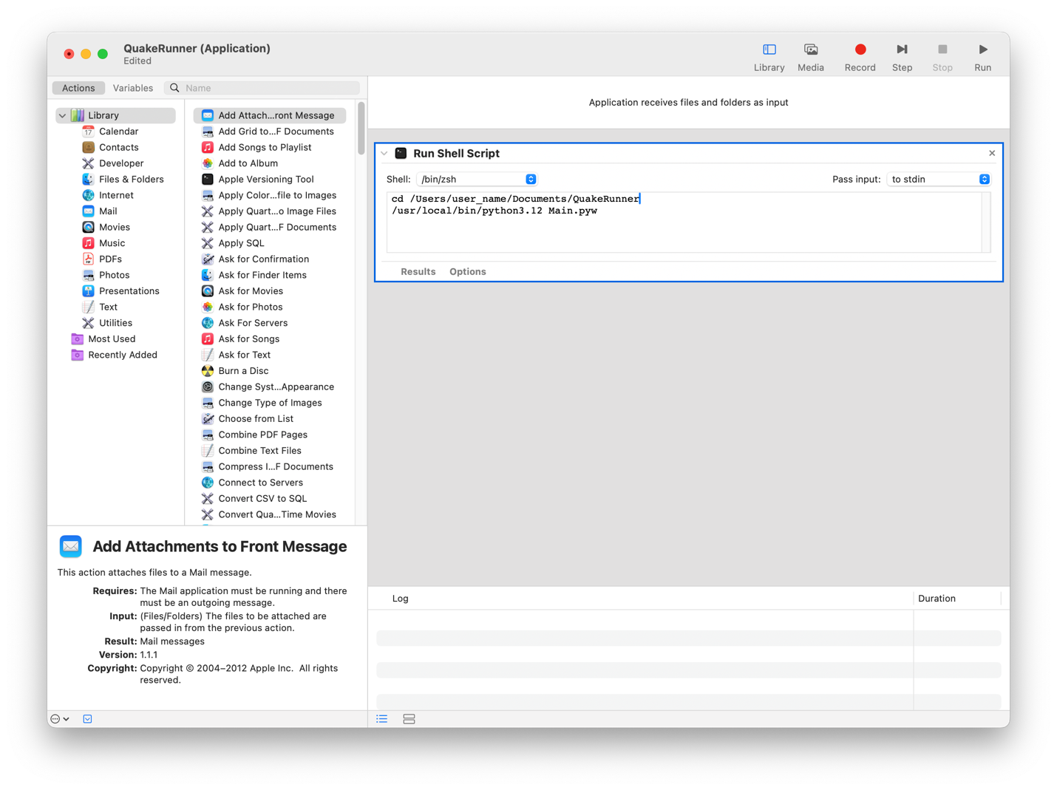

Have fun playing Quake!