## Exercise 1: Use Case Diagram

### 1. **Necessary Elements for the Online Event Ticketing System**

#### **Actors:**

* **Customer:** Browses events, purchases tickets, and checks in at events.
* **Event Organizer:** Creates and manages events, provides event details.
* **System Administrator:** Manages the system's backend operations.
* **Payment Gateway:** Processes payments securely.
* **Check-in Staff:** Scans QR codes at the venue for validation.

#### **Classes:**

1. **Event:**
   * Attributes: Event ID, Name, Description, Date, Time, Venue, Ticket Price, Available Seats.
   * Methods: CreateEvent(), UpdateEvent(), ViewDetails().
2. **Customer:**
   * Attributes: Customer ID, Name, Email, Phone Number.
   * Methods: Register(), Login(), BrowseEvents(), PurchaseTicket(), ViewTickets().
3. **Ticket:**
   * Attributes: Ticket ID, Event ID, Customer ID, QR Code, Status (valid/invalid).
   * Methods: GenerateQRCode(), ValidateTicket().
4. **Payment:**
   * Attributes: Payment ID, Amount, Payment Status, Transaction Details.
   * Methods: ProcessPayment(), RefundPayment().
5. **CheckIn:**
   * Attributes: CheckIn ID, Event ID, Ticket ID, Timestamp.
   * Methods: ScanQRCode(), ValidateEntry().
6. **System:**
   * Attributes: System ID, Name, Version.
   * Methods: SendEmail(), GenerateReports().

#### **States:**

* **Customer States:**
  + Browsing Events
  + Purchasing Tickets
  + Viewing Tickets
  + Checking In
* **Ticket States:**
  + Not Purchased
  + Purchased
  + Canceled
  + Checked In

#### **Activities:**

1. **Browse Events:**
   * Customer searches for events by date, location, or category.
   * Event details are displayed.
2. **Purchase Tickets:**
   * Customer selects an event and ticket type.
   * Makes a payment through the gateway.
   * Receives an electronic ticket with a QR code.
3. **Check-in at Event:**
   * Customer presents QR code.
   * Check-in staff scans QR code for validation.
4. **Create and Manage Events:**
   * Event organizers add, edit, or delete event details.
5. **Process Payment:**
   * Secure payment through the gateway.
   * Refunds if cancellation occurs.

#### **System Activities:**

* **Generate QR Code:** System generates QR codes for tickets.
* **Send Notifications:** System sends email confirmations and reminders.
* **Validate Tickets:** System verifies ticket authenticity during check-in.

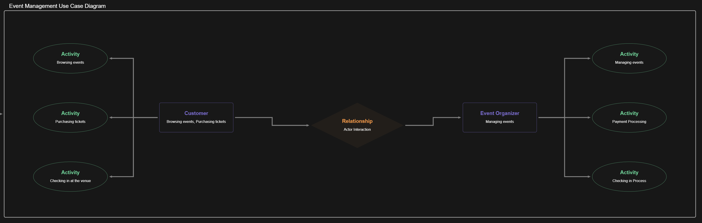

Figure 1 Use Case Diagram

## Exercise 2: Class Diagram

• **Main Classes:**

* **Event:** EventID, Name, Description, Date, Time, Venue, TicketPrice, AvailableSeats.
* **Customer:** CustomerID, Name, Email, PhoneNumber.
* **Ticket:** TicketID, EventID, CustomerID, QRCode, Status.
* **Payment:** PaymentID, Amount, PaymentStatus, TransactionDetails.
* **QRCodeGenerator:** QRCodeData, GenerateQRCode().
* **System:** Name, Version, SendNotifications().

• **Relationships:**

* **Customer** associates with **Ticket** (1-to-many).
* **Event** aggregates **Ticket** (1-to-many).
* **Ticket** uses **QRCodeGenerator**.
* **Payment** is associated with **Customer** and **Ticket**.

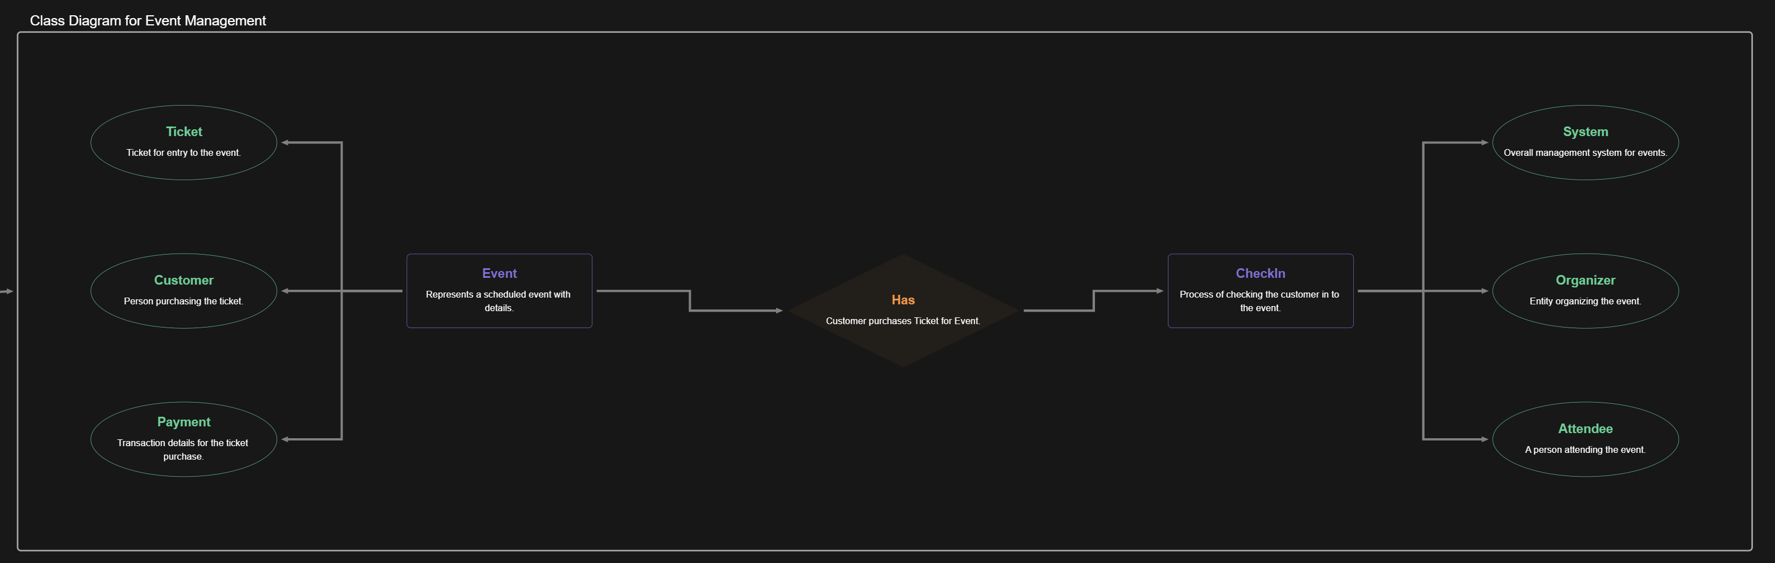

Figure 2 Class Diagram

## Exercise 3: Sequence Diagram

• **Selected Use Case:** “Purchase Ticket.”

• **Participating Objects:**

* Customer
* Event
* Ticket
* PaymentService
* QRCodeGenerator
* System

• **Interactions:**

* Customer browses events.
* Customer selects an event and initiates ticket purchase.
* System interacts with PaymentService to process the payment.
* System generates a QR Code via QRCodeGenerator.
* Ticket is created and linked to the customer and event.
* Confirmation is sent to the customer.

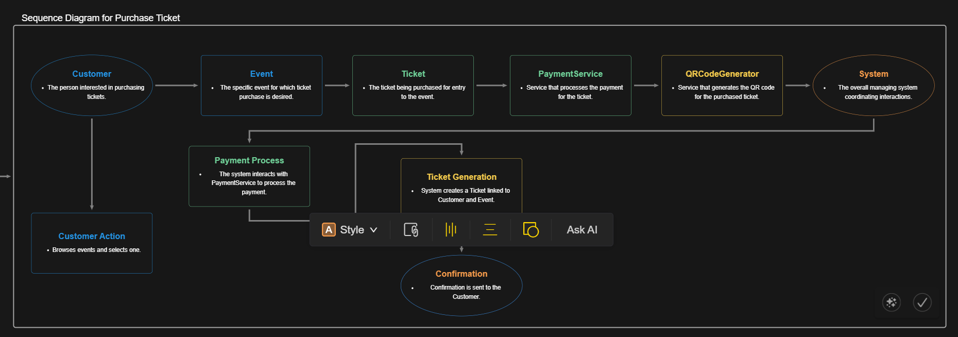

Figure 3 Sequence Diagram

## Exercise 4: State Machine Diagram

1. **Entity:** Ticket.
2. **States:**
   * Available
   * Reserved
   * Purchased
   * CheckedIn
   * Invalid
3. **Transitions:**
   * Reserved -> Purchased (on payment confirmation).
   * Purchased -> CheckedIn (on QR Code scan at the venue).
   * Any state -> Invalid (on cancellation or failure).

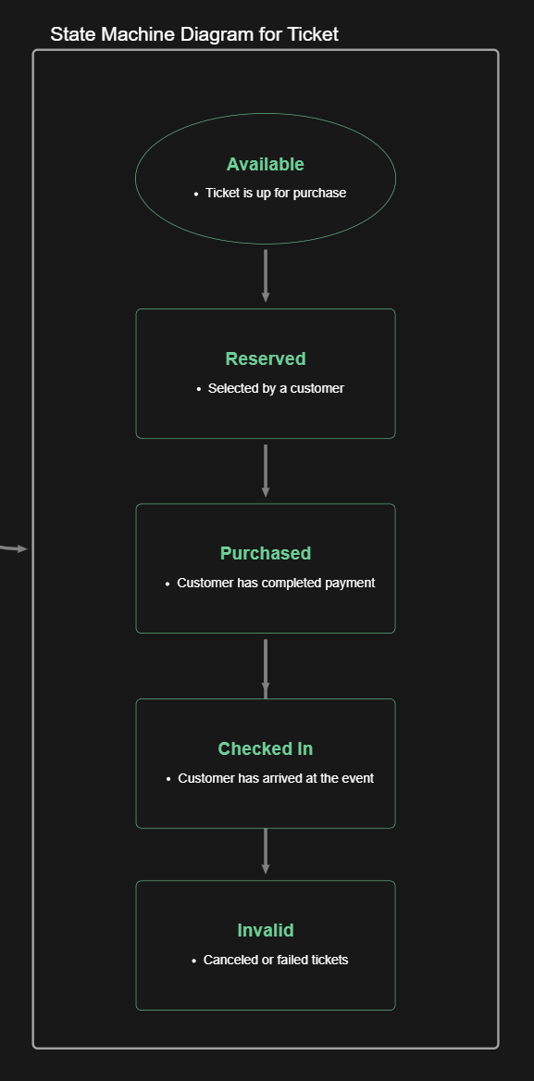

Figure 4 State Machine Diagram

## Exercise 5: Activity Diagram

1. **Process:** Ticket purchasing and event check-in.
2. **Activities:**
   * Customer selects an event.
   * System processes the payment.
   * System generates a QR Code for the ticket.
   * QR Code is sent to the customer.
   * Customer presents QR Code at the venue.
   * System validates the QR Code.
   * Customer is checked in.

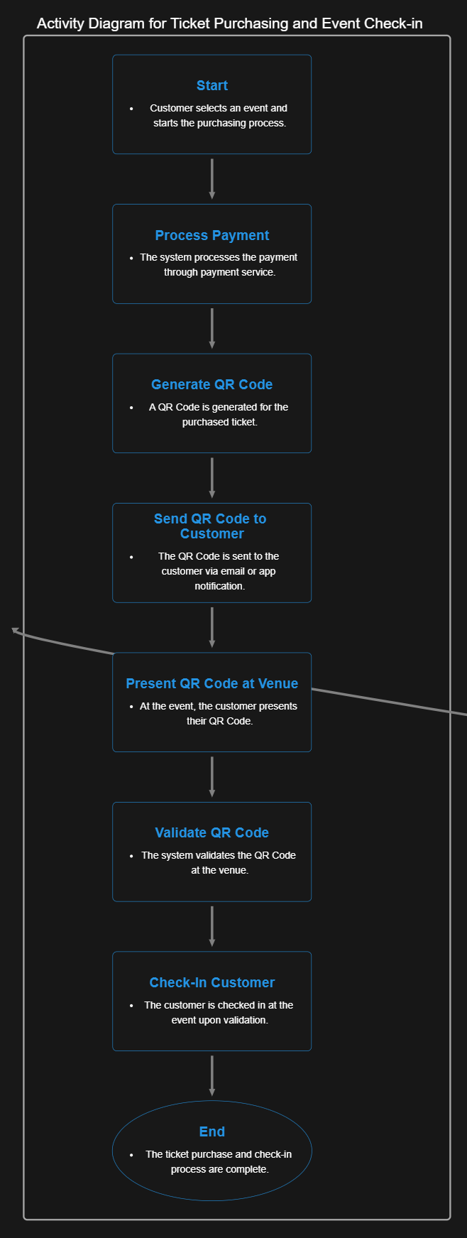

Figure 5 Activity Diagram