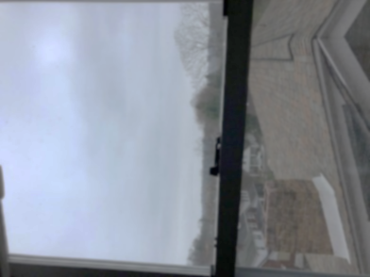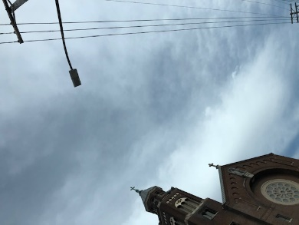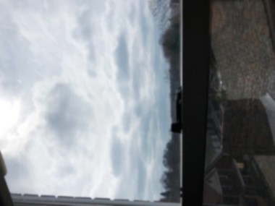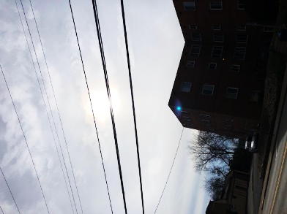

137 photon flux

(Indirect sun, 5:30pm)

1425 photon flux

(Direct sun, 4:32pm)

433 photon flux

(Indirect sun, 3:30pm)

107 photon flux

(Indirect sun,

4pm)

11:35am 3.24.20

1362 lux

26 photon flux

5:30pm 3.25.20

7199 lux

137 photon flux

3:30pm 3.24.20

22821 lux

433 photon flux

4:05pm 3.22.20

(Indirect sun)

106.7 photon flux

4:32pm 3.24.20

(Direct sun, late afternoon)

1425 photon flux

11:35am 3.24.20

1362 lux

26 photon flux