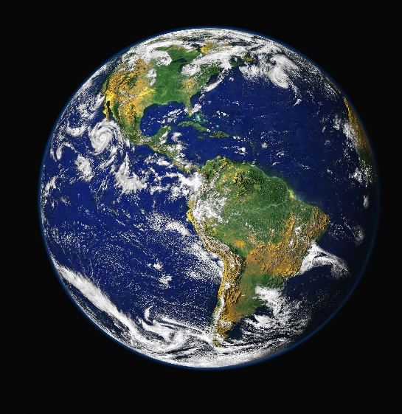

**Incoming energy**

**Outgoing energy**