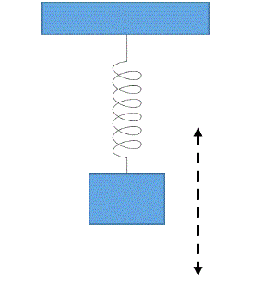

**Time 1**

**Time 2**

**Time 3**



Speed = 0

Highest point

Lowest point

Speed = 0

Speed > 0