**GOALS**

We strive to connect with people wanting to look good and take care of their physical appearance by finding a trusted barber close to them and promoting high quality services, through social media posts and SEO optimization.

**AUDIENCE & SOME PLATFORMS**

* 18-40 year old males
* Danish and international clients looking for a haircut or a beard trim

Facebook:

1. Almost 50% of the clients are international or from Europe
2. In Europe the most used platforms in the last 12 months are **Facebook, Twitter, Instagram**, but **Pinterest is gaining traction too.**
3. Facebook users are around **20 - 35 years old**
4. While many professionals and commuters also check Facebook in the morning before work, the best time to post to Facebook is in the afternoon between **1-4 p.m**. and in the evening between **6-10 p.m**.

Instagram:

1. **200 million+ Instagrammers** visit at least [one business profile daily](https://business.instagram.com/getting-started). → more potential that they also look up Crib Barbershop
2. [**2 billion active** monthly users on Instagram](https://www.statista.com/statistics/253577/number-of-monthly-active-instagram-users/) in 2021 (<https://www.statista.com/statistics/253577/number-of-monthly-active-instagram-users/>)
3. More options for content types→Story/Reel/IGTV/Post
4. Times when users are usually out and about are good times to post. This is between **6-8 a.m**. (e.g. on the way to work) and between **5-8 p.m**. (e.g. after work/on the way home).
5. Looking at the days: the beginning of the week and **Friday** performed well.
6. The worst results came from the tests on weekdays between 3-4 pm. That's when the fewest Instagram users were active.

Pinterest:

1. people around **30-45 years old**
2. The best day to post is **Saturday between 8-11pm**
3. The users of Pinterest are more weekly on the platform and not daily like on the other platforms.

**Potential for inspiration photos for haircuts or beard styling.**

**CONTENT PILLARS**

* Mature audience, semi-formal content
* **Short videos** →Facebook, Instagram
* **Stories**  (Instagram, Facebook) →option to interact with/ask them what they want to see next ( poll )
* **Image Post** (Facebook, Instagram and Pinterest) →connect them and do the same
* ⅔ own content, self-promotion
* ⅓ UGC, hashtags, campaigns

**BRANDED HASHTAGS**

* Keywords resulted from the comparison between the sweetspot and our research based of what users search:
* Specific Keywords
  + **#cribbarbershop, #cribaarhus, #barbershopaarhus, #apprentice**
* General Keywords
  + **#barber, #aarhus, #denmark, #barbershop, #haircut, #beforeafter,, #fresh, #beard. #trim, #fade, #shave, #blade, #foam #barberline, #barberclub, #barberdelux, #barbercut #pricelist #update #meettheteam**
  + **#haircut #barberman #streetbarber #barberintroduction**
* Include min. 1 and max. 5 hashtags per post

**VOICE AND TONE**

**Conversational, Trustworthy, Casual, Elegant**

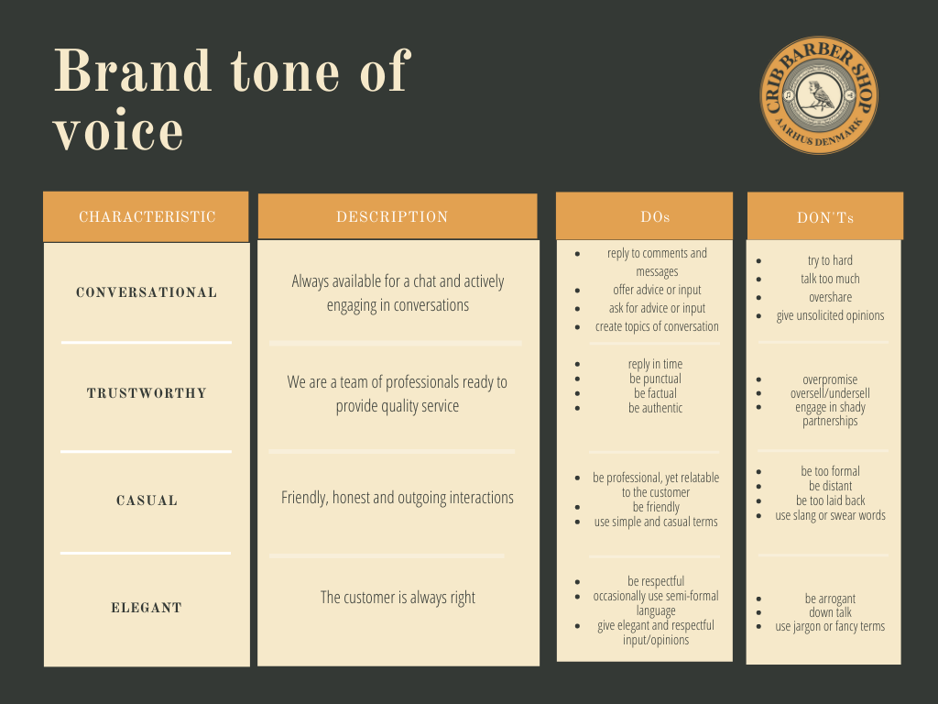

* Humble attitude, inspires growth and openness to improvement
* Professional approach, language & environment, without feeling arrogant
* Welcoming to new & existing clients, helpful and involved
* Transparent, authentic and intuitive

**WORDS AND PHRASES TO AVOID**

* Post descriptions only in Danish
* Slang

**EMOJI**

* Facebook: 1-2 emoji/post
* Instagram: 1-2 emoji/post
* Pinterest: None

**CAPITALIZATION & FONT**

**HEADINGS: BOLD, ALL CAPS, OLD STANDARD**

SUBHEADINGS: REGULAR, ALL CAPS, OPEN SANS

Body: Regular, initial capitalization only, OPEN SANS

**TIMING**

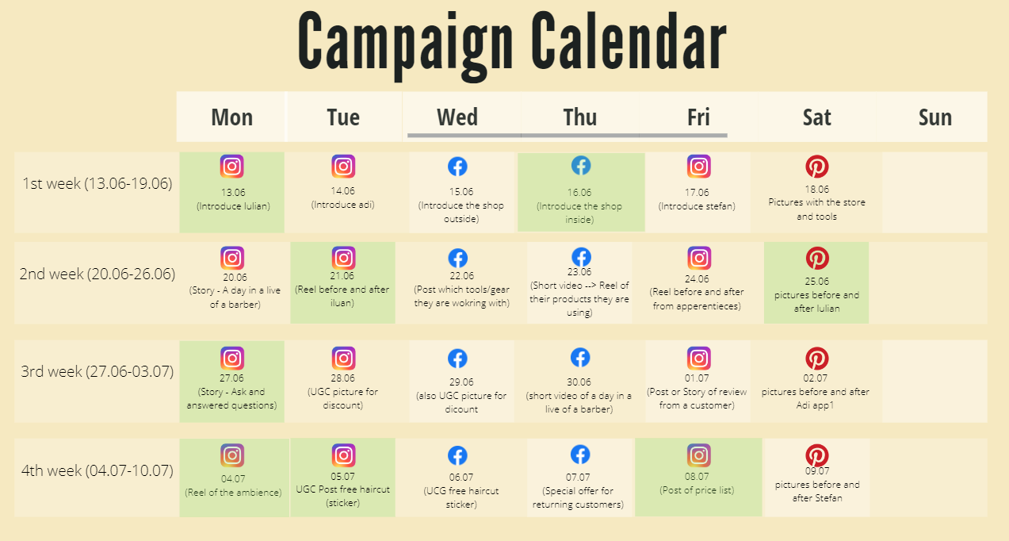

**GUIDELINES FOR VISUALS**

A varied color palette can be accepted, but preference goes to shades of blue, representative of the academy’s logo.

Facebook:

* JPG, PNG
* 1200px x 630px recommended
* 200px x 200px minimum

Instagram:

* JPG, PNG, MP4
* 1080px x 1080px recommended
* 700px x 700px minimum
* Vertical Mp4 1080x1920 for reels & stories

Pinterest:

* JPG, PNG
* Verical, 1080x1920

**TAGGING GUIDELINES**

* When do you tag someone?
  + If we are working together with an client (products)
  + Customer reviews if they want to
  + Introduction of barbers own channel
* Do you include a tag in the photo, caption, or both?
  + In the Caption, so we can write a few sentences. For example something about a client, what they do etc.
* In which cases do you need to ask permission to tag?
  + We ask anytime in case the people/companies don't want it

**CREDITING GUIDELINES**

[make sure to answer the following questions:

* When do you need to credit someone?
  + If the content is not from us for example from a customer which give us permission to take it but we give them credits for it anyways
* What format should the credit follow (i.e., “Name, CCO)
  + Customer = Name
  + Companies (like from the products we use) = Name of the company and the person + position
* Are there different levels of crediting? If so, what are they?
  + No we treat all the same
* When do you *not* need to credit someone?
  + When using royalty free content