|  |  |
| --- | --- |
| Full name of the applicant | Victor Joos |
| Reference |  |

**SCIENTIFIC SECTION OF THE PROPOSAL**

Main language chosen = English

|  |
| --- |
| This part includes the following elements:   1. Description of the research project 2. Comments on changes made in the research project in case of resubmission (optional) 3. Activities report on the first year of doctorate (**ONLY** for 1st grant - **2nd year** applicants)**\*** 4. Potential interdisciplinary approach of the research project (optional) 5. Description of the work environment 6. Summary of the master’s thesis or equivalent 7. Additionnal comments (optional) 8. Ph.D. work calendar per month   **\* “1st grant - 2nd year” applicants have already worked on a full-time basis for one year full time equivalent on the Ph.D. project submitted to the FRIA.**  **The applicant must fill in the sections below and convert the file into an unprotected PDF before appending it to the online application form.**  The F.R.S.-FNRS insists on **strict compliance with the instructions given for each part of the proposal** (scientific section relevant to the instrument selected, number of pages allowed for documents to be enclosed with the application form…) and stresses again the sovereign consideration of the juries in case the file would exceed the applicable page limit. |

1. **Description of the research project**
   1. **Goals of the research**

Convolutional neural networks (CNNs) have recently emerged in the computer vision community as the most effective tools to segment natural images, and are largely studied by UCLouvain [1]–[4]. In this project, we consider the use of CNNs for biomedical image segmentation and interpretation, with a focus on the X-ray images considered in CT scans of vascular and nervous networks.

Extension of CNN usage to the biomedical field is generally not trivial. This is partly due to the fact that deep (convolutional) neural nets are more tricky to train than shallow multilayer perceptrons [5], but also to their failure to account for the specificities of biomedical content and imaging systems. Recent works, including in UCLouvain [1]–[3], have largely revealed that off-the-shelf CNN-based segmentation algorithms fail in exploiting common sense prior knowledge (e.g. related to the connectivity of object voxels, or to the tree structure of blood vessels), making their high-performance dependent on the availability of a large training set of fully annotated samples (i.e. samples for which the model response is explicitly known, in most cases through manual data annotation). When dealing with biomedical images, annotation is especially tedious, due to the expert knowledge required to distinguish tissues and organs of interest. Moreover, the acquisition of X-ray image samples is constrained by the radiation toxicity.

To circumvent the need for large sets of annotated training data, our project investigates unsupervised training methodologies to tailor convolutional neural networks to specific tasks. In line with recent contributions from the CNN scientific community [6], **our research hypothesis states that the image representations, also named features, manipulated by a neural network trained for a given task might, in some cases, be relevant for another task.** This assumption raises a number of fundamental questions related to the conditions under which the transfer of features between CNNs becomes relevant. Those questions are central to the research methodology detailed in Section 1.4, but their investigation primarily requires access to relevant data, which is not trivial.

In practice, to be properly fed in terms of data, our work will cover multiple applicative fields ranging from pulmonary embolism diagnosis to gain in knowledge for tissue engineering. All those fields will be considered in our investigations, not only due to their practical relevance, but also because they offer complementary opportunities in terms of data access. In more details:

* Pulmonary embolism (PE) s an extremely common and highly lethal disease that is a leading cause of death in all age groups. Computerized tomography (CT) scanners have gained acceptance as a minimally invasive method for diagnosing PE. CNNs are here considered to detect embolism in images of low-contrast (to reduce the X-ray doses of CT image acquisition as low as reasonably achievable). Emboli have to be detected and positioned in pulmonary arteries. The proposed method will therefore rely on the segmentation of the blood vessels in the lungs, and the research challenge will consist in providing the CNNs the ability to account for the specific topology of the blood vessels. The developed method will be used as a safeguard by radiologists, or even as preliminary computer-aided diagnosis (CAD) tool (for example for removing negative scanners from human diagnosis). This work will be done partly in the Radiology Department of the St Luc Clinics in Brussels, which will provide the required data sets. The models could be extended to better characterize pulmonary inflamation due to Covid-19.
* Body parts (e.g. face, limbs, trunk) are made of composite tissues, which are organized in assembled tissue layers (e.g. skin, fat and cartilage for the ear) with an intertwining vascular and nervous network, shown in Fig. 1 (sharing the same shape ramification prior than the lung blood vessels considered for pulmonary embolism). Tissue engineering, which envisions the regeneration of a damaged body part is through the manufacturing of appropriate constructs, requires detailed knowledge about the 3D morphology and organization of the different types/layers of the extracellular matrix. Contrast-enhanced micro-CT now allows visualizing those structures, but accurate image segmentation tools are required to extract quantitative and statistically relevant information about them [3]. In this context, images are captured on dead mices, which gives the opportunity to consider multiple acquisitions of the same body part (typically a knee articulation or kidneys) with different settings and thus different SNR levels, allowing to properly assess the CNN performance (since high SNR images give access to a reliable ground truth). Access to images is guaranteed through our close interaction (a 4-year 800k€ collaborative project started in 2019) with Prof. Greet Kerckhofs, expert in contrast enhanced micro-CT.

This project will attempt to bypass the need for large annotated datasets by using self-supervised learning methods, which use the content of the image itself, and prior knowledge on the branch-like structures of the segmentation task that are exhibited in vascular and nervous networks.

* 1. **State of the art**

Less than five years ago, predominant methods for automatic image analysis and interpretation were based on the combination of ad-hoc hand-crafted representations, often chosen for their sparsity [7], [8], with graph-based processing [9], [10] and/or supervised machine learning approaches suited to low-dimensional feature spaces [11]. In the medical imaging community, altas-based methods [12] and statistical shape models [13] have also been intensively used as segmentation tools due to their ability to segment regions with few position, shape and appearance changes (as it is for example the case for many organs).

Since very recently, however, (2012 for image classification [14], 2014 for object detection [15], and 2015 for image segmentation [16]) a new class of cutting-edge machine learning algorithms, called Deep Learning, has emerged in the computer vision community, inspired by artificial neural networks to deal with raw data, instead of sparse representations or manually engineered descriptors. In particular, convolutional neural networks (or CNN) have surpassed traditional methods on almost all vision tasks requiring supervision, and serve as the base for classification, object detection, and semantic segmentation. The last task is best served by an auto-encoder structure, with skip-connections, as shown in U-Net [16] for 2D biomedical images or 3D U-Net [17] and V-Net [18] for their 3D equivalent.

Interestingly, it is generally admitted and experimentally demonstrated that, despite their

massive number of parameters, successful CNN architectures can exhibit a remarkably small

difference between training and test performance, as long as they are trained with a

representative set of samples, and with proper and common regularization mechanisms

(weight decay, dropout, data augmentation).

This observation shifts the problem towards the need for data collection. In many real-life cases, this need is prohibitive, especially for vascular segmentation in X-rays, where expert annotations are needed, and accurate segmentation is time-consuming ([19] extrapolates more than a year of annotation for the vascular structure of one mouse brain from the annotation of 0.02% of a single brain). Previous work, including from UCLouvain, has studied the use of synthetic data [Simone][19], [20], but problems in domain transfer between synthetic data and real data still necessitate a significant subset of data from expert annotation (11% in [19]). **Proposing strategies to train image interpretation CNN models from a limited number of (annotated) images is central to this research project.**

* 1. **Research project**

In order to perform successful segmentation of vascular and nervous networks, we plan to:

* **define self-supervised mechanisms to mitigate the lack of accurate and reliable annotations**. The definition of accurate annotation is generally unrealistic in the context of X-ray medical imaging due to the lack of expertise, and to the ambiguity inherent to the low X-ray image SNR. Different kinds of pretext tasks and contrastive losses will be developed for vascular network segmentation, as explained in Section 1.4.
* **account for vascular or nervous structure as prior for the self-supervision task**. We will first investigate the interaction between prior definition and self-supervised learning: joint learning of the main segmentation task and either branching detection or vascular orientation can lead to better results in the different sub-tasks. We will also define a self-supervised loss function that takes branching structures into account.
  1. **Work plan**

As explained in the previous section, the work plan of this project is based on two parts: self-supervised learning for segmentation networks, and for the segmentation of vascular networks.

Transversal to the following tasks is the collection and annotation of a contrast-enhanced CT dataset, through close collaboration with Prof. Greet Kerckhofs’ team as part of the 4 year Bio-Blueprints effort. In addition to this, we deem it wise to start working on synthetic datasets (as previously developed by [Simone]).

**Objective 1: Self-supervised Learning for segmentation**

Task 1. Supervised CNN implementation for segmentation

State-of-the-art deep learning segmentation architectures are fully convolutional neural networks. For biomedical applications, the U-Net architecture (2D [16] or 3D [17] implementation) is particularly suited and is commonly used in the community. The U-Net architecture consists in a contracting encoder part to analyze the whole input image and a successive expanding part to produce a full-resolution segmentation. Skip connections between the contracting and expanding paths allow to combine high resolution features extracted in the contracting path with the up-sampled output. 2D and 3D U-Net have been implemented in UCLouvain to segment the bladder on CT and CBCT image slices [1], [2], but also the mineralized cartilage on micro-CT images [3]. Those two networks serve as a baseline reference to compare with the alternatives studied in the rest of the project.

Task 2. Self-supervised segmentation using dictionary learning

We plan to investigate dictionary learning tasks as proxy tasks. Unsupervised representation learning has been largely used in natural language processing, but has been less successful for vision tasks. Contrastive loss [21], illustrated in Fig. 3 (a), has very recently been envisioned to learn image representations that effectively transfer to a variety of natural vision tasks. Contrastive methods [22]–[24] cluster related samples (the same image with various kinds of data augmentation), while maximizing distance between different images. Due to the use of strong data augmentation, such contrastive methods are not directly suited for segmentation. We plan to investigate a similar approach in the context of 3D biomedical image segmentation.

The contrastive loss commonly used for self-supervised learning is defined on a comparison between 2 images, which is ill-suited for the end-to-end training needed by U-Net, which doesn’t rely on a shallow decoder. As Fig. 3 (b) shows, we will investigate a pixel-level approach, where pixels from the same image, but different data augmentation schemes will be grouped in feature space, while different pixels from the same or an other image will be separated.

Task 3. Proxy task for 3D segmentation using dictionary learning

As shown in [25], it might make sense to combine a proxy task with the use of a contrastive loss, instead of working at the image level. Completing a jigsaw puzzle [26], predicting rotation [27], or predicting relative placement of a part of the image [28] have shown various levels of success in training the network for the subsequent task. However, few works have investigated the definition of proxy tasks that are suited for 3D segmentation, where the implementation of tasks like jigsaw solving [26] or rotation prediction [27] seem ill-suited to fine-grained segmentation needed in our practical context, either for their definition on images as a whole, or on patches. Our goal is to define pixel-oriented proxy-tasks.

In order to validate and understand the inner-working of the designed tasks, we will look at the weight and gradient characteristics during training, prompted by work done inside our research team [29].

**Objective 2: Branch-like structures as prior for self-supervised learning**

Task 4. Favoring branching priors through CNN regularization

When CNNs are only trained with the classical binary cross-entropy or the Dice loss, the network prediction and the ground truth (i.e. the manual annotations) are compared on a pixel-wise manner and do not necessarily incorporate local geometry such as smoothness and shape features (e.g. tree-based topology of vascular elements). In this project, we consider the regularization of internal CNN representations with respect to the output domain.

The purpose is to favor the emergence of a segmentation mask that shares the structure exhibited by the ground truth output labels. Hence, the proposed CNN regularization scheme relies on the assumption that the ground truth labels exhibit such an internal structure. This is the case in the considered datasets since the organs in CT/micro-CT images contain connected structures (which implies that a shape such as the one segmented in the right image of Figure 1 is definitely not relevant).

Our proposed regularization scheme works in two steps. First, an auto-encoder will be trained to model the internal structure of ground-truth segments. In a second phase, the actual segmentation network of interest (i.e. the U-Net model) is trained by including the auxiliary task of predicting the output via the decoder learned in the first phase [30]. This process is illustrated in Fig. 1. In our case, the auto-encoder will be trained on manual or synthetic segmentation labels embedding models for ramifications.

Alternative approaches to connect the segmentation and the structure encoding networks have been proposed [31], [32] as well. Hence, determining the appropriate way to connect them and to favor the joint training of multiple (i.e. auxiliary and main) tasks by a network remains open and is fully part of this research question [6], [29].

Task 5. Prior information in contrastive losses

The contrastive loss formulation for segmentation of Task 2 gives us another angle at which to solve the problem of prior information. Instead of separating all pixels from an image in the feature space indiscriminately, we can look at local information, using for example graph cut [33], or watershed [34] algorithms, or using predefined filters to describe the natural branch-like structure of the networks. All methods widely used in interactive segmentation of vascular networks [35]–[37].

In this same context, we might try to define pretext tasks more suited to the segmentation of vascular networks.

[1] J. Léger, E. Brion, U. Javaid, J. Lee, C. De Vleeschouwer, and B. Macq, “Contour Propagation in CT Scans with Convolutional Neural Networks,” in *Advanced Concepts for Intelligent Vision Systems*, Cham, 2018, pp. 380–391.

[2] E. Brion, J. Léger, U. Javaid, J. Lee, C. D. Vleeschouwer, and B. Macq, “Using planning CTs to enhance CNN-based bladder segmentation on cone beam CT,” in *Medical Imaging 2019: Image-Guided Procedures, Robotic Interventions, and Modeling*, Mar. 2019, vol. 10951, p. 109511M, Accessed: Aug. 03, 2020. [Online]. Available: https://www.spiedigitallibrary.org/conference-proceedings-of-spie/10951/109511M/Using-planning-CTs-to-enhance-CNN-based-bladder-segmentation-on/10.1117/12.2512791.short.

[3] J. Léger, L. Leyssens, C. De Vleeschouwer, and G. Kerckhofs, “Deep Learning-Based Segmentation of Mineralized Cartilage and Bone in High-Resolution Micro-CT Images,” in *Computer Methods, Imaging and Visualization in Biomechanics and Biomedical Engineering*, Cham, 2020, pp. 158–170.

[4] V. Joos de ter Beerst, A. Vanderschueren, and C. De Vleeschouwer, “Utilisation conjointe d’information sémantique et géométrique pour la localisation d’objets par caméra temps-de-vol,” in *Online proceedings of RFIAP, https://cap-rfiap2020.sciencesconf.org/resource/page/id/9*, 2020, vol. 1, p. 1, Accessed: Aug. 04, 2020. [Online]. Available: https://dial.uclouvain.be/pr/boreal/en/object/boreal%3A231247.

[5] G. Leclerc and A. Madry, “The Two Regimes of Deep Network Training,” *arXiv:2002.10376 [cs, stat]*, Feb. 2020, Accessed: Aug. 04, 2020. [Online]. Available: http://arxiv.org/abs/2002.10376.

[6] Y. Sun, X. Wang, Z. Liu, J. Miller, A. A. Efros, and M. Hardt, “Test-Time Training with Self-Supervision for Generalization under Distribution Shifts,” *arXiv:1909.13231 [cs, stat]*, Jul. 2020, Accessed: Jul. 28, 2020. [Online]. Available: http://arxiv.org/abs/1909.13231.

[7] N. Dalal and B. Triggs, “Histograms of oriented gradients for human detection,” in *2005 IEEE Computer Society Conference on Computer Vision and Pattern Recognition (CVPR’05)*, Jun. 2005, vol. 1, pp. 886–893 vol. 1.

[8] A. Delong, A. Osokin, H. N. Isack, and Y. Boykov, “Fast approximate energy minimization with label costs,” in *2010 IEEE Computer Society Conference on Computer Vision and Pattern Recognition*, Jun. 2010, pp. 2173–2180.

[9] Jianbo Shi and J. Malik, “Normalized cuts and image segmentation,” *IEEE Transactions on Pattern Analysis and Machine Intelligence*, vol. 22, no. 8, pp. 888–905, Aug. 2000.

[10] Y. Boykov and G. Funka-Lea, “Graph Cuts and Efficient N-D Image Segmentation,” *Int J Comput Vision*, vol. 70, no. 2, pp. 109–131, Nov. 2006.

[11] S. Maji, A. C. Berg, and J. Malik, “Efficient Classification for Additive Kernel SVMs,” *IEEE Transactions on Pattern Analysis and Machine Intelligence*, vol. 35, no. 1, pp. 66–77, Jan. 2013.

[12] J. E. Iglesias and M. R. Sabuncu, “Multi-atlas segmentation of biomedical images: A survey,” *Medical Image Analysis*, vol. 24, no. 1, pp. 205–219, Aug. 2015.

[13] T. Heimann and H.-P. Meinzer, “Statistical shape models for 3D medical image segmentation: A review,” *Medical Image Analysis*, vol. 13, no. 4, pp. 543–563, Aug. 2009.

[14] A. Krizhevsky, I. Sutskever, and G. Hinton, “ImageNet Classification with Deep Convolutional Neural Networks,” *Neural Information Processing Systems*, vol. 25, Jan. 2012.

[15] P. Dollár, R. Appel, S. Belongie, and P. Perona, “Fast Feature Pyramids for Object Detection,” *IEEE Transactions on Pattern Analysis and Machine Intelligence*, vol. 36, no. 8, pp. 1532–1545, Aug. 2014.

[16] O. Ronneberger, P. Fischer, and T. Brox, “U-Net: Convolutional Networks for Biomedical Image Segmentation,” in *MICCAI*, 2015, pp. 234–241.

[17] Ö. Çiçek, A. Abdulkadir, S. S. Lienkamp, T. Brox, and O. Ronneberger, “3D U-Net: Learning Dense Volumetric Segmentation from Sparse Annotation,” in *Medical Image Computing and Computer-Assisted Intervention – MICCAI 2016*, Cham, 2016, pp. 424–432.

[18] F. Milletari, N. Navab, and S.-A. Ahmadi, “V-Net: Fully Convolutional Neural Networks for Volumetric Medical Image Segmentation,” in *2016 Fourth International Conference on 3D Vision (3DV)*, Oct. 2016, pp. 565–571.

[19] M. I. Todorov *et al.*, “Machine learning analysis of whole mouse brain vasculature,” *Nature Methods*, vol. 17, no. 4, Art. no. 4, Apr. 2020.

[20] B. Ma, S. Liu, Y. Zhi, and Q. Song, “Flow Based Self-supervised Pixel Embedding for Image Segmentation,” Jan. 2019, [Online]. Available: http://arxiv.org/abs/1901.00520.

[21] M. Gutmann and A. Hyvärinen, “Noise-contrastive estimation: A new estimation principle for unnormalized statistical models,” in *Proceedings of the Thirteenth International Conference on Artificial Intelligence and Statistics*, Mar. 2010, pp. 297–304, Accessed: Jul. 28, 2020. [Online]. Available: http://proceedings.mlr.press/v9/gutmann10a.html.

[22] T. Chen, S. Kornblith, M. Norouzi, and G. Hinton, “A Simple Framework for Contrastive Learning of Visual Representations,” 2020, [Online]. Available: http://arxiv.org/abs/2002.05709.

[23] K. He, H. Fan, Y. Wu, S. Xie, and R. Girshick, “Momentum Contrast for Unsupervised Visual Representation Learning,” 2019, [Online]. Available: http://arxiv.org/abs/1911.05722.

[24] Y. Tian, D. Krishnan, and P. Isola, “Contrastive Multiview Coding,” *arXiv:1906.05849 [cs]*, Mar. 2020, Accessed: Jul. 28, 2020. [Online]. Available: http://arxiv.org/abs/1906.05849.

[25] A. van den Oord, Y. Li, and O. Vinyals, “Representation Learning with Contrastive Predictive Coding,” *arXiv:1807.03748 [cs, stat]*, Jan. 2019, Accessed: Jul. 28, 2020. [Online]. Available: http://arxiv.org/abs/1807.03748.

[26] M. Noroozi and P. Favaro, “Unsupervised Learning of Visual Representations by Solving Jigsaw Puzzles,” *arXiv:1603.09246 [cs]*, Aug. 2017, Accessed: Jul. 28, 2020. [Online]. Available: http://arxiv.org/abs/1603.09246.

[27] S. Gidaris, P. Singh, and N. Komodakis, “Unsupervised Representation Learning by Predicting Image Rotations,” *arXiv:1803.07728 [cs]*, Mar. 2018, Accessed: Jul. 28, 2020. [Online]. Available: http://arxiv.org/abs/1803.07728.

[28] M. Blendowski, H. Nickisch, and M. P. Heinrich, “How to Learn from Unlabeled Volume Data: Self-supervised 3D Context Feature Learning,” in *Medical Image Computing and Computer Assisted Intervention – MICCAI 2019*, Cham, 2019, pp. 649–657.

[29] S. Carbonnelle and C. De Vleeschouwer, “Layer rotation: a surprisingly simple indicator of generalization in deep networks?,” presented at the ICML, 2019.

[30] M. Mostajabi, M. Maire, and G. Shakhnarovich, “Regularizing Deep Networks by Modeling and Predicting Label Structure,” in *Proceedings of the IEEE Computer Society Conference on Computer Vision and Pattern Recognition*, 2018, pp. 5629–5638.

[31] O. Oktay *et al.*, “Anatomically Constrained Neural Networks (ACNNs): Application to Cardiac Image Enhancement and Segmentation,” *IEEE Transactions on Medical Imaging*, vol. 37, no. 2, pp. 384–395, 2018.

[32] H. Ravishankar, R. B. Venkataramani, S. Thiruvenkadam, and P. Sudhakar, “Learning and Incorporating Shape Models,” *Miccai 2017*, vol. 10433, no. 2, pp. 203–211, 2017.

[33] Y. Boykov, O. Veksler, and R. Zabih, “Fast approximate energy minimization via graph cuts,” *IEEE Transactions on Pattern Analysis and Machine Intelligence*, vol. 23, no. 11, pp. 1222–1239, Nov. 2001.

[34] L. Vincent and P. Soille, “Watersheds in digital spaces: an efficient algorithm based on immersion simulations,” *IEEE Transactions on Pattern Analysis & Machine Intelligence*, no. 6, pp. 583–598, 1991.

[35] H. P. Ng, S. H. Ong, K. W. C. Foong, P. S. Goh, and W. L. Nowinski, “Medical Image Segmentation Using K-Means Clustering and Improved Watershed Algorithm,” in *2006 IEEE Southwest Symposium on Image Analysis and Interpretation*, Mar. 2006, pp. 61–65.

[36] Y. Boykov and M.-P. Jolly, “Interactive Organ Segmentation Using Graph Cuts,” in *Medical Image Computing and Computer-Assisted Intervention – MICCAI 2000*, Berlin, Heidelberg, 2000, pp. 276–286.

[37] D. Freedman and Tao Zhang, “Interactive graph cut based segmentation with shape priors,” in *2005 IEEE Computer Society Conference on Computer Vision and Pattern Recognition (CVPR’05)*, Jun. 2005, vol. 1, pp. 755–762 vol. 1.

[38] G. Kerckhofs *et al.*, “Contrast-enhanced microCT to visualize and quantify the 3D vasculature in biological tissues without the need for perfusion,” 20170601, Accessed: Aug. 03, 2020. [Online]. Available: https://lirias.kuleuven.be/retrieve/451736.

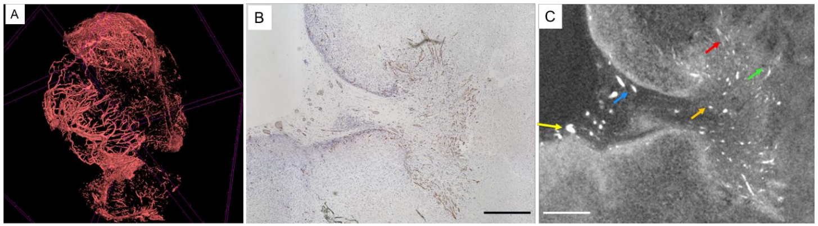

Figure 1: Proposed regularization framework. Step 1: an auto-encoder is trained on the ground truth binary masks. This encodes the internal structure (e.g. classical shape of the regions of interest) at the output of the encoder. Step 2: the trained and fixed decoder is connected to the output of the encoding path of the segmenter. The segmenter is trained by the minimization of a loss function penalizing inconsistencies between the labels and both the segmenter and the decoder outputs. Since the decoder is fixed, this forces the output of the segmenter encoding path to be consistent with the labels internal structure. If it is not the case, the fixed decoder will indeed predict a binary mask inconsistent with the ground truth.

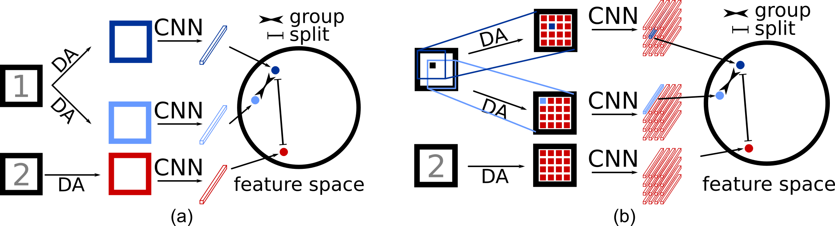

Figure 3: Illustration of contrastive loss for self-supervised learning. (a) Strategy for self-supervised classification. Each image undergoes 2 forms of data-augmentation (only shown for Im1). Once each are passed through a model the features from the same image are grouped, while isolated from other images. (b) Strategy for self-supervised segmentation. The same method as in (a) is used, pixel by pixel, taking zooming and cropping into account.

Figure 2: CE-microCT images of vascularization in a tumour xenograft sample, adapted from *the work by* Kerckhofs et al. [38] (A) 3D rendering of the vasculature in the xenograft, stained with Hf-WD POM; 3D scale bar = 100 μm. (B) The CD31 stained section and (C) the corresponding CE-microCT cross-section through the tumour xenograft. The brown colour in the histological section indicates CD31 positive blood vessels. The white colour in the CE-microCT image represents red blood cells in the blood vessels. Scale bars = 100 μm.

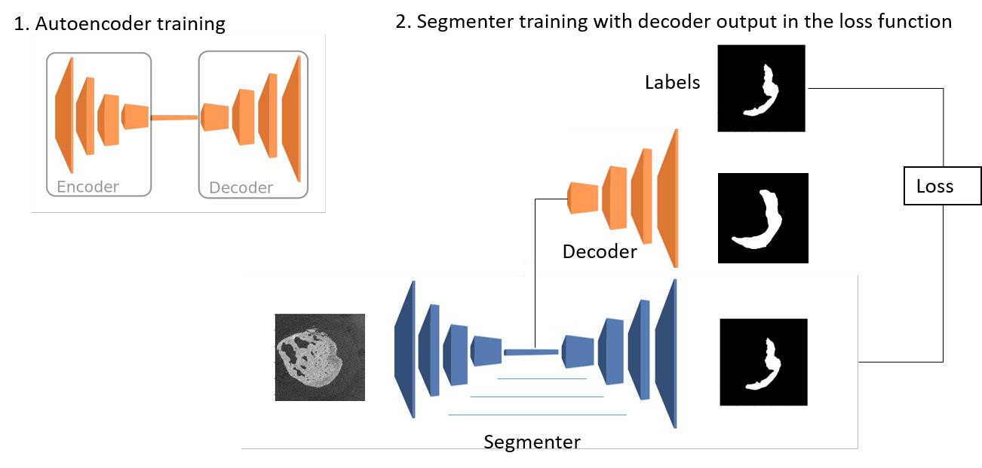

1. **Comments on changes made in the research project in case of resubmission (optional)**

*In case of former application submitted to the F.R.S.-FNRS via the same funding instrument, please specify the main changes made in your funding application following previous submission, identifying comments from experts that you may have taken into account (max. 1 page).*

Not Applicable

1. **Activities report****on the first year of doctorate**

**ONLY for “1st grant - 2nd year” applicants**

*Please write a brief report (max. 2 pages) underlining the progress of your research during the first year of your doctorate.*

Not Applicable

1. **Potential interdisciplinary approach of the research project (optional)**

*If applicable, please identify the interdisciplinary approach of your research project (max. 1 page).*

Thanks to a 4-year inter-university project, called Bio-blueprints, in partnership with Prof. Greet Kerckhofs, this project enjoys support in the creation of a dataset and the definition of success metrics.

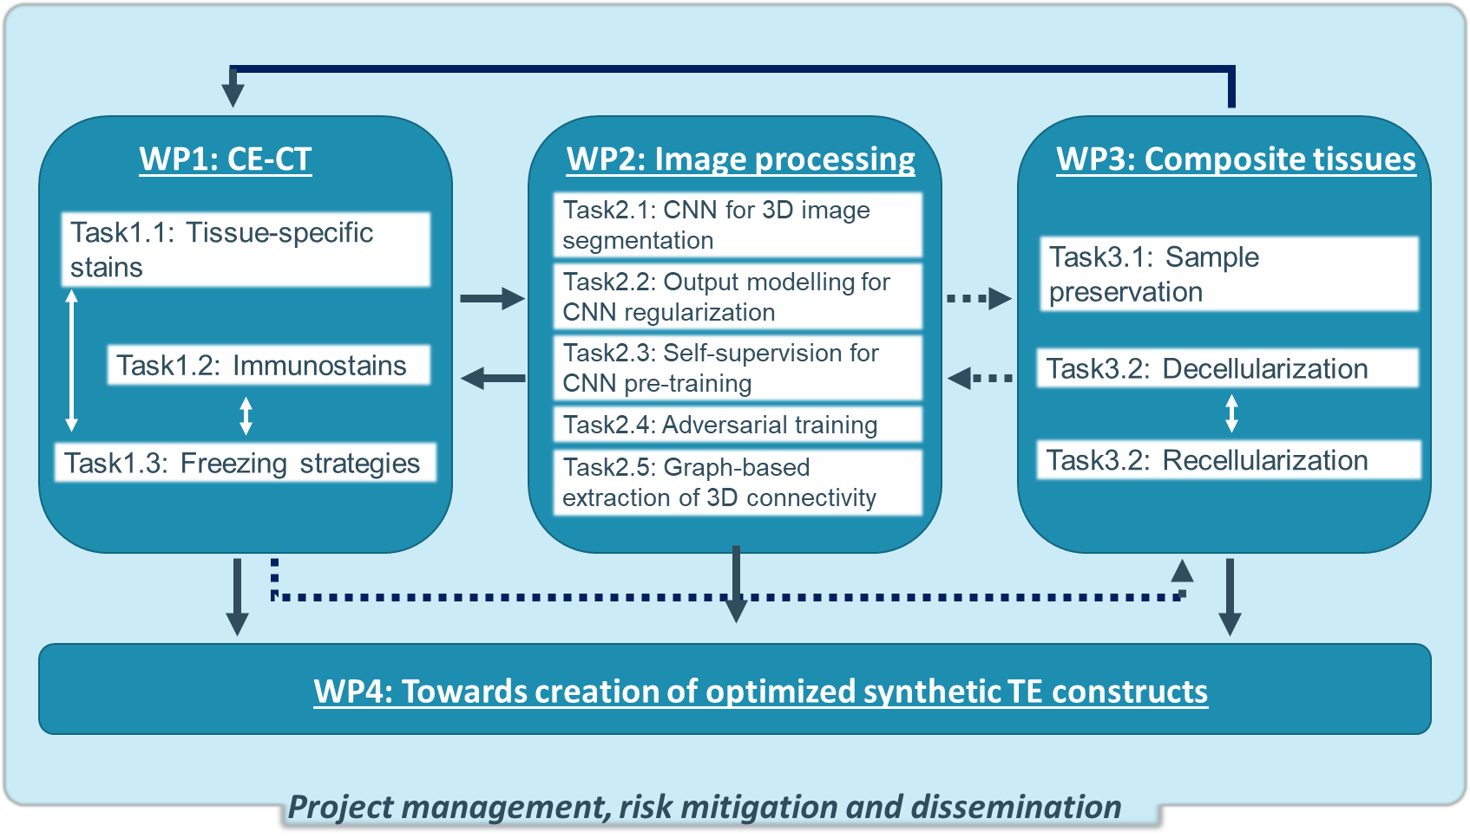

Figure 4: Schematic overview of the Bio-blueprints organization, as presented by its work packages and their tasks. The solid arrows indicate the input from one work package to another. The dashed arrows indicate feedback and potential reiteration based on the outcome of a WP or task.

1. **Description of the work environment**

*Please provide the information accounting for the adequacy of the environment (available intellectual and/or material means) to carry out the research as detailed in the submitted project. Please specify the assets of the research environment related to the project and the main publications of the laboratory/promoter (max. 1 page).*

TODO

1. **Summary of the master’s thesis or equivalent**

*Please provide a summary of your master’s thesis or any equivalent, even if you have not been graduated yet (max. 1 page).*

1. **Additional comments (optional)**

*If you want to communicate elements that have not been mentioned elsewhere in the file, please provide this information below in max. 2 pages.*

*Please note that in case the presented project provides for the involvement of patients and/or human or animal subjects, it is important that the project includes justifications on the planned sample size (number of subjects included in the study/studies) and how the size is relevant (based on statistical power calculations, for instance). It is also important to explain how the number of patients/subjects expected can be reached. In case the project provides for the involvement of patients and/or subjects, please provide those pieces of information under this section (if not already mentioned elsewhere in the project). Ultimately, this information (or the lack of information) may be taken into account by experts in the frame of the evaluation of your funding application.*

[Enter text here. Format: Arial 12, single space]

1. **Ph.D. work calendar per month**

*Please provide a calendar on a monthly basis for your Ph.D. works planned for the next 3 years (*1st grant - 2nd year) *or 4 years (*1st grant - 1st year) *(max. 2 pages).*

[Enter text here. Format: Arial 12, single space]