**KIT418 Assignment 1**

**Overall system architecture**

This system is based Client-Server architecture, it uses the socket to connect to each other. In the server, it takes multi-thread technologies to run the functions at the same time.

There are 9 classes used in the assignment. One client in the client, 5 in the server program, two class communicate with client to receive the command that is inputted by user, two class communicate with Worker Server to calculate the highest frequent character from the splitted strings, and one class to calculate the highest frequent character directly.

**Protocols**

Protocols in this assignment are described as following:

For client-server:

Client use ip “127.0.0.1” and port number 7788 between client and Server

For server-worker:

Server use ip “127.0.0.1” and port number 8889 between Server and Worker Server.

**Synchronization**

The first synchronization used when send split string to worker Server

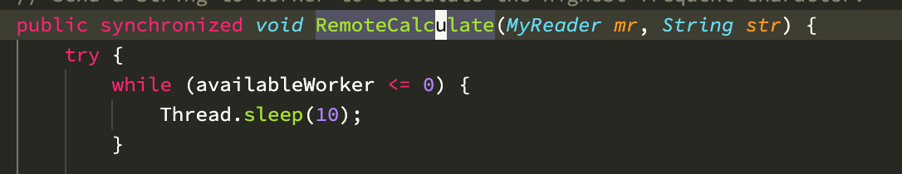

The second synchronization used when the worker Thread return the result of calculation.

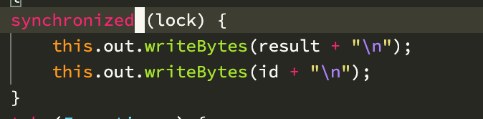

**Error**

**Client:**

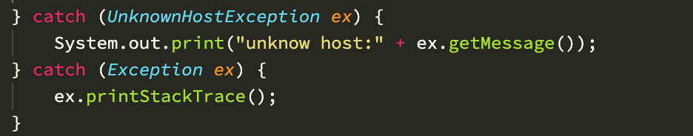

When the client socket is reset by Server, it will generate Exception,

**Server:**

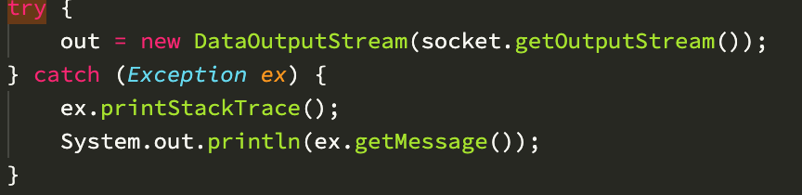

When client socket and Worker Server socket is reset, it will generate exception.

**Worker Server:**

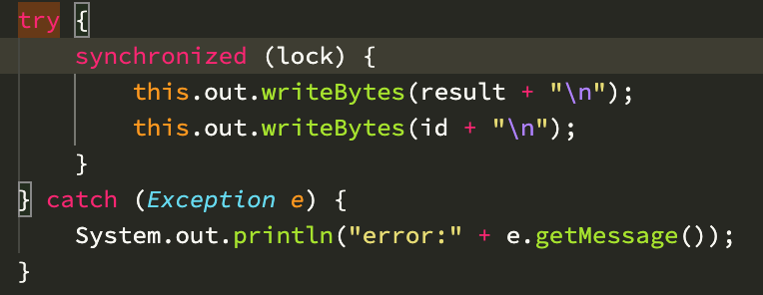

When send data through the socket to the server, there is probability of error generation.

When Server socket is reset, it will generate exception.

**Analysis**

The program is to calculate the highest frequent character from the string which is inputted by user. When the string is small, the server will calculate the result directly and return to the client. When the string is long, the server will send to the worker server to calculate and then return client the result. When the user input a very long string, the string will be split to several small string to worker server to calculate.