AutoM8 (IOS Application)
Requirements Documentation (version 1.0)

Project: AutoM8
Stage 1: Initiating Requirement Documentation
Date(s): 5/03/2016
Prepared by: Mohammed Imran

1. Project Plan
The Project Contains
Stage 1: An OSUL website for mobile devices – Completed
Stage 2: An OSUL mobile application for searching our Catalog and other holdings - In Progress
Stage 3: An innovative mobile application, such as an IPhone app or GPS – Future

  - Description of the Project

Stage 2 of MobileLib will develop a mobile search application for the library catalog and course reserves system. The resulting product of this project will add a search interface to the MobileLib website for OSUL designed specifically for the limitations of mobile devices.
  - Scope of the Project

Stage 2 will implement a mobile catalog search that allows users to look up an item by keyword, title, author, call number? or ISBN and course reserves by course number or instructor name. The mobile search results will be scaled back to fit the mobile use context and will emphasize item location and item availability by clearly displaying call numbers, floor location, and real time availability status. In addition the mobile search application will provide SMS services that text the call numbers of an item to a patron and a hold request functionality that will allow a patron to place an item on hold.
Stage 2 main audience is students/patrons searching for items in the library catalog through newer mobile devices.
Stage 2 will primarily consist of adding searching functionality to the MobileLib site and shall add 3 new interfaces.
Stage 2 will not add new static content to the existing mobile website but will add a new menu item to the main navigation.
Stage 2 will not support older devices that can not render XHTML.
Stage 2 is a stand-alone component of the project and is not dependent on the other stages to be successful.

1.3 Timeline and Methodology

Date | Milestone  (MS) | Goal | Depends on | Req. Resources/People | Outcome
6/15 | 1 | Finalize search application functionality | Feedback | MLib team, Team 200, U-Team | A list of functionality requirements: see below
Request made 6/16 | 2 | Development and Production Infrastructure. Ryan will need to set up Ramaze and hpricot. Maybe upgrade ruby? | Ryan and Stephen | Ryan, Stephen | Ramaze and Hpricot installed on the servers.
6/30 - texting | 3 | Code search application framework. | MS 1, 2 | Stephen, Kim | Basic search app coded to standards
7/15 | 4 | Design layout, write content | MS 1, designer,  MLib | Graphic designer, Mlib team | Mock-ups of layout designs
7/15 | 5 | Develop and test layout with paper prototype. Fix issues and iterate. | MS 4, users, MLib team | MLib team, user test, IRB?, users, UTeam | User tests and result analysis. Informal report.
7/20 | 6 | Add layout to search application and integrate into MobileLib site | MS 3, 4, 5, Stephen | Stephen, Kim | Completed stage 2 of MLib web site.
7/30 | 7 | User Test with cell phones and evaluate project goal evaluation. Fix Issues and iterate. | MS 6, MLib team, Stephen, users | MLib team, user test, IRB?, users, staff, mobile devices, UTeam | User testing of website on mobile devices. Formal goal evaluation and report.
8/15 | 8 | Move to production site. | MS 7, Ryan | Ryan, Stephen and MLib team | MLib available at public website and tracked by urchin
8/15 | 9 | Release | MS 8, MLib team, team 200 | MLib team, team 200, OSUL website, OSU marketing? | Advertisements on OSUL website, OSU marketing

MS | Responsible | Issues | New Date
1 | MLib
2 | Stephen
3 | Stephen/Kim
4 | Kim
5 | MLib
6 | Kim/Stephen
7 | MLib
8 | Stephen
9 | Laurie

2. Project Description

2.1 Project Stakeholder Scenarios

Students
“I can't count how many times I'm in the compact shelves reading a journal, and in the references I'll see some other article that looks relevant. It would be great to pull out my phone right there, look up the journal location for that new article and head directly to its location. That's just something I think would be nice to have.”

Reference Staff
When I am helping a patron find a book I sometimes have to leave them to look up the call number on the closest computer. It would be easier if I could look it up on a portable device as we walk around.

General Public
“The mobile website was very helpful in helping me find my way to the library, now if it would only help me find a book!”

2.2 Project Functions

Stakeholders will be able to use their mobile devices to search the Libraries’ catalog from a specialized OSUL website that is designed for the limitations of mobile devices. They will be able to easily search the catalog through an easy to use and attractive mobile website that takes into account the mobile search context.

2.4 General Constraints and Restrictions

Technology Restrictions:
- Dynamic scripting such as javascript, flash are not supported by the majority of mobile devices.
- Cache size and bandwidth: Due to the small sizes of both, large images and image intensive pages should be avoided. Page length should also be kept as short as possible and possibly broken up into multiple pages if necessary.
- Coding static pages in XHTML will prevent some older/simpler phones from accessing the site as older devices require pages to be coded in WML. This was deemed acceptable in our initial project meeting.
Device Restrictions
- Screen size: Due to the varying number of screen sizes, pages will have to be designed to accommodate both larger screens of the iPhone, Blackberrys, etc. as well as small screens of more standard cell phones.
- Navigation/Forms: The site navigation and forms need to be quick and easy to use for users with touch screen capabilities as well as standard scroll navigation methods.

 | Constraints | Issues/Solution (I/S)
 | Section 508 | (S) Valid XHTML
 | Must work for a wide variety of mobile devices | (S) Valid XHTML, testing
 | Must be branded as OSU site | (S) Logo and color scheme
 | Must be extendable | (I) Code, design and navigation
 | Screen Size | (S) Use min-width to set to medium size and then auto to adjust. Limit height of navigation pages to medium.
 | Technologies and bandwidth | (I) javascript , Images, flash
 | Design (navigation, page length) | (I) work with touch and key pad, (S) short content

2.5 Assumptions and Dependencies

Assumptions
Project will be delivered over the Internet and hosted on OSUL servers. We assume staff will help in advertising and testing and MLib team will have time to work on the project. We assume users will be viewing the web pages on a newer device with adequate bandwidth.

Dependencies
The project is dependent on the MLib team’s time and abilities. It is also dependent on a server admin’s and graphic designer’s time, server space, and feedback from stakeholders. The success of the project depends on adequate advertisement and making the mobile website discoverable.

3. Project Requirements

3.1 User Requirements

- Easy to navigate on a wide variety of mobile devices
- Easy to read information on small screens
- Short concise content
- Easy to use mobile search interface
- Easy to fill out forms with drop downs and check boxes
- Most links on pages shall link to mobile pages (exceptions will indicate with an icon that links are not mobile friendly)
- All phone numbers shall also be links that automatically call
- The pages shall load quickly and render correctly on most mobile devices
- SMS Services shall be easy to use and provide user with pertinent content. All SMS services shall also be mimicked with an email service
- Requesting a hold shall be easy to do and require the least amount of data (this may not be possible)

3.2 Functional Requirements

- Catalog Search by keyword, title, author, call number, ISBN
- Search by Keyword default
- Course Reserve Search by class or instructor
- Course reserves search default is course num
- Filter by branches
- Branches default is all
- Limit by result set size: options (1, 5,10)
- Result set size default is 5
- Call numbers are mapped to floor location and displayed along side
- SMS texts title, author, call number and floor location
- Email option emails title, author, call number and floor location
- Request hold submits to Oasis (may not be possible)

Tab Bar Items
- The tab Bar Items will be consistent on all main pages
- The Tab Bar items shall be grey on default and shall turn blue on being selected
- There shall be 3 Tab Bar items i.e., Dashboard, Account, About Us

Customer Dashboard Page and layout
- Customer Dashboard shall contain 3 buttons each for Booking a Service, Canceling Service and Car inventory
- The logged in Customer Name will be displayed at the top of the screen

Search Home Pages
- The search home page shall use the MobileLib header and footer
- The search home page shall incorporate the search icon
- It shall provide links to parent and related resources
- The search form shall use drop downs and checkboxes when possible
- The search form shall allow a quick search and advanced search on one page
- A quick search shall use pre-populated advanced search options
- The search interface shall provide options to search by keyword, title, author, call num, ISBN
- The search shall provide options to search course reserves by professor or class
- The search form shall provide filtering options such as result set size and branches

Search Results Pages
- The search results page shall use the MobileLib header and footer and include the search icon
- The results page shall be paginated into smaller result sets that is preset to 5 or set by user through filtering option
- The results page shall display title, author, call number, floor number, location and availability
- In the event that more than one location is found the results page shall only show the first location with a link to more
- In the event that the item is not available show title and checked out mssg only
- The item’s title shall link to each item’s record
- The items call number shall show the floor number and link to map
- The search results page shall provide a link to start a new search
- The pagination shall load result pages quickly
- The pagination shall allow users to jump to desired page as well as browse through the results with a next and previous button

Item Record Page
- An item’s record page shall display title, author, call and floor number, location, and content or summary/description. Content and description shall be truncated to a manageable length.
- In the event an item is a serial then the record shall show information about what the library owns. Links out of of mobile context shall be marked with an icon.
- If more than one location is found all locations shall be displayed.
- It shall include a link back to search results and to start a new search.
- An item’s record shall provide SMS and email service to text/email an item’s title, author, call number and floor location.
- (might not be possible) An item’s record shall allow a user to request a hold on an item item for pick-up.
- (might not be possible) The request a hold form shall mimic the catalog’s form.
- An item’s record shall provide pagination through the result’s records without having to go back to the search results page.
- An items record shall provide a link to the ‘shelf view’ based on call number.

Code
- Code shall be valid XHML & CSS & Section 508
- Code shall follow OSU/OSUL standards and requirements
- Code shall be re-usable, well commented, compatible and extendable.

3.3 System Requirements and Software Interfaces

System Requirements
- Ramaze, Hpricot, Ruby (get versions)

Software Interfaces
Stage 2 is required to interface with the MobileLib and OSUL website look and feel and will be joined through links on both systems.

Future stages shall be required to interface with any or all of the following systems:
- Library ala Carte
- Drupal
- E-Journals
- ScholarsArchive
- Databases of Databases
- Site search

3.4 User Interface Requirements
- Conciseness
Do not require user to scroll on navigation pages. Chunk information into sections. Paginate search results.
- Limiting Links to number pad
Assign each link to a number on phone pad. Do not exceed that limit. Display each link with assigned number.
- Descriptive Icons
Assign each navigation link an icon. Use icon as a preview of content
- Home and Parent Link
Include Home icon and link on each page. Add links/icons to parents and related pages of interior pages.
- Footer information
Add Link to main OSUL website and site map in footer of all pages. Add info about mobile site to home page. Add link to search to footer.
- Layout
Layout should be consistent with MobileLib site.
- Extendable
Design must be able to be extended to other stages and to grow in use and links.
- Screen Sizes
Design should target 176X220, but should work for all sizes.
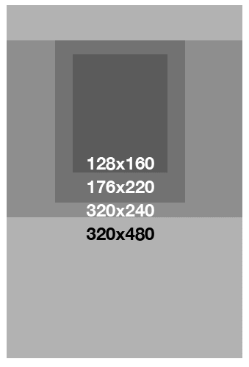
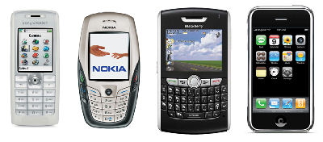
128X160 176X220 320X240 320X480

3.4 User Interface Mock-ups and Examples
Flickr stream of mobile interfaces: http://www.flickr.com/photos/users_lib/collections/72157606321236862/
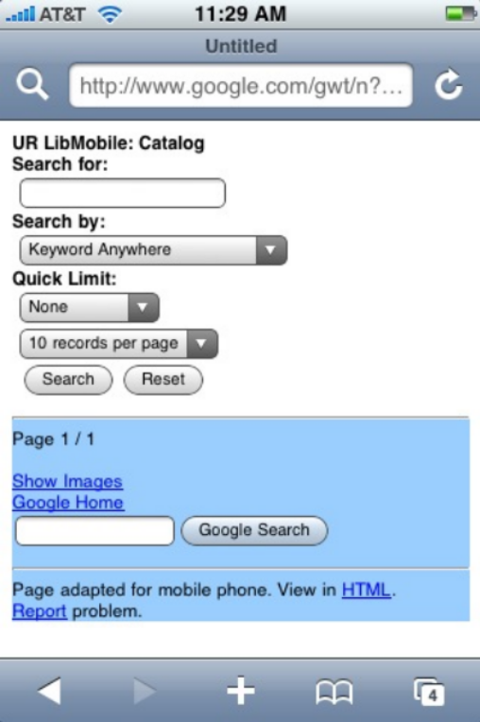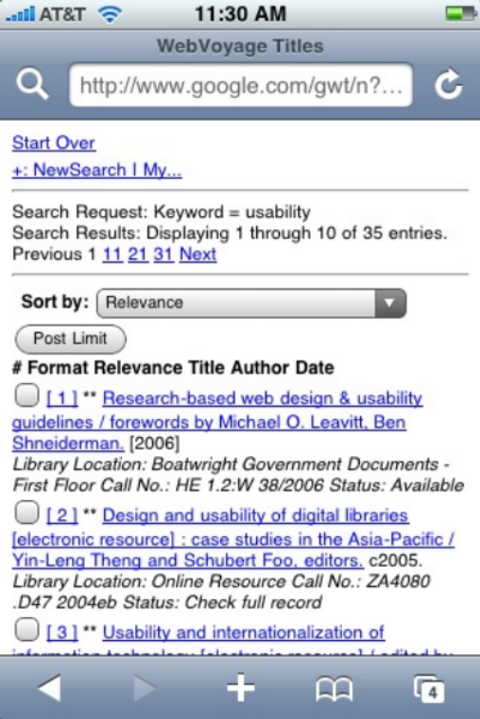

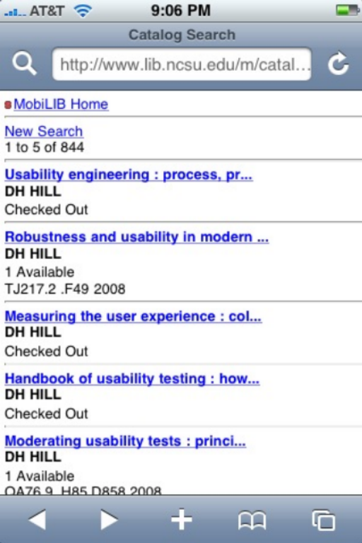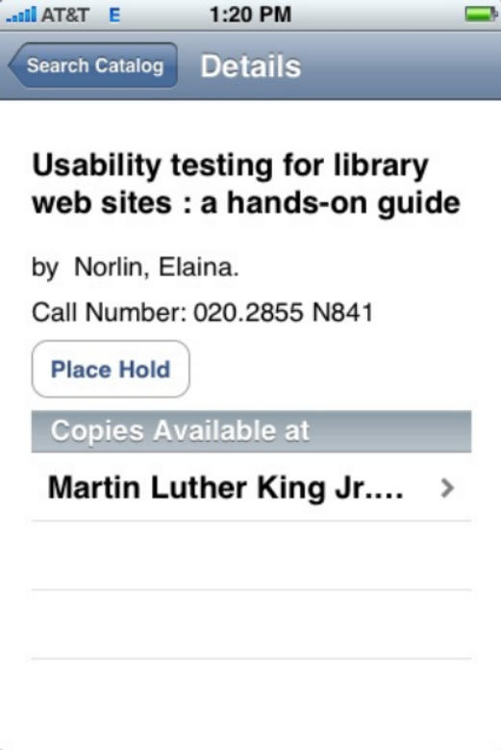

4. High-Level Technology Architecture

- Ramaze: Light-weight Ruby Framework.
- Hpricot: Ruby HTML parser
- Ruby
- Hosted on Unix servers.

5. Maintenance and Support

- Server admin will support server and Internet connection.
- Programmer shall support code and upgrades.
- MLibTeam shall support evaluation and testing.

6. User Testing and Evaluation

Test 1
Testing: Design, layout and navigation
Objective: Evaluate search interface design
Artifacts: Project Prototype (paper or cell phone emulator)
Users: 3 stakeholders
Tasks: Search and find by topic and known title

Test 2
Testing: Mobile website on a wide range of mobile devices
Objective: Evaluate the interface and get staff feedback
Artifacts: Mobile websites, mobile devices, staff email, feedback forum
Users: Staff at large, 3-5 stakeholders
Tasks: Ask users to perform tasks on mobile devices and provide feedback

Test 3
Testing: Project Goals
Artifacts: Heuristic evaluation guide, completed project
Users: MLib team
Tasks: Perform evaluation

Evaluation
Testing: Long term use and project success
Artifacts: Web use statistics
Tasks: Track use statistics

7. Appendix

8. Resources

