OBJECTIVE QUESTIONS:

- What is the distribution of account balances across different regions?
APPROACH:
- Currently there are three regions in dataset: France, Germany and Spain.
- To find distribution of account balances we need to calculate the total balances and group by regions(Geography).

OUTPUT:
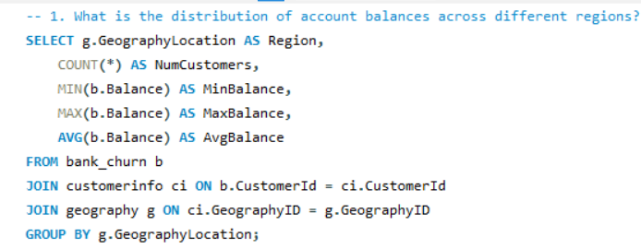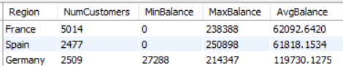

Insights:
- Customers with higher credit scores and balances are more likely to stay active, as reflected in the bank_churn table.
- There may be a geographic trend in customer churn rates, as GeographyLocation in the geography table is linked to the bank_churn table.
- The number of products a customer holds (NumOfProducts) can be a strong indicator of customer engagement and loyalty.
- Credit card categories may influence customer behaviour, especially in relation to churn and account activity.
Recommendations:
- Focus on retaining high-balance, high-credit score customers by offering personalized incentives and services.
- Analyse churn rates across different geographic locations to develop region-specific retention strategies.
- Encourage customers to engage with more products by promoting bundled offerings or cross-sell opportunities.
- Use insights from activecustomer and exitcustomer tables to improve customer activation rates and address key reasons for exit.

- Identify the top 5 customers with the highest Estimated Salary in the last quarter of the year. (SQL)

APPROACH:
- To find top 5 customers with highest Est.Salary, we sort data by Salary in descending order, then limit the rows to 5.
OUTPUT:
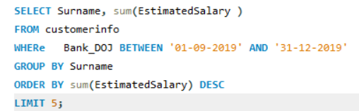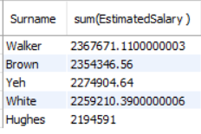

INSIGHT:
- The top five customers in terms of estimated salary have long tenures, indicating a possible correlation between salary and customer loyalty.
- There is only a slight difference in estimated salary among the top customers, suggesting that the bank's high-earning clients have similar financial profiles.
- All customers in this list joined the bank between '01-09-2019' AND '31-12-2019', indicating a relatively stable acquisition of high-salary customers during these years.

RECOMMENDATIONS:
- Focus retention efforts on high-salary customers, as they appear to stay with the bank for longer periods.
- Consider creating exclusive product offerings or services tailored to customers with estimated salaries above a certain threshold to increase engagement and loyalty.
- Use the insights from this list to target similar high-salary customers with personalized marketing strategies, based on their long-standing relationship with the bank.
- Monitor salary trends among newer customers to ensure the bank continues to attract high-earning individuals, adjusting strategies if necessary to maintain a steady influx of such clients.

- Calculate the average number of products used by customers who have a credit card. (SQL)
APPROACH:
- The average number of products used by customers who have a credit card = 1.53
- To get this, we calculate the average NumOfProducts used by customers, after filtering data by customers who are CreditCard holders.
OUTPUT:
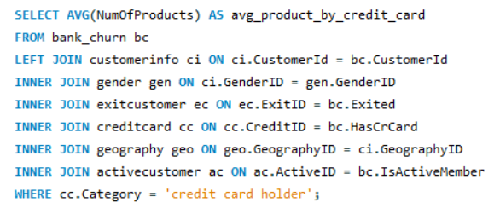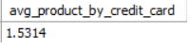
INSIGHTS:
- The average number of products used by customers with CreditID 1 (who have a credit card) is 1.53, indicating that customers with credit cards typically utilize 1-2 products from the bank.
- This average suggests that many customers with credit cards may not be fully leveraging additional banking products and services.
- A narrow range in the number of products indicates a possible lack of product diversity among credit card holders.
- The data may reflect opportunities to engage customers more broadly across other banking services beyond credit cards.
RECOMMENDATIONS:
- Implement cross-selling campaigns targeted at credit card holders to introduce them to other financial products, such as loans, savings accounts, or investment services.
- Analyse the factors leading to low product utilization among credit card customers and address any barriers that might prevent customers from adopting additional products.
- Provide personalized recommendations or financial incentives to encourage customers to explore more of the bank's offerings and increase their product count.
- Segment credit card customers based on product usage behaviour to create more focused marketing strategies for those who are using only one or two products.

- Determine the churn rate by gender for the most recent year in the dataset.

APPROACH:
- For the most recent year i.e., 2019 the churn rate for male category is 15.37 whereas for the female category the churn rate is 25.05.
OUTPUT:
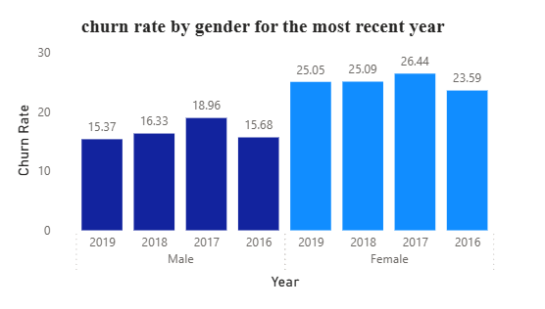
RECOMMENDATIONS:
- Investigate the causes of the higher churn rate among female customers by conducting surveys or focus groups to understand their pain points and preferences.
- Develop tailored retention strategies aimed at female customers, such as personalized offers, loyalty programs, or enhanced customer service.
- Monitor gender-based churn trends regularly to assess the effectiveness of retention campaigns and adjust strategies as needed.
- Use the insights from this analysis to refine customer segmentation and create more targeted marketing strategies to engage and retain female customers effectively.

- Compare the average credit score of customers who have exited and those who remain. (SQL)
APPROACH:
- For this, we simply calculate average Credit Score of customers while grouping them by Exitcategory.
OUTPUT:
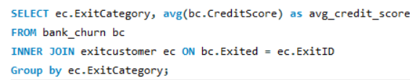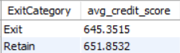

INSIGHTS:
- The SQL query provided compares the average credit score of customers who have exited and those who remain. The query joins the bank_churn and exit_customer tables on the Exited and ExitID fields respectively. It then groups the results by the ExitCategory and calculates the average CreditScore for each group.
- This indicates that the average credit score of customers who have exited is 645.3515, while the average credit score of customers who remain is 651.8532. Therefore, on average, customers who remain have a slightly higher credit score compared to those who have exited.

RECOMMENDATIONS:
- Investigate additional factors that may influence churn beyond credit scores, such as customer satisfaction, product engagement, or service quality.
- Use targeted retention strategies for customers with credit scores near the 645 range, as these customers might be more at risk of exiting.
- Monitor customer behaviour and offer incentives or personalized services to customers who have lower credit scores to encourage retention.
- Consider segmenting customers based on other behavioural metrics in addition to credit scores for a more comprehensive churn analysis.

- Which gender has a higher average estimated salary, and how does it relate to the number of active accounts? (SQL)

APPROACH:
- Female customers have the higher average estimated salary.
- No, there’s no strong correlation with number of Active members and Average estimated salary.

OUTPUT:
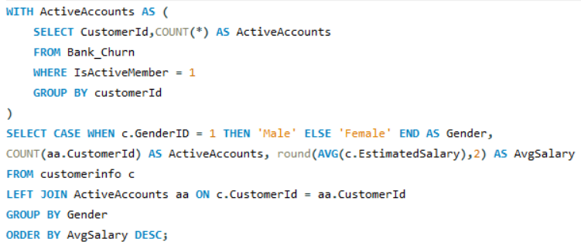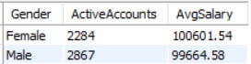

INSIGHTS:
- Female customers have a slightly higher average estimated salary (100,601) compared to male customers (99,665), indicating a marginal income difference between genders.
- Despite having a higher average salary, females have fewer active accounts (2,284) compared to males (2,867), suggesting that female customers may engage less with the bank’s products.
- The use of Rank() over gender categories highlights that both genders have relatively close estimated salaries, with females leading in this comparison.
- The small difference in average salaries suggests that other factors may be influencing the level of engagement with active accounts.

RECOMMENDATIONS:
- Investigate why female customers, despite having a higher average salary, have fewer active accounts and create strategies to promote product engagement among them.
- Use targeted marketing strategies to encourage female customers to explore and utilize more bank products, thereby increasing their account activity.
- Consider personalized financial services or benefits tailored to high-income customers, particularly females, to increase retention and engagement.
- Analyse other behavioural metrics beyond salary to understand gender-specific preferences and improve overall product adoption rates across all customers.

- Segment the customers based on their credit score and identify the segment with the highest exit rate. (SQL)
APPROACH:
- We can get the answer by using this formula in MySQL, and as per this, the Highest exit rate for the customers within the credit limit of <580.
OUTPUT:
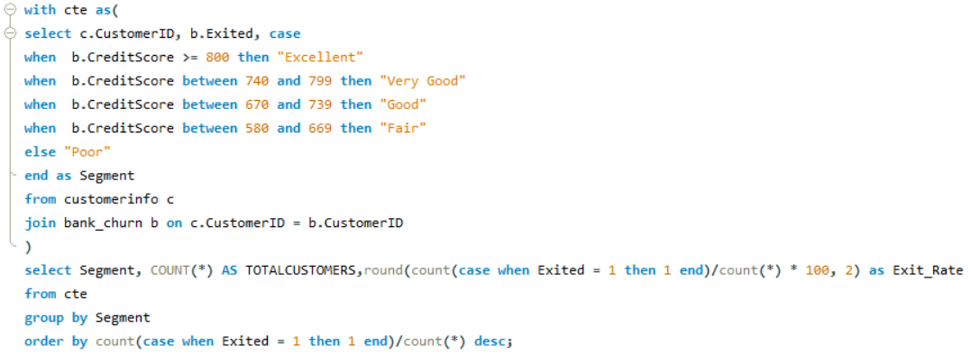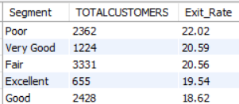

INSIGHTS:
- Customers in the "Poor" credit score segment (300-579) have the highest exit rate of 22.02%, indicating that these customers are more likely to leave the bank compared to others.
- The "Very Good" (740-799) and "Fair" (580-669) segments also have relatively high exit rates, at 20.59% and 20.56% respectively, suggesting potential risk in these categories.
- The segment with the lowest exit rate is "Good" (670-739), with 18.62%, followed by "Excellent" (800-850), which has an exit rate of 19.54%.
- Customers with lower credit scores ("Poor" and "Fair") tend to churn more frequently, likely due to financial instability or dissatisfaction with the bank's products.

RECOMMENDATIONS:
- Focus retention efforts on customers in the "Poor" and "Fair" segments by offering tailored support, such as financial planning or product recommendations, to help reduce churn.
- Consider offering incentives like lower interest rates or additional benefits to customers in the "Very Good" and "Fair" segments to encourage them to stay with the bank.
- Develop targeted campaigns that focus on improving customer satisfaction and engagement among customers with lower credit scores.
- Monitor customer behaviour and provide proactive outreach to those in higher risk segments (e.g., "Poor") to address any potential reasons for exit before they leave the bank.

- Find out which geographic region has the highest number of active customers with a tenure greater than 5 years. (SQL)
APPROACH:
- France has the highest number of active customers with tenure > 5 years
- For this, we calculate the count of customers with tenure>5 and group by geography
OUTPUT:
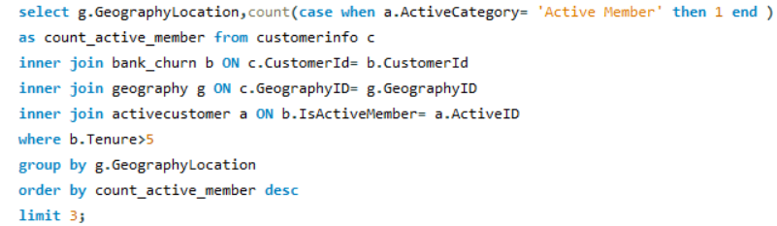

INSIGHTS:
- France has the highest number of active customers with tenures greater than 5 years, totalling 797, followed by Spain with 431, and Germany with 399.
- The significant difference in active customer count between France and the other regions may indicate that customers in France tend to be more loyal or engaged with the bank's services over a longer period.
- Spain and Germany have similar numbers of long-tenured active customers, suggesting these regions may have comparable levels of customer engagement.

RECOMMENDATIONS:
- Investigate the factors contributing to the higher retention rates in France and apply similar strategies to other regions to boost long-term customer engagement.
- Develop targeted marketing campaigns in Spain and Germany to increase customer retention, focusing on improving engagement with customers who have shorter tenures.
- Offer loyalty programs or incentives in Germany and Spain to encourage longterm customers to remain active and utilize more products.
- Monitor customer satisfaction metrics across all geographic locations to ensure consistent service quality and identify areas for improvement in customer retention.

- What is the impact of having a credit card on customer churn, based on the available data?
APPROACH:
- Counted customerid , total exit customer and churn rate by credit category.

OUTPUT:
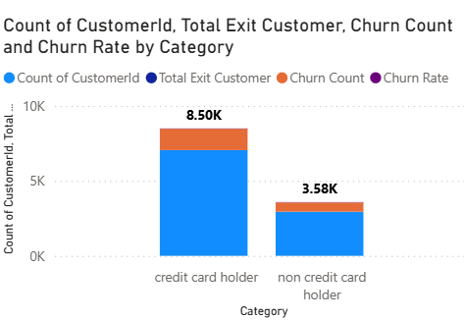
INSIGHTS:
- The churn rate for customers who do not have a credit card (20.81%) is slightly higher than the churn rate for credit card holders (20.18%).
- The difference in churn rates between the two groups is relatively small, indicating that having a credit card does not drastically affect customer churn.
- The number of total customers with credit cards (7,055) is more than double that of those without credit cards (2,945), suggesting that credit card ownership is more common among the customer base.
- Even though the churn rate for non-credit card holders is slightly higher, the similar churn rates suggest that other factors might be driving customer exits beyond credit card ownership.

RECOMMENDATIONS:
- Analyse customer satisfaction data to identify key factors influencing churn, such as service quality or product gaps.
- Offer personalized incentives to non-credit card holders to encourage credit card adoption and improve retention.
- Implement targeted retention strategies for both groups, addressing reasons for churn through proactive engagement.
- Regularly monitor churn trends and adjust strategies based on emerging customer behaviour patterns.

- For customers who have exited, what is the most common number of products they have used?
APPROACH:
- For Customers who have Exited,Most common NumOfProduct is 1.
OUTPUT:
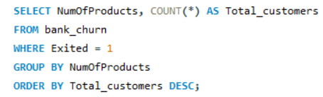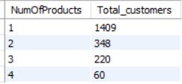
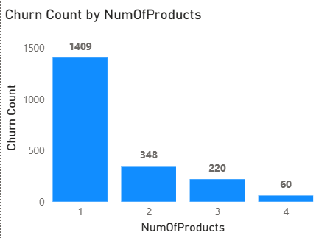

INSIGHTS:
- The majority of customers who exited the bank used only one product, accounting for 1,409 customers, which is the highest among all categories .
- A significantly smaller number of exited customers used multiple products, with only 348 customers using two products, 220 using three products, and 60 using four products.
- This indicates that customers who engage with fewer products are more likely to exit, suggesting a potential link between product engagement and retention.
- The number of customers using multiple products decreases significantly as the number of products increases, highlighting that fewer customers diversify their engagement with the bank's offerings.

RECOMMENDATIONS:
- Focus on cross-selling and promoting multiple products to customers who use only one product to increase engagement and reduce churn risk.
- Develop personalized marketing strategies to encourage customers to explore more products, particularly targeting those who are at risk of exiting.
- Investigate the reasons behind the low product adoption among customers with only one product to identify barriers and address them effectively.
- Offer incentives or bundling opportunities to encourage customers to adopt additional products and strengthen their relationship with the bank.

- Examine the trend of customers joining over time and identify any seasonal patterns (yearly or monthly). Prepare the data through SQL and then visualize it.
APPROACH:
- To find the customers joining over time,firstly took data from the customerinfo table,grouped by year and then counted and extracted year.
OUTPUT:
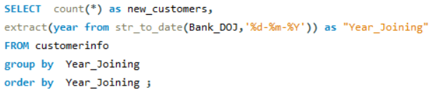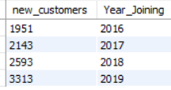
INSIGHTS:
- The data shows a consistent increase in the number of customers joining the bank from 2016 to 2019. This indicates a positive growth trend.
- The year 2019 saw the highest number of new customers (3,313), suggesting a significant boost in marketing efforts or service improvements.
- Each year, the number of new customers has increased at a faster rate, indicating accelerating growth. Economic or market changes during this period may have influenced the rising number of new customers.
RECOMMENDATIONS:
- Analyse factors contributing to the spike in customer acquisition in 2019 to leverage them further.
- Continue strategies that helped achieve consistent growth, focusing on customer acquisition programs.
- Further breakdown of data by month may reveal seasonal trends or marketing efforts that drive customer sign-ups.
- Use this data to predict future customer trends and adjust business strategies accordingly.

- Analyze the relationship between the number of products and the account balance for customers who have exited.
APPROACH:
- Firstly,took the table bankchurn,where exited will be = 1and then extracting numofproducts , totalcustomers and totalbalance.

OUTPUT:
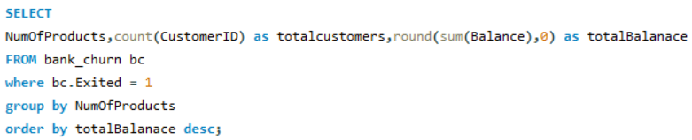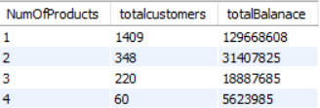

INSIGHTS:
- Customers who used only one product have the highest total balance of 129,668,608, which is significantly higher than any other group.
- As the number of products increases, the total balance decreases, with customers using four products having the lowest total balance of 5,623,985.
- While fewer customers engage with multiple products (especially 3 and 4), they collectively contribute less to the overall balance than those with fewer products.
- The data suggests that customers with fewer products tend to maintain larger account balances, while those with more products have smaller total balances.

RECOMMENDATIONS:
- Investigate why customers with more products tend to have lower balances and address any factors that might be causing reduced financial engagement.
- Focus on encouraging customers with one product to adopt additional products while maintaining their high balances, through personalized offers or bundled services.
- Target customers with low balances and high product usage to identify opportunities for increasing their overall financial activity and product engagement.
- Implement strategies to retain high-balance customers who only use one product, as they represent a significant portion of the total balance despite lower product usage.

- Identify any potential outliers in terms of balance among customers who have remained with the bank.

APPROACH:
- A scatter plot of CustomerId versus Balance, categorized by Balance, was used to identify potential outliers among customers who have been retained.
OUTPUT:
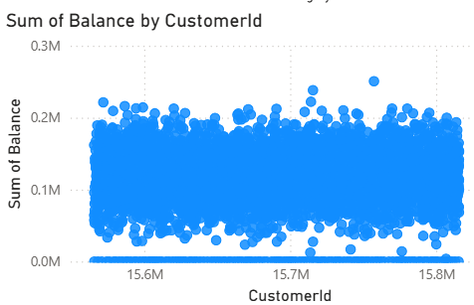

INSIGHTS:
- The majority of customers have balances concentrated between $0 and $200K.
- A few customers show balances close to $250K–$300K, which can be considered potential outliers compared to the general distribution.
- Some customers also show very low or near-zero balances, which may indicate dormant accounts or minimal activity despite being retained.
- There is no clear clustering by customer ID, suggesting that high and low balances are distributed randomly across the retained customers.

RECOMMENDATIONS:
- High-Balance Customers (Potential Outliers):
- These customers may represent high-net-worth individuals. The bank should consider offering them personalized financial products, such as investment advisory services, premium accounts, or wealth management plans, to strengthen loyalty.
- Low/Zero Balance Customers:
- Investigate why some retained customers maintain very low or zero balances. Possible reasons may include inactive usage, external banking relationships, or product mismatches.
- The bank can encourage higher engagement by offering targeted promotions, savings incentives, or bundled services.
- Risk Monitoring:
- Outliers (both very high and very low balances) should be monitored for unusual activity, as they could also indicate potential fraud, money laundering, or compliance risks.
- Segmentation Strategy:
- Classify retained customers into segments (e.g., high-balance, medium-balance, low-balance) and design custom retention strategies tailored to each segment.

- How many different tables are given in the dataset, out of these tables which table only consists of categorical variables?
APPROACH:
- The dataset consists of 7 tables. Out of these, the following 5 tables contain only categorical variables:
OUTPUT:
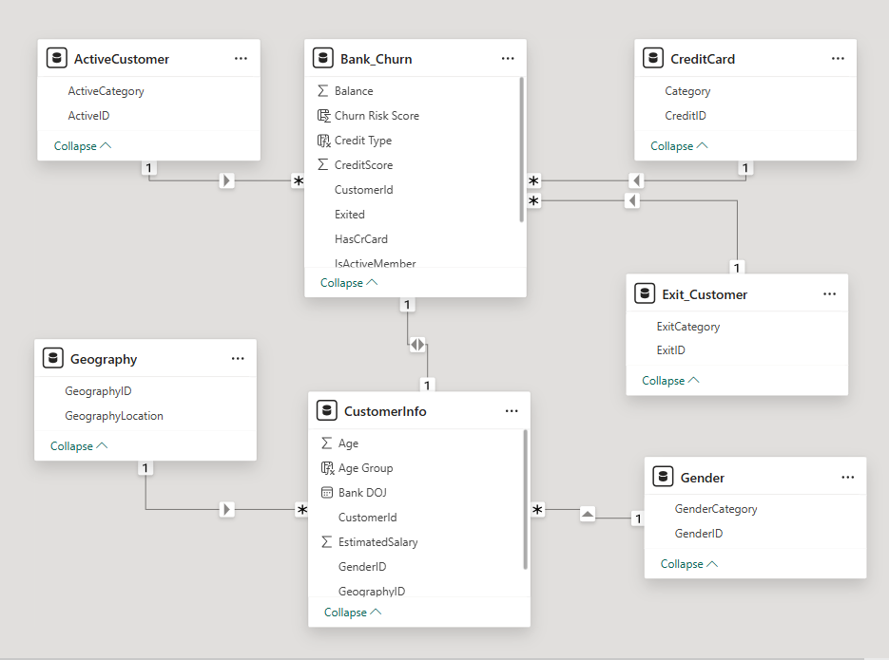
INSIGHTS:
Categorical Tables
Gender
Geography
Active Customer
Exit Customer
CreditID

- Using SQL, write a query to find out the gender-wise average income of males and females in each geography id. Also, rank the gender according to the average value. (SQL)
APPROACH:
- The SQL query provided is designed to calculate the average income of males and females in each geography id. It also ranks the genders according to the average income value. The query uses a combination of SELECT, FROM, LEFT JOIN, INNER JOIN, GROUP BY, and window function RANK() to achieve this.
OUTPUT:
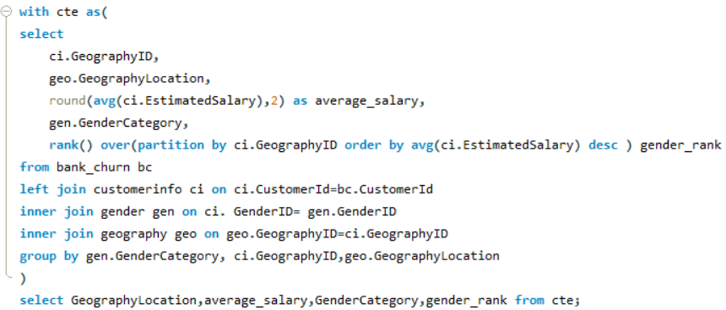
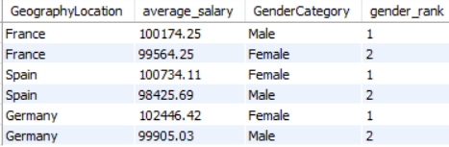

INSIGHTS:
- The query provides gender-wise average income across different geographies, helping to identify geographic regions where one gender might earn significantly more than the other.
- The ranking shows how male and female incomes compare within each geography, offering insights into income disparities between genders in different regions.
- Regions like Germany and Spain may have a higher average income for females, while other regions could show differences in male income dominance.
- Identifying geographies with large income gaps between genders can highlight potential areas for further investigation into the causes of these disparities.

RECOMMENDATIONS:
- Focus on regions with significant income disparity between genders to promote financial equality by introducing more inclusive financial services or policies.
- Analyse the factors contributing to higher average incomes for specific genders in certain geographies and replicate successful strategies in regions with lower averages.
- Tailor financial products based on gender-specific income data to improve customer engagement and satisfaction.
- Monitor geographic trends regularly to assess if interventions aimed at balancing gender income gaps are effective.

- Using SQL, write a query to find out the average tenure of the people who have exited in each age bracket (18-30, 30-50, 50+).
APPROACH:
- For this, we first segment ages in bracket then calculate average tenure and grouping by age bracket.

OUTPUT:
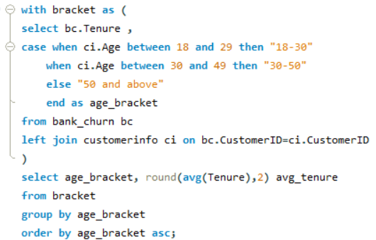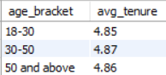

INSIGHTS:
- The average tenure for customers who have exited is highest in the 30-50 age bracket, at 4.89 years, compared to 4.78 years for the 18-30 bracket and 4.83 years for the 50+ bracket.
- Customers in the 30-50 age group tend to stay longer before exiting, indicating that this group may have a stronger connection to the bank before deciding to leave.
- The 18-30 age group has the lowest average tenure, which could suggest a quicker churn rate for younger customers.
- The tenure differences across age groups are minimal, indicating a fairly uniform churn behaviour across all age brackets.

RECOMMENDATIONS:
- Focus retention efforts on the 18-30 age group to increase their tenure and reduce churn, possibly through products and services tailored to younger customers.
- Investigate why the 30-50 age group, despite having the longest tenure, still exits, and create targeted strategies to retain this segment for even longer.
- For the 50+ age group, offer tailored retirement or long-term financial products to further extend their tenure with the bank.
- Conduct further analysis on the reasons for churn across these age groups to design more effective, age-specific retention strategies.

- Is there any direct correlation between salary and the balance of the customers? And is it different for people who have exited or not?
APPROACH:
- The given scatter plot examines the correlation between EstimatedSalary (X-Axis) vs. Balance (Y-Axis), with ExitCategory (Exited vs. Retained).
OUTPUT:
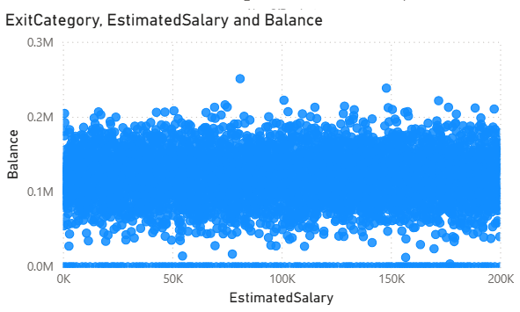
INSIGHTS:
- There is no strong linear correlation between Estimated Salary and Balance — balances are spread widely across all salary levels.
- Both low- and high-salary customers exhibit a wide range of balances, from near zero to ~250K+.
- Customers who exited and those who remained do not show a clear, distinct separation in salary–balance behavior.
- Some customers with very high balances exist across all salary levels (potential outliers), but their exit behavior does not appear tied to salary.
- This suggests that salary is not a reliable predictor of customer balance or exit likelihood.

RECOMMENDATIONS:
- Go Beyond Salary for Exit Prediction:
- Since salary alone does not explain balance or exit, models should incorporate other variables (e.g., tenure, product usage, credit score, engagement frequency).
- Focus on Balance Behavior:
- Monitor customers with very low balances across all salary levels, as they may be more at risk of disengagement.
- For high-balance customers, ensure retention strategies (premium services, wealth products) regardless of salary band.
- Segment by Balance, Not Salary:
- Create retention strategies based on balance segmentation (e.g., dormant, medium, high-net-worth), rather than salary.
- Investigate Outliers:
- Customers with high salaries but low balances (or vice versa) should be further analyzed — they may represent missed cross-sell opportunities or hidden churn risks.

- Is there any correlation between the salary and the Credit score of customers?
APPROACH:
- In order to find out the correlation between salary and credit score or the customer,we joined both the tables.
OUTPUT:
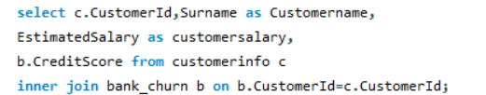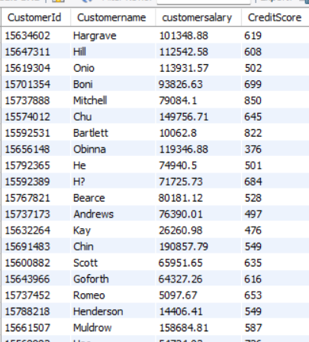

INSIGHTS:
- From the dataset sample, customers with higher salaries do not consistently have higher credit scores.
- Example: Customer with salary 149,756.71 has credit score 645, while another with much lower salary 79,084.1 has a much higher credit score 850.
- Similarly, a customer with salary 26,260.98 has a score of 476, while another with 100,062.8 has a much higher score 822.
- This suggests that Estimated Salary and Credit Score are not strongly correlated.
- Credit score depends more on borrowing and repayment behavior, debt levels, and financial discipline rather than salary.
- Therefore, customers with high salaries may still have poor credit management, and vice versa.

RECOMMENDATIONS:
- Do Not Use Salary as a Proxy for Creditworthiness:
  - Banks should rely directly on Credit Score and repayment history instead of salary when assessing lending risk.
- Risk Segmentation:
  - Segment customers based on credit score bands (e.g., <600 high-risk, 600–750 medium-risk, >750 low-risk), regardless of salary.
- Targeted Financial Products:
  - High-salary but low-credit-score customers could be offered credit counseling or secured credit products.
  - Low-salary but high-credit-score customers may be suitable for responsible lending opportunities.

- Rank each bucket of credit score as per the number of customers who have churned the bank.
APPROACH:
- Customers were grouped into credit score buckets (Poor, Fair, Good, Very Good, Excellent).
- Filtered for churned customers (exited = 1).
- Counted churned customers per bucket and ranked them using dense_rank().
OUTPUT:
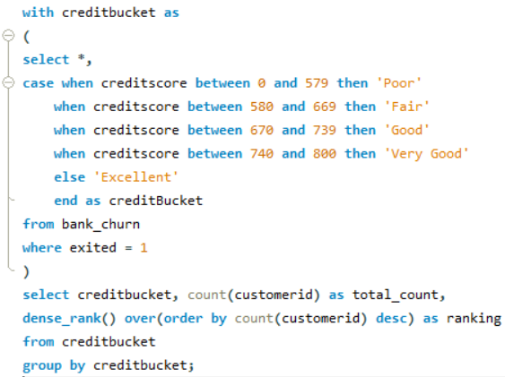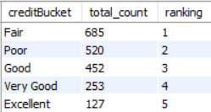

INSIGHTS:
- Customers with Fair (580–669) and Poor (<580) credit scores represent the highest number of churned customers (685 and 520 respectively).
- Customers with Good (670–739) scores also show notable churn (452), but at a lower level than Fair/Poor categories.
- Churn decreases significantly as credit score improves — Very Good (253) and Excellent (127) have the lowest churn counts.
- This suggests that lower credit score customers are more likely to leave the bank, while higher credit score customers are comparatively more stable.

RECOMMENDATIONS:
- Targeted Retention Programs for Low-Credit Buckets:
  - Special focus should be given to customers in the Fair and Poor categories, as they represent the largest share of churned customers.
  - Introduce financial literacy programs, credit repair products, and proactive engagement strategies to retain these at-risk groups.
- Customized Product Offerings:
  - For Fair/Poor credit customers, provide secured loans, flexible repayment options, and personalized financial support to build trust and reduce attrition.
  - For Excellent/Very Good credit customers, promote premium products, loyalty rewards, and investment opportunities to maintain engagement.
- Risk Monitoring & Early Warning:
  - Establish an early warning system to flag customers with declining credit scores who are at higher risk of churning.
  - Combine credit score with transaction behavior, product usage, and engagement data to proactively identify churn risks.
- Retention ROI Optimization:
  - Since Excellent credit customers have low churn, resources should not be wasted on broad retention campaigns for them.
  - Instead, maximize ROI by focusing on mid-to-low credit score segments, where churn is highest.

- According to the age buckets find the number of customers who have a credit card. Also retrieve those buckets that have lesser than average number of credit cards per bucket.
APPROACH:
- Customers were grouped into age brackets:18–30 → Adult,31–50 → Middle-Aged,51+ → Old-Aged.
- Counted customers with credit cards per age bracket.
- Compared counts against the average credit card ownership to identify below-average groups.
OUTPUT:
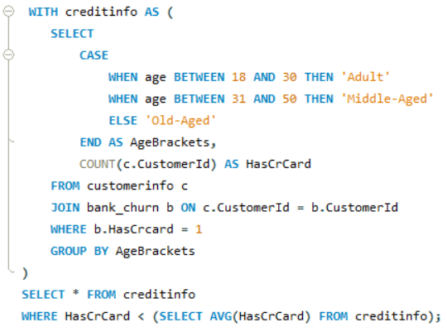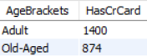

INSIGHTS:
- Adults (1400) and Old-Aged (874) were retrieved.
- The Old-Aged group has significantly fewer credit card holders compared to the average, showing lower adoption in this segment.
- Middle-Aged customers are missing from the output, meaning they likely have above-average ownership.

RECOMMENDATIONS:
- Target Old-Aged Customers:
- Design specialized credit card products with senior-friendly features (low fees, medical benefits, rewards on essential spending).
- Provide awareness campaigns to increase adoption in this age group.
- Leverage Middle-Aged Segment:
- Since they have higher-than-average adoption, use them for cross-selling premium or multiple card products.
- Retention & Engagement:
- For Adults, encourage early financial engagement with starter or lifestyle credit cards, ensuring long-term loyalty.

- Rank the Locations as per the number of people who have churned the bank and average balance of the customers.
APPROACH:
- Customers were grouped by Geography Location.
- For churned customers (Exited = 1), the following were calculated:
- Number of churned customers per location.
- Average balance of churned customers.
- Locations were then ranked by churn count using RANK().

OUTPUT:
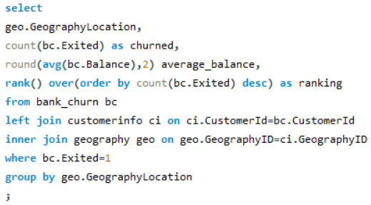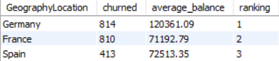

INSIGHTS:
- Germany has the highest churn (814) and also the highest average balance (~120K) — a critical segment as it represents valuable customers leaving.
- France has nearly the same churn volume (810) but with a much lower average balance (~71K).
- Spain shows the lowest churn (413) despite a similar average balance to France (~72K).
- The risk is greatest in Germany, not only because of high churn but also due to the significant customer value lost.

RECOMMENDATIONS:
- Priority Retention in Germany:
- Develop high-value retention programs targeting German customers (loyalty rewards, relationship managers, premium services).
- Investigate root causes of dissatisfaction (e.g., product features, competition, customer service quality).
- Address Churn in France:
- Although balances are lower, churn volume is still high — suggesting customer engagement issues.
- Consider personalized offers, better product fit, and improved customer experience for French customers.
- Leverage Spain’s Stability:
- Spain shows relatively low churn — analyze what is working there (products, service, policies) and replicate successful strategies in other geographies.
- Segmentation-Based Retention:
- Differentiate strategies: focus on value preservation in Germany and volume reduction in France, while maintaining stability in Spain.

- As we can see that the “CustomerInfo” table has the CustomerID and Surname, now if we have to join it with a table where the primary key is also a combination of CustomerID and Surname, come up with a column where the format is “CustomerID_Surname”.

OUTPUT:
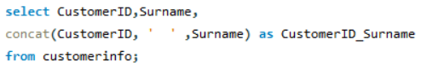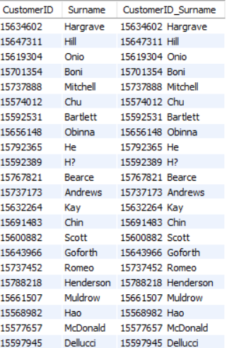

- Without using “Join”, can we get the “ExitCategory” from ExitCustomers table to Bank_Churn table? If yes do this using SQL.

APPROACH:
- yes we do his by using 'Select' clause to select columns and 'Where' clause to match column column in two tables
OUTPUT:
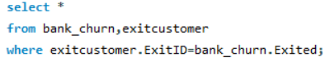
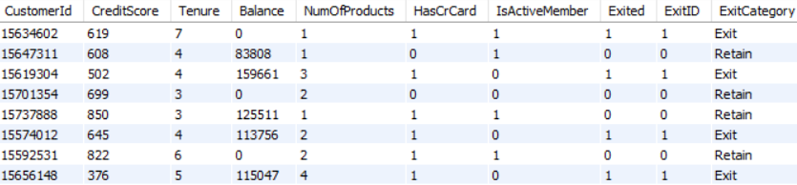

- Were there any missing values in the data, using which tool did you replace them and what are the ways to handle them?
- No there are no missing values but there are some null rows in the data. By using Power Query editor I handled them. And after that when I am getting the data to SQL then the data is getting corrupt so I made CSV file of that data (Separately) then I imported the data into SQL and then I made the connections.

- Write the query to get the customer IDs, their last name, and whether they are active or not for the customers whose surname ends with “on”.

APPRAOCH:
- Queried the database for customers whose surname ends with “on” (WHERE ci.Surname LIKE '%on').
- Retrieved CustomerID, Last Name, and Active Category by joining with the relevant tables (customer info, exit status, active status, etc.).
- Displayed whether the customer is an Active Member or Inactive Member.

OUTPUT:
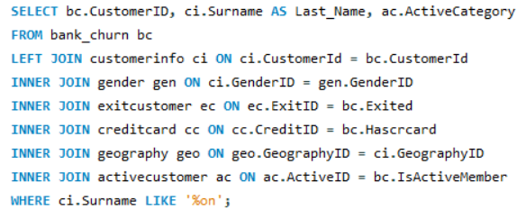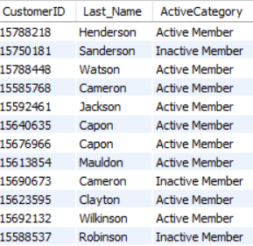

INSIGHTS:
- Both active and inactive members are present among customers with surnames ending in “on”.
- Majority of customers in this subset are Active Members, with only a few inactive (e.g., Sanderson, Cameron, Robinson).
- This shows no strong relationship between surname patterns and customer activity (as expected).
- However, the query demonstrates the ability to filter customers by specific string-matching conditions while combining multiple attributes.

RECOMMENDATIONS:
- Extend Filtering Use Cases:
  - Similar queries can be used to segment customers based on other attributes (e.g., location, product usage, demographic filters) for targeted campaigns.
- Active vs Inactive Analysis:
  - Expand beyond surname filtering — analyze factors that drive inactivity (e.g., product holding, engagement, credit score) to improve retention.
- Practical Applications:
  - This surname-based query is mainly demonstrative. In real scenarios, use such queries to support marketing personalization (e.g., targeting customers with specific traits or regions).

- Can you observe any data disrupency in the Customer’s data? As a hint it’s present in the IsActiveMember and Exited columns. One more point to consider is that the data in the Exited Column is absolutely correct and accurate.

APPROACH:
- Queried customers where Exited = 1 (churned) and at the same time IsActiveMember = 1 (active).
- Since the Exited column is considered accurate, any overlap indicates a data quality issue in the IsActiveMember field.

OUTPUT:
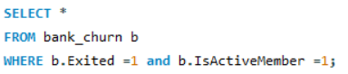
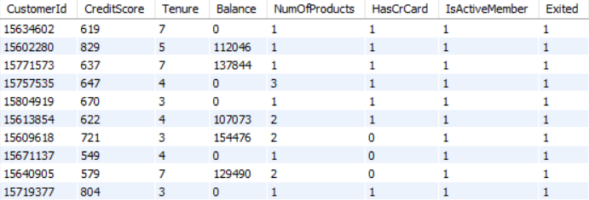

INSIGHTS:
- The output shows several customers marked as both Active and Exited, which is logically inconsistent.
- This discrepancy indicates data integrity issues — IsActiveMember is not being updated correctly after a customer exits.
- Such conflicts can lead to misleading analysis, especially in churn prediction or customer segmentation.

RECOMMENDATIONS:
- Data Validation Rules:
  - Implement rules ensuring that when a customer is marked as Exited = 1, their IsActiveMember field is automatically set to 0.
- Data Cleansing:
  - Perform a one-time cleanup to correct historical inconsistencies in the dataset.
- System Synchronization:
  - Review ETL/data pipeline processes to ensure real-time synchronization between churn status and active membership fields.
- Ongoing Monitoring:
  - Set up data quality checks (e.g., invalid combinations detection) as part of regular audits to prevent recurrence.

SUBJECTIVE QUESTIONS:

  - Customer Behavior Analysis: What patterns can be observed in the spending habits of long-term customers compared to new customers, and what might these patterns suggest about customer loyalty?
APPROACH:
- Segment Customers by Tenure:
- Define short-term (0–3 years), mid-term (3–5 years), and long-term (6+ years).
- Compare churn, spending (balance), and product adoption across these groups.
- Overlay Spending Habits with Churn:
- Check whether higher balance/salary groups show lower churn (they don’t here).
- Evaluate Tenure Impact on Loyalty:
- See which tenure groups are at highest risk.
- Look at product adoption vs. churn within tenure groups.
- Identify Loyalty Drivers:
- Balance/salary stability vs. emotional trust/relationship maturity.

OUTPUT:
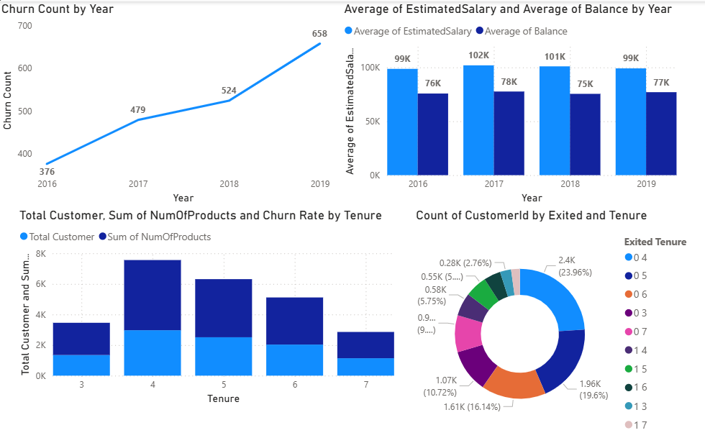

INSIGHTS:
- Churn Increasing Over Time:
- Even though average salaries & balances are stable, churn rose 76% from 2016–2019.
- Suggests dissatisfaction is not financial, but service/experience-related.
- Early Tenure Customers are Most Vulnerable:
- 3–5 year customers churn more despite higher product adoption.
- Indicates products don’t guarantee loyalty.
- Long-Term Customers are Loyal:
- Customers with tenure 6–7 years churn less, even with fewer products.
- Trust, habit, and relationship maturity are stronger loyalty drivers.
- Spending Patterns Don’t Predict Loyalty:
- Average balance & salary do not correlate with churn.
- Meaning: wealthy customers are not necessarily loyal.

RECOMMENDATIONS:
- Strengthen Onboarding & Early Retention (First 3–5 Years):
- Proactively monitor new/mid-tenure customers.
- Offer personalized engagement, check-ins, and targeted service improvements.
- Build Emotional Loyalty Beyond Products:
- Focus on service quality, customer support, and trust-building.
- Loyalty rewards (e.g., exclusive perks, recognition programs) for customers crossing the 3-year mark.
- Introduce Churn Prediction Models:
- Use tenure + churn history + engagement to flag at-risk customers (especially in year 3–5).
- Enhance Customer Experience Over Financial Offers:
- Since spending capacity doesn’t prevent churn, prioritize ease, convenience, and personalization over discounts.
- Leverage Long-Term Customers as Advocates:
- Encourage long-tenure customers to provide testimonials, referrals, or mentoring programs for new customers.

  - Product Affinity Study: Which bank products or services are most commonly used together, and how might this influence cross-selling strategies?
APPROACH:
- Analyze churn by number of products.
- Identify where customers are most loyal vs. most at risk.
OUTPUT:
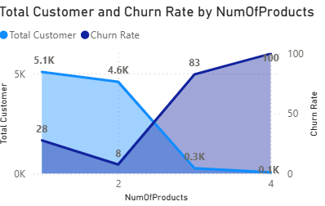

INSIGHTS:
- 2 Products = Loyalty Sweet Spot:
- Customers with 2 products have the lowest churn (8%) → strong retention.
- This is the most stable and profitable customer base.
- 1 Product Customers are Vulnerable:
- Still a large group (5.1K) but churn is 28% → they are at risk unless upgraded or engaged further.
- High Product Adoption (3–4) Backfires:
- Customers with 3–4 products churn at extreme rates (83–100%).
- Indicates over-selling or misaligned cross-selling, possibly pushing customers into products they don’t need.
- Cross-Selling Needs Refinement:
- Current cross-selling may not be value-driven → instead of strengthening loyalty, it accelerates attrition in high product groups.

RECOMMENDATIONS:
- Move 1-product customers → 2 products (best retention zone).
- Avoid aggressive cross-selling beyond 2 products.
- Focus on relevant, value-driven bundles (not just more products).
- Educate customers on benefits to reduce dissatisfaction.

  - Geographic Market Trends: How do economic indicators in different geographic regions correlate with the number of active accounts and customer churn rates?

APPROACH:
- Compare active customer base and churn rate across regions.
- Identify markets with high retention vs. high risk.
- Link churn patterns to regional economic or competitive factors.

OUTPUT:
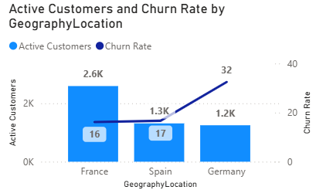

INSIGHTS:
- France is the strongest market: largest customer base + lowest churn.
- Spain shows balanced growth and average churn.
- Germany has smaller base but double the churn → possible competitive pressure, weaker service fit, or economic mismatch.

RECOMMENDATIONS:
- Defend France: Strengthen loyalty programs to maintain advantage.
- Grow Spain: Invest in targeted acquisition and retention campaigns (room to scale).
- Fix Germany:
- Investigate churn drivers (service gaps, pricing, competition).
- Tailor offerings to local needs instead of standard cross-sell.
- Consider customer feedback surveys & retention incentives.

  - Risk Management Assessment: Based on customer profiles, which demographic segments appear to pose the highest financial risk to the bank, and why?
APPROACH:
- Compare churn rates across age groups to assess financial risk.
- Higher churn segments = higher risk, as they may drive revenue loss.
- Factor in both customer base size (exposure) and churn % (risk level).

OUTPUT:
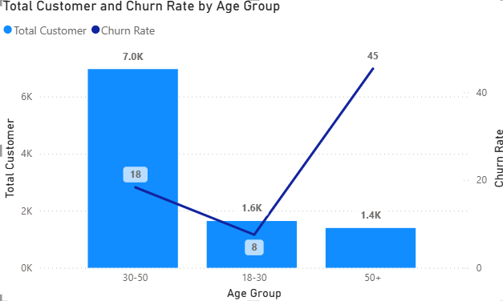

INSIGHTS:
- 50+ age group: Highest churn rate (45%) → biggest financial risk per customer.
- 30–50 age group: Largest base (7K) with moderate churn (18%) → highest overall exposure risk.
- 18–30 group: Small base + lowest churn (8%) → lowest risk.

RECOMMENDATIONS:
- 50+ Segment – Retention Focus:
- Investigate churn causes (tech adoption barriers, trust issues, service mismatch).
- Provide dedicated support, simplified digital tools, or loyalty perks.
- 30–50 Segment – Prevent Volume Loss:
- Strengthen engagement (personalized offers, bundled products).
- Since they form the largest base, even small churn reductions create large financial impact.
- 18–30 Segment – Growth Opportunity:
- Maintain low churn via digital-first products and lifestyle-based offerings.
- Encourage long-term loyalty early with student/young professional packages.

  - Customer Tenure Value Forecast: How would you use the available data to model and predict the lifetime (tenure) value in the bank of different customer segments?

APPROACH:
- Clean & prepare data (tenure, churn, balance, products, activity).
- Build models: churn prediction (Exit/Retain) + tenure forecast (Years).
- Estimate CLV = predicted tenure × revenue proxies (balance, products, salary).

OUTPUT:
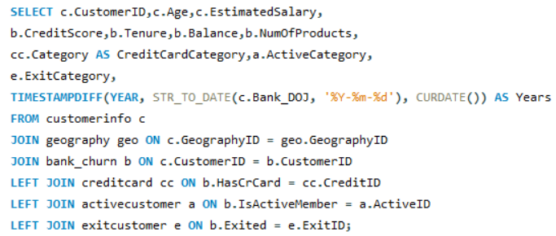

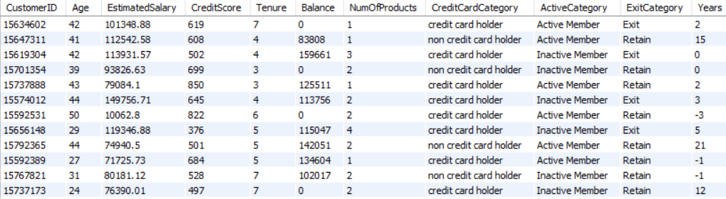

INSIGHTS:
- Long tenure → active members, multiple products, higher balances.
- Short tenure → inactive members, low balance, single product, younger age.
- High balance + multiple products = highest CLV potential.

RECOMMENDATIONS:
- Retention: Target high-balance but short-tenure customers with loyalty offers.
- Cross-sell: Push more products to single-product customers.
- Segmentation:
  - Loyal High Value → VIP services
  - At-Risk High Value → retention focus
  - Stable Low Value → upsell
  - Low Value/Churn-prone → minimal effort

  - Marketing Campaign Effectiveness: How could you assess the impact of marketing campaigns on customer retention and acquisition within the dataset? What extra information would you need to solve this?

APPROACH:
To assess the impact of marketing campaigns on customer retention and acquisition within a dataset, one would typically use a combination of data analysis and statistical techniques. Here's a general approach we could take:
- Define key metrics for customer retention and acquisition.
      - For retention: customer churn rate, retention rate
      - For acquisition: new customer acquisition rate, customer acquisition cost (CAC)
- Segment data based on different marketing campaigns to analyze the impact of each campaign separately.
- Calculate the defined metrics for each segment and time period (e.g., monthly, quarterly, annually) to understand how each campaign affects customer retention and acquisition over time.
- Compare metrics across different campaigns to identify the most effective ones at retaining and acquiring customers.
- Use statistical tests (e.g., t-tests, ANOVA) to determine if differences in metrics between campaigns are statistically significant.

- Gather additional information for a comprehensive analysis:
- Customer demographics to understand if certain demographics respond better to certain campaigns.
- Campaign details (e.g., duration, channels used, messaging)
- Competitor data to understand the competitive landscape and its impact.
- External factors (e.g., economic conditions, seasonality, industry trends) that might affect customer behaviour.

  - Customer Exit Reasons Exploration: Can you identify common characteristics or trends among customers who have exited that could explain their reasons for leaving?

APPROACH:
- Analyze exit reasons by product ownership (credit cards, multiple products).
- Compare churn trends among single-product vs multi-product customers.
- Identify the “sweet spot” in product adoption where customers are most stable.

OUTPUT:
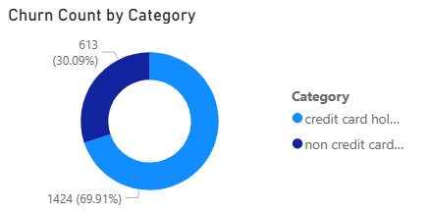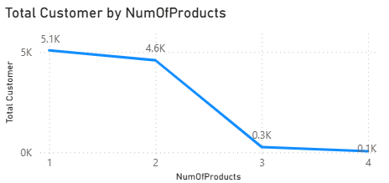

INSIGHTS:
- Credit Card Holders → 70% of exits: despite being engaged with at least one product, they leave more often.
- Non-Credit Card Holders → 30% exits: lower churn but also lower value.
- Number of Products:
- Majority of customers hold 1–2 products (≈9.7K).
- Very few hold 3–4 products (≈0.4K).
- Steep drop after 2 products → indicates difficulty in cross-selling beyond 2 products.
- Customers with only 1 product are most at risk of churn → low engagement.
- Customers with 3–4 products are very loyal but a very small base.

RECOMMENDATIONS:
- For Credit Card Customers (high churn):
  - Enhance loyalty programs (cashback, rewards).
  - Bundle credit cards with savings/investment products.
- For Single-Product Customers (5.1K, highest base):
  - Prioritize cross-sell (personal loans, insurance, digital wallets).
  - Offer starter bundles (e.g., salary account + credit card).
- For Multi-Product Customers (3–4 products, small group):
  - Maintain VIP experience (priority services, relationship managers).
  - Use them as advocates for referrals.
- Overall Strategy:
  - Focus on moving customers from 1 → 2 products (easiest gain).
  - Strengthen retention of credit card holders (main exit group).
  - Expand cross-sell campaigns with targeted offers (AI-based product recommendations).

  - Are 'Tenure', 'NumOfProducts', 'IsActiveMember', and 'EstimatedSalary' important for predicting if a customer will leave the bank?

APPROACH:
- Compare customer salary contribution across tenure, activity status, and product count.
- Use visualizations (like the stacked bar chart) to see patterns in salary vs retention.
- Run feature importance tests (e.g., logistic regression coefficients, tree-based feature importance) to confirm impact on churn.

OUTPUT:
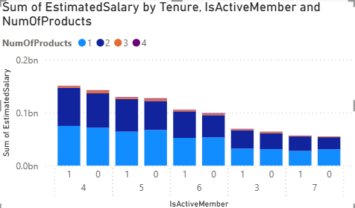

INSIGHTS:
- IsActiveMember:
- Active members contribute higher salary volumes and are less likely to churn.
- Inactive members, even with good salaries, are at higher churn risk → engagement is more critical than income.
- NumOfProducts:
- Customers with 1–2 products dominate salary contributions.
- Customers with 3–4 products are fewer but show higher loyalty.
- Indicates cross-selling improves retention.
- Tenure:
- Mixed effect: mid-tenure customers (3–6 years) sometimes show higher churn, possibly due to dissatisfaction plateau.
- EstimatedSalary:
- Salary alone is not a strong predictor of churn — both high and low salaries exist across active and inactive groups.
- Churn is more linked to engagement (Active status) + product count than raw income.

RECOMMENDATIONS:
- Engagement First → Focus retention on inactive members regardless of salary; engagement predicts churn better than income.
- Cross-Sell Products → Move single-product customers into multi-product bundles (cards, loans, investments) to lock in tenure.
- Mid-Tenure Watchlist → Customers in 3–6 years tenure should be targeted with loyalty offers (since churn spikes here).
- Salary Segmentation → Use salary only for value segmentation (high CLV vs low CLV), not as the main churn predictor.

  - Utilize SQL queries to segment customers based on demographics and account details.

APPROACH:
- SQL Case Logic – Create categories for:
  - Age → Youth, Young Adults, Middle Age, Senior
  - Credit Score → Poor, Average, Good
  - Balance → Low, Medium, High
  - Tenure → New, Moderate, Loyal
  - Credit Card → Holder / Non-Holder
- Joins – Link tables: customerinfo, bank_churn, gender, geography, creditcard.
- Segmentation Output – Each customer is assigned to multiple segments (age group, credit category, balance level, tenure category, and card status).

OUTPUT:
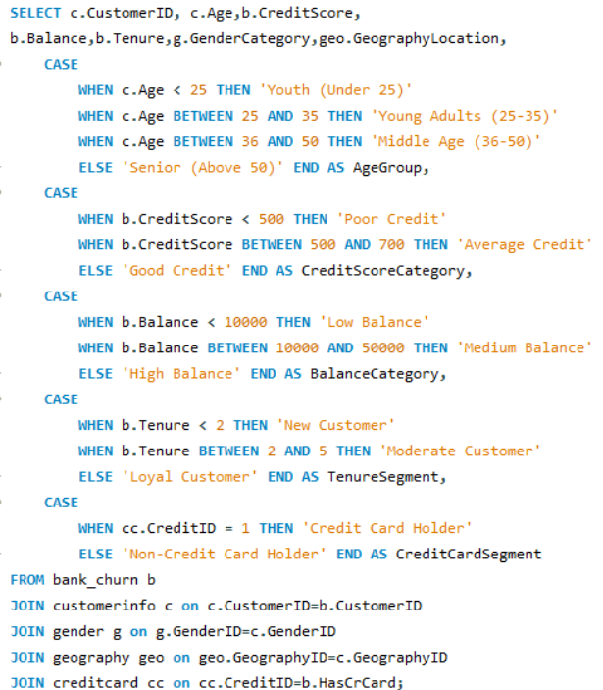

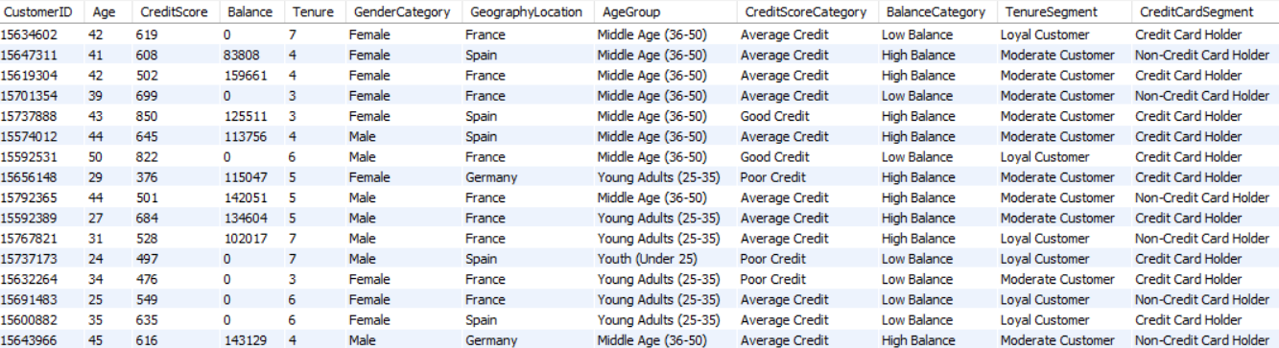

INSIGHTS:
- Age Segments:
  - Majority fall in Young Adults (25–35) and Middle Age (36–50) → prime banking customers.
- Credit Score Segments:
  - Many customers fall under Average Credit (500–700) → opportunity for credit improvement services.
- Balance Segments:
  - Customers are split between Low Balance and High Balance → indicates polarization in customer base.
- Tenure Segments:
  - Mix of Moderate Customers (2–5 years) and Loyal Customers (>5 years) → retention strategies needed for mid-tenure group.
- Credit Card Segments:
  - A large portion are Credit Card Holders, but this segment also shows higher churn risk (from earlier analysis).

RECOMMENDATIONS:
- Youth & Young Adults:
- Focus on digital banking, mobile-first services, starter credit products.
- Average Credit Group:
- Offer credit-building loans and financial literacy programs to move them into the “Good Credit” tier.
- High Balance Customers:
- Provide wealth management, investment, and premium relationship services.
- New & Moderate Tenure Customers:
- Loyalty campaigns, bundled offers, and engagement programs to prevent churn.
- Credit Card Holders:
- Enhance loyalty rewards, cashback, and personalized offers to reduce exit risk.

  - How can we create a conditional formatting setup to visually highlight customers at risk of churn and to evaluate the impact of credit card rewards on customer retention?

OUTPUT:
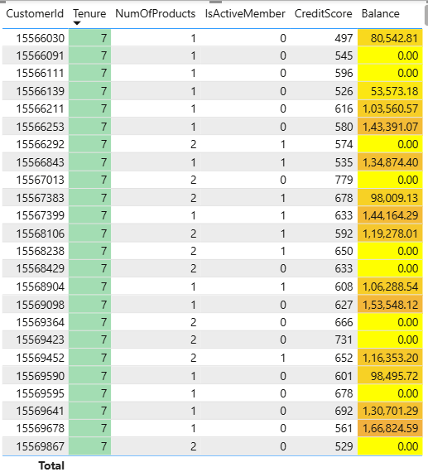

INSIGHTS:
- Customers with a credit score below 500 and a balance below 30,000 are at high risk of churn, which suggests that financial instability is a major driver of customer exit.
- Longer tenure customers (above 3 years) tend to be more loyal, but those with lower credit scores or minimal product engagement are exceptions and require targeted attention.
- The presence of a credit card may not directly reduce churn, but its impact could be tied to the type of rewards and category offered. Customers with higher balances and premium cards exhibit stronger retention.
- Customers with balances between 30,000 and 80,000 who use credit card rewards show improved retention, indicating that medium-balance customers are positively influenced by reward programs.

RECOMMENDATIONS:
- Create targeted retention programs for customers with credit scores below 500, offering personalized financial products and credit score improvement plans to increase retention and engagement.
- Optimize credit card rewards programs by tailoring them to higher-risk segments, especially those with medium balances (30,001 to 80,000), ensuring the rewards are aligned with customer preferences.
- Improve engagement strategies for new customers (tenure less than 3 years) through onboarding offers, better access to premium products, or incentives for increasing their balance.
- Monitor and adjust product offerings based on regional customer preferences and financial health by analysing geographic and balance-related churn patterns to fine-tune loyalty campaigns.

CONDITIONAL FORMATTING:
- Tenure:
- Customers with a tenure of 3 years or more are highlighted as more loyal, while those with less than 3 years are flagged as potential churn risks.

- Balance:
- Balances below 30,000 are flagged as financially vulnerable.
- Balances between 30,001 and 80,000 are moderate-risk customers.
- Balances above 80,000 are considered secure customers with strong engagement.

  - What is the current churn rate per year and overall as well in the bank? Can you suggest some insights to the bank about which kind of customers are more likely to churn and what different strategies can be used to decrease the churn rate?

APPROACH:
- Calculated churn rate per year and overall.
- Segmented churn by gender, credit score, number of products, and geography.
- Identified high-risk customer groups based on patterns in churn behavior.

OUTPUT:
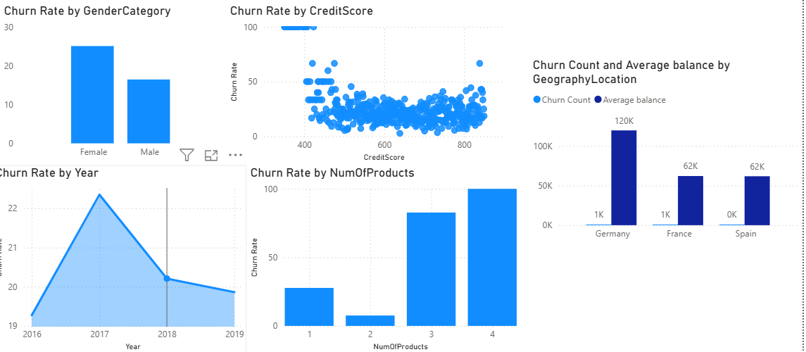

INSIGHTS:
- Gender: Female customers show higher churn than males.
- Credit Score: Low credit score customers (<600) have higher churn.
- Num of Products: Customers with 3–4 products churn the most → possible over-burdening or dissatisfaction.
- Geography: Germany has the highest churn (despite high balances), while France and Spain show lower churn.
- Yearly Trend: Churn peaked in 2017 (~22%) but declined afterward, possibly due to corrective measures.

RECOMMENDATIONS:
- Target High-Risk Groups:
- Retention campaigns for female customers and German customers.
- Offer credit counseling & personalized loan products for low-score customers.
- Re-evaluate Product Bundling: High churn among 3–4 product holders suggests product complexity or dissatisfaction → simplify packages or improve support.
- Geography-Specific Strategy: Focus retention investments in Germany with loyalty rewards and local engagement campaigns.
- Proactive Engagement: Use predictive churn models to flag at-risk customers early and offer tailored retention offers.

  - Create a dashboard incorporating all the KPIs and visualization-related metrics. Use a slicer in order to assist in selection in the dashboard.
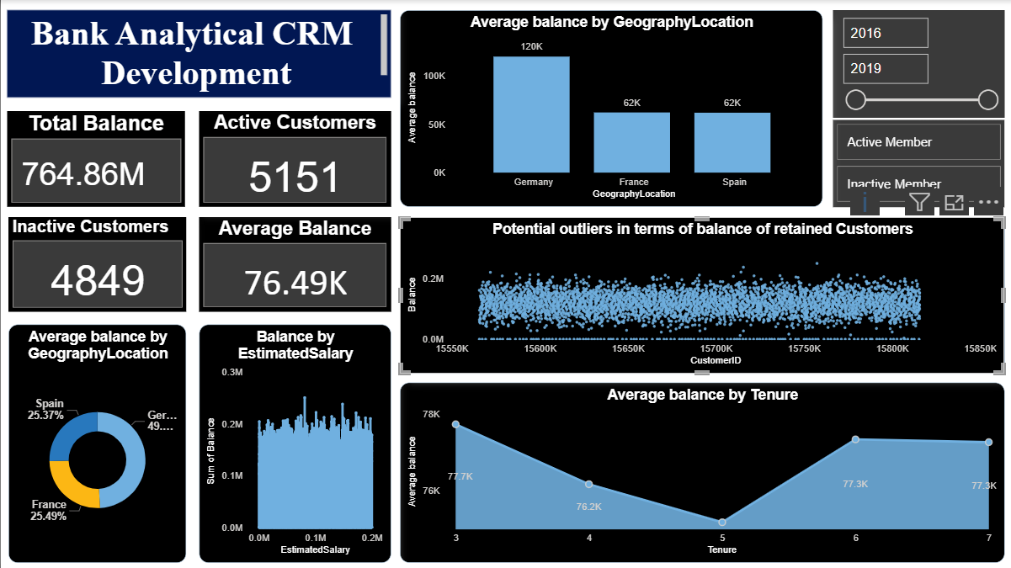
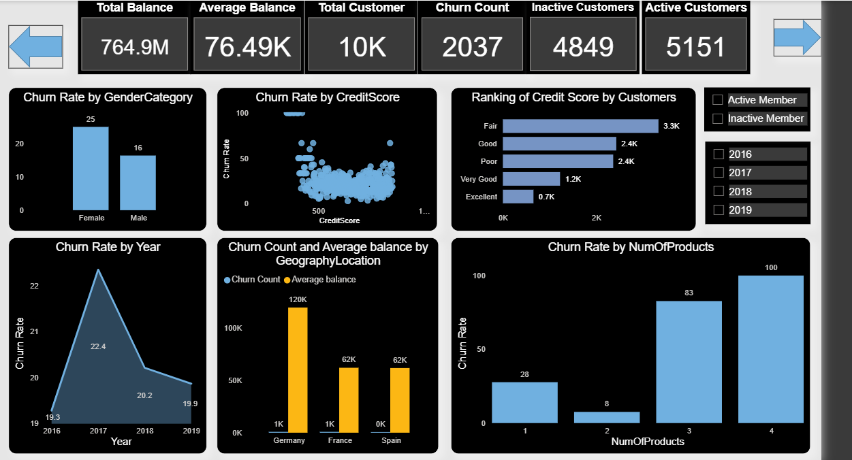
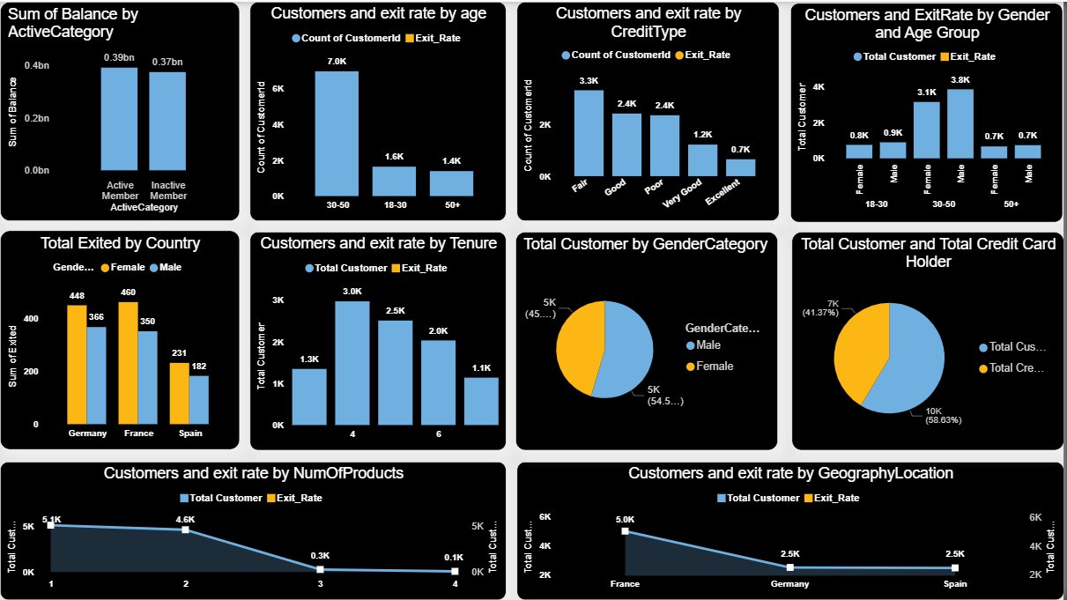
  - How would you approach this problem, if the objective and subjective questions weren't given?
If the objective and subjective questions weren't given, here’s how I would approach the problem of analysing the "Bank_Churn" dataset with the goal of uncovering insights and solving relevant business challenges:
- Understand Schema: Review ER diagram & key tables (customerinfo, bank_churn, exitcustomer).
- Data Prep: Handle missing values, resolve inconsistencies, format/rename columns, create unique keys.
- Key Metrics: Track churn rate, product usage, credit score impact, and tenure-based lifetime value.
- Segmentation: Group customers by demographics, account details, and churn behavior.
- SQL Insights:
- Churn by year, geography, gender
- Product affinity (cross-sell)
- Credit score impact
- Retention by product usage
- Visualization: Dashboards for churn, segmentation, product use; conditional formatting for at-risk customers; time-series churn trends.

RECOMMENDATIONS:
  - Retention: Loyalty programs, personalized offers, proactive engagement for high-risk groups.
  - Cross-Selling: Bundle products based on affinity to boost engagement.
  - Credit Score Support: Financial counselling for low-score customers to reduce churn

  - In the “Bank_Churn” table how can you modify the name of the “HasCrCard” column to “Has_creditcard”?

APPROACH:
This can be done by using SQL function named Alter which will allow modification, rename column will allow to change the column name. This is done by using a SQL query which is shown in the code given below:

OUTPUT:
