Uploading sample information into ISPyB from a spreadsheet

Dear user we are now beta-testing sample information upload into ISPyB using a standard template spreadsheet file. The following provides some guidelines on use.

An important caveat:
a) At present the spreadsheet will create a sample detailed in the spreadsheet if it is not present in the ISPyB database. Hence, you should take care when filling out the protein name, protein acronym and sample name fields (compulsory fields in the file) and ensure correct spelling etc. The next version will automatically harvest all sample information that has been received by the ESRF user office (i.e. from submitted sample sheets) to reduce human error (i.e. available proteins and protein acronyms will be available in pull-down mode in the relevant columns).

How to proceed

- First download the spreadsheet template file from within your ISPyB account (Click on shipment tab-> create sub-tab->upload from file). Here you will find a link to download an excel spreadsheet template file. For those not using MSoffice, you can read this file with openoffice 2.0.

- Rename the spreadsheet appropriately as the spreadsheet file name is used to automatically generate your shipment name within ISPyB qualified with the date of upload as follows :
FilePrefix_dd-mm-yyyy

(e.g. a file called walsh.xls uploaded on the 5th November 2006 would create a shipment name walsh_05-11-2006)

- The spreadsheet is formatted to allow entry of 50 samples in 5 pucks/baskets to mirror a shipment of a fully charged standard dry-shipper dewar that is in use with the SC3 sample changer. Hence, the workbook consists by default of 5 worksheets.

- Sample details are detailed in each column. Categories of data entry are colour coded. RED indicates required data, orange indicates highly recommended data entry and no colour indicates optional data entry. Data columns A-Q only, are uploaded to ISPyB (indicated in the spreadsheet by a blue outline box). Other columns and their function should be clear by their respective column labels.

- The required input fields indicated in RED in the template file are
  - Dewar label/name [required for creation of shipment]
  - Puck label/name [required for creation of shipment]
  - Protein acronym [required for creation of a sample]
  - Sample name [required for creation of a sample]

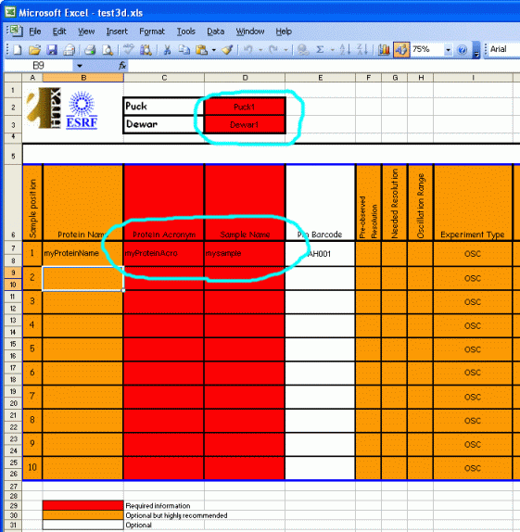
Please note that your diffraction image file name is constructed from this information as:

ProteinAcronym_SampleName_RunNumber_ImageNumber

- The orange columns are not compulsory but are highly recommended as they provide relevant information to allow DNA screening /sample ranking to be carried out.

- To ease data input for defined data entry such as space-group or experiment type the columns have pull-down entry allowing you to click on the appropriate entry. At present this applies to the columns: experiment type, space group and loop type. Please ensure that the pull-down menus are not activated when you save the file as this will result in failure to upload into the ISPyB database
