Standard Operating Procedure (SOP) for SmartTech
Graduation Project 2025
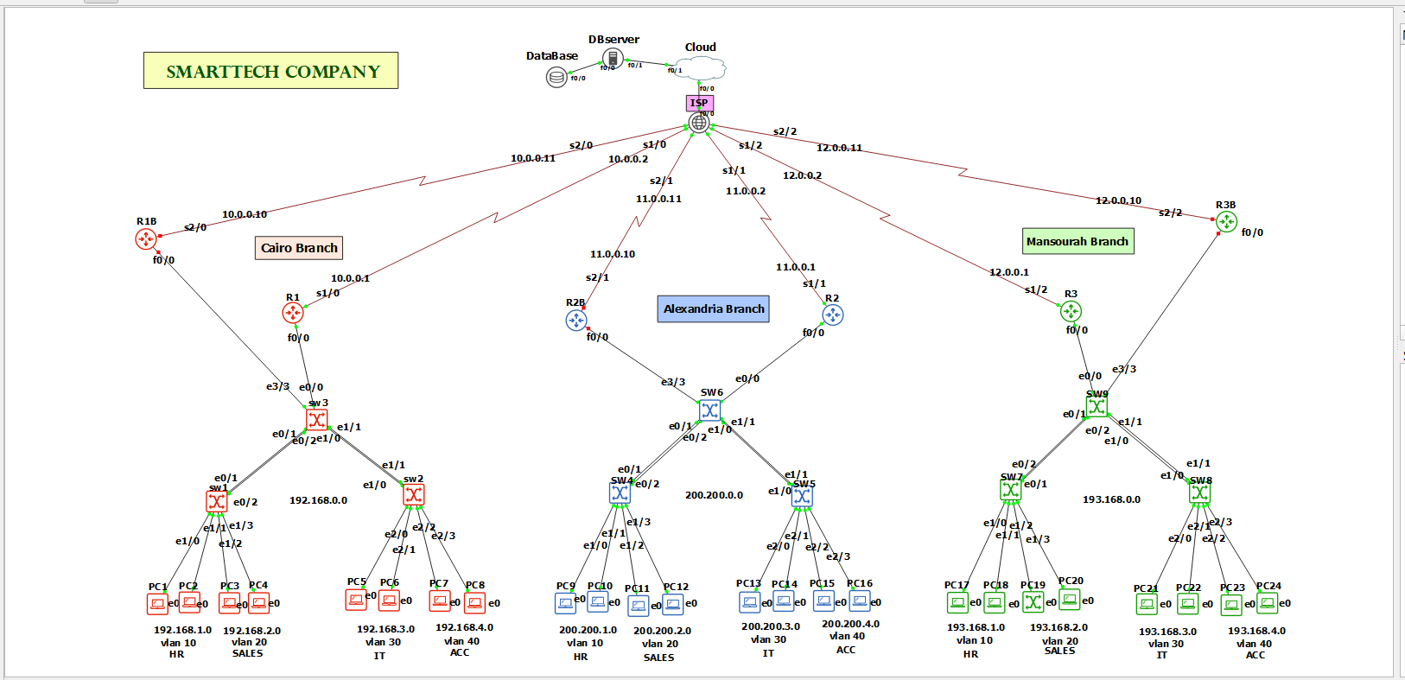

Project Objective:
Design and simulate a secure, redundant, and scalable enterprise network for SmartTech company with three branch offices (Cairo, Alexandria, Mansoura) using GNS3, three branches are connected to an ISP. Each branch includes routers and switches configured for VLANs, DHCP, ACLs, VRRP, GRE Tunnels, OSPF, and secure access. ensuring interconnectivity, internet access, redundancy, and segmentation of departments.

Network Design Overview:
1. Three Main Branches:
- Cairo Branch: Router R1
- Alexandria Branch: Router R2
- Mansoura Branch: Router R3

2. ISP & Core Router:
- Centralized ISP Router (R4) connects to all branches.
- Static Routing used between R4 and R1/R2/R3.

3. Internal Router Redundancy:
- Implemented VRRP between Routers 5, 6, and 7 for high availability.
Router Configuration
- Router on a Stick
Allows the router to handle multiple VLANs using sub-interfaces on a single physical interface.

- int f0/0.10
- encapsulation dot1q 10
- ip address 192.168.1.1 255.255.255.0

- int f0/0.20
- encapsulation dot1q 20
- ip address 192.168.2.1 255.255.255.0

- int f0/0.30
- encapsulation dot1q 30
- ip address 192.168.3.1 255.255.255.0

- int f0/0.40
- encapsulation dot1q 40
- ip address 192.168.4.1 255.255.255.0

show ip interface br

The same for Branch2,3 with change network

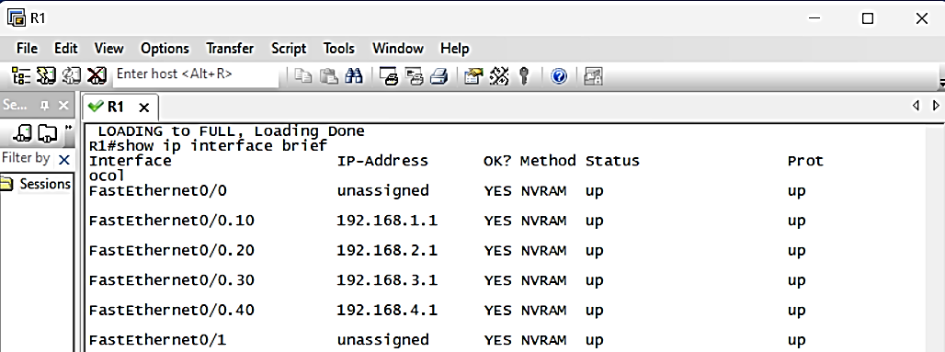

- DHCP
Enables automatic IP address distribution within VLANs using the router as a DHCP server.

- ip dhcp pool 10
- network 192.168.1.0 255.255.255.0
- default-router 192.168.1.1

- ip dhcp pool 20
- network 192.168.2.0 255.255.255.0
- default-router 192.168.2.0

- ip dhcp pool 30
- network 192.168.3.0 255.255.255.0
- default-router 192.168.3.1

- ip dhcp pool 40
- network 192.168.4.0 255.255.255.0
- default-router 192.168.4.1

The same for Branch2,3 with change network
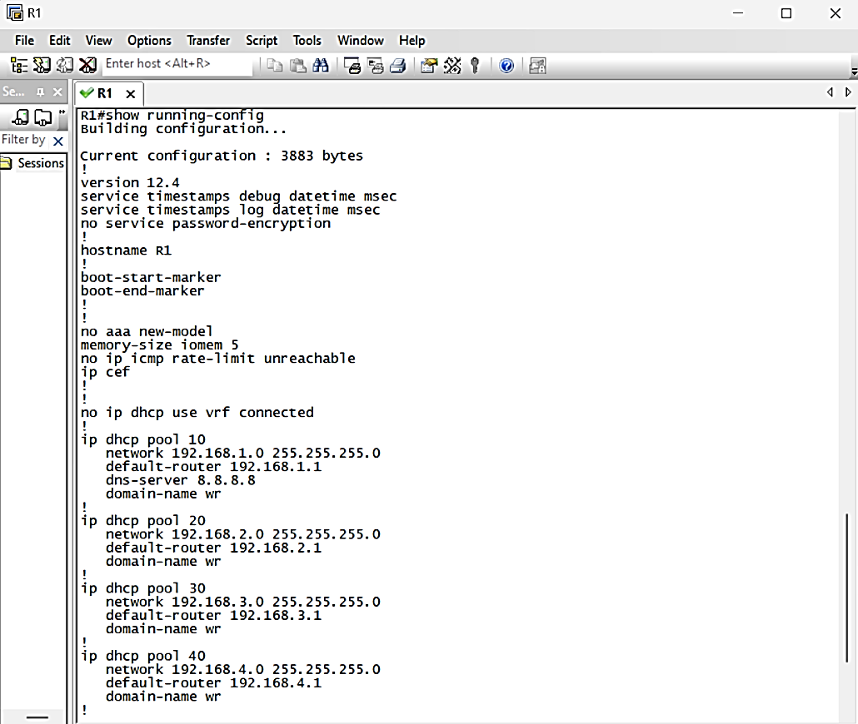

Switch Layer Configuration
Switches in each branch are configured with EtherChannel between pairs and multiple VLANs for department segmentation.
- EtherChannel
Aggregates links between switches for higher bandwidth and redundancy using PAgP or LACP.

EtherChannel between switches:
on sw1:
- int range e0/1-2
- channel-group 1 mode on
- do wr
- exit

on SW2:
- int range e1/0-1
- channel-group 2 mode on
- do wr
on sw3 (core SW):
- config t
- int range e0/1-2
- channel-group 1 mode on
- do wr

on sw3 (core SW):
- int range e1/0-1
- channel-group 2 mode on
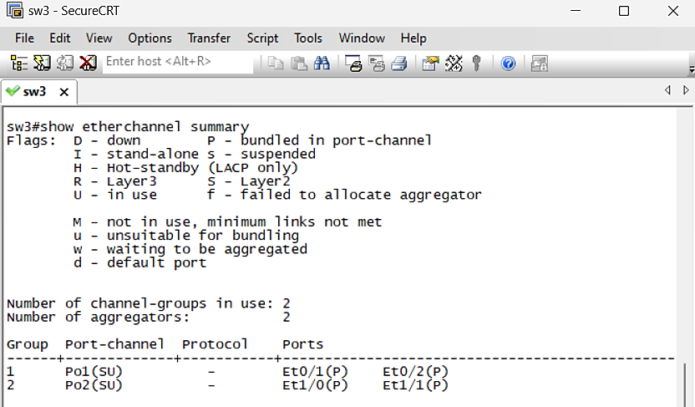
- do wr

show EtherChannel summary
The same for Branch2,3

- VLANs
Segregates network traffic by department: VLAN 10 (HR), VLAN 20 (Sales), VLAN 30 (IT), VLAN 40 (Accounting).

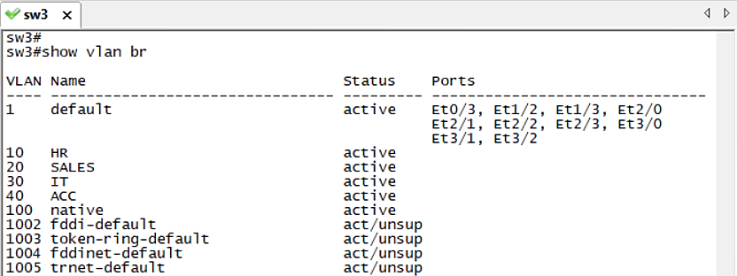
on sw3:
- vlan 10
- name HR
- vlan 20
- name SALES
- vlan 30
- name IT
- vlan 40
- name ACC
- vlan 100
- name native
- do wr
show vlan br

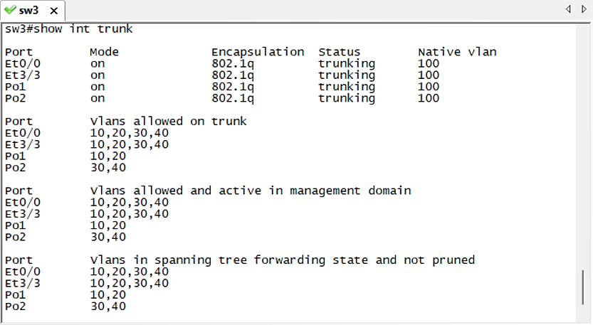
- TRUNK MODE:

- int e0/0
- switchport trunk encapsulation dot1q
- switchport mode trunk
- switchport trunk native vlan 100

int port 1
- switchport trunk encapsulation dot1q
- switchport mode trunk
- switchport trunk allowed vlan 10,20
- switchport trunk native vlan 100
int port 2
- switchport trunk encapsulation dot1q
- switchport mode trunk
- switchport trunk allowed vlan 30,40
- switchport trunk native vlan 100
show int trunk
The same for Branch2,3
on sw1
- vlan 10
- name HR
- vlan 20
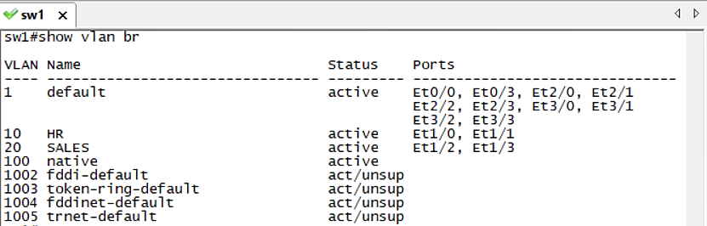
- name SALES
- vlan 100
- name native
- do wr

- int vlan 10
- no shutdown
- ip helper-address 192.168.1.1
- do wr

- int vlan 20
- no shutdown
- ip helper-address 192.168.2.1
- do wr
show vlan br
The same for Branch2,3

ACCESS MODE:
- int range e1/0-1
- no shutdown
- switchport mode access
- switchport access vlan 10
- do wr

- int range e1/2-3
- no shutdown
- switchport mode access
- switchport access vlan 20

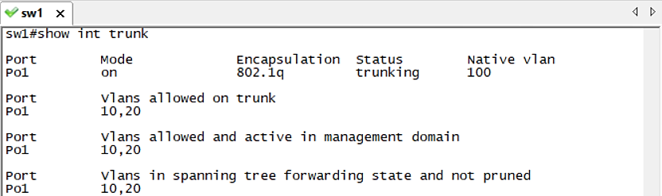
TRUNK MODE:
- int port 1
- switchport trunk encapsulation dot1q
- switchport mode trunk
- switchport trunk allowed vlan 10,20
- switchport trunk native vlan 100
on SW2
- vlan 30
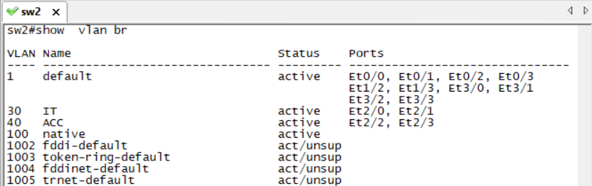
- name IT
- vlan 40
- name ACC
- vlan 100
- name native
- do wr

- int vlan 30
- no shutdown
- ip helper-address 192.168.3.1
- do wr

- int vlan 40
- no shutdown
- ip helper-address 192.168.4.1
- do wr

ACCESS MODE:
- int range e2/0-1
- no shutdown
- switchport mode access
- switchport access vlan 30
- do wr

- int range e2/2-3
- no shutdown
- switchport mode access
- switchport access vlan 40

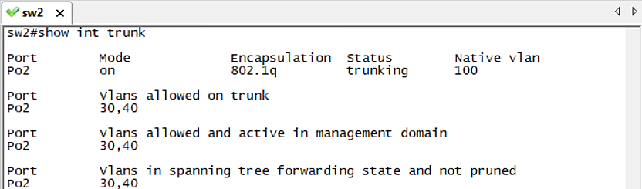
TRUNK MODE:
- int port 2
- switchport trunk encapsulation dot1q
- switchport mode trunk
- switchport trunk allowed vlan 30,40
- switchport trunk native vlan 100

The same for Branch2,3

Network Security Features
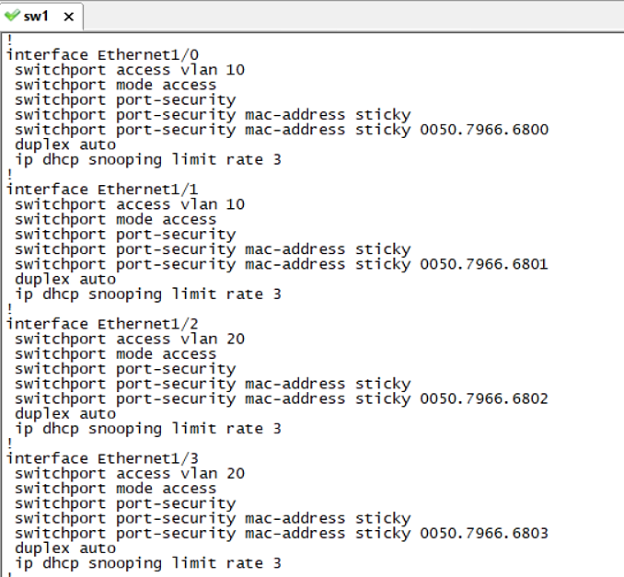
Security is enhanced through ACLs, SSH access, and DHCP Snooping on switches.
- PORT SECURITY
ON SW1
- int e1/0
- Switchport mode access
- Switchport port-security
- Switchport port-security mac-address sticky
- do wr
ON SW2
- int e2/0
- Switchport mode access
- Switchport port-security
- Switchport port-security mac-address sticky
- do wr
show port- security int e1/0
// (this command used when the cable break down and reconnect again)
- Shutdown
- no shutdown
The same for Branch2,3
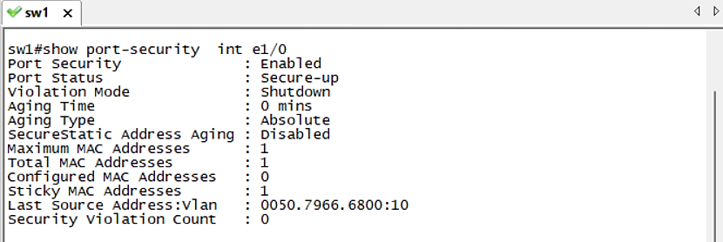

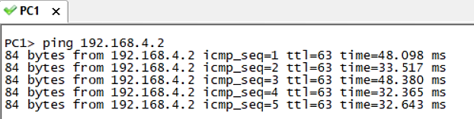
- ACL

  - HR -> ACC
  - SALES -> ACC
  - IT -> HR, SALES, ACC
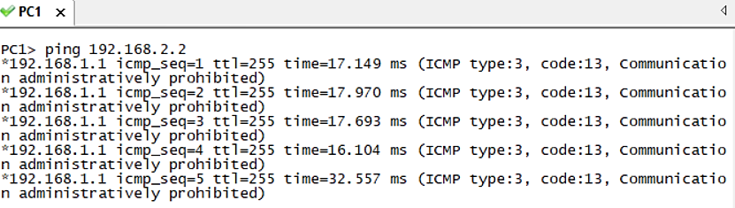
  - ACC-> HR, SALES

  - ip access-list extended vlan-filter
  - permit udp any eq 68 any eq 67
  - permit udp any eq 67 any eq 68
  - deny ip 192.168.1.0 0.0.0.255 192.168.2.0 0.0.0.255
  - deny ip 192.168.1.0 0.0.0.255 192.168.3.0 0.0.0.255
  - deny ip 192.168.2.0 0.0.0.255 192.168.1.0 0.0.0.255
  - deny ip 192.168.2.0 0.0.0.255 192.168.3.0 0.0.0.255
  - deny ip 192.168.4.0 0.0.0.255 192.168.3.0 0.0.0.255
  - permit ip any any

  - int f0/0.10
  - ip access-group vlan-filter in

  - int f0/0.20
  - ip access-group vlan-filter in

  - int f0/0.30
  - ip access-group vlan-filter in

  - int f0/0.40
  - ip access-group vlan-filter in

show ip access-lists, //ping by Gateway
The same for Branch2,3

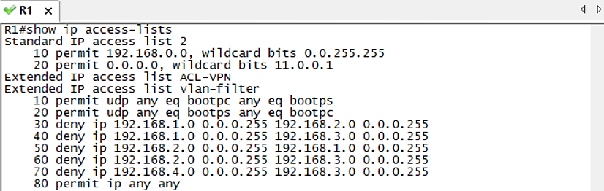
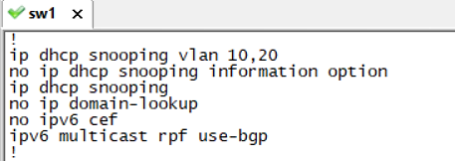
- DHCP SECURITYTURNK MODE

ON SW1
- ip dhcp snooping
- ip dhcp snooping vlan 10,20
- no ip dhcp snooping information option
- do wr

- int port 1
- Ip dhcp snooping trust
- do wr

BETWEEN SW & PCs:
- int e1/0
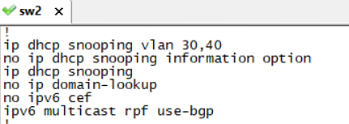
- Ip dhcp snooping limit rate 3

ON SW2
- ip dhcp snooping
- ip dhcp snooping vlan 30,40
- no ip dhcp snooping information option
- do wr

- int port 1
- Ip dhcp snooping trust
- do wr
- exit

BETWEEN SW & PCs:
- int e2/0
- Ip dhcp snooping limit rate 3
The same for Branch2,3

Static Routing (ISP)
Defines fixed routes between the ISP and branch routers for
Internet access or external communication.

Between router and isp router.
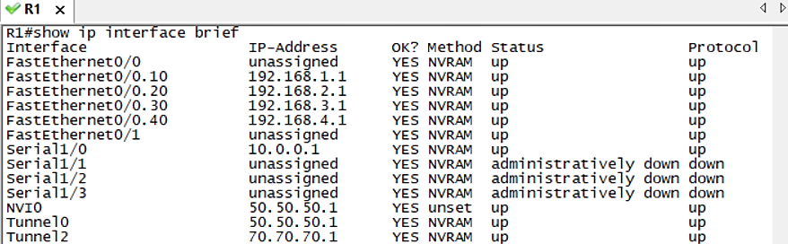
on R1
- int s1/0
- ip address 10.0.0.1 255.255.255.252
- no shutdown
- do wr
- exit
- ip route 0.0.0.0 0.0.0.0 10.0.0.2

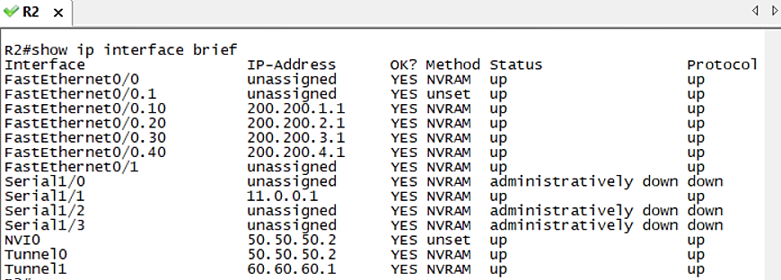
on R2
- int s1/1
- ip address 11.0.0.1 255.255.255.0
- no shutdown
- do wr
- exit
- ip route 0.0.0.0 0.0.0.0 11.0.0.2

on R3
- int s1/2
- ip address 12.0.0.1 255.255.255.0
- no shutdown
- do wr
- exit
- ip route 0.0.0.0 0.0.0.0 12.0.0.2

on R5
- int s2/0
- ip address 10.0.0.10 255.255.255.0
- no shutdown
- do wr
- exit
- ip route 0.0.0.0 0.0.0.0 10.0.0.11

on R6
- int s2/1
- ip address 11.0.0.10 255.255.255.0
- no shutdown
- do wr
- exit
- ip route 0.0.0.0 0.0.0.0 11.0.0.11

on R7
- int s2/2
- ip address 12.0.0.10 255.255.255.0
- no shutdown
- do wr
- exit
- ip route 0.0.0.0 0.0.0.0 12.0.0.11

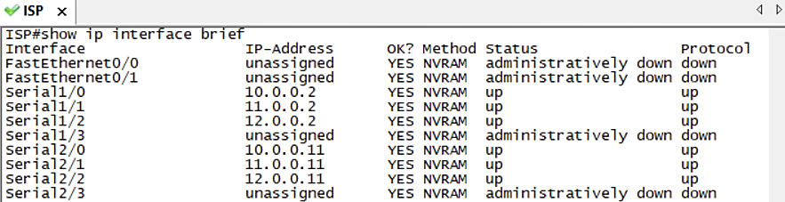
on R4 (ISP)
- int s1/0
- ip address 10.0.0.2 255.255.255.0
- no shutdown

- int s1/1
- ip address 11.0.0.2 255.255.255.0
- no shutdown

- int s1/2
- ip address 12.0.0.2 255.255.255.0
- no shutdown

- int s2/0
- ip address 10.0.0.11 255.255.255.0
- no shutdown

- int s2/1
- ip address 11.0.0.11 255.255.255.0
- no shutdown

- int s2/2
- ip address 12.0.0.11 255.255.255.0
- no shutdown
show ip interface brief
VPN Tunnel (GRE) + OSPF
Establishes site-to-site VPNs over GRE tunnels between branches with OSPF for dynamic routing.

Before VPN Configuration
NAT
on R1
- access-list 2 permit 192.168.0.0 0.0.255.255
- interface f0/0
- ip nat inside
- do wr

- interface serial 1/0
- ip nat outside
- do wr
- ip nat inside source list 2 interface s1/0 overload

on R2
- access-list 2 permit 192.168.0.0 0.0.255.255
- interface f0/0
- ip nat inside
- do wr
- exit
- interface serial 1/1
- ip nat outside
- do wr
- exit
- ip nat inside source list 2 interface s1/0 overload
on R3
- access-list 2 permit 192.168.0.0 0.0.255.255
- interface f0/0
- ip nat inside
- do wr
- interface serial 1/2
- ip nat outside
- do wr
- ip nat inside source list 2 interface s1/0 overload
BETWEEN R1, R2 (Create GRE Tunnel)

ON R1/Tunnel0
- interface Tunnel0
- ip address 50.50.50.1 255.255.255.0
- tunnel mode gre ip
- tunnel source 10.0.0.1
- tunnel destination 11.0.0.1
- do wr

ON R2/Tunnel0
- interface Tunnel0
- ip address 50.50.50.2 255.255.255.0
- tunnel mode gre ip
- tunnel source 11.0.0.1
- tunnel destination 10.0.0.1
- do wr
BETWEEN R2, R3(Create GRE Tunnel)

ON R2/Tunnel1
- interface Tunnel1
- ip address 60.60.60.1 255.255.255.0
- tunnel mode gre ip
- tunnel source 11.0.0.1
- tunnel destination 12.0.0.1
ON R3/Tunnel1
- interface Tunnel0
- ip address 60.60.60.2 255.255.255.0
- tunnel mode gre ip
- tunnel source 12.0.0.1
- tunnel destination 11.0.0.1

BETWEEN R1, R3(Create GRE Tunnel)
ON R1/Tunnel12
- interface Tunnel2
- ip address 70.70.70.1 255.255.255.0
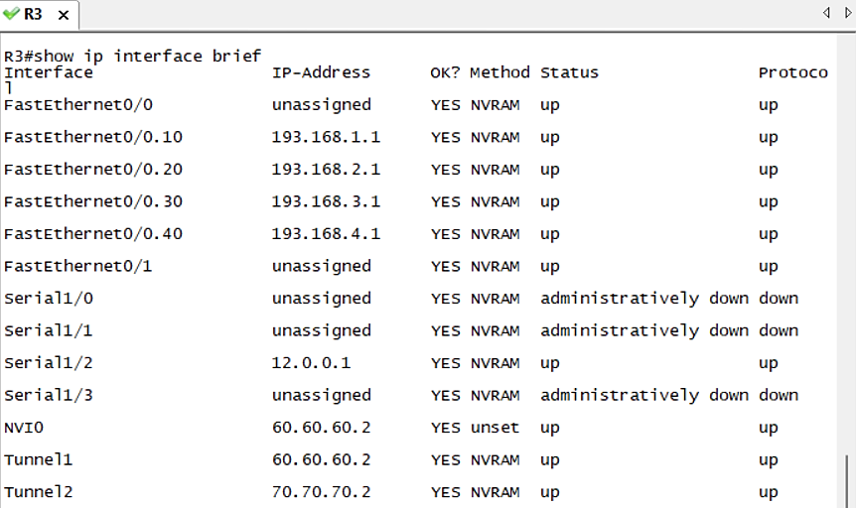
- tunnel mode gre ip
- tunnel source 10.0.0.1
- tunnel destination 12.0.0.1
ON R3/Tunnel2
- interface Tunnel2
- ip address 70.70.70.2 255.255.255.0
- tunnel mode gre ip
- tunnel source 12.0.0.1
- tunnel destination 10.0.0.1
OSPF

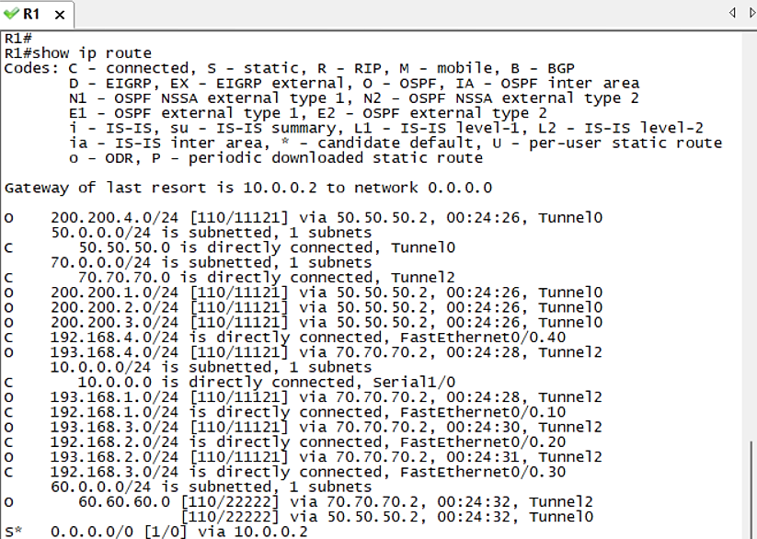
ON R1
- router ospf 1
- network 50.50.50.1 0.0.0.0 area 0
- network 192.168.0.0 0.0.255.255 area 0
- network 70.70.70.1 0.0.0.0 area 0
- network 192.168.0.0 0.0.255.255 area 0
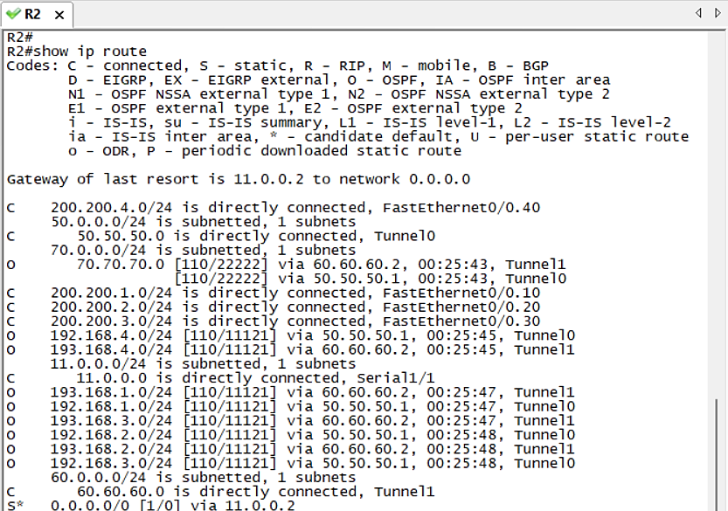
ON R2
- router ospf 1
- network 50.50.50.2 0.0.0.0 area 0
- network 200.200.0.0 0.0.255.255 area 0
- network 60.60.60.1 0.0.0.0 area 0
- network 200.200.0.0 0.0.255.255 area 0

ON R3
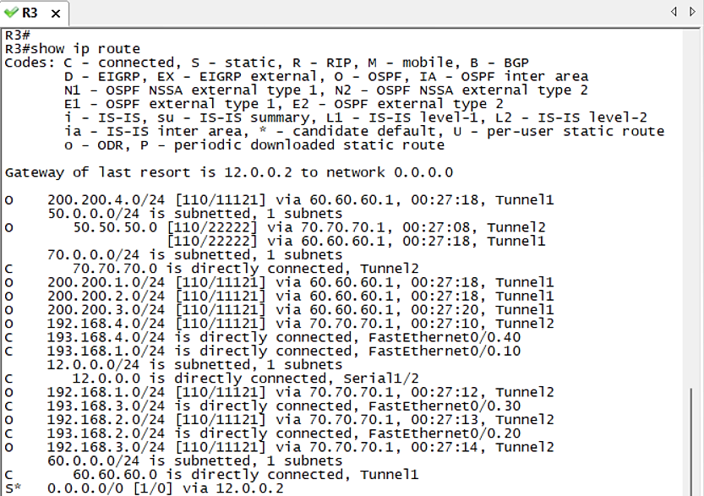
- router ospf 1
- network 60.60.60.2 0.0.0.0 area 0
- network 193.168.0.0 0.0.255.255 area 0
- network 70.70.70.2 0.0.0.0 area 0
- network 193.168.0.0 0.0.255.255 area 0
show ip route
VRRP
Provides redundancy by creating a virtual IP for default gateway
between a main and backup router.
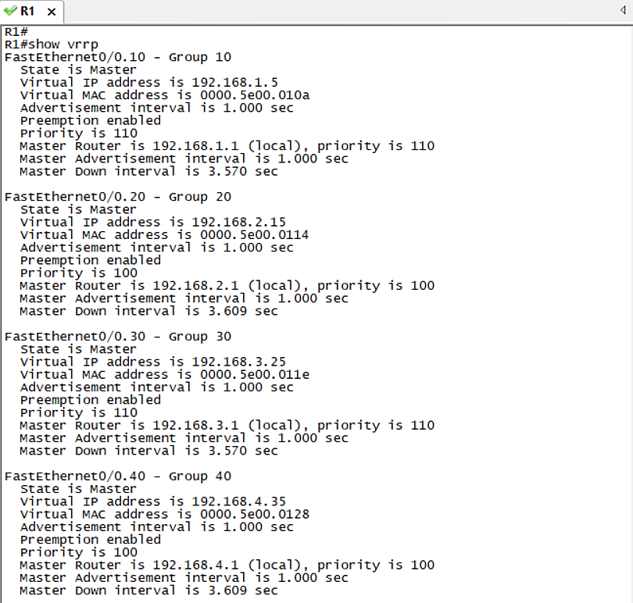
ON R1
- int f0/0.10
- vrrp 10 ip 192.168.1.5
- vrrp 10 priority 110
- int f0/0.20
- vrrp 20 ip 192.168.2.15
- vrrp 20 priority 110

- int f0/0.30
- vrrp 30 ip 192.168.3.25
- vrrp 30 priority 110

- int f0/0.40
- vrrp 40 ip 192.168.4.35
- vrrp 40 priority 110

ON R5
- int f0/0.10
- ip address 192.168.1.10 255.255.255.0
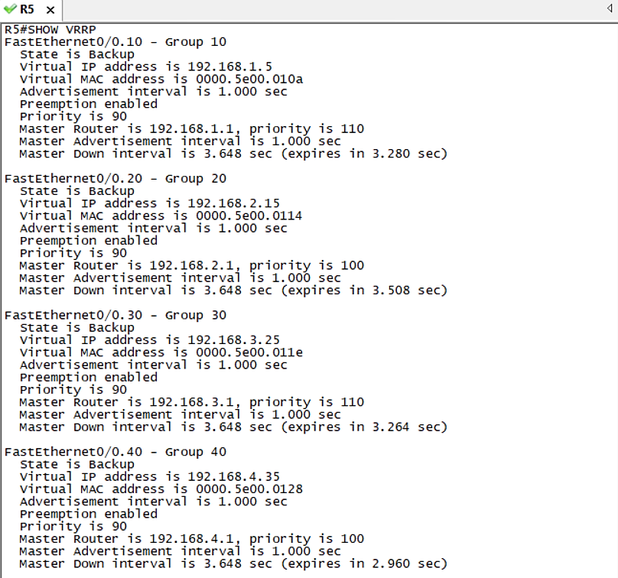
- vrrp 10 ip 192.168.1.5
- vrrp 10 priority 90

- int f0/0.20
- ip address 192.168.2.20 255.255.255.0
- vrrp 20 ip 192.168.2.15
- vrrp 20 priority 90

- int f0/0.30
- ip address 192.168.3.30 255.255.255.0
- vrrp 30 ip 192.168.3.25
- vrrp 30 priority 90
- int f0/0.40
- ip address 192.168.4.40 255.255.255.0
- vrrp 40 ip 192.168.4.35
- vrrp 40 priority 90
show vrrp
SSH
Secures remote administrative access to routers by encrypting the session.
- line vty 0 4
- login local
- do wr
- exit
- username Graduation_project password 1234
- ip domain-name smartTech.com
- crypto key generate rsa modulus 1024
- ip ssh version 2
- do wr
show crypto key mypubkey rsa
