SOP – MySQL Server Installation and Remote Access
Objective:
Set up MySQL Server on Ubuntu, configure it for remote access, and create a user ('student') to allow database team members to connect.
Steps:
- Download and Install Ubuntu Server
- Download Ubuntu Server ISO from the official website: https://ubuntu.com/download
- Boot the ISO on VMware Workstation.
- Follow the installation steps: select language, time zone, and keyboard; create a local user account.
- After installation, log in to your Ubuntu system.

- Update the System
- Open the terminal and run:
- sudo apt update

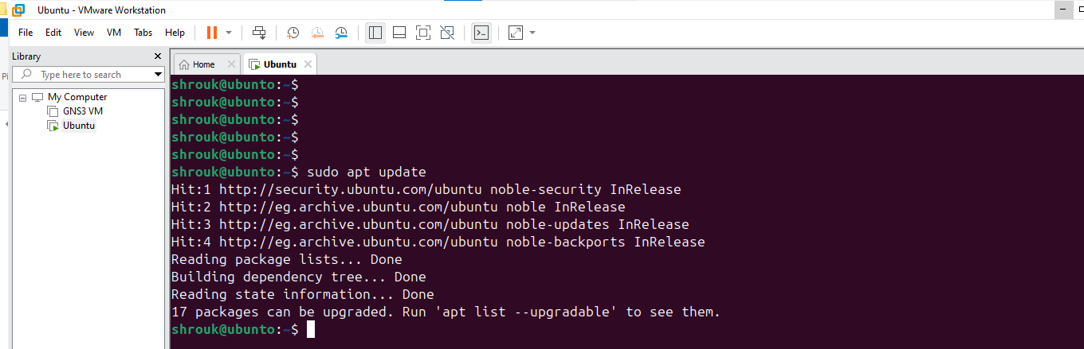

- Install MySQL Server
First login in Ec2
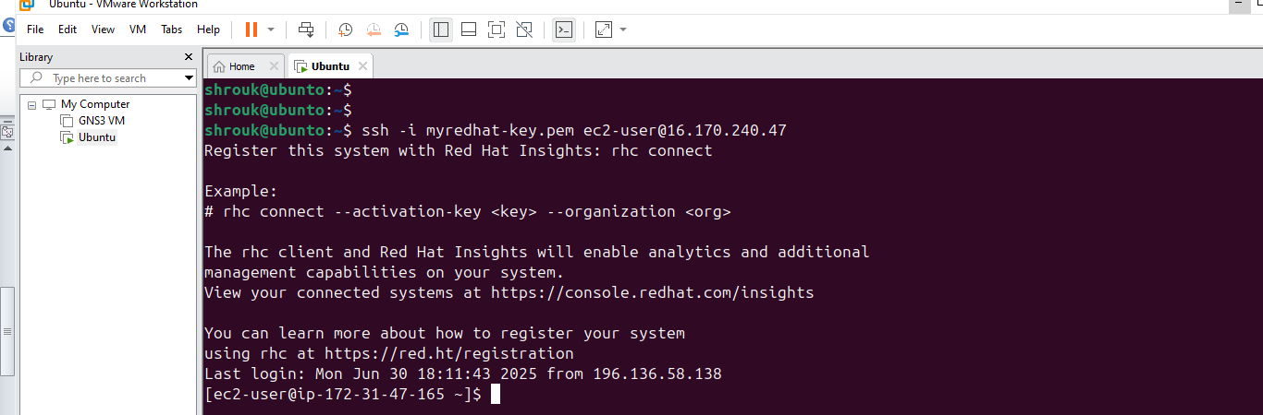
- Run: sudo yum install mysql-server –y
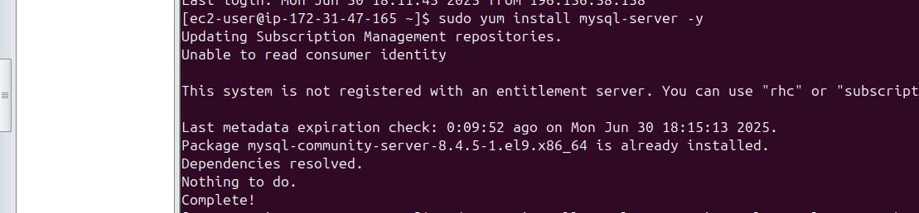
- Ensure installation completes without errors.

- Start MySQL Service
- Run: sudo systemctl start mysql
- Run: sudo systemctl enable mysql

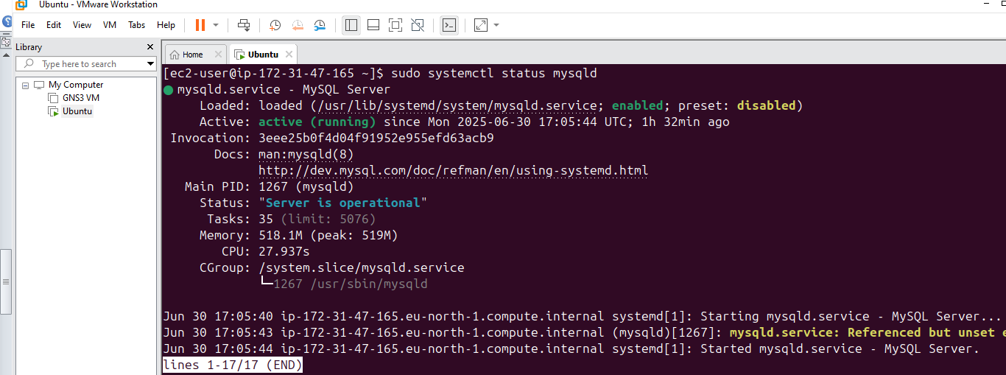

- Verify it is running: sudo systemctl status mysql (should show 'active (running)')

- Secure MySQL Installation
- Run: sudo mysql_secure_installation

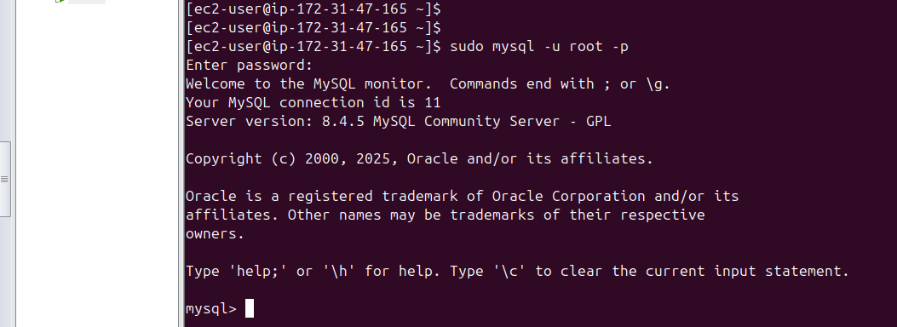

- Follow the prompts to set root password, remove anonymous users, disallow remote root login, remove test DB, and reload privilege tables.

- Configure MySQL to Allow Remote Connections
- Open config file: sudo nano /etc/mysql/mysql.conf.d/mysqld.cnf
- Change 'bind-address = 127.0.0.1' to 'bind-address = 0.0.0.0'
- Save and exit: Ctrl+O, Enter, Ctrl+X

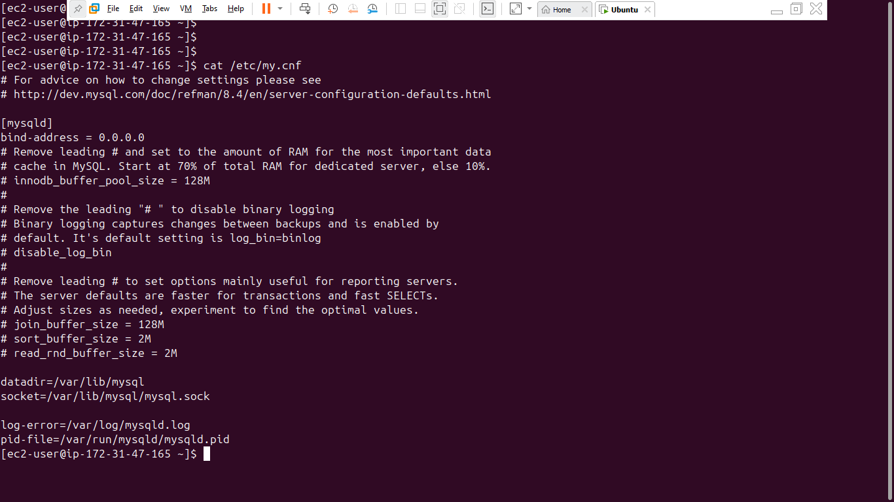

- Restart MySQL Service
- Run: sudo systemctl restart mysql

- Create a Remote Access User
Log into MySQL: sudo mysql -u root -p
Then run:
CREATE USER 'student'@'%' IDENTIFIED BY 'Student2024!';
GRANT ALL PRIVILEGES ON *.* TO 'student'@'%' WITH GRANT OPTION;
FLUSH PRIVILEGES;
EXIT;

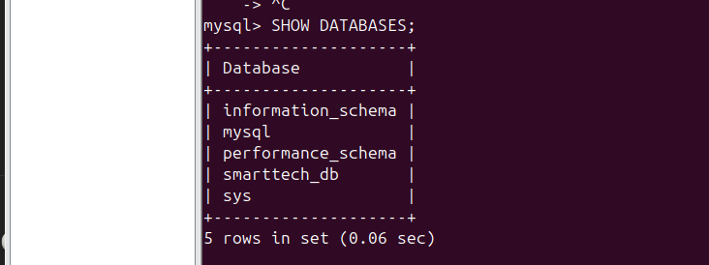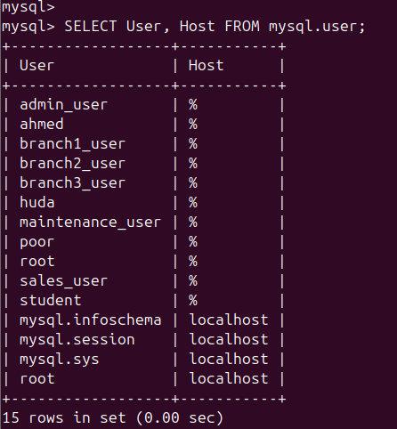

- Open Port 3306 in Firewall, If using UFW:
- sudo ufw allow 3306
- sudo ufw reload
- sudo ufw status
- *Skip this step if UFW is inactive.*
10. Verify Remote Connection
- Use MySQL Workbench or client software with:
- Host: Public IP of Ubuntu server
- Port: 3306
- Username: student
- Password: Student2024!

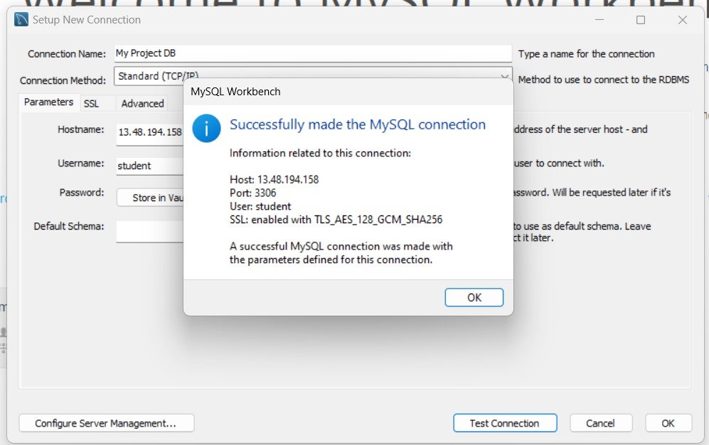

Important Notes
Ensure AWS Security Group allows inbound TCP on port 3306.

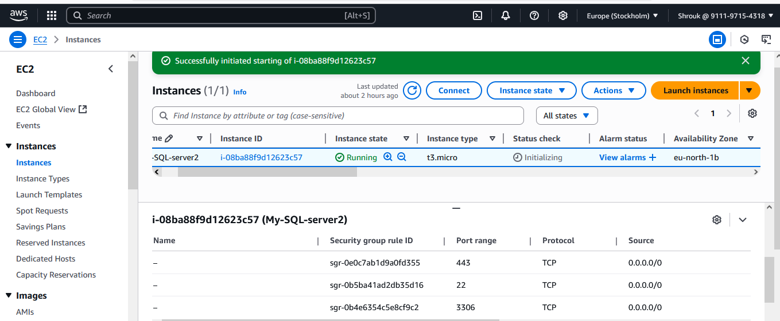

- Store credentials securely.
- Grant limited privileges to users as needed.
- Avoid sharing the root password.

