**Contents**

Project Overview 2

Modeling Approach 2

Finance Data Mart 3

1. Business Process 3

2. Granuality 3

3. Dimensions 3

4. Measures 5

5. Logical Model 6

Executives Data Mart 7

1. Business Process 7

2. Granuality 7

3. Dimensions 7

4. Measures 8

5. Logical Model 9

Marketing Data Mart 10

1. Business Process 10

2. Granuality 10

3. Dimensions 10

4. Measures 11

5. Logical Model 12

Customer Care Data Mart 13

1. Business Process: 13

2. Grain: 13

3. Dimensions 13

4. Measures: 14

5. Logical Model 15

# Project Overview

The Project aims to analyze flight activity of frequent flyers, including their travel patterns, fare basis, upgrade frequency, and loyalty program engagement. Evaluate reservation processes across various channels to assess profitability. Study customer care interactions to understand inquiry types, complaint severity, and feedback for business improvement.

# Modeling Approach

We are following Kimpall approach with a **galaxy schema** type for the following reasons:

1. We are focusing on certain business processes rather than the modeling of the whole enterprise.
2. We prioritize the fast delivery of a data-driven decision-making solution, and Kimball's methodology supports this approach effectively.
3. Breaking down the model into separate data marts can boost productivity for data engineers, allowing them to work in parallel more effectively.
4. Galaxy schema since we have data marts sharing same dimensions.



Figure 1:Ralph Kimpall DWH Architecture

# Finance Data Mart

### Business Process

Managing airline reservations and related financial transactions that take place through multiple channels.

### Granuality

Individual reservations (Each ticket)

### Dimensions

#### Passenger:

* PassengerKey: Primary key identifying each passenger.
* PassengerId: Identifier for the passenger.
* PassengerName: Name of the passenger.
* PassengerType: Type of the passenger (e.g., adult, child).
* Email: Email address of the passenger.
* PhoneNumber: Phone number of the passenger.

#### Flight:

* FlightKey: Primary key identifying each flight.
* FlightNumber: Unique identifier for the flight.
* DepartureAirport: Three-letter code for the departure airport.
* ArrivalAirport: Three-letter code for the arrival airport.
* DepartureTime: Timestamp indicating the departure time of the flight.
* ArrivalTime: Timestamp indicating the arrival time of the flight.

#### Aircraft:

* AircraftKey: Primary key identifying each aircraft.
* AircraftNumber: Unique identifier for the aircraft.
* AircraftType: Type or model of the aircraft.
* Manufacturer: Manufacturer of the aircraft.
* Model: Model of the aircraft.

#### FareBasis:

* FareBasisKey: Primary key identifying each fare basis.
* FareBasisCode: Code representing the fare basis.
* FareType: Type of the fare.
* Restrictions: Restrictions associated with the fare basis.

#### PaymentMethod:

* PaymentMethodKey: Primary key identifying each payment method.
* PaymentMethodCode: Code representing the payment method.
* PaymentMethod: Description of the payment method.
* PaymentStatus: Status of the payment (e.g., pending, completed).

#### Promotion:

* PromotionKey: Primary key identifying each promotion.
* PromotionCode: Code representing the promotion.
* PromotionDescription: Description of the promotion.
* StartDate: Start date of the promotion.
* EndDate: End date of the promotion.

#### BookingChannel:

* BookingChannelKey: Primary key identifying each booking channel.
* BookingChannelId: Identifier for the booking channel.
* BookingChannel: Description of the booking channel.
* ChannelDescription: Description of the channel.

#### CancellationReason:

* CancellationKey: Primary key identifying each cancellation reason.
* CancellationId: Identifier for the cancellation reason.
* CancellationReason: Description of the cancellation reason.
* CancellationTimestamp: Timestamp indicating when the cancellation occurred.

#### RefundReason:

* RefundKey: Primary key identifying each refund reason.
* RefundId: Identifier for the refund reason.
* RefundReason: Description of the refund reason.

#### TicketClass:

* TicketClassKey: Primary key identifying each ticket class.
* TicketId: Identifier for the ticket.
* TicketClass: Class of the ticket (e.g., economy, business).

#### DateTable:

* DateKey: Primary key identifying each date.
* DateValue: Date value.
* Year: Year component of the date.
* Month: Month component of the date.
* Quarter: Quarter of the year.
* DayOfWeek: Day of the week.
* DayOfMonth: Day of the month.
* DayOfYear: Day of the year.

### Measures

* BaseFare: Base fare amount for the reservation.
* GovernmentTaxes: Taxes imposed by the government for the reservation.
* Discount: Discount applied to the reservation.
* TaxesFeesCharges: Additional taxes, fees, and charges for the reservation.
* AncillaryRevenue: Revenue from ancillary services associated with the reservation.
* Revenue: Total revenue calculated for the reservation.( (BaseFare + GovernmentTaxes + TaxesFeesCharges - Discount))
* Profit: Profit calculated for the reservation ((BaseFare + GovernmentTaxes + TaxesFeesCharges - Discount) - AncillaryRevenue)

### Logical Model

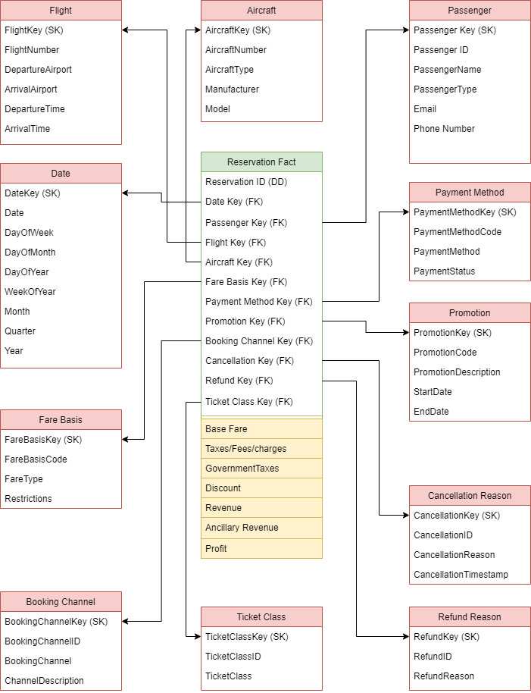

# Executives Data Mart

### Business Process

* Tracking flight operations and performance.

### Granuality

Each Flight Recorded on the system whether it flown or canceled.

### Dimensions

#### Location:

* LocationKey: Primary key identifying each location.
* City: Name of the city.
* Country: Name of the country.
* Latitude: Latitude coordinate of the location.
* Longitude: Longitude coordinate of the location.
* Timezone: Timezone of the location.

#### Airport:

* AirportKey: Primary key identifying each airport.
* AirportID: Identifier for the airport.
* AirportName: Name of the airport.
* LocationKey: Foreign key referencing the location of the airport in the Location table.

#### Date:

Roleplaying dimension that represent flight take off date in this mart.

#### TimeTable:

* TimeKey: Primary key identifying each time entry.
* Hour: Hour component of the time.
* Minutes: Minutes component of the time.
* Seconds: Seconds component of the time.

#### FlightCancellationReason:

* CancellationKey: Primary key identifying each flight cancellation reason.
* CancellationID: Identifier for the flight cancellation reason.
* CancellationReason: Description of the flight cancellation reason.
* CancellationTimestamp: Timestamp indicating when the flight cancellation occurred.

#### Aircraft

Conformed dimension with the finance data mart.

### Measures

* NumOfPassengers: Number of passengers on the flight.
* LoadFactor: Load factor of the flight (percentage of available seats occupied).
* Duration: Duration of the flight.
* DistanceFlown: Distance flown by the flight.
* FuelConsumption: Amount of fuel consumed by the flight.
* FreightWeight: Weight of freight carried by the flight.

### Logical Model

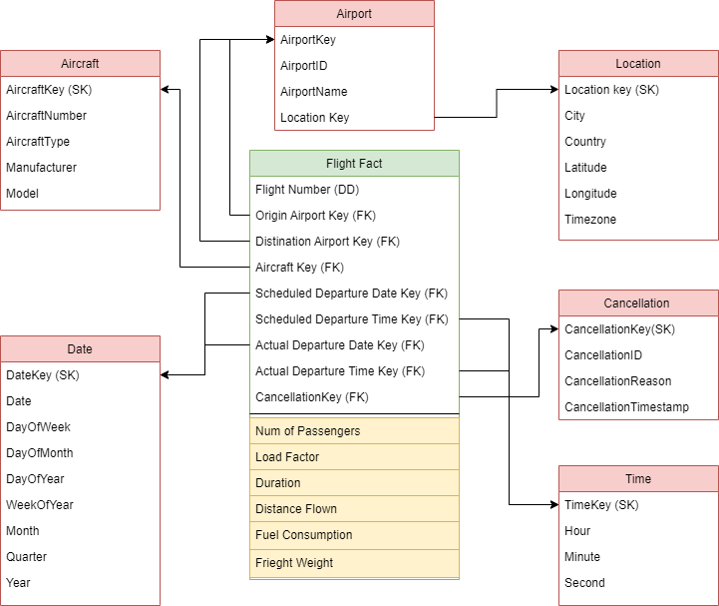

# Marketing Data Mart

### Business Process

* Tracking frequent flyers activities and miles collecting process.
* Tracking frequent flyers redemption process.

### Granuality

* Passenger check in level of details For **Passenger Miles Fact.**
* We have each redemption transaction grain For **Redemption Fact.**

### Dimensions

#### Passenger Profile

* PassengerProfileKey: Unique identifier for each passenger profile.
* FrequentFlyerTier: Level of frequent flyer status (e.g., Gold, Silver, Platinum).
* HomeAirport: Passenger's primary airport location.
* ClubMembershipStatus: Membership status in airline clubs or loyalty programs.
* LifetimeMileageTier: Threshold miles for each tier.

#### Service

* ServiceKey: Unique identifier for each service record in the dimension table.
* Partner: Name of the partner or provider associated with the service.
* ServiceType: Type or category of the service provided.
* EquivalentPoints: Numeric value representing equivalent points or benefits associated with

#### Passenger

Conformed dimension with the finance data mart.

#### Fare Basis

Conformed dimension with the finance data mart.

#### TimeTable:

Roleplaying dimension represent the time at with the redemption transactions happened.

#### Payment Method

Conformed dimension with the finance data mart.

#### Booking Channel

Conformed dimension with the finance data mart.

#### Ticket Class

Conformed dimension with the finance data mart

#### Promotion

Conformed dimension with the finance data mart

#### Flight

Conformed dimension with the finance data mart

#### Date

Roleplaying dimension represent the date at with the redemption transactions happened.

### Measures

**Passenger Miles Fact:**

* MilesFlown: The total number of miles flown by the passenger.
* MilesEarned: The number of miles earned by the passenger, which can be used for loyalty program accrual.
* DollarsQualification: The amount of dollars spent by the passenger that qualifies towards program benefits or status qualification

**Redemption Fact:**

* PointsRedeemed: Number of loyalty points redeemed by the passenger.
* EquivalentMiles: Equivalent number of miles corresponding to the redeemed points.
* EquivalentDollars: Equivalent dollar value of the redeemed points.

### Logical Model

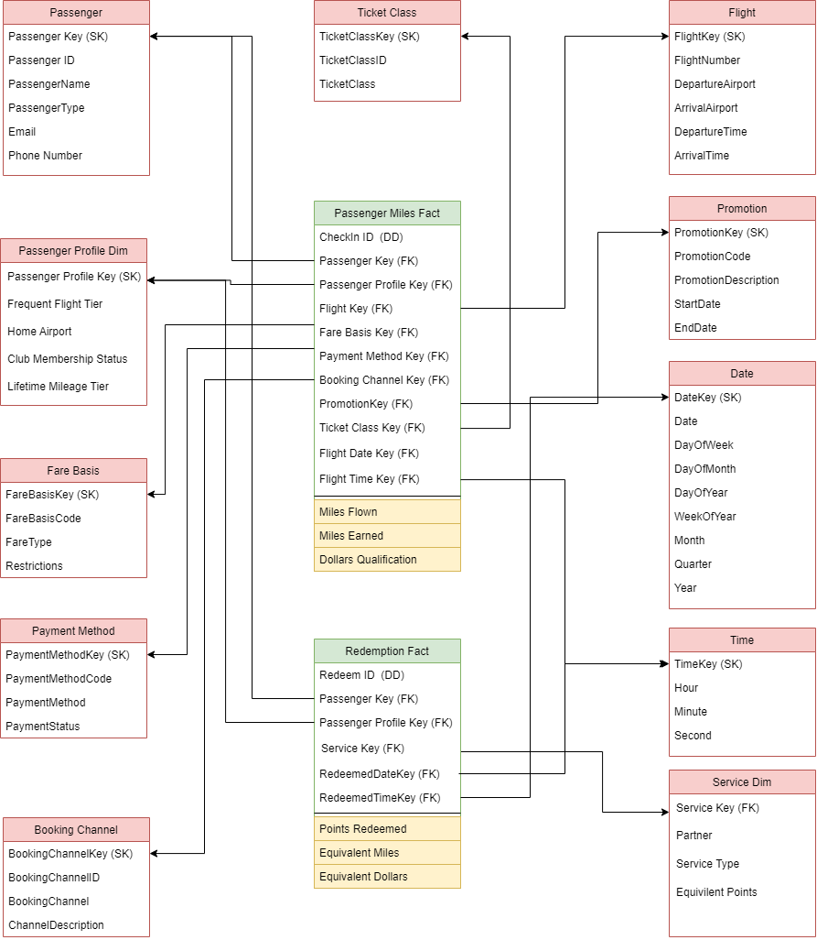

# Customer Care Data Mart

### Business Process:

* For customer care department it handles customer inquiries, complaints and keep their feedback for business enhancements.

### Grain:

* One row per client interactionin both fact tables.

### Dimensions

#### Flight

Conformed dimension with the finance data mart

#### Airport

Conformed dimension with the finance data mart

#### Location

Conformed dimension with the finance data mart

#### Passenger

Conformed dimension with the finance data mart

#### Agent

* AgentKey: surrogate key for identifying every client
* NationalID: natural key for each client
* Name
* Gender
* DateOfBirth
* ContactNumber
* Nationality
* Title: position of the agent in the department

#### Class

Conformed dimension with the finance data mart

#### Interaction method

* MethodKey: surrogate key for identifying each method
* Type: (website – application – call center – email)

#### Date

Roleplaying dimension represens when the did complaint happen.

#### Case status

* CaseKey: surrogate key for identifying each case
* Type: (fininsh – in progress – cancelled)
* Priorty: (high – medium – low)

#### Interaction type:

* InteractionTypeKey: surrogate key for identifying every interaction type
* Type: (complaint – inquiry)
* Severity: (urgent – normal)

### Measures:

* FlightRating: Rating from 1 to 5 from the client to describe the filght experience.
* ServiceRating: Rating from 1 to 5 from the client to describe the airline service.
* OverallRating: Rating from 1 to 5 from the client.
* ComplaintCount: 1 for each complaint on each reservation.

### Logical Model

