EDA
Israa Atike
library(readr)
## Warning: package 'readr' was built under R version 4.5.2
data <- read_csv("C:/Users/Israa Atike/Documents/Project/thesis-project-israa-atike/data/processed_data.csv")
## Rows: 68629 Columns: 42
## ── Column specification ────────────────────────────────────────────────────────
## Delimiter: ","
## chr (30): race, gender, age, diag_1, diag_2, diag_3, max_glu_serum, A1Cresul...
## dbl (12): patient_nbr, admission_type_id, discharge_disposition_id, admissio...
##
## ℹ Use `spec()` to retrieve the full column specification for this data.
## ℹ Specify the column types or set `show_col_types = FALSE` to quiet this message.
head(data)
## # A tibble: 6 × 42
## patient_nbr race gender age admission_type_id discharge_dispositio…¹
## <dbl> <chr> <chr> <chr> <dbl> <dbl>
## 1 55629189 Caucasian Female [10-… 1 1
## 2 86047875 African Ame… Female [20-… 1 1
## 3 82442376 Caucasian Male [30-… 1 1
## 4 42519267 Caucasian Male [40-… 1 1
## 5 82637451 Caucasian Male [50-… 2 1
## 6 84259809 Caucasian Male [60-… 3 1
## # ℹ abbreviated name: ¹​discharge_disposition_id
## # ℹ 36 more variables: admission_source_id <dbl>, time_in_hospital <dbl>,
## # num_lab_procedures <dbl>, num_procedures <dbl>, num_medications <dbl>,
## # number_outpatient <dbl>, number_emergency <dbl>, number_inpatient <dbl>,
## # diag_1 <chr>, diag_2 <chr>, diag_3 <chr>, number_diagnoses <dbl>,
## # max_glu_serum <chr>, A1Cresult <chr>, metformin <chr>, repaglinide <chr>,
## # nateglinide <chr>, chlorpropamide <chr>, glimepiride <chr>, …
str(data)
## spc_tbl_ [68,629 × 42] (S3: spec_tbl_df/tbl_df/tbl/data.frame)
## $ patient_nbr : num [1:68629] 55629189 86047875 82442376 42519267 82637451 ...
## $ race : chr [1:68629] "Caucasian" "African American" "Caucasian" "Caucasian" ...
## $ gender : chr [1:68629] "Female" "Female" "Male" "Male" ...
## $ age : chr [1:68629] "[10-20)" "[20-30)" "[30-40)" "[40-50)" ...
## $ admission_type_id : num [1:68629] 1 1 1 1 2 3 1 2 3 1 ...
## $ discharge_disposition_id: num [1:68629] 1 1 1 1 1 1 1 1 3 1 ...
## $ admission_source_id : num [1:68629] 7 7 7 7 2 2 7 4 4 7 ...
## $ time_in_hospital : num [1:68629] 3 2 2 1 3 4 5 13 12 9 ...
## $ num_lab_procedures : num [1:68629] 59 11 44 51 31 70 73 68 33 47 ...
## $ num_procedures : num [1:68629] 0 5 1 0 6 1 0 2 3 2 ...
## $ num_medications : num [1:68629] 18 13 16 8 16 21 12 28 18 17 ...
## $ number_outpatient : num [1:68629] 0 2 0 0 0 0 0 0 0 0 ...
## $ number_emergency : num [1:68629] 0 0 0 0 0 0 0 0 0 0 ...
## $ number_inpatient : num [1:68629] 0 1 0 0 0 0 0 0 0 0 ...
## $ diag_1 : chr [1:68629] "Other" "Other" "Other" "Neoplasms" ...
## $ diag_2 : chr [1:68629] "Diabetes" "Diabetes" "Diabetes" "Neoplasms" ...
## $ diag_3 : chr [1:68629] "Other" "Other" "Circulatory" "Diabetes" ...
## $ number_diagnoses : num [1:68629] 9 6 7 5 9 7 8 8 8 9 ...
## $ max_glu_serum : chr [1:68629] "Not measured" "Not measured" "Not measured" "Not measured" ...
## $ A1Cresult : chr [1:68629] "Not measured" "Not measured" "Not measured" "Not measured" ...
## $ metformin : chr [1:68629] "No" "No" "No" "No" ...
## $ repaglinide : chr [1:68629] "No" "No" "No" "No" ...
## $ nateglinide : chr [1:68629] "No" "No" "No" "No" ...
## $ chlorpropamide : chr [1:68629] "No" "No" "No" "No" ...
## $ glimepiride : chr [1:68629] "No" "No" "No" "No" ...
## $ acetohexamide : chr [1:68629] "No" "No" "No" "No" ...
## $ glipizide : chr [1:68629] "No" "Steady" "No" "Steady" ...
## $ glyburide : chr [1:68629] "No" "No" "No" "No" ...
## $ tolbutamide : chr [1:68629] "No" "No" "No" "No" ...
## $ pioglitazone : chr [1:68629] "No" "No" "No" "No" ...
## $ rosiglitazone : chr [1:68629] "No" "No" "No" "No" ...
## $ acarbose : chr [1:68629] "No" "No" "No" "No" ...
## $ miglitol : chr [1:68629] "No" "No" "No" "No" ...
## $ troglitazone : chr [1:68629] "No" "No" "No" "No" ...
## $ tolazamide : chr [1:68629] "No" "No" "No" "No" ...
## $ insulin : chr [1:68629] "Up" "No" "Up" "Steady" ...
## $ glyburide-metformin : chr [1:68629] "No" "No" "No" "No" ...
## $ glipizide-metformin : chr [1:68629] "No" "No" "No" "No" ...
## $ metformin-pioglitazone : chr [1:68629] "No" "No" "No" "No" ...
## $ change : chr [1:68629] "Yes" "No" "Yes" "Yes" ...
## $ diabetesMed : chr [1:68629] "Yes" "Yes" "Yes" "Yes" ...
## $ readmitted : chr [1:68629] ">30" "No" "No" "No" ...
## - attr(*, "spec")=
## .. cols(
## .. patient_nbr = col_double(),
## .. race = col_character(),
## .. gender = col_character(),
## .. age = col_character(),
## .. admission_type_id = col_double(),
## .. discharge_disposition_id = col_double(),
## .. admission_source_id = col_double(),
## .. time_in_hospital = col_double(),
## .. num_lab_procedures = col_double(),
## .. num_procedures = col_double(),
## .. num_medications = col_double(),
## .. number_outpatient = col_double(),
## .. number_emergency = col_double(),
## .. number_inpatient = col_double(),
## .. diag_1 = col_character(),
## .. diag_2 = col_character(),
## .. diag_3 = col_character(),
## .. number_diagnoses = col_double(),
## .. max_glu_serum = col_character(),
## .. A1Cresult = col_character(),
## .. metformin = col_character(),
## .. repaglinide = col_character(),
## .. nateglinide = col_character(),
## .. chlorpropamide = col_character(),
## .. glimepiride = col_character(),
## .. acetohexamide = col_character(),
## .. glipizide = col_character(),
## .. glyburide = col_character(),
## .. tolbutamide = col_character(),
## .. pioglitazone = col_character(),
## .. rosiglitazone = col_character(),
## .. acarbose = col_character(),
## .. miglitol = col_character(),
## .. troglitazone = col_character(),
## .. tolazamide = col_character(),
## .. insulin = col_character(),
## .. `glyburide-metformin` = col_character(),
## .. `glipizide-metformin` = col_character(),
## .. `metformin-pioglitazone` = col_character(),
## .. change = col_character(),
## .. diabetesMed = col_character(),
## .. readmitted = col_character()
## .. )
## - attr(*, "problems")=<externalptr>
# Load libraries
library(dplyr)
## Warning: package 'dplyr' was built under R version 4.5.2
##
## Attaching package: 'dplyr'
## The following objects are masked from 'package:stats':
##
## filter, lag
## The following objects are masked from 'package:base':
##
## intersect, setdiff, setequal, union
library(knitr)
categorical_summary <- function(df, col_name) {
summary_table <- df %>%
group_by(.data[[col_name]]) %>%
reframe(
Count = n(),
Percentage = round(100 * n() / nrow(df), 2)
) %>%
ungroup() %>% # make sure it's ungrouped
arrange(desc(Count))
print(
knitr::kable(
summary_table,
caption = paste("Table: Distribution of", col_name),
col.names = c(col_name, "Count", "Percentage (%)"),
align = "lcc"
)
)
}
# List of categorical variables
categorical_vars <- c(
"race", "gender", "age", "readmitted",
"change", "diabetesMed",
"diag_1", "diag_2", "diag_3",
"max_glu_serum", "A1Cresult",
"metformin", "repaglinide", "nateglinide", "chlorpropamide",
"glimepiride", "acetohexamide", "glipizide", "glyburide", "tolbutamide",
"pioglitazone", "rosiglitazone", "acarbose", "miglitol", "troglitazone",
"tolazamide", "insulin",
"glyburide-metformin", "glipizide-metformin",
"metformin-pioglitazone"
)
# Generate tables for all categorical variables
for (var in categorical_vars) {
categorical_summary(data, var)
}
##
##
## Table: Table: Distribution of race
##
## |race | Count | Percentage (%) |
## |:----------------|:-----:|:--------------:|
## |Caucasian | 52842 | 77.00 |
## |African American | 12665 | 18.45 |
## |Hispanic | 1477 | 2.15 |
## |Other | 1160 | 1.69 |
## |Asian | 485 | 0.71 |
##
##
## Table: Table: Distribution of gender
##
## |gender | Count | Percentage (%) |
## |:------|:-----:|:--------------:|
## |Female | 36582 | 53.3 |
## |Male | 32047 | 46.7 |
##
##
## Table: Table: Distribution of age
##
## |age | Count | Percentage (%) |
## |:--------|:-----:|:--------------:|
## |[70-80) | 17642 | 25.71 |
## |[60-70) | 15414 | 22.46 |
## |[50-60) | 11999 | 17.48 |
## |[80-90) | 11247 | 16.39 |
## |[40-50) | 6530 | 9.51 |
## |[30-40) | 2526 | 3.68 |
## |[90-100) | 1841 | 2.68 |
## |[20-30) | 1009 | 1.47 |
## |[10-20) | 357 | 0.52 |
## |[0-10) | 64 | 0.09 |
##
##
## Table: Table: Distribution of readmitted
##
## |readmitted | Count | Percentage (%) |
## |:----------|:-----:|:--------------:|
## |No | 40879 | 59.57 |
## |>30 | 21624 | 31.51 |
## |<30 | 6126 | 8.93 |
##
##
## Table: Table: Distribution of change
##
## |change | Count | Percentage (%) |
## |:------|:-----:|:--------------:|
## |No | 37923 | 55.26 |
## |Yes | 30706 | 44.74 |
##
##
## Table: Table: Distribution of diabetesMed
##
## |diabetesMed | Count | Percentage (%) |
## |:-----------|:-----:|:--------------:|
## |Yes | 52002 | 75.77 |
## |No | 16627 | 24.23 |
##
##
## Table: Table: Distribution of diag_1
##
## |diag_1 | Count | Percentage (%) |
## |:---------------|:-----:|:--------------:|
## |Circulatory | 21255 | 30.97 |
## |Other | 11881 | 17.31 |
## |Respiratory | 9454 | 13.78 |
## |Digestive | 6337 | 9.23 |
## |Diabetes | 5199 | 7.58 |
## |Injury | 4563 | 6.65 |
## |Musculoskeletal | 3888 | 5.67 |
## |Genitourinary | 3415 | 4.98 |
## |Neoplasms | 2637 | 3.84 |
##
##
## Table: Table: Distribution of diag_2
##
## |diag_2 | Count | Percentage (%) |
## |:---------------|:-----:|:--------------:|
## |Circulatory | 21936 | 31.96 |
## |Other | 17748 | 25.86 |
## |Diabetes | 8973 | 13.07 |
## |Respiratory | 7066 | 10.30 |
## |Genitourinary | 5345 | 7.79 |
## |Digestive | 2817 | 4.10 |
## |Injury | 1777 | 2.59 |
## |Neoplasms | 1711 | 2.49 |
## |Musculoskeletal | 1256 | 1.83 |
##
##
## Table: Table: Distribution of diag_3
##
## |diag_3 | Count | Percentage (%) |
## |:---------------|:-----:|:--------------:|
## |Circulatory | 20794 | 30.30 |
## |Other | 19987 | 29.12 |
## |Diabetes | 12331 | 17.97 |
## |Respiratory | 4763 | 6.94 |
## |Genitourinary | 4086 | 5.95 |
## |Digestive | 2689 | 3.92 |
## |Injury | 1397 | 2.04 |
## |Musculoskeletal | 1337 | 1.95 |
## |Neoplasms | 1245 | 1.81 |
##
##
## Table: Table: Distribution of max_glu_serum
##
## |max_glu_serum | Count | Percentage (%) |
## |:-------------|:-----:|:--------------:|
## |Not measured | 65270 | 95.11 |
## |Norm | 1686 | 2.46 |
## |>200 | 939 | 1.37 |
## |>300 | 734 | 1.07 |
##
##
## Table: Table: Distribution of A1Cresult
##
## |A1Cresult | Count | Percentage (%) |
## |:------------|:-----:|:--------------:|
## |Not measured | 56348 | 82.11 |
## |>8 | 5793 | 8.44 |
## |Norm | 3683 | 5.37 |
## |>7 | 2805 | 4.09 |
##
##
## Table: Table: Distribution of metformin
##
## |metformin | Count | Percentage (%) |
## |:---------|:-----:|:--------------:|
## |No | 54253 | 79.05 |
## |Steady | 13169 | 19.19 |
## |Up | 793 | 1.16 |
## |Down | 414 | 0.60 |
##
##
## Table: Table: Distribution of repaglinide
##
## |repaglinide | Count | Percentage (%) |
## |:-----------|:-----:|:--------------:|
## |No | 67716 | 98.67 |
## |Steady | 814 | 1.19 |
## |Up | 70 | 0.10 |
## |Down | 29 | 0.04 |
##
##
## Table: Table: Distribution of nateglinide
##
## |nateglinide | Count | Percentage (%) |
## |:-----------|:-----:|:--------------:|
## |No | 68140 | 99.29 |
## |Steady | 465 | 0.68 |
## |Up | 16 | 0.02 |
## |Down | 8 | 0.01 |
##
##
## Table: Table: Distribution of chlorpropamide
##
## |chlorpropamide | Count | Percentage (%) |
## |:--------------|:-----:|:--------------:|
## |No | 68560 | 99.90 |
## |Steady | 64 | 0.09 |
## |Up | 4 | 0.01 |
## |Down | 1 | 0.00 |
##
##
## Table: Table: Distribution of glimepiride
##
## |glimepiride | Count | Percentage (%) |
## |:-----------|:-----:|:--------------:|
## |No | 65041 | 94.77 |
## |Steady | 3229 | 4.71 |
## |Up | 226 | 0.33 |
## |Down | 133 | 0.19 |
##
##
## Table: Table: Distribution of acetohexamide
##
## |acetohexamide | Count | Percentage (%) |
## |:-------------|:-----:|:--------------:|
## |No | 68628 | 100 |
## |Steady | 1 | 0 |
##
##
## Table: Table: Distribution of glipizide
##
## |glipizide | Count | Percentage (%) |
## |:---------|:-----:|:--------------:|
## |No | 59837 | 87.19 |
## |Steady | 7862 | 11.46 |
## |Up | 566 | 0.82 |
## |Down | 364 | 0.53 |
##
##
## Table: Table: Distribution of glyburide
##
## |glyburide | Count | Percentage (%) |
## |:---------|:-----:|:--------------:|
## |No | 61089 | 89.01 |
## |Steady | 6534 | 9.52 |
## |Up | 604 | 0.88 |
## |Down | 402 | 0.59 |
##
##
## Table: Table: Distribution of tolbutamide
##
## |tolbutamide | Count | Percentage (%) |
## |:-----------|:-----:|:--------------:|
## |No | 68611 | 99.97 |
## |Steady | 18 | 0.03 |
##
##
## Table: Table: Distribution of pioglitazone
##
## |pioglitazone | Count | Percentage (%) |
## |:------------|:-----:|:--------------:|
## |No | 63505 | 92.53 |
## |Steady | 4871 | 7.10 |
## |Up | 174 | 0.25 |
## |Down | 79 | 0.12 |
##
##
## Table: Table: Distribution of rosiglitazone
##
## |rosiglitazone | Count | Percentage (%) |
## |:-------------|:-----:|:--------------:|
## |No | 64084 | 93.38 |
## |Steady | 4340 | 6.32 |
## |Up | 133 | 0.19 |
## |Down | 72 | 0.10 |
##
##
## Table: Table: Distribution of acarbose
##
## |acarbose | Count | Percentage (%) |
## |:--------|:-----:|:--------------:|
## |No | 68434 | 99.72 |
## |Steady | 185 | 0.27 |
## |Up | 10 | 0.01 |
##
##
## Table: Table: Distribution of miglitol
##
## |miglitol | Count | Percentage (%) |
## |:--------|:-----:|:--------------:|
## |No | 68609 | 99.97 |
## |Steady | 18 | 0.03 |
## |Down | 1 | 0.00 |
## |Up | 1 | 0.00 |
##
##
## Table: Table: Distribution of troglitazone
##
## |troglitazone | Count | Percentage (%) |
## |:------------|:-----:|:--------------:|
## |No | 68626 | 100 |
## |Steady | 3 | 0 |
##
##
## Table: Table: Distribution of tolazamide
##
## |tolazamide | Count | Percentage (%) |
## |:----------|:-----:|:--------------:|
## |No | 68601 | 99.96 |
## |Steady | 28 | 0.04 |
##
##
## Table: Table: Distribution of insulin
##
## |insulin | Count | Percentage (%) |
## |:-------|:-----:|:--------------:|
## |No | 33750 | 49.18 |
## |Steady | 20971 | 30.56 |
## |Down | 7240 | 10.55 |
## |Up | 6668 | 9.72 |
##
##
## Table: Table: Distribution of glyburide-metformin
##
## |glyburide-metformin | Count | Percentage (%) |
## |:-------------------|:-----:|:--------------:|
## |No | 68154 | 99.31 |
## |Steady | 466 | 0.68 |
## |Up | 6 | 0.01 |
## |Down | 3 | 0.00 |
##
##
## Table: Table: Distribution of glipizide-metformin
##
## |glipizide-metformin | Count | Percentage (%) |
## |:-------------------|:-----:|:--------------:|
## |No | 68622 | 99.99 |
## |Steady | 7 | 0.01 |
##
##
## Table: Table: Distribution of metformin-pioglitazone
##
## |metformin-pioglitazone | Count | Percentage (%) |
## |:----------------------|:-----:|:--------------:|
## |No | 68628 | 100 |
## |Steady | 1 | 0 |
# Load libraries
library(tidyverse)
## Warning: package 'tidyverse' was built under R version 4.5.2
## Warning: package 'ggplot2' was built under R version 4.5.2
## Warning: package 'lubridate' was built under R version 4.5.2
## ── Attaching core tidyverse packages ──────────────────────── tidyverse 2.0.0 ──
## ✔ forcats 1.0.1 ✔ stringr 1.5.2
## ✔ ggplot2 4.0.1 ✔ tibble 3.3.0
## ✔ lubridate 1.9.4 ✔ tidyr 1.3.1
## ✔ purrr 1.1.0
## ── Conflicts ────────────────────────────────────────── tidyverse_conflicts() ──
## ✖ dplyr::filter() masks stats::filter()
## ✖ dplyr::lag() masks stats::lag()
## ℹ Use the conflicted package (<http://conflicted.r-lib.org/>) to force all conflicts to become errors
# List of categorical columns
categorical_cols <- c(
"gender", "race", "age",
"admission_type_id", "discharge_disposition_id", "admission_source_id",
"diag_1", "diag_2", "diag_3",
"metformin", "repaglinide", "nateglinide", "chlorpropamide",
"glimepiride", "acetohexamide", "glipizide", "glyburide", "tolbutamide",
"pioglitazone", "rosiglitazone", "acarbose", "miglitol", "troglitazone",
"tolazamide", "insulin",
"glyburide-metformin", "glipizide-metformin",
"metformin-pioglitazone",
"change", "diabetesMed", "readmitted"
)
# barplots for all categorical variables
for (col in categorical_cols) {
p <- ggplot(data, aes(x = .data[[col]])) +
geom_bar(
fill = "#4C72B0",
color = "grey30",
width = 0.65
) +
theme_minimal(base_size = 12) +
theme(
axis.text.x = element_text(
angle = 45,
hjust = 1,
color = "grey20"
),
axis.text.y = element_text(color = "grey20"),
axis.title = element_text(color = "grey20", face = "bold"),
plot.title = element_text(
face = "bold",
hjust = 0.5,
color = "grey10"
),
panel.grid.major.x = element_blank(),
panel.grid.minor = element_blank()
) +
labs(
title = paste("Distribution of", col),
x = col,
y = "Count of Patients"
)
print(p)
}
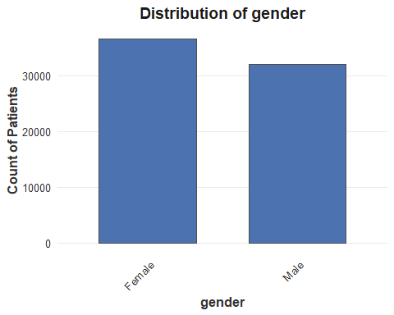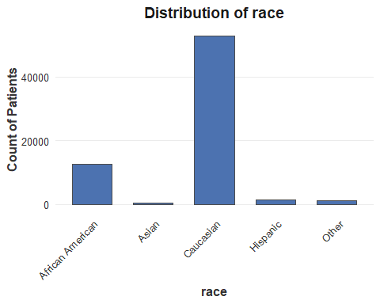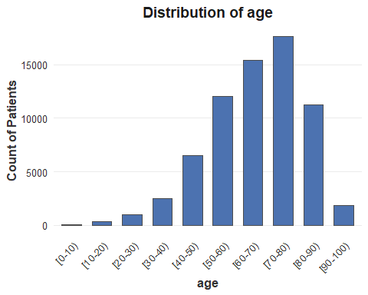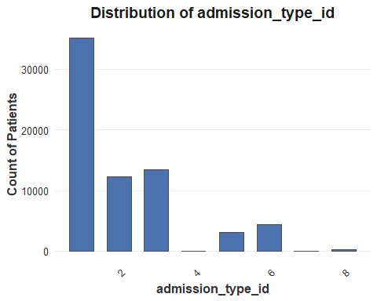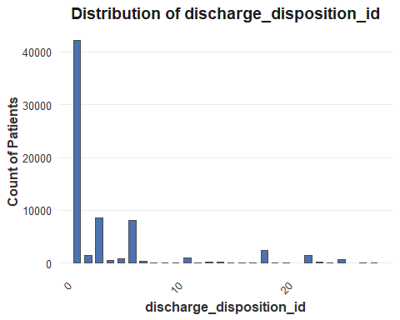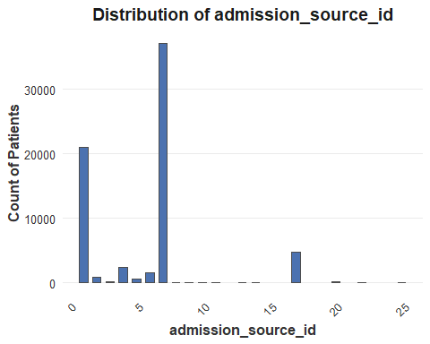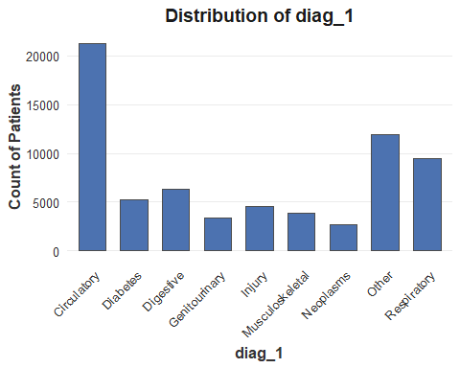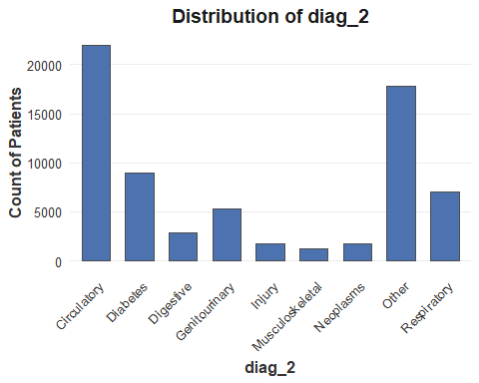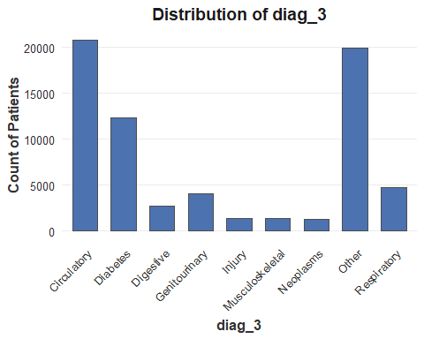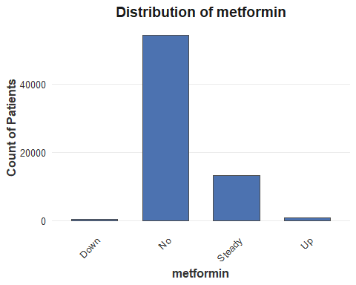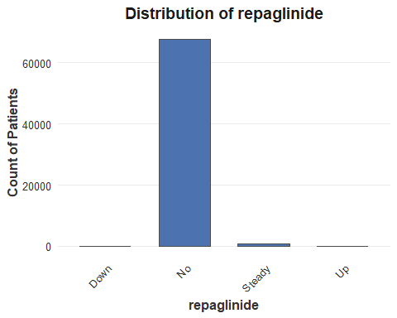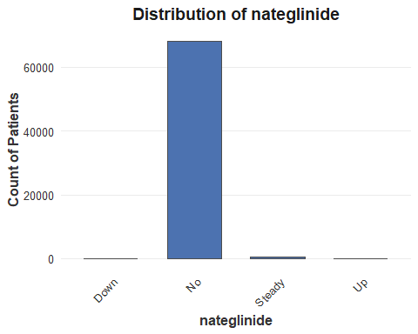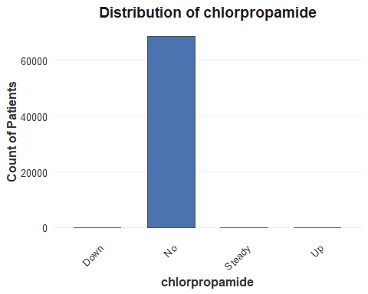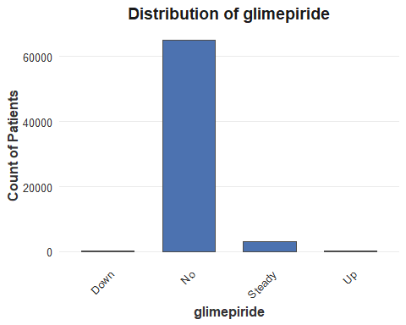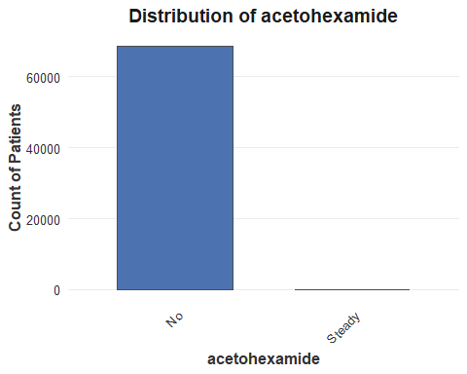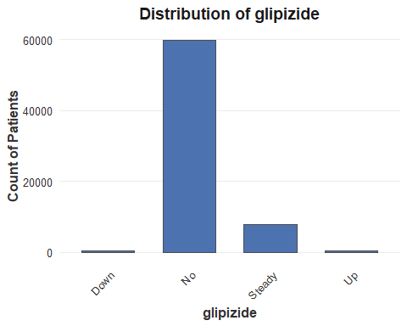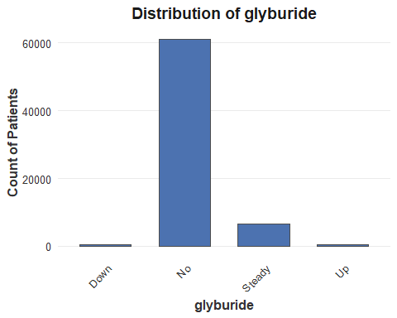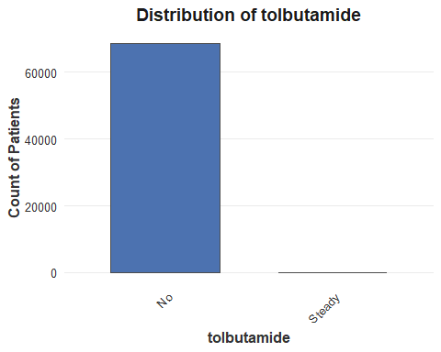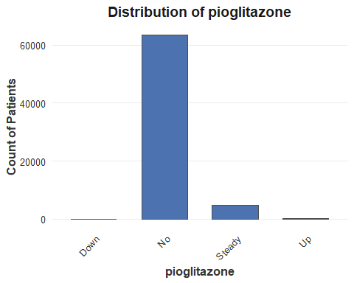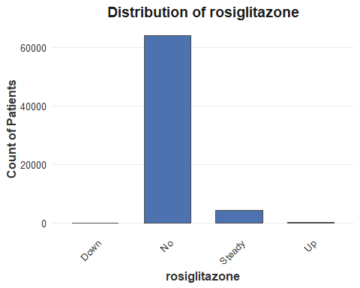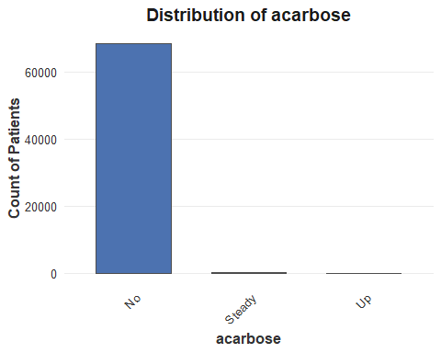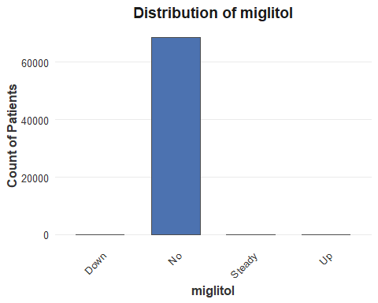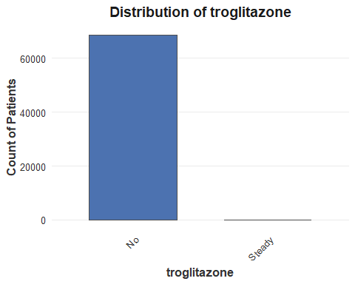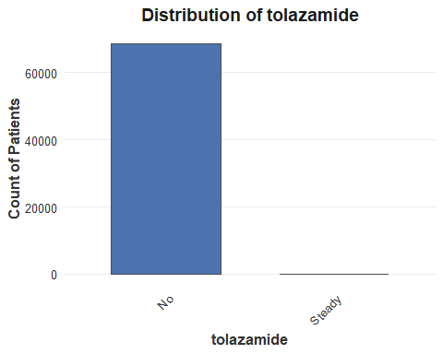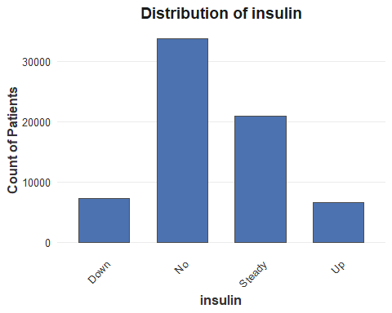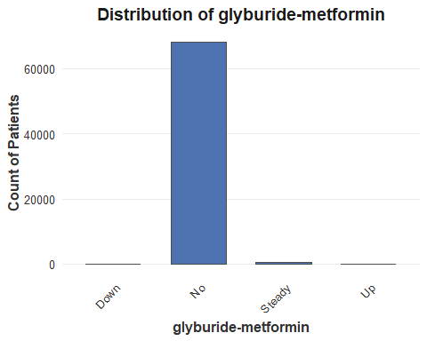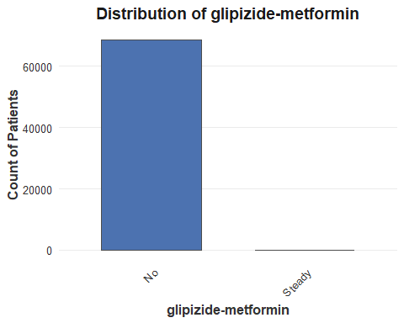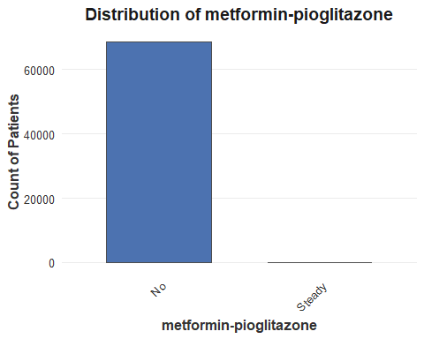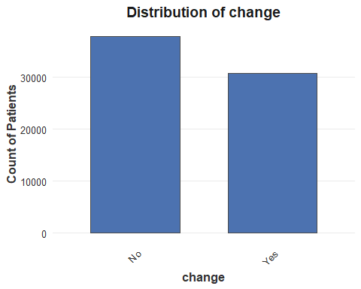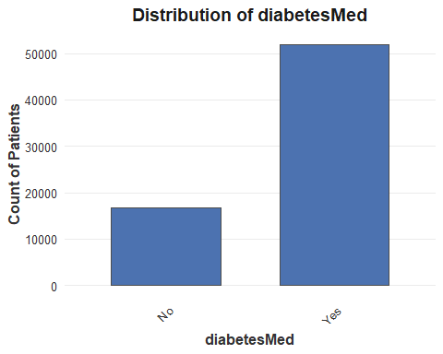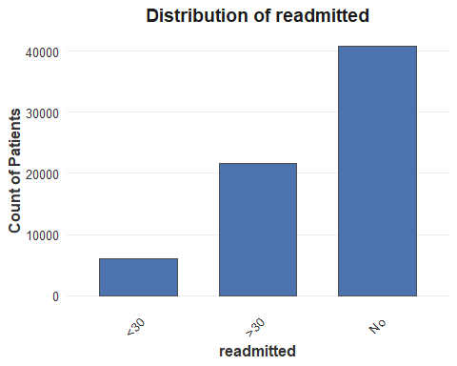
library(tidyverse)
# List of numeric columns
numeric_cols <- c(
"time_in_hospital",
"num_lab_procedures",
"num_procedures",
"num_medications",
"number_outpatient",
"number_emergency",
"number_inpatient",
"number_diagnoses"
)
for (col in numeric_cols) {
# Dynamic bin width
range_val <- max(data[[col]], na.rm = TRUE) - min(data[[col]], na.rm = TRUE)
bin_width <- ceiling(range_val / 30)
p <- ggplot(data, aes(x = .data[[col]])) +
geom_histogram(
binwidth = bin_width,
fill = "#4C72B0",
color = "grey30",
alpha = 0.9
) +
labs(
title = paste("Distribution of", col),
x = col,
y = "Frequency"
) +
theme_minimal(base_size = 12) +
theme(
axis.text.x = element_text(color = "grey20"),
axis.text.y = element_text(color = "grey20"),
axis.title = element_text(color = "grey20", face = "bold"),
plot.title = element_text(
face = "bold",
hjust = 0.5,
color = "grey10"
),
panel.grid.major.x = element_blank(),
panel.grid.minor = element_blank()
)
print(p)
}
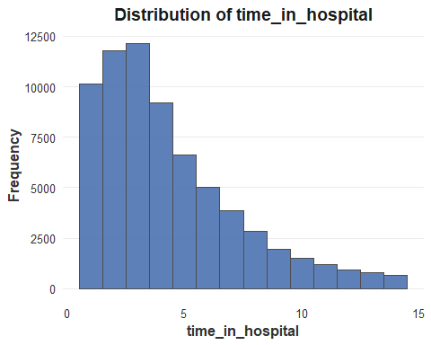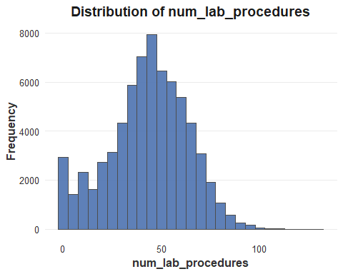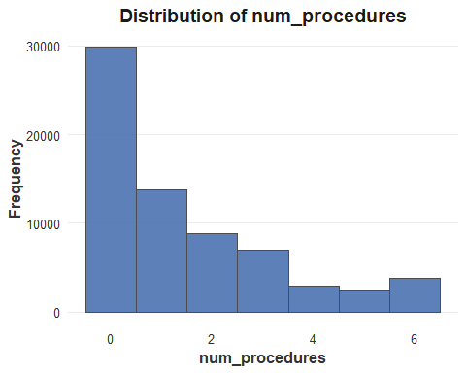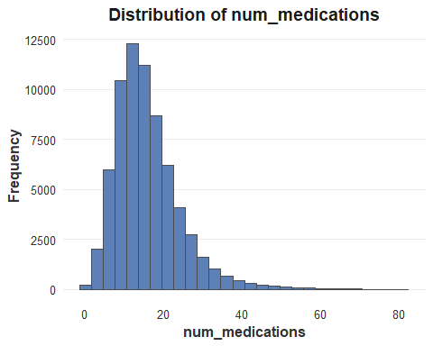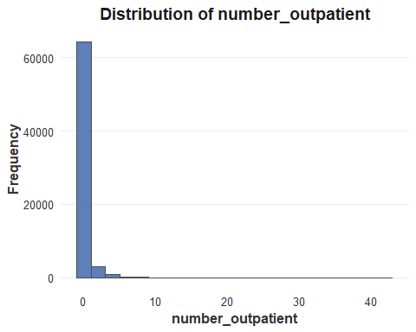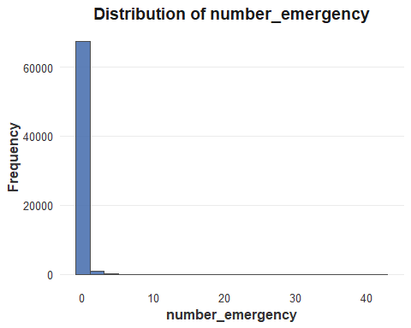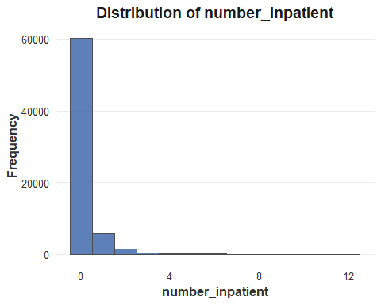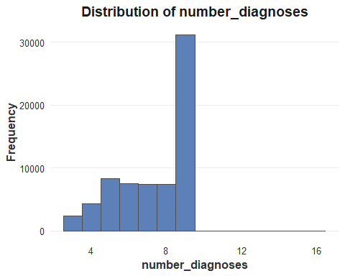
library(tidyverse)
numeric_cols <- c(
"time_in_hospital",
"num_lab_procedures",
"num_procedures",
"num_medications",
"number_outpatient",
"number_emergency",
"number_inpatient",
"number_diagnoses"
)
for (col in numeric_cols) {
p <- ggplot(data, aes(x = readmitted, y = .data[[col]], fill = readmitted)) +
geom_boxplot(
color = "grey30",
width = 0.6,
outlier.color = "grey50"
) +
scale_fill_manual(
values = c(
"NO" = "#4C72B0",
">30" = "#55A868",
"<30" = "#DD8452" #
)
) +
theme_minimal(base_size = 12) +
theme(
axis.text.x = element_text(color = "grey20"),
axis.text.y = element_text(color = "grey20"),
axis.title = element_text(color = "grey20", face = "bold"),
plot.title = element_text(
face = "bold",
hjust = 0.5,
color = "grey10"
),
panel.grid.major.x = element_blank(),
panel.grid.minor = element_blank(),
legend.position = "none"
) +
labs(
title = paste("Boxplot of", col, "by Readmission Status"),
x = "Readmission Status",
y = col
)
print(p)
}
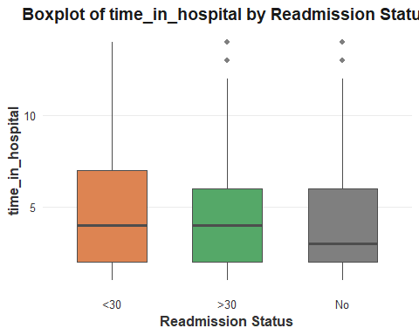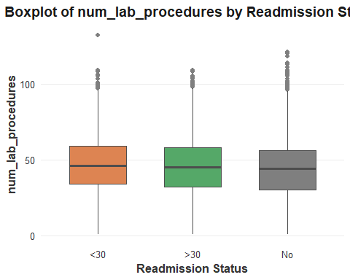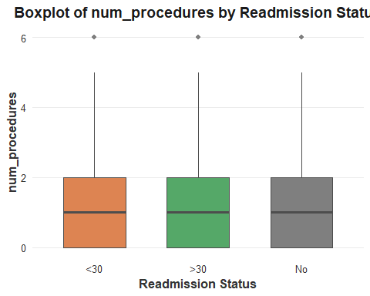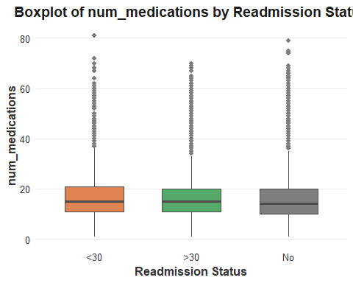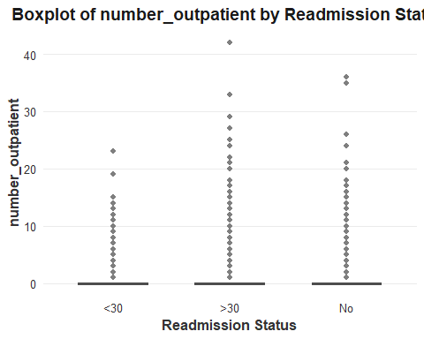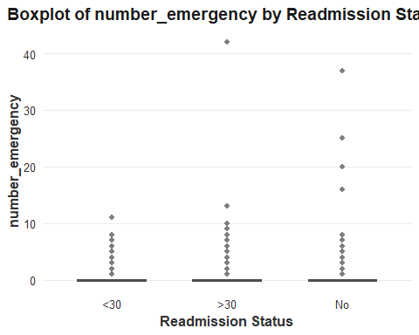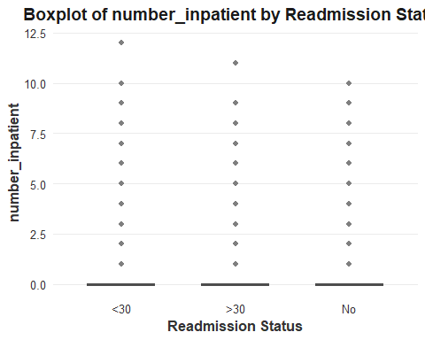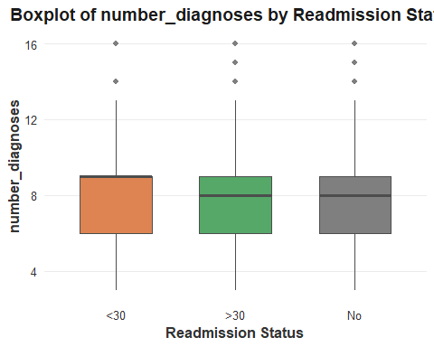
# Select numerical variables only (
num_df <- data[, c(
"time_in_hospital",
"num_lab_procedures",
"num_procedures",
"num_medications",
"number_outpatient",
"number_emergency",
"number_inpatient",
"number_diagnoses"
)]
# Scatterplot matrix
pairs(
num_df,
main = "Scatterplot Matrix of Numerical Features",
pch = 19,
col = "#4C72B0AA",
cex = 0.6
)
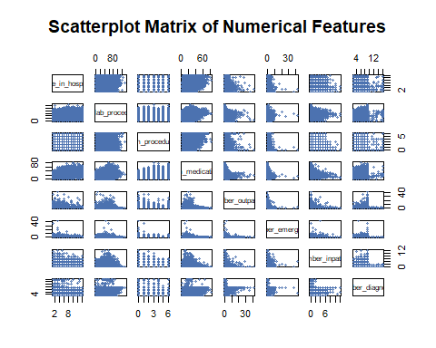
# Load necessary libraries
library(ggplot2)
library(reshape2)
## Warning: package 'reshape2' was built under R version 4.5.2
##
## Attaching package: 'reshape2'
## The following object is masked from 'package:tidyr':
##
## smiths
numeric_cols <- c(
"time_in_hospital",
"num_lab_procedures",
"num_procedures",
"num_medications",
"number_outpatient",
"number_emergency",
"number_inpatient",
"number_diagnoses"
)
cor_matrix <- cor(data[, numeric_cols], use = "complete.obs")
melted_cor <- melt(cor_matrix)
# Correlation heatmap
ggplot(melted_cor, aes(x = Var1, y = Var2, fill = value)) +
geom_tile(color = "grey90", linewidth = 0.3) +
scale_fill_gradient2(
low = "#4C72B0",
mid = "white",
high = "#DD8452",
midpoint = 0,
limits = c(-1, 1)
) +
geom_text(
aes(label = sprintf("%.2f", value)),
size = 3,
color = "grey20"
) +
theme_minimal(base_size = 12) +
labs(
title = "Correlation Heatmap of Numerical Features",
x = "",
y = "",
fill = "Correlation"
) +
theme(
axis.text.x = element_text(
angle = 45,
hjust = 1,
color = "grey20",
face = "bold"
),
axis.text.y = element_text(
color = "grey20",
face = "bold"
),
plot.title = element_text(
hjust = 0.5,
face = "bold",
color = "grey10"
),
panel.grid = element_blank()
)
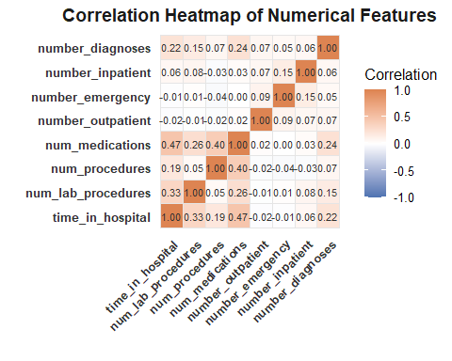
library(dplyr)
library(tidyr)
library(knitr)
# All categorical variables
categorical_cols <- c(
"gender", "race", "age",
"admission_type_id", "discharge_disposition_id", "admission_source_id",
"diag_1", "diag_2", "diag_3",
"metformin", "repaglinide", "nateglinide", "chlorpropamide",
"glimepiride", "acetohexamide", "glipizide", "glyburide", "tolbutamide",
"pioglitazone", "rosiglitazone", "acarbose", "miglitol", "troglitazone",
"tolazamide", "insulin",
"glyburide-metformin", "glipizide-metformin",
"metformin-pioglitazone",
"change", "diabetesMed"
)
# Remove near-zero variance variables
nzv_vars <- c(
"nateglinide", "chlorpropamide", "acetohexamide", "tolbutamide",
"acarbose", "miglitol", "troglitazone", "tolazamide",
"glyburide-metformin", "glipizide-metformin",
"metformin-pioglitazone"
)
categorical_cols <- setdiff(categorical_cols, nzv_vars)
# Function to create pivoted table for a categorical variable
categorical_table <- function(df, cat_var) {
df %>%
group_by(.data[[cat_var]], readmitted) %>%
summarise(Count = n(), .groups = "drop") %>%
pivot_wider(
names_from = readmitted,
values_from = Count,
values_fill = 0
) %>%
arrange(.data[[cat_var]]) %>%
rename(!!cat_var := 1) %>%
kable(caption = paste("Distribution of", cat_var, "by Readmission"))
}
# Loop over all selected categorical variables
for (var in categorical_cols) {
print(categorical_table(data, var))
}
##
##
## Table: Distribution of gender by Readmission
##
## |gender | <30| >30| No|
## |:------|----:|-----:|-----:|
## |Female | 3291| 11785| 21506|
## |Male | 2835| 9839| 19373|
##
##
## Table: Distribution of race by Readmission
##
## |race | <30| >30| No|
## |:----------------|----:|-----:|-----:|
## |African American | 1086| 3823| 7756|
## |Asian | 41| 106| 338|
## |Caucasian | 4803| 16978| 31061|
## |Hispanic | 119| 410| 948|
## |Other | 77| 307| 776|
##
##
## Table: Distribution of age by Readmission
##
## |age | <30| >30| No|
## |:--------|----:|----:|----:|
## |[0-10) | 1| 12| 51|
## |[10-20) | 21| 102| 234|
## |[20-30) | 81| 246| 682|
## |[30-40) | 181| 664| 1681|
## |[40-50) | 486| 1885| 4159|
## |[50-60) | 856| 3648| 7495|
## |[60-70) | 1384| 4836| 9194|
## |[70-80) | 1788| 5990| 9864|
## |[80-90) | 1167| 3775| 6305|
## |[90-100) | 161| 466| 1214|
##
##
## Table: Distribution of admission_type_id by Readmission
##
## | admission_type_id| <30| >30| No|
## |-----------------:|----:|-----:|-----:|
## | 1| 3174| 11135| 20812|
## | 2| 1105| 3956| 7212|
## | 3| 1121| 3629| 8647|
## | 4| 1| 2| 6|
## | 5| 260| 1017| 1807|
## | 6| 444| 1818| 2180|
## | 7| 0| 0| 20|
## | 8| 21| 67| 195|
##
##
## Table: Distribution of discharge_disposition_id by Readmission
##
## | discharge_disposition_id| <30| >30| No|
## |------------------------:|----:|-----:|-----:|
## | 1| 2991| 13652| 25587|
## | 2| 205| 431| 840|
## | 3| 1131| 2682| 4700|
## | 4| 50| 159| 286|
## | 5| 177| 237| 451|
## | 6| 785| 3036| 4260|
## | 7| 39| 110| 237|
## | 8| 7| 23| 41|
## | 9| 2| 1| 6|
## | 10| 0| 4| 2|
## | 11| 0| 0| 1053|
## | 12| 1| 0| 1|
## | 13| 5| 16| 221|
## | 14| 11| 2| 202|
## | 15| 18| 12| 10|
## | 16| 0| 1| 2|
## | 17| 0| 4| 4|
## | 18| 248| 554| 1624|
## | 19| 0| 0| 6|
## | 20| 0| 0| 1|
## | 22| 369| 331| 698|
## | 23| 8| 78| 168|
## | 24| 1| 4| 20|
## | 25| 46| 269| 417|
## | 27| 0| 0| 3|
## | 28| 32| 18| 39|
##
##
## Table: Distribution of admission_source_id by Readmission
##
## | admission_source_id| <30| >30| No|
## |-------------------:|----:|-----:|-----:|
## | 1| 1824| 6250| 12977|
## | 2| 79| 222| 559|
## | 3| 18| 38| 75|
## | 4| 204| 480| 1697|
## | 5| 47| 144| 347|
## | 6| 114| 271| 1110|
## | 7| 3396| 12454| 21290|
## | 8| 1| 1| 9|
## | 9| 6| 2| 28|
## | 10| 0| 2| 4|
## | 11| 0| 0| 1|
## | 13| 0| 0| 1|
## | 14| 0| 0| 2|
## | 17| 416| 1684| 2716|
## | 20| 21| 76| 57|
## | 22| 0| 0| 4|
## | 25| 0| 0| 2|
##
##
## Table: Distribution of diag_1 by Readmission
##
## |diag_1 | <30| >30| No|
## |:---------------|----:|----:|-----:|
## |Circulatory | 2038| 6904| 12313|
## |Diabetes | 495| 1818| 2886|
## |Digestive | 509| 1994| 3834|
## |Genitourinary | 308| 1023| 2084|
## |Injury | 487| 1305| 2771|
## |Musculoskeletal | 332| 1071| 2485|
## |Neoplasms | 226| 582| 1829|
## |Other | 1057| 3654| 7170|
## |Respiratory | 674| 3273| 5507|
##
##
## Table: Distribution of diag_2 by Readmission
##
## |diag_2 | <30| >30| No|
## |:---------------|----:|----:|-----:|
## |Circulatory | 2013| 7305| 12618|
## |Diabetes | 790| 2686| 5497|
## |Digestive | 229| 826| 1762|
## |Genitourinary | 472| 1693| 3180|
## |Injury | 179| 447| 1151|
## |Musculoskeletal | 100| 378| 778|
## |Neoplasms | 205| 458| 1048|
## |Other | 1571| 5512| 10665|
## |Respiratory | 567| 2319| 4180|
##
##
## Table: Distribution of diag_3 by Readmission
##
## |diag_3 | <30| >30| No|
## |:---------------|----:|----:|-----:|
## |Circulatory | 1848| 6882| 12064|
## |Diabetes | 1055| 3726| 7550|
## |Digestive | 257| 858| 1574|
## |Genitourinary | 396| 1341| 2349|
## |Injury | 141| 366| 890|
## |Musculoskeletal | 113| 407| 817|
## |Neoplasms | 144| 327| 774|
## |Other | 1706| 6150| 12131|
## |Respiratory | 466| 1567| 2730|
##
##
## Table: Distribution of metformin by Readmission
##
## |metformin | <30| >30| No|
## |:---------|----:|-----:|-----:|
## |Down | 42| 123| 249|
## |No | 4929| 17245| 32079|
## |Steady | 1100| 4013| 8056|
## |Up | 55| 243| 495|
##
##
## Table: Distribution of repaglinide by Readmission
##
## |repaglinide | <30| >30| No|
## |:-----------|----:|-----:|-----:|
## |Down | 1| 11| 17|
## |No | 6012| 21287| 40417|
## |Steady | 98| 310| 406|
## |Up | 15| 16| 39|
##
##
## Table: Distribution of glimepiride by Readmission
##
## |glimepiride | <30| >30| No|
## |:-----------|----:|-----:|-----:|
## |Down | 18| 44| 71|
## |No | 5817| 20437| 38787|
## |Steady | 269| 1077| 1883|
## |Up | 22| 66| 138|
##
##
## Table: Distribution of glipizide by Readmission
##
## |glipizide | <30| >30| No|
## |:---------|----:|-----:|-----:|
## |Down | 48| 134| 182|
## |No | 5267| 18607| 35963|
## |Steady | 748| 2696| 4418|
## |Up | 63| 187| 316|
##
##
## Table: Distribution of glyburide by Readmission
##
## |glyburide | <30| >30| No|
## |:---------|----:|-----:|-----:|
## |Down | 39| 146| 217|
## |No | 5416| 19158| 36515|
## |Steady | 612| 2123| 3799|
## |Up | 59| 197| 348|
##
##
## Table: Distribution of pioglitazone by Readmission
##
## |pioglitazone | <30| >30| No|
## |:------------|----:|-----:|-----:|
## |Down | 9| 34| 36|
## |No | 5678| 19844| 37983|
## |Steady | 419| 1680| 2772|
## |Up | 20| 66| 88|
##
##
## Table: Distribution of rosiglitazone by Readmission
##
## |rosiglitazone | <30| >30| No|
## |:-------------|----:|-----:|-----:|
## |Down | 4| 18| 50|
## |No | 5732| 19992| 38360|
## |Steady | 378| 1577| 2385|
## |Up | 12| 37| 84|
##
##
## Table: Distribution of insulin by Readmission
##
## |insulin | <30| >30| No|
## |:-------|----:|-----:|-----:|
## |Down | 766| 2469| 4005|
## |No | 2771| 10300| 20679|
## |Steady | 1941| 6595| 12435|
## |Up | 648| 2260| 3760|
##
##
## Table: Distribution of change by Readmission
##
## |change | <30| >30| No|
## |:------|----:|-----:|-----:|
## |No | 3232| 11457| 23234|
## |Yes | 2894| 10167| 17645|
##
##
## Table: Distribution of diabetesMed by Readmission
##
## |diabetesMed | <30| >30| No|
## |:-----------|----:|-----:|-----:|
## |No | 1238| 4546| 10843|
## |Yes | 4888| 17078| 30036|
library(ggplot2)
library(dplyr)
library(reshape2)
library(scales)
##
## Attaching package: 'scales'
## The following object is masked from 'package:purrr':
##
## discard
## The following object is masked from 'package:readr':
##
## col_factor
# All categorical columns
categorical_cols <- c(
"gender", "race", "age",
"admission_type_id", "discharge_disposition_id", "admission_source_id",
"diag_1", "diag_2", "diag_3",
"metformin", "repaglinide",
"glimepiride", "glipizide", "glyburide", "pioglitazone", "rosiglitazone",
"insulin", "change", "diabetesMed"
)
# Near-zero variance vars to remove
nzv_vars <- c(
"nateglinide", "chlorpropamide", "acetohexamide", "tolbutamide",
"acarbose", "miglitol", "troglitazone", "tolazamide",
"glyburide-metformin", "glipizide-metformin", "metformin-pioglitazone"
)
categorical_cols <- setdiff(categorical_cols, nzv_vars)
data$readmitted <- factor(
data$readmitted,
levels = c("No", ">30", "<30")
)
# Barplots for remaining categorical variables
for (col in categorical_cols) {
p <- ggplot(data, aes(x = .data[[col]], fill = readmitted)) +
geom_bar(
position = "fill",
color = "grey30",
width = 0.75
) +
scale_y_continuous(labels = percent_format()) +
scale_fill_manual(
values = c(
"No" = "#4C72B0",
">30" = "#55A868",
"<30" = "#DD8452"
)
) +
theme_minimal(base_size = 12) +
theme(
axis.text.x = element_text(
angle = 45,
hjust = 1,
color = "grey20"
),
axis.text.y = element_text(color = "grey20"),
axis.title = element_text(color = "grey20", face = "bold"),
legend.title = element_text(face = "bold"),
plot.title = element_text(
face = "bold",
hjust = 0.5,
color = "grey10"
),
panel.grid.major.x = element_blank(),
panel.grid.minor = element_blank()
) +
labs(
title = paste("Readmission Distribution by", col),
x = col,
y = "Percentage",
fill = "Readmitted"
)
print(p)
}
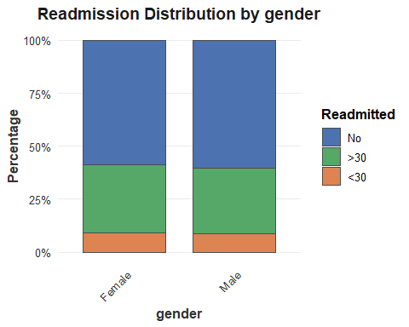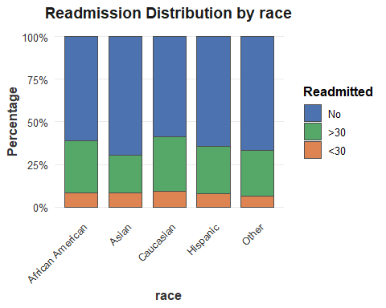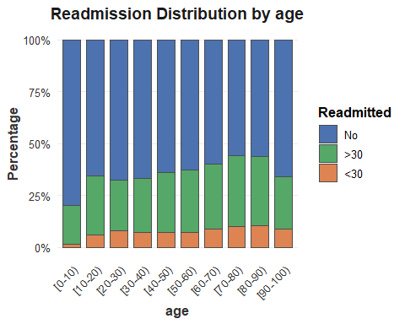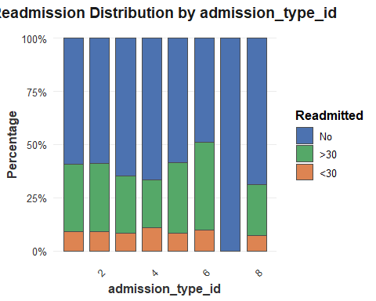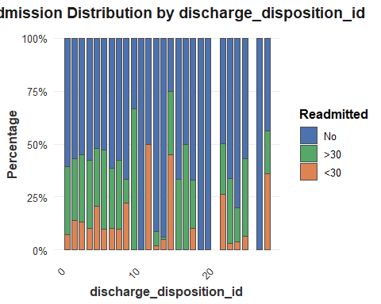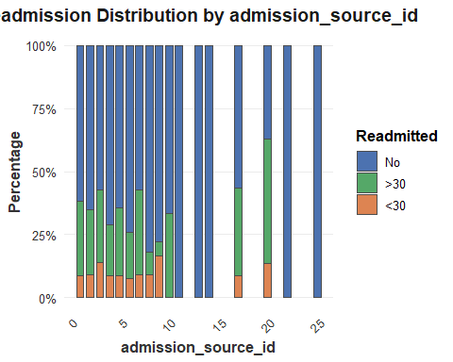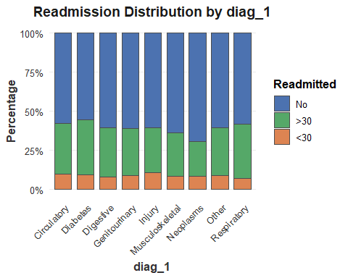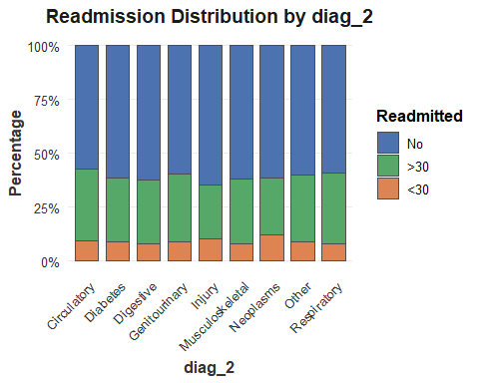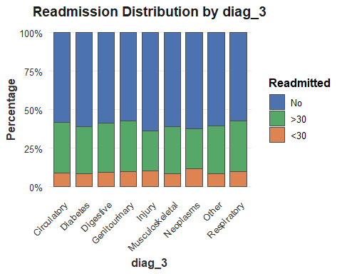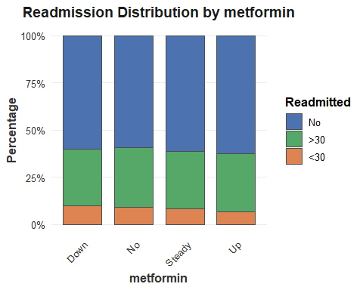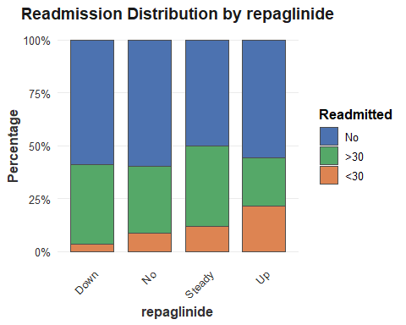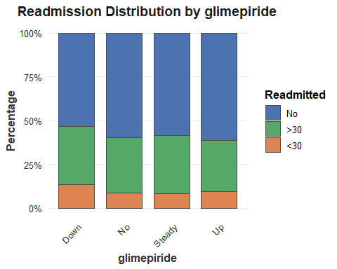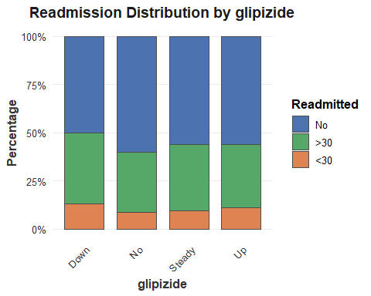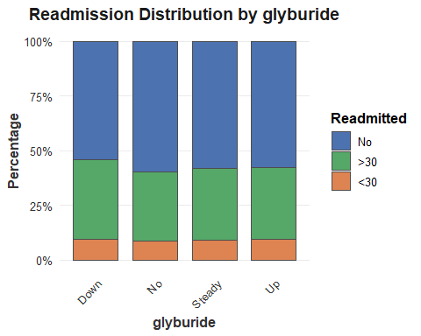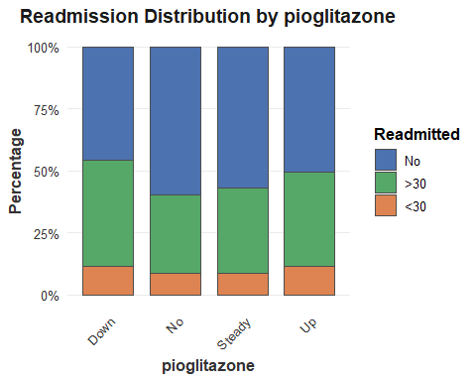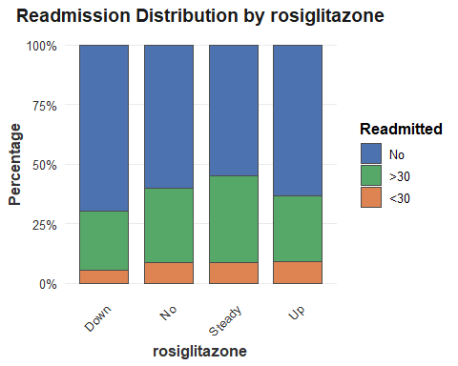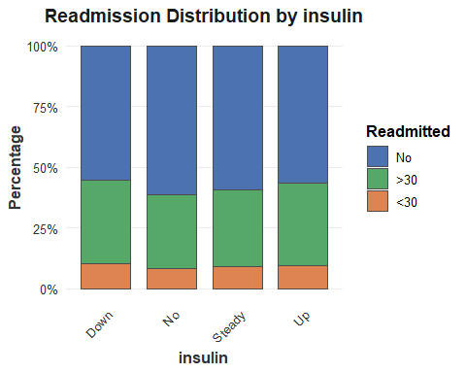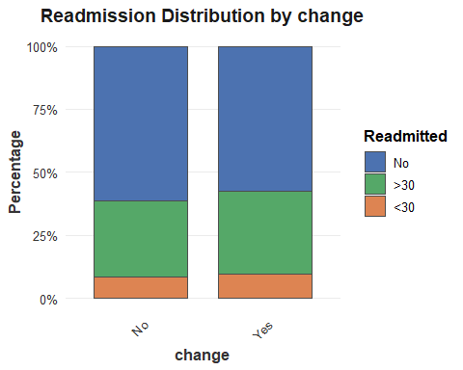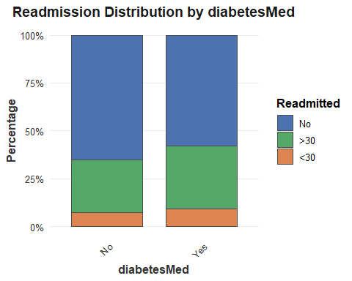
library(dplyr)
numeric_cols <- c(
"time_in_hospital",
"num_lab_procedures",
"num_procedures",
"num_medications",
"number_outpatient",
"number_emergency",
"number_inpatient",
"number_diagnoses"
)
numeric_summary_by_readmitted <- data %>%
group_by(readmitted) %>%
summarise(across(all_of(numeric_cols),
list(mean = ~mean(.x, na.rm = TRUE),
median = ~median(.x, na.rm = TRUE),
min = ~min(.x, na.rm = TRUE),
max = ~max(.x, na.rm = TRUE)),
.names = "{.col}_{.fn}"),
.groups = "drop")
print(numeric_summary_by_readmitted)
## # A tibble: 3 × 33
## readmitted time_in_hospital_mean time_in_hospital_median time_in_hospital_min
## <fct> <dbl> <dbl> <dbl>
## 1 No 4.18 3 1
## 2 >30 4.44 4 1
## 3 <30 4.81 4 1
## # ℹ 29 more variables: time_in_hospital_max <dbl>,
## # num_lab_procedures_mean <dbl>, num_lab_procedures_median <dbl>,
## # num_lab_procedures_min <dbl>, num_lab_procedures_max <dbl>,
## # num_procedures_mean <dbl>, num_procedures_median <dbl>,
## # num_procedures_min <dbl>, num_procedures_max <dbl>,
## # num_medications_mean <dbl>, num_medications_median <dbl>,
## # num_medications_min <dbl>, num_medications_max <dbl>, …
numeric_summary_overall <- data %>%
summarise(across(all_of(numeric_cols),
list(mean = ~round(mean(.x, na.rm = TRUE), 2),
median = ~median(.x, na.rm = TRUE),
min = ~min(.x, na.rm = TRUE),
max = ~max(.x, na.rm = TRUE)),
.names = "{.col}_{.fn}"))
print(numeric_summary_overall)
## # A tibble: 1 × 32
## time_in_hospital_mean time_in_hospital_median time_in_hospital_min
## <dbl> <dbl> <dbl>
## 1 4.32 4 1
## # ℹ 29 more variables: time_in_hospital_max <dbl>,
## # num_lab_procedures_mean <dbl>, num_lab_procedures_median <dbl>,
## # num_lab_procedures_min <dbl>, num_lab_procedures_max <dbl>,
## # num_procedures_mean <dbl>, num_procedures_median <dbl>,
## # num_procedures_min <dbl>, num_procedures_max <dbl>,
## # num_medications_mean <dbl>, num_medications_median <dbl>,
## # num_medications_min <dbl>, num_medications_max <dbl>, …
Metric | Readmitted <30 Days | Readmitted >30 Days | No Readmission
Time in Hospital (Days)
Mean | 4.81 | 4.44 | 4.18
Median | 4 | 4 | 3
Range (Min-Max) | 1–14 | 1–14 | 1–14
Lab Procedures
Mean | 44.91 | 43.98 | 42.41
Median | 46 | 45 | 44
Range (Min-Max) | 1–132 | 1–109 | 1–121
Procedures
Mean | 1.43 | 1.37 | 1.49
Median | 1 | 1 | 1
Range (Min-Max) | 0–6 | 0–6 | 0–6
Medications
Mean | 16.69 | 15.95 | 15.6
Median | 15 | 15 | 14
Range (Min-Max) | 1–81 | 1–70 | 1–79
Emergency Visits (Prior)
Mean | 0.15 | 0.15 | 0.07
Max | 11 | 42 | 37
Inpatient Visits (Prior)
Mean | 0.38 | 0.26 | 0.11
Max | 12 | 11 | 10

Variable | Mean | Median | Min | Max
Time in Hospital | 4.32 | 4 | 1 | 14
Num. Lab Procedures | 43.13 | 44 | 1 | 132
Num. Procedures | 1.44 | 1 | 0 | 6
Num. Medications | 15.81 | 14 | 1 | 81
Number Outpatient | 0.29 | 0 | 0 | 42
Number Emergency | 0.11 | 0 | 0 | 42
Number Inpatient | 0.18 | 0 | 0 | 12
Number Diagnoses | 7.35 | 8 | 3 | 16

