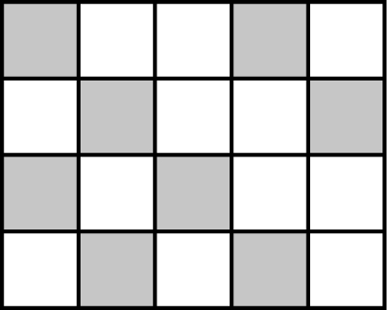
1 a What fraction of this rectangle is shaded?
b What percentage of the rectangle is not shaded?
c Draw a similar rectangle, 5 squares long and 4 squares wide.
Shade 65% of the new rectangle.
2 On 1 June the number of visitors to a theme park was recorded
as 19 476.
a Write the number 19 476 in words.
b What is the value of the digit 4 in this number?
c Write the number 19 476 to the nearest thousand.
d The next day there were two-and-a-half thousand more visitors than on 1 June. How many visitors went to the theme park on 2 June?
e Write the number of visitors on 2 June to the nearest 10.
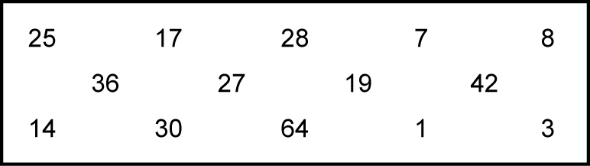
3 From the numbers in the rectangle, write down all of the:
a square numbers
b cube numbers
c prime numbers
d factors of 56
e multiples of 6.
4 List these fractions in order of size, starting with the smallest.
Show your method.
5 A factory worker packed 67 boxes of drawing pins in an hour.
Each box contained 48 drawing pins.
a Explain how you would estimate the number of drawing pins that she packed.
b Would you expect the actual number to be more or less than your estimate?
Explain your answer.
c Calculate the exact number of drawing pins that she packed into the boxes.
Show your method.
6 Jack saw two identical sweatshirts for sale, one in a shop and one in a market.
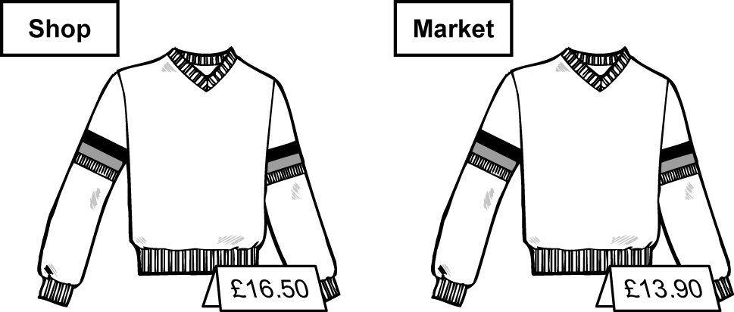
The sweatshirt in the shop was on sale at of the marked price.
The sweatshirt in the market was on sale with 20% off the marked price.
Work out which sweatshirt would cost less to buy.
Show all your working.
7 Work these out:
a 5³ b 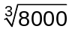 c 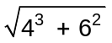 d 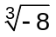
8 Copy and complete the following table showing equivalent fractions, decimals and percentages.
Fraction | Decimal | Percentage
 | 0.3
 |  | 65%
 |  | 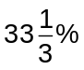
 | 0.84
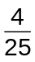

9 a Simplify these ratios: i 15 : 25 ii : iii 2.4 : 1.6 iv 30 cm : 1.5 m
b The audience in a theatre is made up of the following ratio:
men : women : children = 2 : 4 : 3
There are 207 people in the audience. Calculate the number of men.
c Copy and complete these equivalent ratios:
i 3 : 7 = 21 : ...... ii 18 : 30 = ...... : 5 iii 2½ : 5¾ = 10 : ......
10 a Rhian measures the height of one of her tomato plants as 20 cm.
The next week it is 15% taller. What is its new height?
b Another tomato plant grows from 240 cm to 312 cm.
Calculate the percentage change in height.
11 Look at these number cards:
Copy and complete the blank cards below and work out the answers to parts a and b.
a Choose the two cards that give the lowest possible answer.
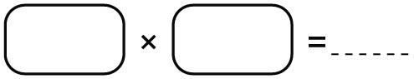
b Choose two of the cards that give the answer 100.
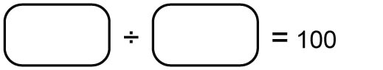
12 Use the rules of indices to simplify the following.
Give your answers in index form.
a 4³ × 4⁵ b 3⁸ ÷ 3² c (t⁴)³ d 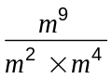
13 Sharon is making fairy cakes. She uses 150 g flour to make 24 cakes.
The following week she wants to make 60 fairy cakes.
How much flour will she need?

