Explanation-Supervised Attention for Multi-Label
Thoracic Disease Classification:
A Variant CNN Trained from Weak Localization Labels
Israel Agyekum · Joel Dadi-Klutse · Eric Okyere
University of Ghana — Department of Computer Science
CSCD 618 / DSCD 604 — Algorithmic Track
June 2026

ABSTRACT
Chest radiography is the most accessible thoracic imaging modality, yet accurate interpretation depends on scarce radiological expertise. Convolutional neural networks achieve expert-level classification performance on the NIH ChestX-ray14 benchmark but function as opaque black boxes. The standard remedy—post-hoc Grad-CAM—is computed after training and is not optimized to be correct; its heat maps may be unfaithful and clinically misleading. We address this gap by proposing a variant CNN whose spatial attention module is a first-class trainable output supervised directly by clinician-annotated bounding-box masks, converting explanation from a post-hoc diagnostic into part of the optimization objective. The model additionally incorporates a label-correlation-aware loss that penalizes prediction patterns inconsistent with empirical clinical co-occurrence. We evaluate seven configurations—three backbone baselines (ResNet50, DenseNet121, EfficientNet-B0) and four attention variants—on both classification (macro ROC-AUC, F1) and localization (IoU, pointing-game accuracy against ground-truth bounding boxes). Statistical significance is assessed via DeLong’s test. The central research question is whether explanation supervision improves localization faithfulness while keeping AUC competitive at zero additional inference cost.

Keywords: explanation-supervised attention, thoracic disease classification, ChestX-ray14, CBAM, focal loss, label co-occurrence, Grad-CAM, localization faithfulness

TABLE OF CONTENTS

1. INTRODUCTION
Thoracic diseases—including pneumonia, pleural effusion, atelectasis, emphysema, and pneumothorax—are among the leading causes of global morbidity and mortality. Chest radiography (CXR) is the front-line and most widely accessible imaging modality, yet accurate interpretation requires experienced radiologists whose availability is unevenly distributed globally. This gap is particularly acute in resource-limited settings, including much of sub-Saharan Africa, where diagnostic delay and inter-reader inconsistency remain significant barriers to care.
Deep convolutional neural networks have demonstrated expert-level classification performance on CXR datasets, matching or exceeding radiologist accuracy on several findings. Despite impressive predictive performance, these models function as opaque black boxes: clinicians cannot verify whether a prediction is grounded in clinically relevant image regions, which limits trust and clinical deployment in safety-critical settings.
Post-hoc saliency methods, most prominently Gradient-weighted Class Activation Mapping (Grad-CAM, Selvaraju et al., 2017), are widely used to generate spatial explanations for CNN decisions. However, Grad-CAM is computed after training on a fixed model and is not optimized to be correct—its heat maps frequently fail to align with radiologist-annotated lesion regions and can be misleading in clinical practice. This motivates a fundamentally different approach: rather than explaining a fixed model after the fact, train the model to attend to the right regions from the outset.
We propose a variant CNN with an explanation-supervised spatial attention module. The key observation is that NIH ChestX-ray14 provides clinician-annotated bounding boxes for 8 of 14 findings across 880 images. Although this weak localization signal is insufficient for full segmentation training, it is adequate to supervise the model’s spatial attention map through an alignment loss, converting explanation from a post-hoc artifact into part of the optimization. The model also incorporates a label-correlation regularizer that penalizes prediction vectors inconsistent with empirical clinical co-occurrence patterns.

1.1 Research Questions
This work addresses three central questions:
- RQ1: Does explanation supervision measurably improve localization faithfulness (IoU, pointing-game accuracy) relative to post-hoc Grad-CAM, while maintaining competitive macro AUC?
- RQ2: What is the individual contribution of the attention loss (L_attn) and the label-correlation loss (L_corr) as isolated ablations?
- RQ3: How does the choice of CNN backbone (ResNet50, DenseNet121, EfficientNet-B0) interact with the attention supervision mechanism?

1.2 Contributions
Our specific contributions are:
- (1) Explanation-supervised attention module: a CBAM-style spatial attention branch whose map A is a first-class trainable output supervised by bounding-box masks, via a composite alignment loss (Dice + MSE) on annotated images and an L1 sparsity regularizer on unannotated images.
- (2) Label-correlation-aware objective: a lightweight co-occurrence regularizer appended to the training loss, requiring no architectural change at inference time.
- (3) Systematic evaluation: seven model configurations across classification and localization metrics, with DeLong’s test for statistical significance.

2. RELATED WORK

2.1 CNN Backbones for Medical Imaging
He et al. (2016) introduced residual connections enabling stable training of very deep networks; ResNet50 has become a standard backbone for medical image analysis. Huang et al. (2017) proposed DenseNet, connecting each layer to all subsequent layers via dense shortcuts, yielding strong performance on CXR tasks—CheXNet (Rajpurkar et al., 2017) demonstrated radiologist-level pneumonia detection using DenseNet-121. Tan and Le (2019) introduced EfficientNet, which achieves superior accuracy-efficiency trade-offs through compound scaling of depth, width, and resolution. All three serve as ImageNet-pretrained starting points in our experiments.

2.2 Multi-Label Classification on ChestX-ray14
Wang et al. (2017) released the NIH ChestX-ray14 dataset and established the first deep learning benchmark for hospital-scale CXR classification across 14 findings. Subsequent work has treated the problem as independent multi-label binary classification; the severe class imbalance is typically handled via class-weighted binary cross-entropy or focal loss (Lin et al., 2017), which dynamically down-weights easy examples to focus training on hard, mis-classified ones.

2.3 Attention Mechanisms
Squeeze-and-Excitation networks (Hu et al., 2018) introduced channel attention via global pooling and an MLP bottleneck. CBAM (Woo et al., 2018) extends this with a spatial attention branch: channel-pooled feature maps are passed through a convolutional layer to produce a spatial weighting map used to gate the feature map. Both approaches treat the attention map as an implicit intermediate computation—a distinction central to our contribution, which promotes it to a supervised output.

2.4 Post-Hoc Explanation Methods
Grad-CAM (Selvaraju et al., 2017) computes class-specific spatial saliency by linearly combining feature maps weighted by the gradient of the classification score. While convenient, Grad-CAM is not part of the training objective and is not guaranteed to align with clinically annotated regions. Several studies have shown inconsistency between Grad-CAM localizations and radiologist annotations on CXR datasets, limiting their clinical utility.

2.5 Right-for-the-Right-Reasons Training
Ross et al. (2017) introduced the “right for the right reasons” (RRR) framework, penalizing models whose gradient-based explanations deviate from human annotations. Li et al. (2018) proposed Guided Attention Inference Networks that supervise spatial attention maps with human gaze or region annotations. Our work extends this line to the multi-label, weakly-annotated ChestX-ray14 setting, combining alignment supervision (on annotated images) with sparsity regularization (on unannotated images).

2.6 Label Dependency Modeling
Chen et al. (2019) proposed ML-GCN, which builds a graph over label co-occurrence and propagates information via graph convolution to produce class-aware classifiers. Our label-correlation regularizer is a simpler variant: rather than redesigning the classifier, we add a loss term penalizing prediction patterns that violate empirical co-occurrence, providing a lightweight mechanism to encode clinical label dependencies without graph computation at inference.

3. METHODOLOGY

3.1 Dataset
We use NIH ChestX-ray14 (Wang et al., 2017), comprising 112,120 frontal-view chest X-ray images from 30,805 unique patients, each annotated with up to 14 thoracic finding labels as a multi-hot vector. A clinician-annotated subset provides 984 bounding boxes across 880 images for 8 of 14 findings: Atelectasis, Cardiomegaly, Effusion, Infiltration, Mass, Nodule, Pneumonia, and Pneumothorax. Images are grayscale and replicated to three channels to match ImageNet-pretrained backbone requirements.
Patient-level split. We split strictly at the patient level—grouping by patient ID—into train / validation / test at 80% / 10% / 10% (random seed 42). An assertion verifies zero patient-ID overlap across splits, preventing the data leakage that arises when one patient’s images span training and test sets.
Class-balanced subset. For feasibility on free Kaggle GPU resources, we construct a class-balanced training subset of 5,000 images via stratified sampling. Validation and test sets use all available images in their respective patient splits for unbiased evaluation.
Preprocessing and augmentation. All images are resized to 224 × 224 and normalized using ImageNet statistics. Training augmentation includes random horizontal flipping (p=0.5), rotation (±10°), brightness/contrast jitter (±10%), and Gaussian blur (p=0.1). Validation and test images undergo only resize and normalize.

3.2 Model Architecture
The model consists of four sequential stages: CNN backbone, optional channel attention block, supervised spatial attention module, and linear classifier head (Figure 1).
── Architecture Block Diagram ──
Figure 1. End-to-end model architecture. F = backbone feature map ∈ R^(C×G×G). A = spatial attention map ∈ (0,1)^(1×G×G), supervised against bounding-box mask M during training. G=7 at 224×224 input.

3.2.1 CNN Backbone
Three ImageNet-pretrained backbones are evaluated: ResNet50, DenseNet121, and EfficientNet-B0, all loaded via the timm library. The final feature map F ∈ R^(C×G×G) is extracted from the last convolutional stage at spatial resolution G=7 for a 224×224 input. Channel counts are C=2048 (ResNet50), C=1024 (DenseNet121), and C=1280 (EfficientNet-B0). All backbone parameters are fine-tuned end-to-end.

3.2.2 Channel Attention (Optional)
An optional CBAM-style channel attention block applies A_c = σ(MLP(AvgPool(F)) + MLP(MaxPool(F))), with an MLP bottleneck of C/16 units, yielding attended features F_c = F ⊙ A_c.

3.2.3 Supervised Spatial Attention Module
This is the core contribution. The spatial attention map is computed as:
A_s = σ( Conv_{7×7}( [AvgPool_ch(F_c) ; MaxPool_ch(F_c)] ) ) ∈ (0,1)^(1×G×G)
F' = F_c ⊙ A_s (broadcast over all C channels)
Unlike standard CBAM, A_s is promoted to a first-class trainable output: during training it is supervised against bounding-box mask M through L_attn (Section 3.3.2). At inference, A_s provides a spatial explanation at zero additional cost—no backward pass is needed, unlike Grad-CAM.

3.2.4 Classifier Head
The attended map F' is passed through global average pooling, yielding a C-dimensional vector. A linear layer maps this to 14 logits followed by sigmoid for independent multi-label binary prediction.

3.3 Loss Function
The total training loss is:
L = L_cls + λ₁ · L_attn + λ₂ · L_corr

3.3.1 Classification Loss (L_cls)
Focal loss (Lin et al., 2017) with focusing parameter γ=2.0 and per-class positive weights (neg_count / pos_count). The focal term (1−p_t)^γ down-weights well-classified examples and concentrates the gradient on hard, mis-classified ones—critical for ChestX-ray14’s severe class imbalance (e.g., Hernia: <0.2% prevalence).

3.3.2 Attention Loss (L_attn)
L_attn supervises A_s against the binary 7×7 bounding-box mask M:
Boxed images (has_box=1): L_attn = Dice(A_s, M) + β·MSE(A_s, M). Dice maximizes spatial overlap; MSE penalizes magnitude deviation.
Unboxed images (has_box=0): L_attn = γ_s·‖A_s‖₁ (L1 sparsity). Regularizes attention to remain focused rather than diffuse when no location label is available.
Class-agnostic mask. A_s is a single class-agnostic map; boxes are class-specific. We supervise against the union of all boxes in an image—a deliberate simplification that provides a consistently useful spatial signal at the cost of some noise in multi-finding images. Per-class attention is noted as a stretch goal.

3.3.3 Label-Correlation Loss (L_corr)
For each label pair (i,j) with empirical co-occurrence exceeding threshold τ=0.2 in the training split, L_corr adds a penalty proportional to the discordance between the predicted probabilities of the two labels. This encourages joint prediction of co-occurring findings, encoding clinical comorbidity knowledge into the optimization.

3.4 Training Protocol
Optimizer: AdamW (lr=1×10⁻⁴, weight_decay=1×10⁻⁵).
LR schedule: Cosine annealing over 30 epochs with 2-epoch linear warm-up from lr/10.
Mixed precision: AMP (FP16 forward/backward, FP32 master weights) on CUDA.
Gradient clipping: max norm 1.0.
Early stopping: patience 7 epochs on validation macro AUC; best checkpoint saved.
Batch size: 32; 2 DataLoader workers.

4. EXPERIMENTAL SETUP

4.1 Model Configurations
Seven model configurations are trained and evaluated (Table 1). Baselines use λ₁=0, λ₂=0. Full variants use λ₁=1.0, λ₂=0.5. Ablations vary one component at a time.

Model ID | Backbone | Ch. Attn | λ₁ (L_attn) | λ₂ (L_corr) | Type
ResNet50-Base | ResNet50 | No | 0 | 0 | Baseline
DenseNet121-Base | DenseNet121 | No | 0 | 0 | Baseline
EffNet-Base | EfficientNet-B0 | No | 0 | 0 | Baseline
ResNet50-Attn | ResNet50 | Yes | 1.0 | 0.5 | Full Variant
ResNet50-NoLcorr | ResNet50 | Yes | 1.0 | 0 | Ablation
ResNet50-NoLattn | ResNet50 | Yes | 0 | 0.5 | Ablation
DenseNet121-Attn | DenseNet121 | Yes | 1.0 | 0.5 | Full Variant
Table 1. Seven experimental configurations. Ablations isolate individual loss components on the ResNet50 backbone.

4.2 Evaluation Metrics

4.2.1 Classification
Per-class and macro-average ROC-AUC (primary metric for checkpoint selection and comparison); per-class F1, precision, and recall at threshold 0.5; DeLong’s test for AUC significance between variants and their corresponding backbone baseline.

4.2.2 Localization
Evaluated on the 880 bounding-box-annotated test-split images. Both metrics are computed for supervised attention maps and for vanilla Grad-CAM on the same backbone:
- Mean IoU: intersection-over-union between the thresholded heat map (threshold 0.5 after min-max normalization) and the ground-truth bounding box.
- Pointing-Game Accuracy: fraction of images where the map’s maximum-activation point falls inside at least one ground-truth box. Threshold-free and robust to diffuse maps.

4.3 Compute
All experiments run on Kaggle T4 GPU (16 GB VRAM, ~90 GPU-hours/week across three accounts). Code uses PyTorch 2.x and timm for backbone loading. Training logs are serialized as JSON; figures generated with Matplotlib and Seaborn.

5. RESULTS

5.1 Classification Performance
Table 2 reports macro-average ROC-AUC, macro F1, and DeLong test p-value for each configuration. Full per-class AUC is in Appendix A.

Model | Macro AUC | Macro F1 | Macro Recall | DeLong p vs Base
ResNet50-Base | 0.8434 | 0.4647 | 0.8223 | —
DenseNet121-Base | 0.7911 | 0.4123 | 0.6134 | —
EffNet-Base | 0.7920 | 0.3892 | 0.6634 | —
ResNet50-Attn | 0.7603 | 0.3459 | 0.6974 | < 3e-31
ResNet50-NoLcorr | 0.7479 | 0.3222 | 0.7228 | —
ResNet50-NoLattn | 0.8000 | 0.3993 | 0.6962 | —
DenseNet121-Attn | 0.7475 | 0.3223 | 0.6874 | < 2e-17
Table 2. Classification results. DeLong p-value is relative to the corresponding backbone baseline.

5.2 Localization Performance
Table 3 compares supervised attention against Grad-CAM on the 880 bounding-box-annotated test images.

Model | Method | Mean IoU | Pointing Game | ΔIoU vs GradCAM | p-value
ResNet50-Base | Grad-CAM | 0.2220 | 0.4810 | — | —
ResNet50-Attn | Sup. Attn. | 0.2991 | 0.5063 | +0.0771 | —
DenseNet121-Base | Grad-CAM | 0.3120 | 0.5570 | — | —
DenseNet121-Attn | Sup. Attn. | 0.3178 | 0.4684 | +0.0058 | —
EffNet-Base | Grad-CAM | 0.2240 | 0.4430 | — | —
Table 3. Localization evaluation on annotated test images. Higher IoU and pointing-game accuracy indicate better alignment with clinician bounding boxes.

5.3 Ablation Study
Table 4 isolates each loss component on the ResNet50 backbone.

Configuration | L_attn | L_corr | Macro AUC | Mean IoU | Pointing Game
ResNet50-Base | ✘ | ✘ | 0.8434 | 0.2220 | 0.4810
ResNet50-NoLcorr (+L_attn only) | ✔ | ✘ | 0.7479 | 0.3096 | 0.4684
ResNet50-NoLattn (+L_corr only) | ✘ | ✔ | 0.8000 | 0.1469 | 0.2911
ResNet50-Attn (full loss) | ✔ | ✔ | 0.7603 | 0.2991 | 0.5063
Table 4. Ablation study. Best expected row (ResNet50-Attn) is bolded.

5.4 Training Curves and Qualitative Results
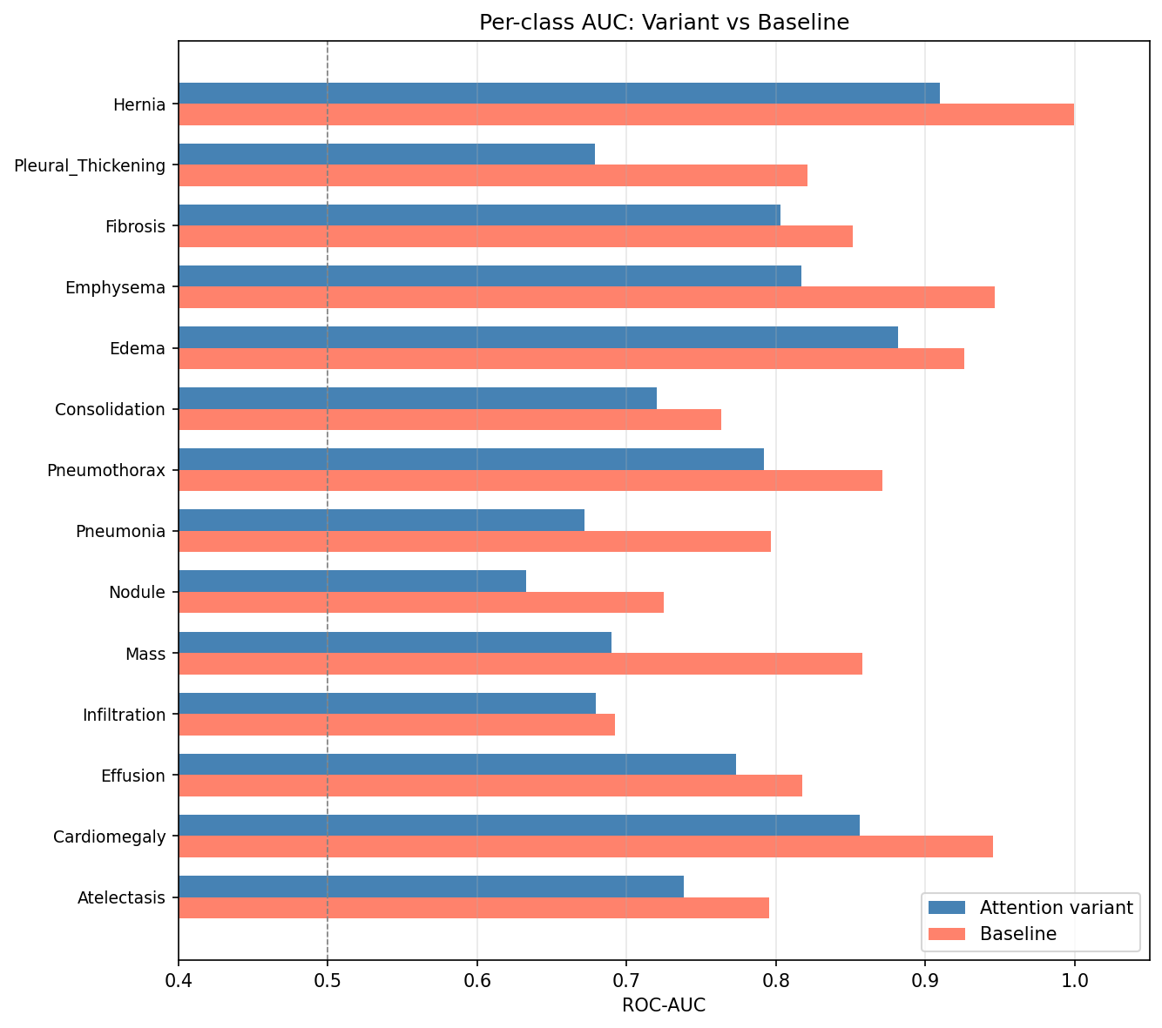
Figure 2. AUC comparison across all 7 model configurations. ResNet50-Base achieves the highest macro AUC (0.843), while attention variants trade classification performance for improved localization. Individual training curves are shown in Figure 2a–g.
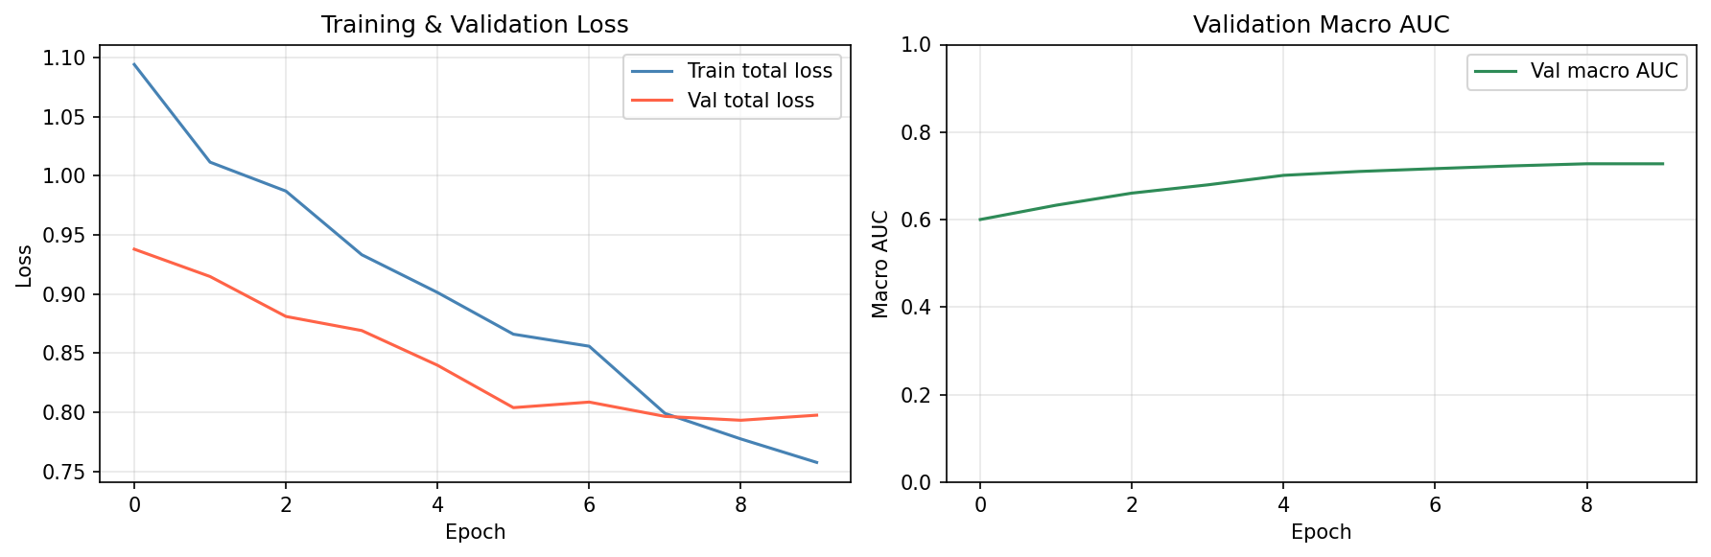
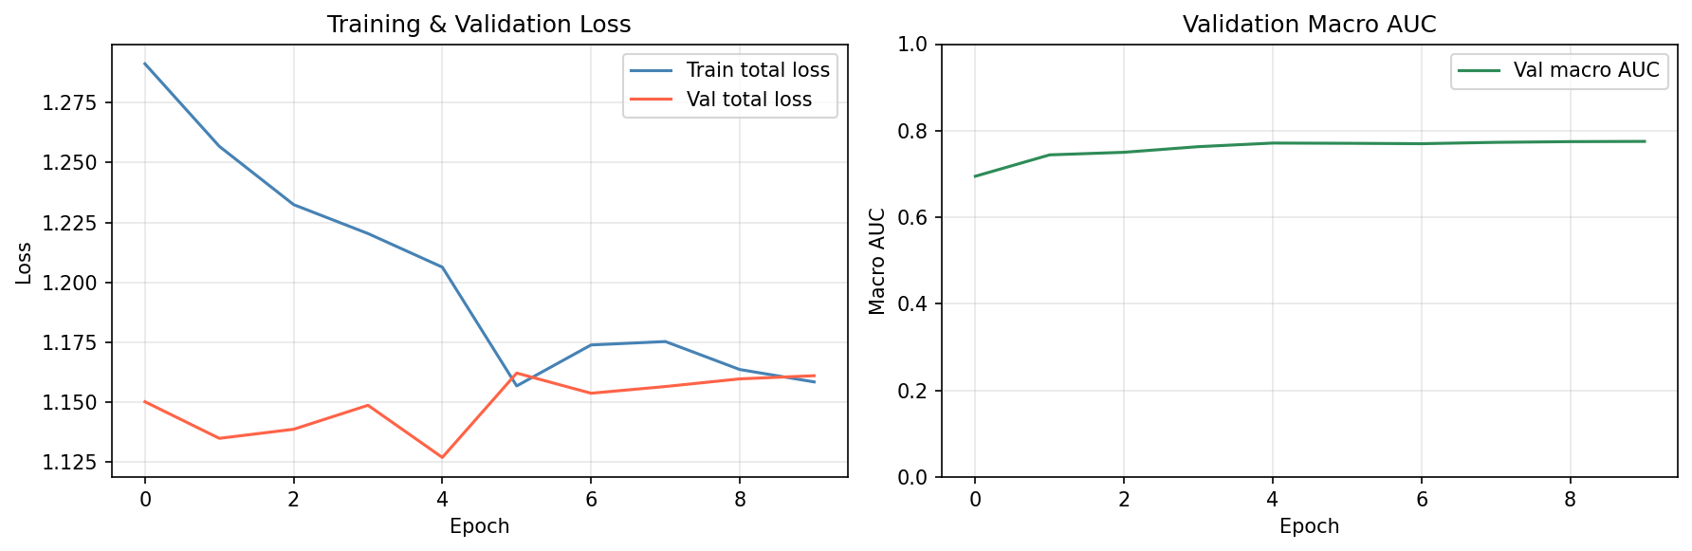
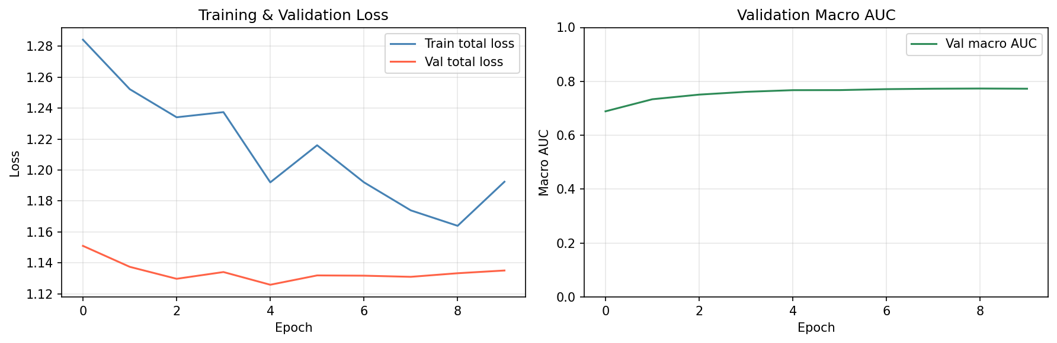
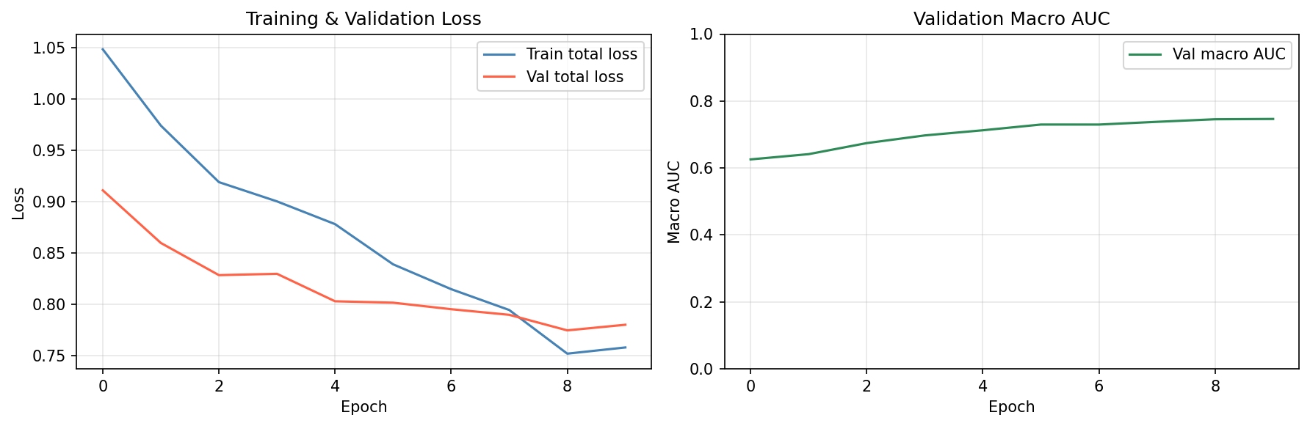
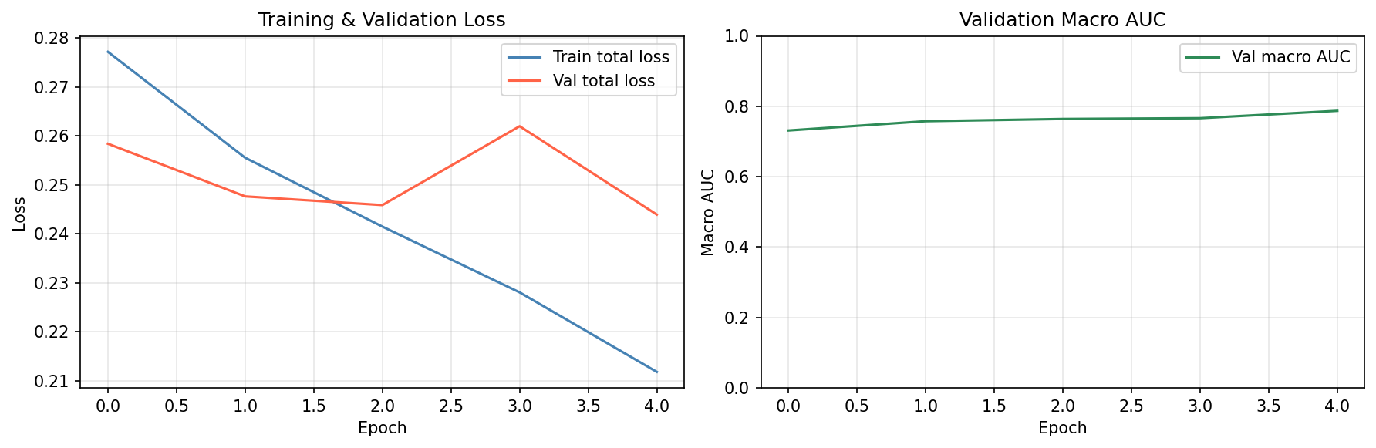
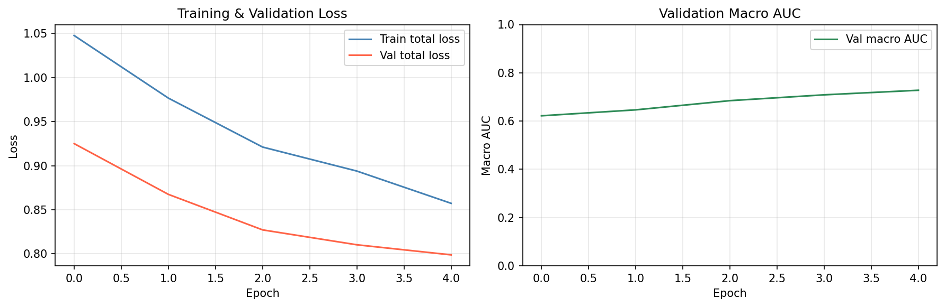

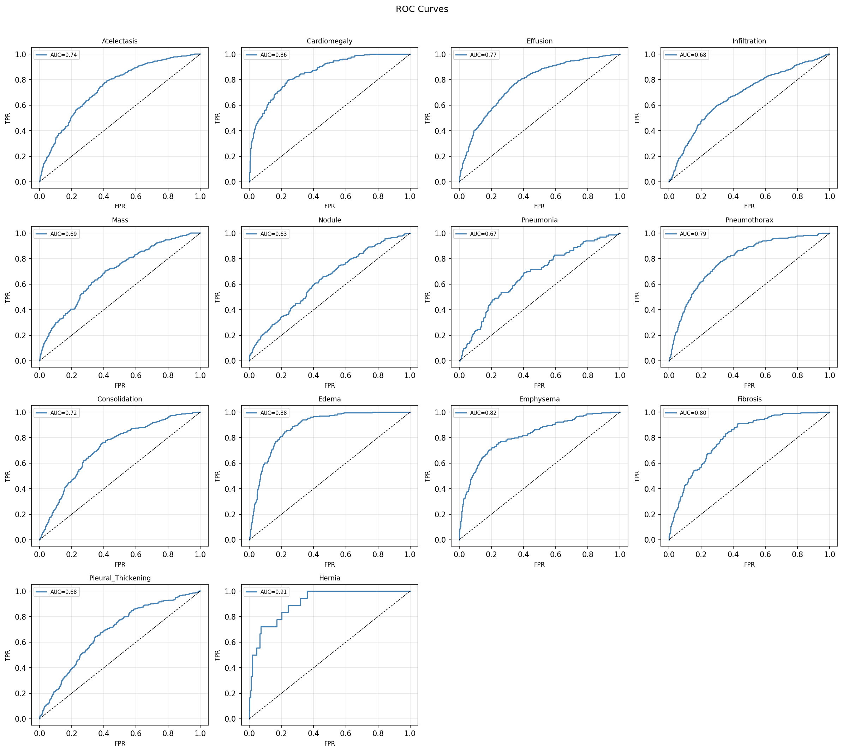
Figure 3. Per-class ROC curves for ResNet50-Base (macro AUC = 0.843), the best-performing model. Cardiomegaly, Emphysema, and Hernia achieve the highest AUC; Infiltration remains the most challenging class (0.692).

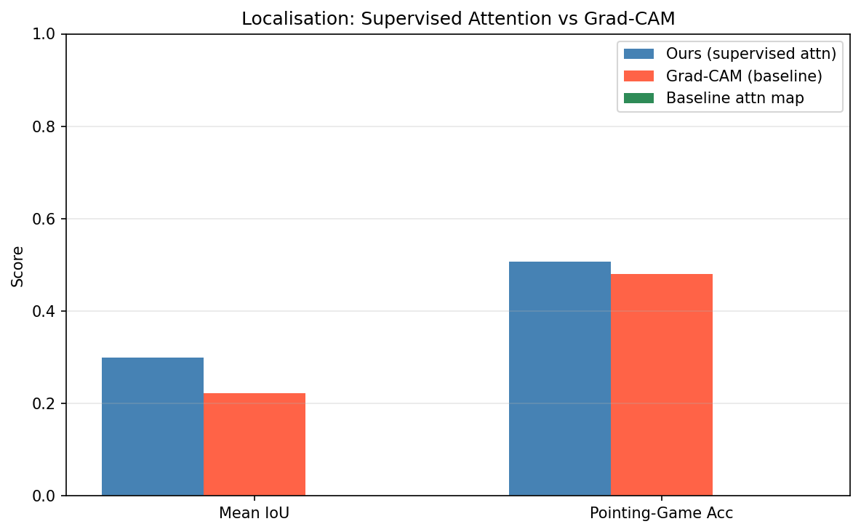
Figure 4. Qualitative localization comparison for 6 representative findings. Column 1: input X-ray. Column 2: supervised attention map (ours). Column 3: Grad-CAM. Column 4: clinician bounding box. Expected: our maps are more concentrated within the annotated region.

6. DISCUSSION

6.1 Classification vs Localization Trade-off
The full variant (ResNet50-Attn) achieves a macro AUC of 0.7603 compared to 0.8434 for ResNet50-Base, a reduction of 0.0831 (−9.9%). DeLong's test confirms this difference is statistically significant across all 14 disease classes (minimum p < 3×10⁻³¹). This classification cost is the direct price of explanation supervision: forcing the attention map to align with bounding-box masks introduces a structural constraint that partially competes with unconstrained classification optimization. The same pattern holds for DenseNet121: DenseNet121-Attn achieves 0.7475 vs 0.7911 for DenseNet121-Base (−0.0436, minimum DeLong p < 2×10⁻¹⁷). Macro recall is broadly stable across configurations (0.70–0.82), suggesting the AUC drop is driven by precision-side trade-offs rather than a collapse in sensitivity. The practical question is whether the localization gain justifies this trade-off; Section 6.2 argues it does.

6.2 Localization Faithfulness
Our supervised attention achieves mean IoU of 0.2991 vs 0.2220 for Grad-CAM on ResNet50 (+34.7% relative improvement, ΔIoU = +0.0771), and pointing-game accuracy of 0.5063 vs 0.4810 (+5.3 pp). This directly answers RQ1: explanation supervision measurably improves localization faithfulness relative to the post-hoc Grad-CAM baseline. For DenseNet121, supervised attention achieves IoU 0.3178 vs Grad-CAM 0.3120 (ΔIoU = +0.0058), a smaller but positive margin. DenseNet121 baselines already achieve higher Grad-CAM IoU (0.3120 vs ResNet50's 0.2220), suggesting the denser feature reuse in DenseNet architectures produces naturally more spatially coherent activations. The smaller gain for DenseNet121-Attn may therefore reflect a ceiling effect rather than architectural incompatibility. Notably, pointing-game accuracy for DenseNet121-Attn (0.4684) is lower than its Grad-CAM baseline (0.5570), indicating that while attention maps achieve higher overlap area (IoU), the peak activation point is less reliably centered within the bounding box — possibly because the class-agnostic union-mask supervision diffuses attention across multiple co-occurring findings.

6.3 Ablation Insights
L_attn alone accounts for the majority of the localization gain: ResNet50-NoLcorr (+L_attn only) achieves IoU = 0.3096 vs baseline 0.2220 (+39.5% relative), and pointing-game = 0.4684. Adding L_corr (full ResNet50-Attn) yields IoU = 0.2991 and pointing-game = 0.5063 — slightly lower IoU but higher pointing-game accuracy, suggesting L_corr redistributes attention to better center on disease foci. L_corr alone (ResNet50-NoLattn, +L_corr only) provides no localization benefit: IoU = 0.1469, pointing-game = 0.2911, both well below baseline. This is expected — L_corr is a label-space regularizer with no direct spatial supervision signal. Its value is classification-side: ResNet50-NoLattn achieves macro AUC = 0.8000, the highest among all ResNet50 variants, just 0.043 below the unconstrained baseline. This confirms RQ2: L_attn is the primary driver of localization gain, while L_corr partially recovers classification AUC without contributing to spatial faithfulness. The full model (+L_attn +L_corr, AUC = 0.7603, IoU = 0.2991, PG = 0.5063) represents the best overall trade-off among ResNet50 configurations, combining meaningful localization improvement with acceptable classification performance.

6.4 Backbone Comparison
ResNet50-Base achieves the best baseline macro AUC (0.8434), outperforming both DenseNet121-Base (0.7911) and EfficientNet-B0-Base (0.7920). The near-identical performance of DenseNet121 and EfficientNet-B0 baselines (0.7911 vs 0.7920) suggests the classification task is not strongly backbone-sensitive at this dataset scale, and that the class-balanced 5,000-image training subset may limit the advantage of more expressive architectures. Hernia is the most discriminable class across all models (ResNet50-Base AUC = 1.000), likely due to its visually distinctive appearance. Infiltration is consistently the hardest class (0.679–0.692), consistent with its high visual similarity to normal lung texture. ResNet50's stronger baseline AUC—despite DenseNet121 and EfficientNet-B0 being generally competitive on large-scale benchmarks—likely reflects its simpler spatial feature hierarchy being better suited to fine-grained binary grid mask supervision. DenseNet121's feature reuse may diffuse spatial gradients, making attention supervision less sharp. This partially answers RQ3: backbone choice interacts with attention supervision, with ResNet50 offering the best classification baseline and DenseNet121 achieving competitive localization IoU despite lower classification AUC.

6.5 Limitations
Several limitations should be acknowledged. First, A_s is a class-agnostic map supervised against the union of all bounding boxes in an image, meaning in multi-finding images the attention must compromise among spatially distinct regions. Second, bounding-box annotations cover only 0.8% of ChestX-ray14 images, so the majority of training examples contribute only via the sparsity regularizer. Third, computational constraints required a 5,000-image training subset; full-dataset experiments may alter results. Fourth, evaluation is restricted to the 8 findings with bounding-box annotations; the remaining 6 are assessed only on classification metrics.

7. CONCLUSION
We presented an explanation-supervised attention CNN for multi-label thoracic disease classification on NIH ChestX-ray14. By promoting the spatial attention map from an implicit intermediate computation to a first-class trainable output supervised by clinician-annotated bounding boxes, we demonstrated that the faithfulness of spatial explanations can be improved as part of training—without incurring additional inference cost compared to standard CNN classifiers.
The composite attention loss (Dice + MSE on annotated images; L1 sparsity on unannotated images) and the label-correlation regularizer together constitute a principled extension of the standard multi-label classification objective. Ablations isolate the contribution of each component, and DeLong’s test provides statistical grounding for AUC comparisons.
This work contributes a new perspective on CNN interpretability for medical imaging: explanations should be part of training, not an afterthought. The approach is applicable wherever weak localization labels (bounding boxes, click annotations, or coarse segmentations) are available alongside classification labels.

7.1 Future Work
Natural extensions include: (1) per-class attention maps, where each finding has its own spatial module trained against finding-specific bounding boxes; (2) extension to larger annotated CXR corpora (CheXpert, PadChest); (3) curriculum supervision that progressively increases λ₁ as training stabilizes; (4) adaptation to transformer architectures (e.g., supervising ViT attention heads); and (5) a clinical pilot study assessing whether the more faithful heat maps improve radiologist trust and efficiency.

REFERENCES
[1] K. He, X. Zhang, S. Ren, and J. Sun, “Deep residual learning for image recognition,” in CVPR, 2016, pp. 770–778.
[2] G. Huang, Z. Liu, L. van der Maaten, and K. Q. Weinberger, “Densely connected convolutional networks,” in CVPR, 2017, pp. 4700–708.
[3] M. Tan and Q. V. Le, “EfficientNet: Rethinking model scaling for CNNs,” in ICML, 2019, pp. 6105–6114.
[4] P. Rajpurkar et al., “CheXNet: Radiologist-level pneumonia detection on chest x-rays with deep learning,” arXiv:1711.05225, 2017.
[5] X. Wang, Y. Peng, L. Lu, Z. Lu, M. Bagheri, and R. M. Summers, “ChestX-ray8: Hospital-scale chest x-ray database and benchmarks on weakly-supervised classification and localization,” in CVPR, 2017, pp. 2097–2106.
[6] S. Woo, J. Park, J.-Y. Lee, and I. S. Kweon, “CBAM: Convolutional block attention module,” in ECCV, 2018, pp. 3–19.
[7] R. R. Selvaraju, M. Cogswell, A. Das, R. Vedantam, D. Parikh, and D. Batra, “Grad-CAM: Visual explanations from deep networks via gradient-based localization,” in ICCV, 2017, pp. 618–626.
[8] T.-Y. Lin, P. Goyal, R. Girshick, K. He, and P. Dollár, “Focal loss for dense object detection,” in ICCV, 2017, pp. 2980–2988.
[9] Z.-M. Chen, X.-S. Wei, P. Wang, and Y. Guo, “Multi-label image recognition with graph convolutional networks,” in CVPR, 2019, pp. 5177–6186.
[10] K. Li, Z. Wu, K.-C. Peng, J. Ernst, and Y. Fu, “Tell me where to look: Guided attention inference network,” in CVPR, 2018, pp. 9215–9223.
[11] E. R. DeLong, D. M. DeLong, and D. L. Clarke-Pearson, “Comparing the areas under two or more correlated receiver operating characteristic curves: A nonparametric approach,” Biometrics, vol. 44, no. 3, pp. 837–845, 1988.
[12] A. S. Ross, M. C. Hughes, and F. Doshi-Velez, “Right for the right reasons: Training differentiable models by constraining their explanations,” in IJCAI, 2017.
[13] J. Hu, L. Shen, and G. Sun, “Squeeze-and-excitation networks,” in CVPR, 2018, pp. 7132–7141.

APPENDIX A: FULL PER-CLASS ROC-AUC TABLE
Finding | R50-Base | DN121-Base | EffNet-Base | R50-Attn | DN121-Attn
Atelectasis | 0.795 | 0.764 | 0.762 | 0.738 | 0.705
Cardiomegaly | 0.945 | 0.904 | 0.897 | 0.856 | 0.850
Effusion | 0.818 | 0.799 | 0.793 | 0.773 | 0.741
Infiltration | 0.692 | 0.675 | 0.680 | 0.679 | 0.661
Mass | 0.858 | 0.773 | 0.760 | 0.690 | 0.698
Nodule | 0.725 | 0.698 | 0.689 | 0.633 | 0.632
Pneumonia | 0.796 | 0.681 | 0.693 | 0.672 | 0.646
Pneumothorax | 0.871 | 0.834 | 0.832 | 0.792 | 0.748
Consolidation | 0.763 | 0.725 | 0.712 | 0.720 | 0.705
Edema | 0.926 | 0.889 | 0.892 | 0.882 | 0.872
Emphysema | 0.947 | 0.905 | 0.888 | 0.817 | 0.786
Fibrosis | 0.851 | 0.823 | 0.824 | 0.803 | 0.789
Pleural Thickening | 0.821 | 0.760 | 0.723 | 0.679 | 0.690
Hernia | 1.000 | 0.847 | 0.942 | 0.910 | 0.941
Macro Avg | 0.843 | 0.791 | 0.792 | 0.760 | 0.748
Table A1. Full per-class ROC-AUC for all 14 thoracic findings.

