TEVEL2 – Soreq Payload

Operation & ICD

|  |  |  |  |
| --- | --- | --- | --- |
|  | | | |
| Version: 1.0 | | Doc ID: ICD-002-01 | |
|  | | | |
| Created by: | Checked by: | | Approved by: |
| Date: | Date: | | Date: |

Table of Contents:

1. Introduction 4

2. Operation Concept 4

2.1. Orbit 4

2.2. Scheduled operation 4

2.2.1. Radiation collection data 4

2.3. Summary 4

3. Mechanical Interface 6

3.1. Payload 6

4. Electrical interface 7

4.1. Power Allocation 7

4.1. Power Distribution diagram (TBF) 7

4.2. Data Interface Diagram (TBF) 7

4.3. CSKB stack connectors overview 7

5. Software Requirements 10

5.1. Overview 10

5.2. Description 11

5.3. Parameter / response length 11

5.4. Format specification 12

5.5. Telemetry and Command Definition 13

5.5.1. Functionality overview 13

5.5.2. Data interface specification 13

6. Appendix 1 - General PCB description 14

7. Appendix 2 – Soreq Payload layout 16

# Introduction

This document controls the required interfaces between the Soreq Science Unit and the TEVEL platform. The following document describes in details the mechanical and electrical interfaces.

# Operation Concept

The following paragraph details the operation concept for the Soreq payload.

## Orbit

The Satellite will be launched preferable by SpaceX transporter mission to a SSO Orbit

|  |  |
| --- | --- |
| Inclination | 97.7 deg |
| Height | 567 km |

## Scheduled operation

The Soreq payload is comprised of 1 unit which will have the following capabilities.

### Radiation collection data

The first capability of the payload is to collect data regarding the Total Dose (RADFET). The second capability is to collect data regarding SEU. And the third capability is to collect data regarding latch up of electronic components. This data will be collected by the OBC during the entire mission every 1 min from the SOREQ payload and stored in the OBC for future download.

## Summary

|  |  |  |  |  |  |
| --- | --- | --- | --- | --- | --- |
| **Unit** | **Operation period** | **Data collection** | **Data size [per collection]** | **Data size [total daily]** | **Remarks** |
| RADFET | Entire mission | Every 1 min | 96 bit | 138Kbit | Add time stamp |
| SEU (Spartan) | Entire mission | Every 30 seconds | 320bit |  | Reference 32X720 |
| Latchup (PIC32) | Entire mission | Every hour | 64bit |  |  |
| Timestamp | Entire mission | Every 1 min | 128bit | 92Kbit |  |
| **TOTAL** |  |  |  |  |  |

# Mechanical Interface

The Soreq science unit will be accommodated on top of all the satellite components and bellow the +Z face of the CubeSat.

The Soreq Payload is assembled from 2 PCB cards which will have a CSKB connector to connect to both power and data.

## Payload

The main unit of the Soreq payload are 2PCB boards which are connected via CSKB – PC104 connector (see figure 1) to the iOBC. The units they are connected between them directly via dedicated cables. The allocated space is between 2 to 2.5 cm (TBF)

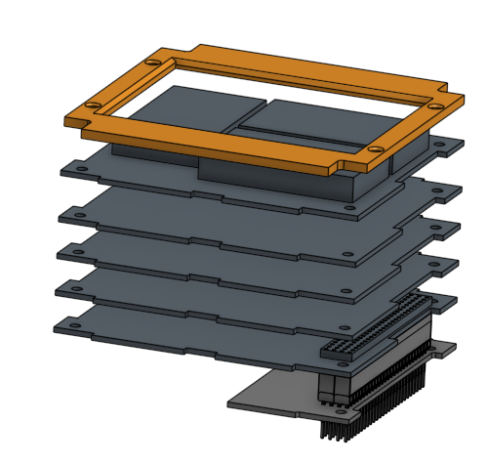

1- Figure 1: Main unit of Soreq payload

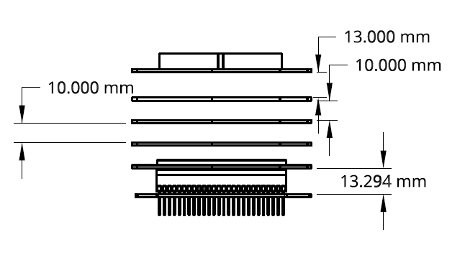

4- Figure 4: Dimensions of distance between PCB- back view

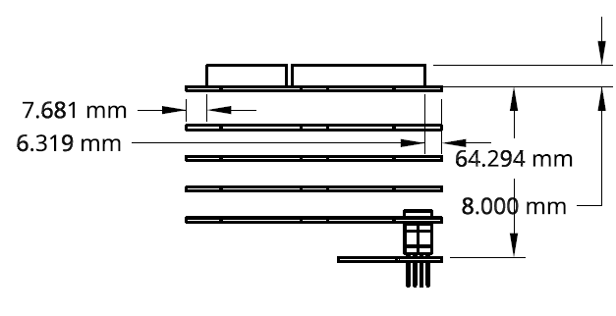

5- Figure 5: Dimensions of distance between PCB – side view

# Electrical interface

## Power Allocation

The following table shows current overview of the power allocation to the Soreq payload. It verifies that for each line the maximum current expected is below the current limit.

|  |  |  |  |  |  |
| --- | --- | --- | --- | --- | --- |
| Line | CSKB ref | Item Powered | Current Max | Current Limit | Description |
| 5V_SW | H1-49 | Soreq Payload | ??? | 2A | Switchable |
| GND | H2-32 |  |  |  |  |

## Power Distribution diagram (TBF)

5V

Soreq

EPS

## Data Interface Diagram (TBF)

I2C

Soreq

iOBC

## CSKB stack connectors overview

The CSKB is composed of 2 connectors of 52 pins for a total of 104 pins available. The CSKB of the avionics stack is described in the table below:

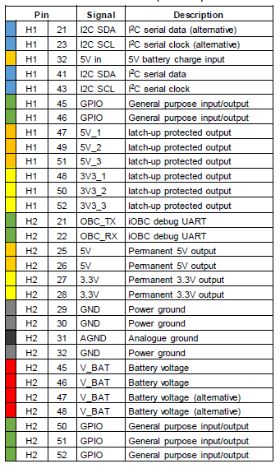

The following scheme represents an overlay of all the pins used in the CSKB connectors of the platform avionics. The pins H1-47 and H1-48 are used in the satellite to power the CubeADCS, but their default state is configured to OFF.

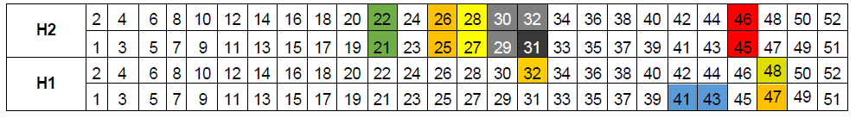

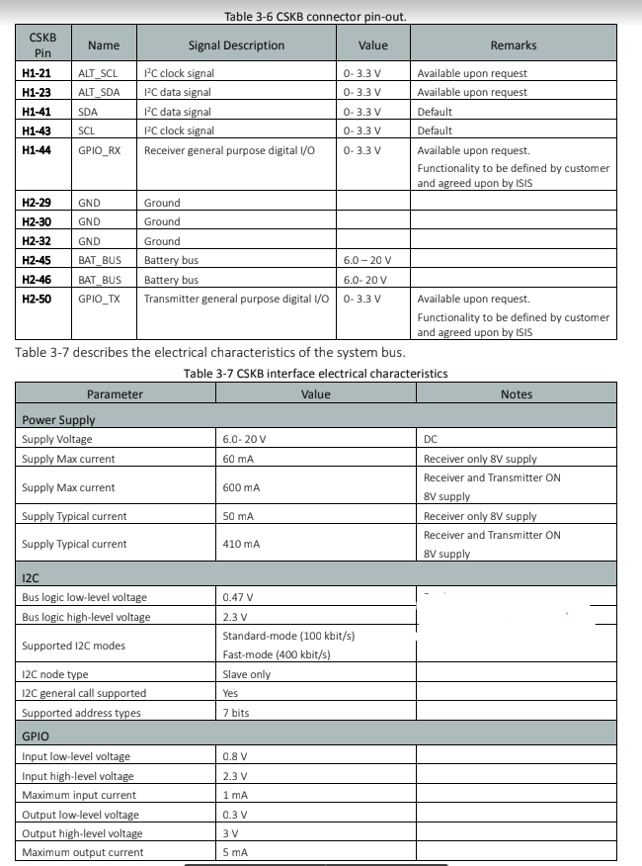

# Software Requirements

## Overview

The iOBC is the On Board Computer (OBC) and the data processor of the platform. It is used on the platform as the master of the I2C bus with the different platform subsystems and as part of it with the SOREQ payload.

The designated I2C address of the SOREQ payload is **0x55**. The I2C bus speed is 100 kHz.

The software of the satellite-payload is designed taking in account the following list of designed requirements:

|  |  |  |
| --- | --- | --- |
| **Software -Requirements** | |  |
| **ID** | **Statement** | **comment** |
| 1 | The payload has a watchdog of 150 sec controlled by the iOBC that performs a system reset unless accepting an ACK from the payload. | There should be an option to change the time eg. in safe mode. |
| 2 | After startup, the SOREQ payload will answer for a command sent by the iOBC to read all available telemetries of the payload. | The iOBC needs to record the times of the SOREQ payload powerup, shutdown and ACK (anti-watchdog) times in a dedicated log. |
| 3 | There should by an option to format and update the payload software while it is connected to the satellite without disconnecting it from the satellite. | The update is performed via a dedicated JTAG connector that is not part of the main connector between the satellite and the payload and shall require to disassemble the solar panels to approach it. While update, the power for the payload should be supported from an outside power source. |
| 4 | Currently, there is no checksum byte returned by the SOREQ payload. |  |
| 16 | The RADFET scientific mission should not be hampered even in cases when the payload is off for long periods of time. |  |
| 17 | After a RADFET read command is performed the iOBC adds only a time stamp.  It is important to record by the iOBC the individual times between each payload shutdown since the RADFET counter is erased after every reset. | This data will be collected during the entire mission every 1 min. |

## Description

Commands are used to set the SOREQ payload parameters. Additionally, some of them can have responses (return values). These responses need to be retrieved from the iOBC using a separate data transfer (master read) following the data transfer that contained the command (master write). The response of a command will be generated at the time of reception of the command and not at the time the response is retrieved from the transceiver. This applies for example to the commands requesting telemetry values: the measurements are performed when the command is received by the SOREQ payload. The response to a command will be available until another command that has a response is executed. The commands are listed in the following section.

Please find the format specification for all the commands below.

|  |  |
| --- | --- |
| **Command Name** | **Command Opcode** |
| Name of the command | Command code in binary |

## Parameter / response length

This specifies the length and the location in the byte sequence of the parameter or response of the command. Several examples are provided below to explain the possible options.

|  |  |
| --- | --- |
| [001 - 001] | Parameter / response has a fixed length of 1 byte and is located in byte 001 |
| [001 - 020] | Parameter / response has a fixed length of 20 bytes and is located in bytes 001 through 020 |
| [001 - 020*] | Parameter / response has an arbitrary length between 1 byte and 20 bytes and is located in the corresponding number of bytes starting at byte 001 |

Description - Extended description of the command.

Parameters - [000 – 000] format: Specification of the parameters required after the command.

Response - [000 – 000] format: Specification of the response that the antenna system will generate for this command.

The parameter and response descriptions contain specifications per byte or sequence of bytes. There can be several parameters or responses associated with a command and each have its own specification. Please note that parameters always start at byte 001, as byte 000 contains the command code. These specifications contain the following items:

## Format specification

This specifies the format of the byte(s) of the parameter or response. Several examples are provided below to explain the possible options.

|  |  |
| --- | --- |
| 0000xxxx | The four most significant bits contain zeroes, while the four least significant ones contain the relevant bits |
| xxxxxxxx 000000xx | All bits of the first (and least significant) byte are relevant, while of the second byte only the two least significant bits are relevant |
| n/a, binary | All bits in all the bytes are relevant and are interpreted as binary content, i.e. no interpretation will take place |
| _ _ _ _ _ _01 | The two least significant bits have the specific value of '01', while the other bits can be either a 1 or a 0 (don't care) |

## Telemetry and Command Definition

### Functionality overview

The SOREQ payload should contain the following functionalities:

* System software reset.
* ACK telemetry.
* System format and update option (not part of the I2C).
* All telemetry status
* RADFET count.

"הפקודות שיש לנו בקוד הנוכחי: כיבוי מתח ה-FPGA , הדלקת מתח ה-FPGA, ביצוע קריאה מה-FPGA, קינפוג ה-FPGA, קריאת ה-RADFET, מדידת התנגדות ה-SMP, הפעלת תהליך פתיחת ה-SMP, מדידת ה-ORMADD, קריאת ה-BUSY FLAG"

### Data interface specification

* + - 1. Software reset

|  |  |
| --- | --- |
| **Command Name** | **Command Opcode** |
| *Software_reset* | 0xTBD |

Description - Performs a software reset of the SOREQ payload processor.

Parameters – None.

Response – None.

* + - 1. SOREQ payload ACK Measurement

…

# Appendix 1 - General PCB description

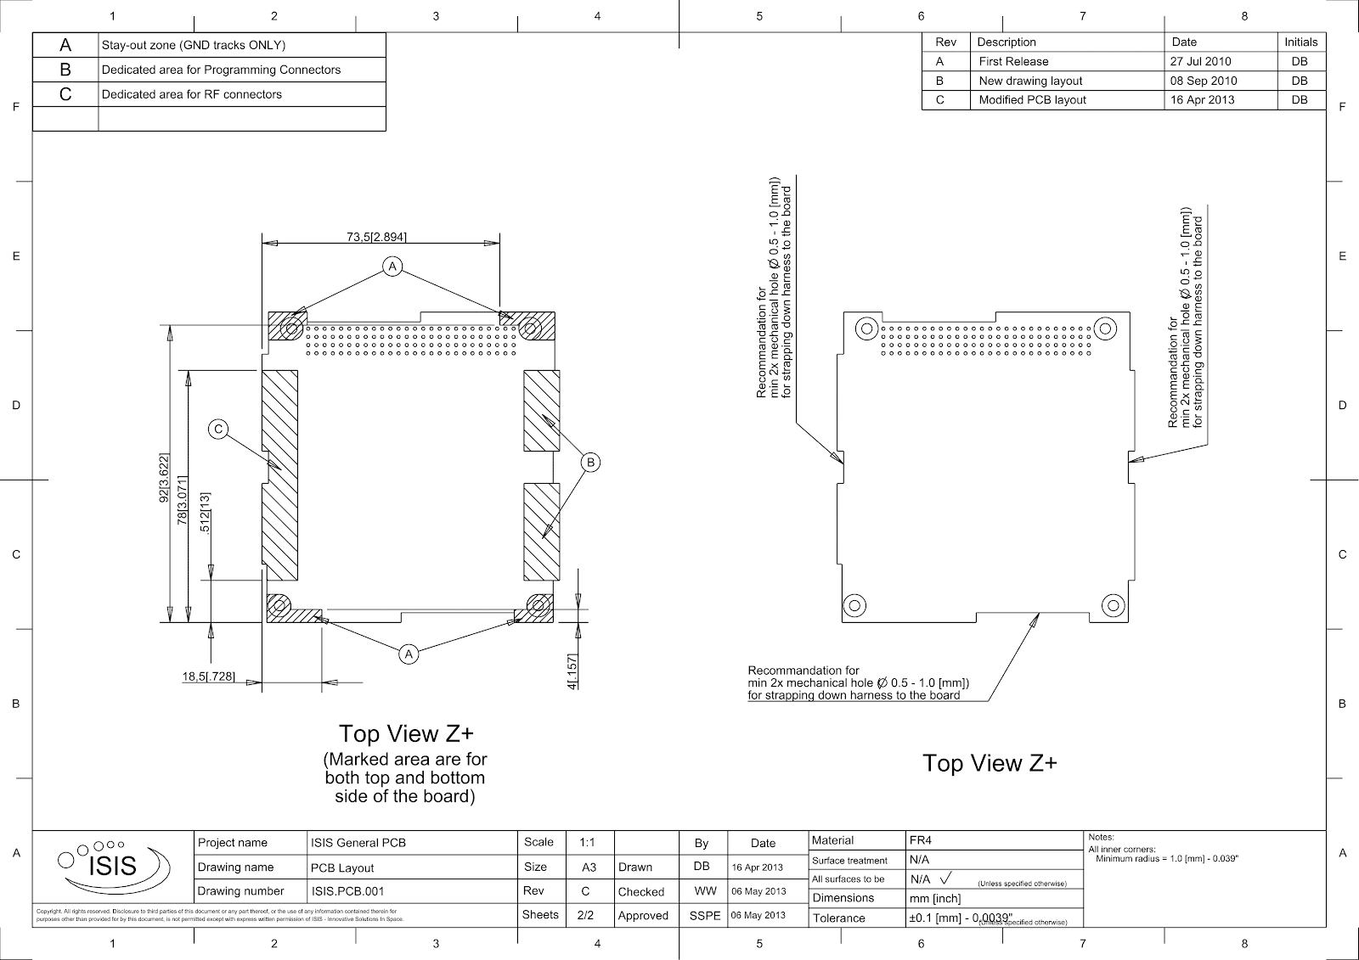

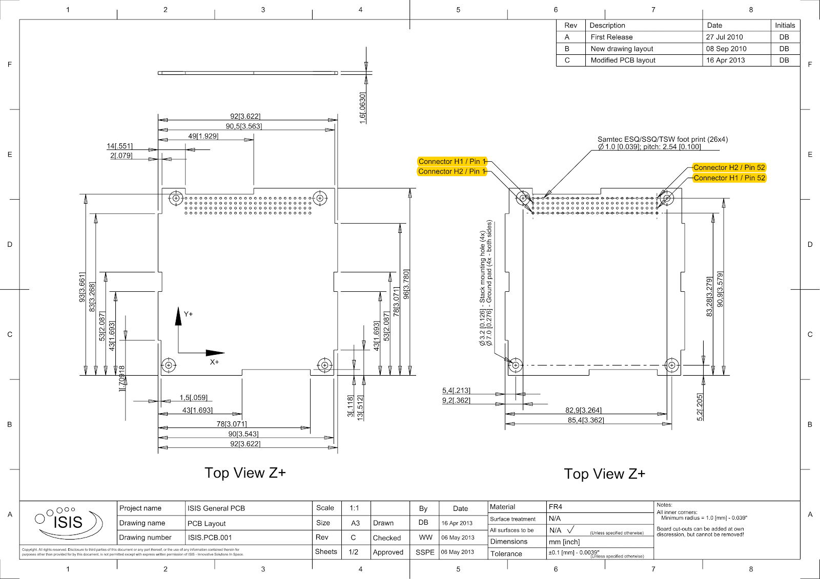

# Appendix 2 – Soreq Payload layout )TBF(