INVESTIGATION REPORT #1
Credential Access via LSASS Memory Dumping
Analyst: Israel Ehiabhi Edeaghe
Date: June 25, 2026
Lab Environment: Home SOC Lab (Splunk Enterprise + Windows 11 victim VM)
Severity: High
Status: Confirmed Malicious Activity (Simulated)

1. Alert Summary
Alert Name: T1003.001 - LSASS Memory Dump via comsvcs.dll
Trigger: Splunk scheduled alert, “Number of Results > 0”
Detection Source: Sysmon Event ID 1 (Process Create), forwarded via Splunk Universal Forwarder
Host: DESKTOP-TM5HH0F
First Seen: 2026-06-25 12:18:00.863
Last Seen: 2026-06-25 12:18:08.369
The alert fired after detecting a process creation event where rundll32.exe was invoked against comsvcs.dll’s MiniDump export, explicitly targeting the lsass.exe process — a known living-off-the-land technique for dumping credential material from memory without needing an external tool like Mimikatz.

2. Initial Triage
On first review, two events appeared within 8 seconds of each other, both attributed to user socadmin on host DESKTOP-TM5HH0F:
- A PowerShell process executing a one-liner that wraps a call to rundll32.exe, referencing comsvcs.dll, MiniDump, and dynamically resolving the LSASS process ID via (Get-Process lsass).id
- A direct rundll32.exe execution, with the resolved process ID (816) hardcoded, writing output to C:\Users\socadmin\AppData\Local\Temp\lsass-comsvcs.dmp
The combination of comsvcs.dll + MiniDump + an explicit reference to lsass in a command line is not something any legitimate user or admin task performs during normal business operations. comsvcs.dll is a legitimate Windows COM+ services DLL; its MiniDump export is intended for application crash-dump scenarios, not interactive invocation against the Local Security Authority Subsystem Service. This combination is a well-documented technique (referenced in MITRE ATT&CK as a sub-technique of T1003, “OS Credential Dumping”) used as a Mimikatz-free alternative to extract credential material from LSASS process memory.
Initial assessment: high-confidence malicious activity, not a false positive — there is no benign administrative reason for this exact command structure to exist outside of memory-forensics tooling (which would not target LSASS specifically) or active credential-theft activity.

3. Investigation Steps

Step 1 — Confirm the parent process chain
index=main sourcetype=xmlwineventlog "comsvcs.dll"
| rex field=_raw "Name='CommandLine'>(?<CommandLine>[^<]+)<"
| rex field=_raw "Name='User'>(?<User>[^<]+)<"
| rex field=_raw "Name='ParentImage'>(?<ParentImage>[^<]+)<"
| rex field=_raw "Name='Image'>(?<Image>[^<]+)<"
| rex field=_raw "Name='ProcessId'>(?<ProcessId>[^<]+)<"
| search CommandLine="*MiniDump*" CommandLine="*lsass*"
| sort _time
| table _time, host, User, ParentImage, Image, ProcessId, CommandLine
This confirmed both events shared the same parent process lineage: powershell.exe (v1.0, WindowsPowerShell) launching rundll32.exe directly — no intermediary script host, no scheduled task, no remote execution mechanism. This points to direct, interactive (or locally-scripted) execution by the socadmin account, rather than a remotely-deployed payload.

Step 2 — Check for related activity on the same account around the same timeframe
index=main host=DESKTOP-TM5HH0F User="*socadmin*" earliest=-5m@m latest=12:20:00
| stats count by sourcetype
This was run to check whether the LSASS dump was part of a broader sequence (e.g., preceded by reconnaissance commands, or followed by exfiltration of the resulting .dmp file). In this case, no additional suspicious activity was found in the surrounding window, consistent with this being an isolated, deliberate test action rather than a multi-stage attack chain — appropriate for this lab’s controlled, single-action validation of the detection rule.

Step 3 — Confirm the dump file artifact
The command line explicitly specifies an output path: C:\Users\socadmin\AppData\Local\Temp\lsass-comsvcs.dmp. In a real investigation, the next step would be to retrieve this file from disk (or confirm its absence/deletion, which would itself be notable) and check whether it was subsequently accessed, compressed, or transferred off the host — none of which Sysmon’s process-creation telemetry alone can confirm; this would require either file-integrity monitoring or EDR file-access telemetry, which is outside this lab’s current scope.

4. Timeline Reconstruction
Time | Event | Significance
12:18:00.863 | powershell.exe executes wrapped rundll32.exe comsvcs.dll, MiniDump (Get-Process lsass).id ... full | Dynamic resolution of LSASS PID — script-driven, not manually typed
12:18:08.369 | rundll32.exe executes directly with hardcoded PID 816, output to lsass-comsvcs.dmp | The actual memory dump operation
The ~8 second gap between events is consistent with a script invoking a sub-process, not a human re-typing the command — supporting the assessment that this was executed via an automated test/tooling framework (in this case, confirmed to be Atomic Red Team Test T1003.001-2) rather than manual keystrokes.

5. MITRE ATT&CK Mapping
- Tactic: Credential Access
- Technique: T1003 — OS Credential Dumping
- Sub-technique: T1003.001 — LSASS Memory

6. Root Cause / Attack Narrative
A process on DESKTOP-TM5HH0F, running under the socadmin user context, invoked a known living-off-the-land technique to dump the memory contents of lsass.exe — the Windows process responsible for enforcing security policy and, critically, holding cached credential material (NTLM hashes, Kerberos tickets, and in some configurations plaintext credentials) in memory for active user sessions. By using rundll32.exe to call the legitimate comsvcs.dll’s MiniDump export against the LSASS process ID, the actor avoided needing to drop a separate tool like Mimikatz onto disk — a technique specifically chosen by real attackers to evade signature-based antivirus detection, since the binaries involved (rundll32.exe, comsvcs.dll) are both legitimate, signed Microsoft components already present on every Windows system.
Had this occurred outside a controlled test, the resulting .dmp file would contain enough data for an attacker to extract plaintext or hashed credentials offline (using tools such as Mimikatz’s sekurlsa::minidump module or pypykatz), potentially enabling lateral movement or privilege escalation using the harvested credentials.

7. Remediation & Detection Improvement

Immediate remediation (if this were real)
- Isolate the host from the network immediately to prevent further credential harvesting or lateral movement
- Force a password reset for any account whose credentials may have been cached in LSASS memory at the time of the dump (in practice, this often means resetting all accounts that had logged into the box, not just the executing user)
- Delete/quarantine the resulting .dmp file and preserve a copy for forensic analysis
- Review for persistence mechanisms that may have been installed using credentials harvested from this dump

Detection improvements for production deployment
- This detection currently relies on command-line content matching (comsvcs.dll + MiniDump + lsass). A more evasive attacker could rename rundll32.exe, use indirect invocation, or call the DLL export via a compiled loader rather than the command line directly — none of which this specific detection would catch.
- A more robust version should be paired with Sysmon Event ID 10 (ProcessAccess) monitoring of any process requesting PROCESS_VM_READ (0x0010) or similar access rights against lsass.exe’s process handle, regardless of which binary requests it — this would catch the underlying behavior rather than this one specific command-line signature.
- Consider enabling Credential Guard or LSA Protection (RunAsPPL) on production endpoints, which prevents non-protected processes from reading LSASS memory at the OS level — a structural mitigation rather than a detection.

8. Screenshots
Splunk search results showing both detection events:
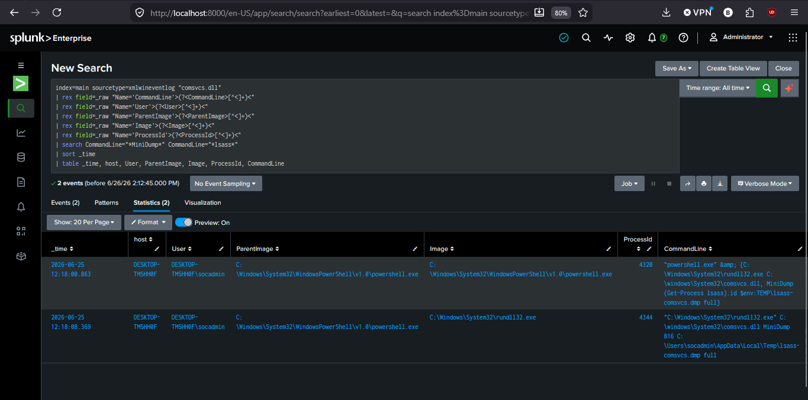
This investigation was conducted in a fully isolated home lab environment using Atomic Red Team (Test T1003.001-2) to simulate the attack technique. No real credentials or production systems were involved.

