INVESTIGATION REPORT #2
Lateral Movement via SMB Administrative Shares
Analyst: Israel Ehiabhi Edeaghe
Date: June 26, 2026
Lab Environment: Home SOC Lab (Splunk Enterprise + two Windows 11 VMs: victim-win11 and victim-win11-target)
Severity: High
Status: Confirmed Malicious Activity (Simulated)

1. Alert Summary
Alert Name: T1021.002 - Lateral Movement via SMB Admin Shares
Trigger: Splunk scheduled alert, “Number of Results > 0”
Detection Source: Windows Security Event 5140 (Network Share Object Accessed)
Target Host: DESKTOP-TM5HH0F (victim-win11)
Source Host: 192.168.56.102 (victim-win11-target)
First Seen: 2026-06-26 13:18:42.751
Last Seen: 2026-06-26 13:18:43.192
The alert fired after detecting two Security Event 5140 entries showing a remote host (192.168.56.102) accessing the hidden administrative shares IPC$ and C$ on DESKTOP-TM5HH0F using the local account socadmin. This is the exact mechanism used by attackers and legitimate remote administration tools (and tools like PsExec) to move between machines on a network using a single set of valid credentials.

2. Initial Triage
Two events appeared roughly 0.4 seconds apart, both attributed to socadmin connecting from 192.168.56.102:
- Access to \\*\IPC$ — the inter-process communication share, typically accessed first to negotiate the SMB session and authenticate
- Access to \\*\C$ — the hidden administrative share exposing the entire C: drive of the target machine
This sequence (IPC$ followed immediately by C$) is the standard SMB session-establishment pattern: a client first authenticates against IPC$ to establish a session, then accesses the actual administrative share it wants. Seeing this pattern from an unfamiliar or unexpected source address is a strong lateral-movement indicator, since legitimate users rarely need direct, authenticated access to another workstation’s root C$ share — file servers and properly-scoped shares are the normal mechanism for legitimate file access.
Initial assessment: high-confidence lateral movement activity. C$ share access from a remote host using a local (non-domain) account is unusual in almost any environment and warrants immediate investigation of both the source and target machines.

3. Investigation Steps

Step 1 — Confirm the share access events and their source
index=main host=DESKTOP-TM5HH0F sourcetype="WinEventLog:Security" EventCode=5140
| search Share_Name="*C$*" OR Share_Name="*ADMIN$*"
| table _time, ComputerName, Account_Name, Source_Address, Share_Name
This confirmed the target machine (DESKTOP-TM5HH0F) logged both the IPC$ and C$ accesses, both originating from 192.168.56.102, both authenticated as socadmin.

Step 2 — Determine whether this access used elevated/administrative privileges
In a real investigation, the next step is to check Event 4624 (logon) and 4672 (special privileges assigned) on the target host around the same timestamp, correlated by Logon ID, to confirm whether the remote session was granted administrator-level access — which it must have been, since accessing C$ specifically requires local administrator rights on the target. This corroborates that the credentials used (socadmin) had administrative privileges on DESKTOP-TM5HH0F, meaning a compromise of this account anywhere on the network would grant an attacker full read/write access to this machine’s entire filesystem.

Step 3 — Identify what made this access technically possible (root-cause configuration review)
During the controlled test that produced this telemetry, two specific configuration states had to be true for the access to succeed at all — both are worth checking on any real host as part of this investigation, since their presence is itself a risk factor independent of whether an actual attack occurred:
- LocalAccountTokenFilterPolicy registry value (HKLM\SOFTWARE\Microsoft\Windows\CurrentVersion\Policies\System) set to 1 — Windows applies UAC remote restrictions to local accounts by default, issuing a filtered, non-administrative token over the network even for local admin accounts. If this value is enabled on a production host, any local administrator account effectively loses this protection and can be used for remote administrative share access exactly as demonstrated here.
- File Share auditing (Advanced Audit Policy → Other Object Access Events) must be enabled for Event 5140 to be logged at all — on a default Windows installation, this access would succeed but generate no audit trail whatsoever, meaning this entire investigation would have been impossible without first enabling this policy.

4. Timeline Reconstruction
Time | Event | Significance
13:18:42.751 | Source 192.168.56.102 accesses \\*\IPC$ as socadmin | SMB session/authentication negotiation
13:18:43.192 | Source 192.168.56.102 accesses \\*\C$ as socadmin | Administrative share access — full filesystem exposure
The sub-second gap between the two events is consistent with an automated tool or scripted connection (in this case, the Windows net use command) rather than a human manually browsing shares, which would typically show a longer, more varied gap between session negotiation and the specific resource request.

5. MITRE ATT&CK Mapping
- Tactic: Lateral Movement
- Technique: T1021 — Remote Services
- Sub-technique: T1021.002 — SMB/Windows Admin Shares

6. Root Cause / Attack Narrative
A remote host (192.168.56.102) authenticated to DESKTOP-TM5HH0F using the local socadmin account and accessed the hidden C$ administrative share — a share that exposes the entire contents of the target’s C: drive to anyone with valid administrative credentials. This is one of the oldest and most reliable lateral movement techniques in Windows environments, forming the basis for tools like PsExec, which use this exact share-access mechanism to remotely deploy and execute payloads.
In a real attack, this step typically follows credential theft (such as the LSASS dumping demonstrated in Investigation #1) — an attacker who has harvested valid local administrator credentials from one machine can reuse them across any other machine on the network where the same local account exists with the same password, a pattern especially common in environments where IT deployed identical local admin accounts/passwords across a fleet of machines (a well-known anti-pattern that this technique specifically exploits).
Once C$ access is established, an attacker can copy a malicious executable onto the target’s filesystem, then combine this with a remote service-creation technique (such as PsExec’s use of the Service Control Manager) to execute it remotely — effectively achieving full code execution on the target machine using nothing but valid credentials and built-in Windows functionality, no custom malware required for this stage.

7. Remediation & Detection Improvement

Immediate remediation (if this were real)
- Disable or reset the socadmin account immediately on all machines where it exists, not just the affected host
- Audit all machines on the network for the same local account/password combination — this is the single highest-leverage fix, since it eliminates the entire attack path rather than just this one instance
- Review the source host (192.168.56.102) for signs of compromise, since it was the origin of this connection, not just the target
- Set LocalAccountTokenFilterPolicy back to its secure default (0 or removed) unless there is a documented business reason for remote local-admin access

Detection improvements for production deployment
- This detection currently fires on any C$/ADMIN$ access — in environments with legitimate remote administration tools (backup agents, RMM software, patch management), this will generate false positives. A production version should maintain an allowlist of known management-server source IPs and only alert on C$/ADMIN$ access from source addresses not on that list.
- Pair this detection with correlation against Event 4648 (explicit credential use) and successful 4624 logon Type 3 (network) events on the same Logon ID, to build a complete picture of the authentication-to-share-access chain rather than relying on Event 5140 alone.
- Consider monitoring for the specific follow-on pattern of C$ access immediately followed by a new service creation (Event 7045) on the same host within a short window — this is the signature of PsExec-style remote execution and would catch the full attack chain, not just the access step.

8. Screenshots
Splunk search results showing both share-access events:
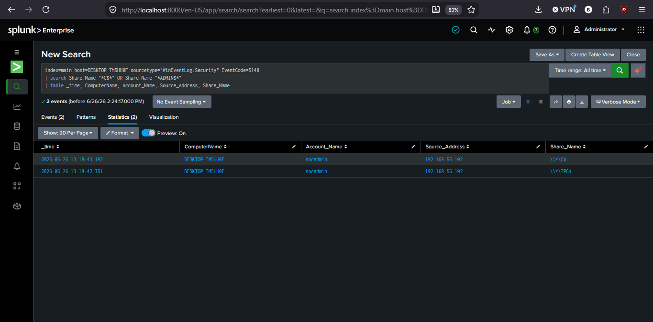
This investigation was conducted in a fully isolated home lab environment using two cloned Windows 11 VMs to simulate cross-host lateral movement via the net use command and a shared local administrator account. No real credentials or production systems were involved.

