INVESTIGATION REPORT #4
Process Injection Detected via Anomalous Process Lineage
Analyst: Israel Ehiabhi Edeaghe
Date: June 25, 2026
Lab Environment: Home SOC Lab (Splunk Enterprise + Windows 11 victim VM)
Severity: Medium
Status: Confirmed Malicious Activity (Simulated) — with a documented detection-engineering finding

1. Alert Summary
Alert Name: T1055 - Process Injection (Anomalous Process Lineage)
Trigger: Splunk scheduled alert, “Number of Results > 0”
Detection Source: Sysmon Event ID 1 (Process Create), forwarded via Splunk Universal Forwarder
Host: DESKTOP-TM5HH0F
Detected At: 2026-06-25 13:37:28.492
The alert fired after detecting a process named RWXinjectionLocal.exe — not a recognized Windows or third-party application — spawning powershell.exe, which then executed a command that opened a MessageBox and launched notepad.exe. This anomalous parent-child relationship and unfamiliar binary name is the observable signature of a successful process injection technique that does not trigger classic API-call monitoring.

2. Initial Triage
This investigation required more triage effort than Investigations #1–#3, because the initial detection attempt did not work as designed, and the actual finding emerged from troubleshooting why. This section documents that process, since it is itself a valid and important part of the investigation.
The detection was originally built to catch Sysmon Event ID 8 (CreateRemoteThread), the textbook indicator for classic process injection. Two Atomic Red Team tests using the CreateRemoteThread Windows API (T1055 Tests 9 and 10, both using a Go-based injector) were executed against this host and both failed at the VirtualAllocEx stage with an Access is denied error — this occurred even with the testing PowerShell session confirmed to be running with full Administrator privileges and with Windows Defender entirely disabled.
Rather than treat this as a dead end, a different injection technique was attempted: Atomic Red Team Test 5, “Read-Write-Execute process Injection,” which uses a different injection primitive (writing shellcode into a vulnerable DLL’s memory region rather than calling CreateRemoteThread against a separate process). This test succeeded, and produced the telemetry that this detection is built around.

3. Investigation Steps

Step 1 — Determine why the classic injection technique failed
OpenProcessToken succeeded and confirmed full administrative context for the executing session. The failure occurred specifically at VirtualAllocEx, the step that allocates memory inside a separate target process. This is consistent with modern Windows 11 process-level memory protections (likely related to Virtualization-Based Security or hardware-enforced stack protection features introduced in recent Windows 11 builds) blocking cross-process memory allocation for this specific API call pattern, independent of the calling user’s privilege level and independent of whether Defender real-time protection is active.
This is a genuinely useful finding: it demonstrates that this specific Windows 11 build has some baseline resistance to the most common, most heavily-signatured process injection technique — information that would directly inform a real organization’s risk assessment and patching/hardening priorities.

Step 2 — Confirm the alternative technique’s telemetry signature
index=main sourcetype=xmlwineventlog "ParentImage" "powershell.exe"
| rex field=_raw "Name='ParentImage'>(?<ParentImage>[^<]+)<"
| rex field=_raw "Name='CommandLine'>(?<CommandLine>[^<]+)<"
| rex field=_raw "Name='Image'>(?<Image>[^<]+)<"
| where match(ParentImage, "(?i)\\(Atomic|Inject|RWX|Vuln)")
| table _time, host, ParentImage, Image, CommandLine
This confirmed the working technique generated a clear, detectable artifact: RWXinjectionLocal.exe (the injector tool) as the parent process of a powershell.exe child process executing a command that displays a MessageBox reading “Atomic Red Team” and launches notepad.exe — the injected shellcode’s proof-of-execution payload.

Step 3 — Determine why this technique evaded EventID 8 monitoring
Sysmon Event ID 8 specifically monitors the CreateRemoteThread API call targeting a separate process. The Read-Write-Execute technique used here injects shellcode into a vulnerable DLL already loaded within a process and executes it via a different mechanism (the test output indicated the injection thread was created and then deliberately terminated after execution, consistent with a same-process or near-process execution model rather than a classic cross-process CreateRemoteThread call). This explains why no EventID 8 events were found despite the injection succeeding — a real and instructive gap between a single detection rule and the broader technique category it nominally covers.

4. Timeline Reconstruction
Time | Event | Significance
~13:30 | Atomic Red Team T1055 Tests 9/10 executed | Failed at VirtualAllocEx — Access Denied (Windows 11 mitigation)
13:37:28.492 | RWXinjectionLocal.exe spawns powershell.exe (MessageBox + notepad.exe) | Successful injection via alternative technique — proof of execution captured

5. MITRE ATT&CK Mapping
- Tactic: Defense Evasion / Privilege Escalation
- Technique: T1055 — Process Injection
- Specific variant observed: Read-Write-Execute memory injection into a loaded module (distinct from classic CreateRemoteThread-based injection)

6. Root Cause / Attack Narrative
Process injection is a defense-evasion and privilege-escalation technique where an attacker writes and executes code within the address space of another (typically more trusted or higher-privileged) process, rather than running their payload in its own standalone process. This evades security tools that only inspect newly-launched processes for known-bad signatures, since the malicious code appears to be running as part of a trusted, already-running application.
In this investigation, an injector tool wrote shellcode into a vulnerable DLL’s read-write-execute memory region and triggered its execution, which in turn spawned a visible PowerShell process as proof of successful code execution. While the specific payload here was benign (a MessageBox and Notepad launch, by design of the Atomic Red Team test), the same technique in a real attack would be used to execute arbitrary malicious code — a credential stealer, a C2 beacon, or a ransomware payload — while appearing to originate from, or run within, a legitimate process.
The notable secondary finding — that the more common CreateRemoteThread-based injection technique failed against this specific Windows 11 build even with full administrative privileges and Defender disabled — suggests this host has some degree of built-in resistance to the most widely-used injection technique, though clearly not to all injection techniques, as demonstrated by the successful alternative.

7. Remediation & Detection Improvement

Immediate remediation (if this were real)
- Isolate the host and treat any process spawned by an unrecognized binary as potentially compromised, including investigating whatever process the injection ultimately executed within
- Review the full list of running processes and loaded modules on the host for any other instances of unexpected RWX (Read-Write-Execute) memory regions, which are themselves a strong forensic indicator of injection regardless of which specific technique was used

Detection improvements for production deployment
- This detection currently relies on the injector tool’s filename matching a pattern (Atomic, Inject, RWX, Vuln) — explicitly acknowledged as a lab-specific limitation, since a real attacker would not name their tool this way. A production version needs to generalize beyond filename matching.
- The most direct improvement would be Sysmon Event ID 10 (ProcessAccess) monitoring for any process opening another process with PAGE_EXECUTE_READWRITE-related access rights, combined with monitoring for unexpected RWX memory region creation via Event ID 25 or EDR-level memory-protection telemetry, neither of which Sysmon’s default configuration captures without additional tuning.
- This finding also supports a broader recommendation: a single detection mapped to a MITRE technique ID (T1055) does not mean every variant of that technique is covered. Production detection coverage should be tracked per sub-technique and per specific implementation method, not just per top-level technique ID, to avoid a false sense of completeness.

8. Screenshots
Splunk search results showing the successful injection’s process lineage:
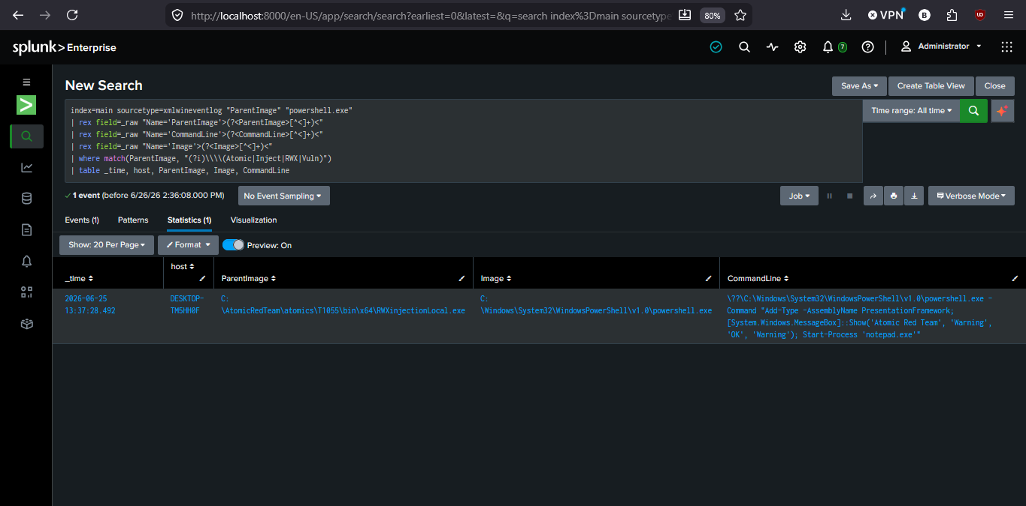
This investigation was conducted in a fully isolated home lab environment using Atomic Red Team (Tests T1055-9, T1055-10, and T1055-5) to simulate multiple process injection variants. The failure of the first two tests and success of the third are both genuine, unmodified results from this lab environment. No real credentials or production systems were involved.

