INVESTIGATION REPORT #5
Data Exfiltration Attempt via DNS-over-HTTPS Covert Channel
Analyst: Israel Ehiabhi Edeaghe
Date: June 25, 2026
Lab Environment: Home SOC Lab (Splunk Enterprise + Windows 11 victim VM)
Severity: High
Status: Confirmed Exfiltration Attempt (Simulated) — Failed at Network Layer, Successful Detection

1. Alert Summary
Alert Name: T1048 - DNS Exfiltration via DNSExfiltrator/DoH
Trigger: Splunk scheduled alert, “Number of Results > 0”
Detection Source: Sysmon Event ID 1 (Process Create), forwarded via Splunk Universal Forwarder
Host: DESKTOP-TM5HH0F
First Seen: 2026-06-25 14:14:57.224
Last Seen: 2026-06-25 14:16:19.626
The alert fired after detecting two related PowerShell process creation events: first, the download of a tool named DNSExfiltrator (Invoke-DNSExfiltrator.ps1) from a public GitHub repository, and second, the execution of that tool targeting a domain (target.example.com) using DNS-over-HTTPS (DoH) as the transport mechanism for the covert channel.

2. Initial Triage
Two events appeared roughly 82 seconds apart, both attributed to socadmin on DESKTOP-TM5HH0F:
- A PowerShell command creating a directory and downloading Invoke-DNSExfiltrator.ps1 from the Arno0x/DNSExfiltrator GitHub repository — a publicly known, purpose-built data exfiltration tool with no legitimate administrative use case
- A PowerShell command importing that module and invoking Invoke-DNSExfiltrator with parameters specifying a target domain (target.example.com), a password for encryption (atomic), DNS-over-HTTPS as the resolution method (-doh google), and a throttle time of 500ms between requests
DNS exfiltration is one of the most difficult data-loss techniques to block at the network perimeter, because DNS traffic is almost universally permitted outbound by firewalls (it has to be, for basic internet functionality), and DNS-over-HTTPS specifically routes the DNS resolution itself through an encrypted HTTPS connection to a public resolver (Google, in this case), making it indistinguishable from ordinary encrypted web traffic at the network level unless the endpoint or DNS resolver itself is instrumented.
Initial assessment: high-confidence, deliberate data exfiltration tooling. There is no benign interpretation of downloading a tool explicitly named DNSExfiltrator and invoking it with exfiltration-specific parameters (target domain, encryption password, throttle timing) against an external domain.

3. Investigation Steps

Step 1 — Confirm both stages of the attack chain
index=main sourcetype=xmlwineventlog "powershell.exe"
| rex field=_raw "Name='CommandLine'>(?<CommandLine>[^<]+)<"
| rex field=_raw "Name='User'>(?<User>[^<]+)<"
| where match(CommandLine, "(?i)(DNSExfiltrator|Invoke-DNSExfiltrator|-doh\s+\w+.*-d\s+\S+\.\S+)")
| table _time, host, User, CommandLine
This confirmed both the tool-acquisition stage (download) and the execution stage (invocation against target.example.com) were captured, giving a complete picture of intent: deliberate tool retrieval followed immediately by configured, parameterized use against a specific target domain.

Step 2 — Determine the outcome of the exfiltration attempt
PowerShell console output captured during the controlled test showed the tool successfully prepared its payload (compressed and encrypted a target file, calculated a total transmission size of 17,779 bytes split into 81 DNS-request chunks) but failed when attempting to send the initial ‘init’ request, throwing a null-reference exception. This is consistent with the tool requiring a real, attacker-controlled domain configured with the appropriate DNS A and NS records to receive the exfiltrated chunks — infrastructure that does not exist for target.example.com (a reserved, non-routable example domain per RFC 2606).
This distinction matters for severity assessment: the attempt was technically unsuccessful in this lab due to the absence of real attacker-controlled DNS infrastructure, not because any defensive control intervened. In a real attack using a genuine attacker-owned domain, this exact sequence of commands would have succeeded in transmitting data out of the network.

Step 3 — Assess what data may have been targeted
The Invoke-DNSExfiltrator command in this test was configured to exfiltrate the tool’s own script file (dnsexfil.ps1) as a proof-of-concept payload, rather than any sensitive document or credential file. In a real investigation, the next step would be identifying the -i (input file) parameter’s actual target in the live attack to determine what data was being exfiltrated, and reviewing file-access logs for that specific file in the time leading up to the exfiltration attempt to understand how the attacker selected it.

4. Timeline Reconstruction
Time | Event | Significance
14:14:57.224 | PowerShell downloads Invoke-DNSExfiltrator.ps1 from GitHub | Tool acquisition stage
14:16:19.626 | PowerShell invokes the tool against target.example.com via DoH | Exfiltration attempt — failed at network layer (no real C2 domain)
The 82-second gap between download and execution is consistent with a human operator manually reviewing or configuring the tool between steps, rather than a fully automated script — a useful behavioral distinction from the sub-second, fully-scripted timing seen in Investigation #2’s lateral movement sequence.

5. MITRE ATT&CK Mapping
- Tactic: Exfiltration
- Technique: T1048 — Exfiltration Over Alternative Protocol
- Sub-technique context: DNS tunneling / DNS-over-HTTPS covert channel

6. Root Cause / Attack Narrative
An actor on DESKTOP-TM5HH0F downloaded a purpose-built DNS exfiltration tool and configured it to transmit data to an external domain using DNS-over-HTTPS as the transport. DNS exfiltration works by encoding data into the subdomain portion of DNS queries (e.g., chunk1.targetdomain.com, chunk2.targetdomain.com), which an attacker-controlled authoritative DNS server then reconstructs from the incoming query log — a technique that succeeds specifically because DNS queries are rarely inspected or blocked the way HTTP/HTTPS traffic to unknown destinations typically is.
Using DNS-over-HTTPS specifically (routing the DNS resolution itself through an encrypted channel to a major public resolver like Google’s 8.8.8.8 DoH endpoint) adds a further evasion layer: even organizations that do inspect or log plaintext DNS traffic on port 53 would miss this entirely, since the actual DNS queries never appear in plaintext on the wire — they’re wrapped inside an HTTPS connection to a legitimate, widely-trusted destination (Google), which is exactly why this is considered a sophisticated, high-severity technique despite this particular attempt failing for an unrelated infrastructure reason.

7. Remediation & Detection Improvement

Immediate remediation (if this were real)
- Identify and isolate the host, and determine what file or data the -i parameter actually pointed to in a real incident, to assess data-loss scope
- Block outbound access to the specific target domain at the firewall/proxy level once identified, and review DNS resolver logs (if available) for any successful queries to that domain that may have already transmitted data before this command was caught
- Review for the presence of the downloaded tool file (dnsexfil.ps1 or similar) on disk, and treat its existence as an indicator requiring full host forensic review

Detection improvements for production deployment
- This detection currently relies entirely on endpoint command-line telemetry (the tool name and its invocation parameters). A more evasive attacker could rename the tool or rewrite the exfiltration logic from scratch to avoid this specific signature — a significant limitation acknowledged here.
- A more robust, technique-level detection (rather than tool-specific) would monitor DNS query volume and entropy per host: an unusually high rate of DNS queries with high-entropy, long subdomain labels to a small number of distinct second-level domains is the generic behavioral signature of DNS tunneling regardless of which specific tool generates it. This requires DNS server/resolver-level logging, which is outside this lab’s current Sysmon/Security-log-only telemetry scope and would be a natural next expansion of this lab.
- Organizations with the budget for it should also consider blocking or tightly controlling DNS-over-HTTPS at the network egress level specifically, since DoH’s entire purpose (encrypting DNS to public resolvers) directly defeats traditional plaintext DNS monitoring — forcing all DNS resolution through an internal, logged resolver is a structural mitigation worth recommending alongside the detection itself.

8. Screenshots
Splunk search results showing both stages of the exfiltration attempt:
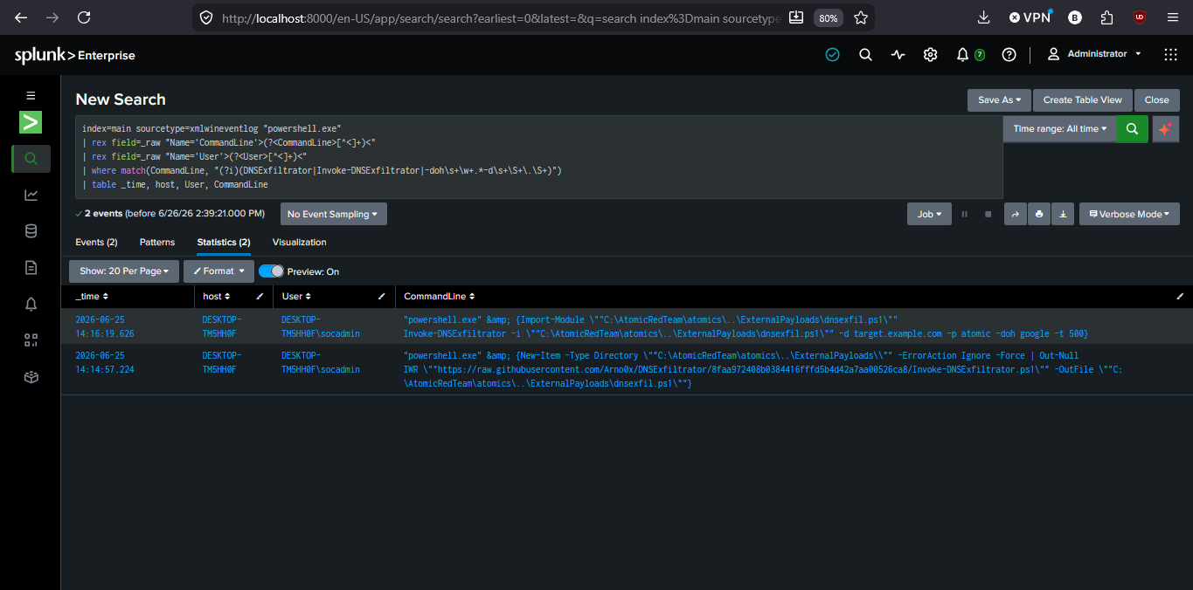
This investigation was conducted in a fully isolated home lab environment using Atomic Red Team (Test T1048-3) to simulate the attack technique. The exfiltration attempt failed in this lab specifically because no real attacker-controlled domain infrastructure was configured (by design, since the lab has no internet-facing C2 infrastructure). No real credentials, sensitive data, or production systems were involved.

