Introduction to Deep Learning Project Proposal

Israel Jesus Santos Filho

Kaust-ID: 179023

**Exploration of Deep Learning regression capabilities for Diastolic and Systolic Blood Pressure Estimation (DBP and SBP) through ECG (electrocardiogram) and PPG (photoplethysmogram)**

Many discoveries and applications have been explored through the combination of novel machine learning algorithms for solving healthcare problems. Nowadays, there is a lot of interest in developing machine learning models, and engineering systems, that could predict with some of the principal biological signals to self-monitoring. Some of those signals are oxygen saturation, heart rate, respiratory rate, and systolic and diastolic blood pressure (SBP and DBP, respectively). Due to the success of deep learning the research community and practitioners have been trying to apply those models to solve this estimation problem.

This work aims to use two different biological signals, ECG and PPG respectively, through a subset of a public dataset, PULSE-DB. Motivated by [1] we will explore ways of using deep learning algorithms for solving the estimation of two quantities, SBP and DBP, using each signal alone and a combination of them (modal fusion). It is well known that deep learning algorithms are good for learning features from structured signal manifolds and as both signals, ECG and PPG, have a singular signature, their own structure, this information motivates the use of those machines to solve this estimation problem.

The subset information and description will be provided in the guidelines, but it is a dataset with 27GB of memory size, and 2506 different persons and I would like to show the distribution of the interest variables (SBP and DBP):

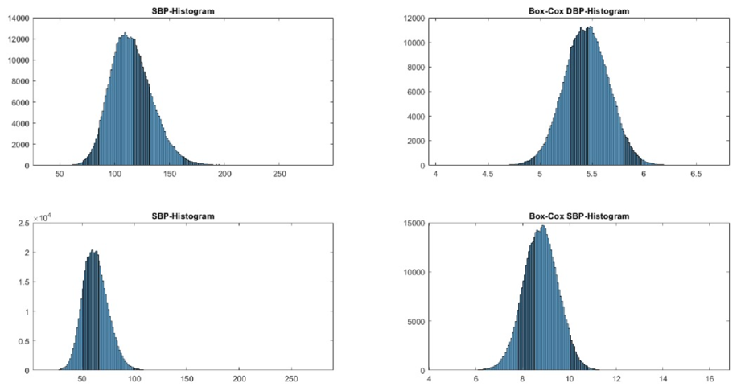

References:

[1] Long, W., & Wang, X. (2023). BPNet: A multi-modal fusion neural network for blood pressure estimation using ECG and PPG. In Biomedical Signal Processing and Control (Vol. 86, p. 105287). Elsevier BV. https://doi.org/10.1016/j.bspc.2023.105287