1. **Executive Summary**

This report presents a comprehensive analysis of the airline industry based on a dataset encompassing major airlines' operations, flight schedules, pricing strategies, connectivity, and revenue generation. Key findings reveal that Vistara emerges as a prominent player with the highest number of flights operated, while Delhi and Mumbai are the most connected cities. Passenger preferences lean towards morning flights, with shorter durations being favored, and one-stop flights are the most common choice. Pricing dynamics highlight premium positioning by Vistara and Air India, particularly in the business class.

Notably, Vistara and Air India also lead in revenue generation, particularly in the economy class on flights to Delhi with the use of customise filters. Recommendations include optimizing pricing strategies, scheduling flights during peak hours, investing in route expansion, and tailoring services to passenger preferences. Overall, this report equips stakeholders with actionable insights to enhance operational efficiency, customer experiences, and revenue growth within the airline industry.

1.1 **Introduction**

The dataset used for this analysis is sourced from Kaggle and encompasses various aspects of the airline industry, including airline names, flight details, source and destination cities, departure and arrival times, number of stops, seat classes, flight durations, days left until departure, and ticket prices. This dataset serves as the foundation for the case study, where the aim to extract actionable insights to enhance operational efficiency and improve the overall customer experience in the airline industry.

The primary objectives of this case study are to:

* Analyze and understand the major airlines' presence and performance within the dataset, identifying which carriers have the most significant presence.
* Examine the connectivity and flight schedules between different cities, shedding light on key travel routes and patterns.
* Evaluate and compare the average ticket prices across airlines and seat classes, providing insights into pricing strategies.
* Investigate the distribution of flight durations to understand typical travel times and identify any outliers or irregularities.
* Analyze flight schedules throughout the day to identify peak hours, gaps, and optimization opportunities.
* Determine how ticket prices vary based on the number of days left until departure, revealing insights into pricing dynamics.
* Explore passenger preferences for non-stop or multi-stop flights by examining the distribution of flights based on the number of stops.
* Calculate the total revenue generated by each airline to assess their financial performance.
* Investigate flight counts or average prices based on the time of day or day of the week to uncover temporal patterns and trends.
* Implement interactive dropdown filters in Tableau to empower users to explore the data based on various dimensions, such as airline, class, city, stops, and more.

Through data visualization and analytics in Tableau, this report aims to provide valuable insights that can inform strategic decisions and drive improvements in the airline industry, benefiting both operators and passengers alike.

1.3. **Methodology**

The methodology employed for analyzing the airline dataset involved several key steps, including data cleaning, transformations, and visualization techniques within Tableau:

* Initial Data Assessment: I began by thoroughly reviewing the dataset to identify any missing values, duplicates, or inconsistencies.
* Data Type Validation: I confirmed that each column had the correct data type assigned to it for further analysis.
* Binning: Flight durations were binned to categorize them into specific duration ranges for better visualization.
* Charts and Graphs: Various types of charts and graphs were used, including bar charts, heatmaps, linechart to represent different aspects of the dataset.
* Filters: Interactive filters were implemented to enable users to customize their analysis based on specific criteria.
* EDA helped uncover insights into airline performance, pricing strategies, route optimization
* The results from the analysis were interpreted to derive actionable insights that inform decision-making in various aspects of airline operations.

**1.4. Dataset**

The dataset is sourced from Kaggle, a popular platform for sharing and discovering datasets. The data was likely collected from airline reservation systems, ticketing platforms, or other sources related to airline operations.

**1.5 Data Visualizations and findings**

1. Number of flights operated by Airline

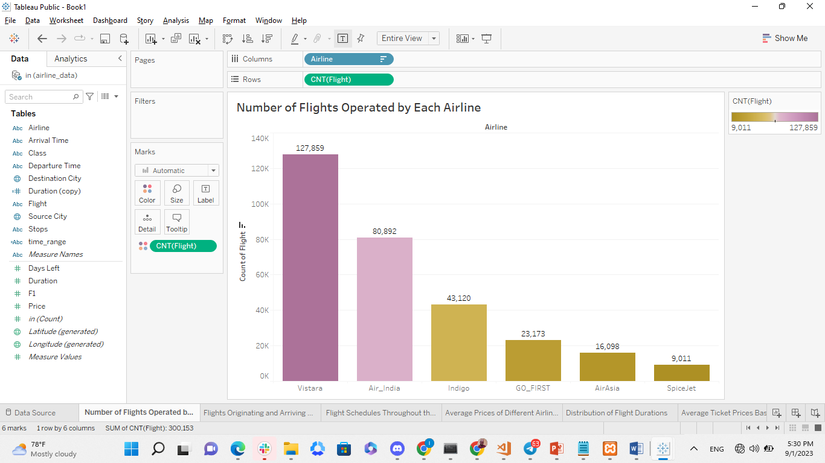

The dataset reveals a competitive landscape in the airline industry, with six major airlines commanding a significant presence. Vistara emerges as the dominant player, operating a substantial number of flights, followed closely by Air India and Indigo. This diversity in the number of flights offered by these major carriers underscores the choices available to travelers and the potential for competitive pricing and services.

1. Flights origin and arrival at different cities

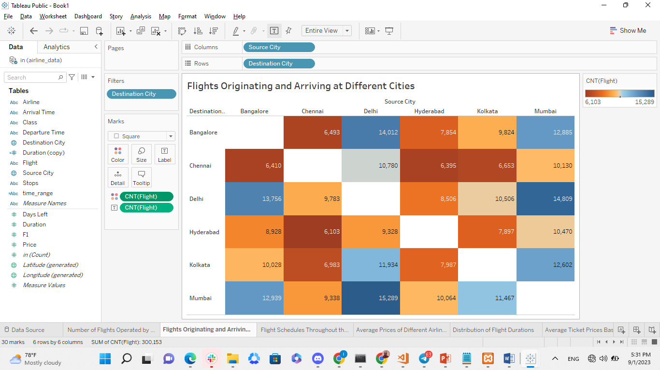

The provided dataset paints a clear picture of the flight connectivity landscape in India, showcasing the vibrant and dynamic nature of air travel within the country. Among the major cities examined, Delhi and Mumbai emerge as pivotal hubs, with a remarkable 15,289 flights connecting them, indicative of strong travel demand between these economic and cultural centers. The prominence of routes like Delhi to Bangalore, with 14,012 flights, underscores the importance of regional connectivity, particularly between the northern and southern regions of India. The bidirectional nature of this connectivity highlights balanced demand for air travel, both outbound and inbound, facilitating the movement of passengers and goods.

1. Flight Schedules throughout the day

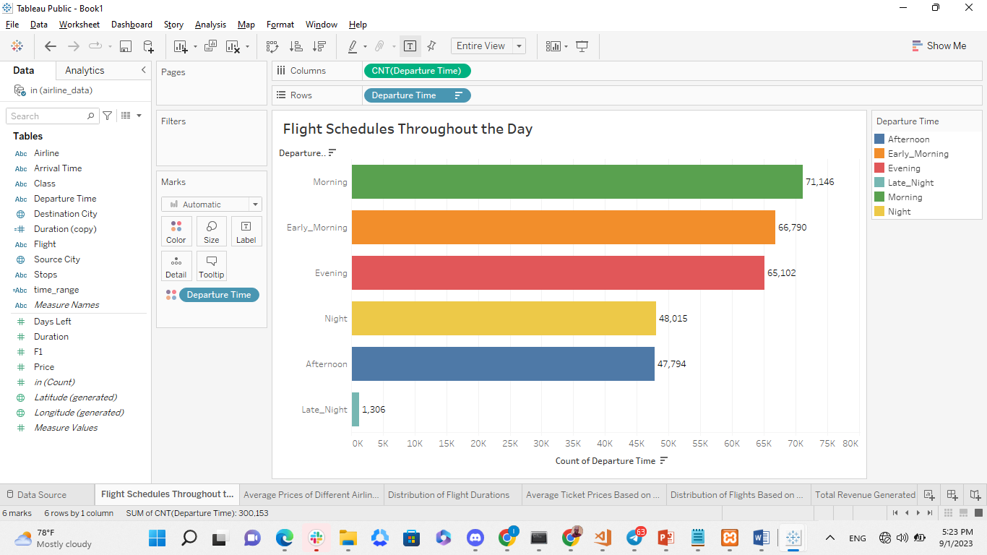

The analysis of flight schedules and their corresponding booking numbers reveals interesting patterns in passenger preferences. Morning flights emerge as the most popular choice among travelers, with a substantial 71,146 bookings, likely due to their convenience in aligning with daytime activities and business commitments. Early morning flights, closely following with 66,790 bookings, appeal to passengers seeking to kickstart their journeys early, possibly for business or time optimization. Additionally, evening and night schedules exhibit strong demand, with 66,102 and 48,015 bookings, respectively, offering flexibility for those who prefer later departures. Afternoon flights, with 47,794 bookings, represent a midday travel option, while late-night schedules, with 1,306 bookings, are the least preferred, possibly due to their limited availability or inconvenience. These insights underline the importance of tailoring flight schedules to accommodate the diverse needs and preferences of passengers, allowing airlines and airports to optimize their services accordingly.

1. Average price based on day left for departure

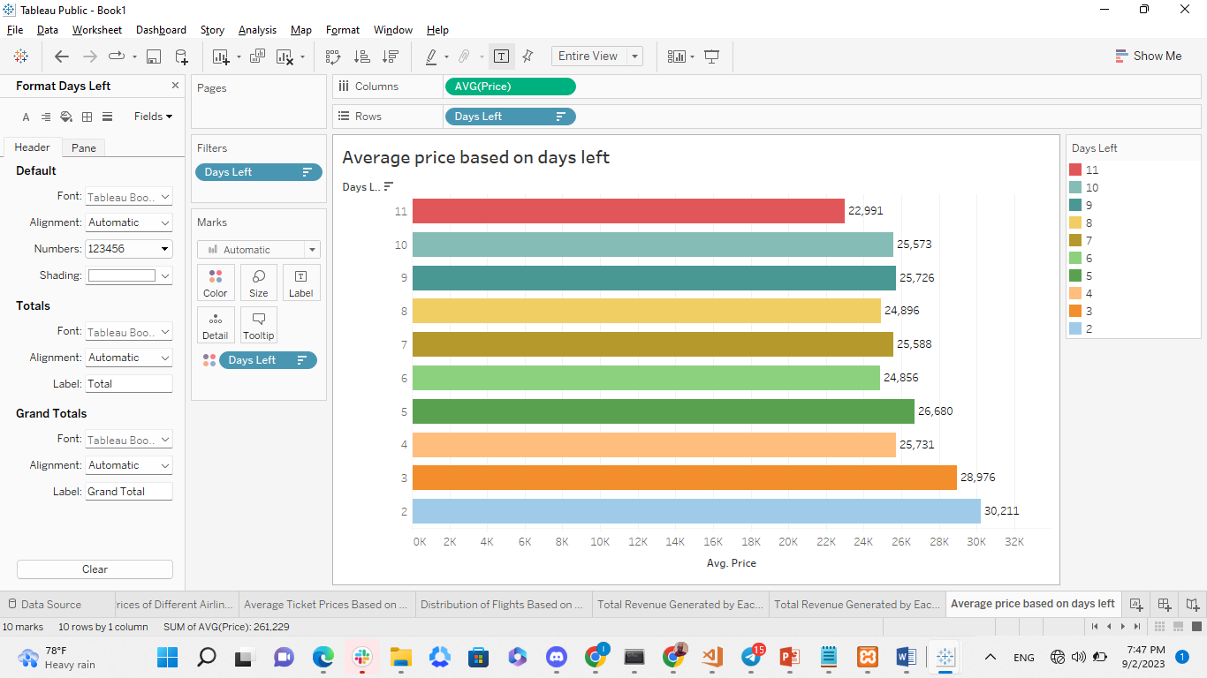

The result above shows that the shorter the day for the departure, the price increases while the longer the day for departure the price decreases. The records for the Top 10 days before departures shows that for 2 days, the cost averagely is 30,211 and others shorter days respectively.

1. Average prices of different Airlines and Classes

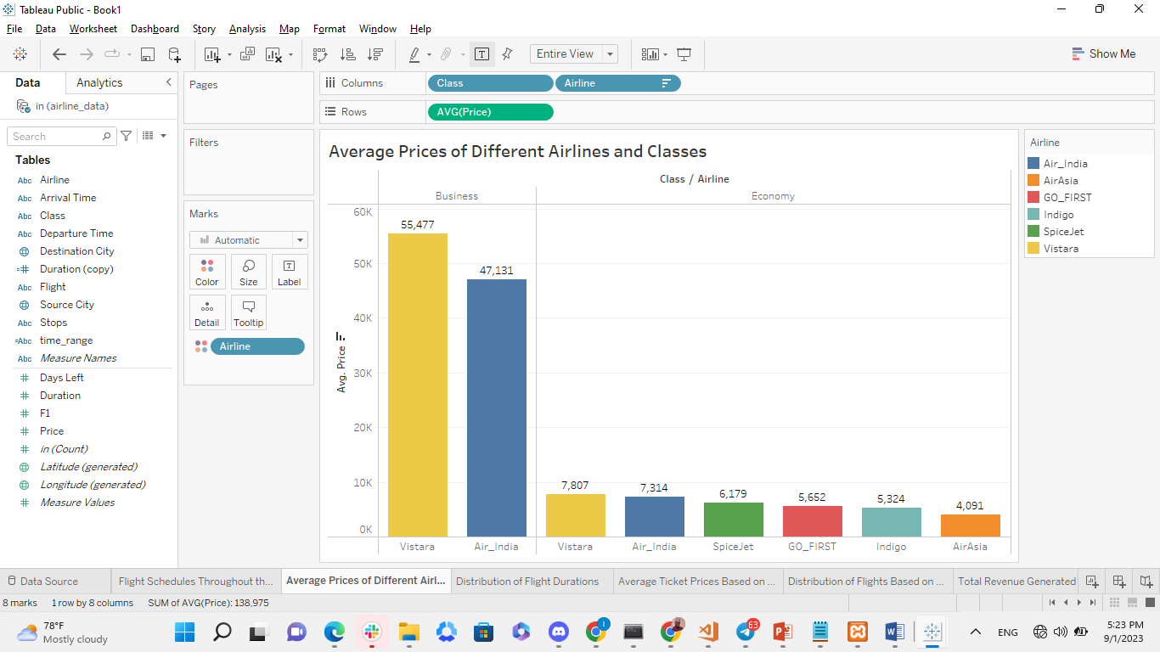

The analysis of average ticket prices across major airlines and their respective classes provides valuable insights into pricing dynamics within the airline industry. Within the business class category, Vistara and Air India stand out with average prices of 55,477 and 47,131, respectively.

This suggests a premium pricing strategy for business class services offered by these two airlines.

In contrast, the other airlines predominantly offer economy class, with Vistara and Air India maintaining higher average prices in this category as well, at 7,807 and 7,314, respectively. This indicates a potentially elevated level of service or brand perception associated with these two carriers in the economy class.

Among the airlines exclusively offering economy class, SpiceJet leads with an average price of 6,179, followed by GO_FIRST with 5,652, Indigo with 5,324, and AirAsia with 4,091. These variations in pricing reflect a combination of factors including airline reputation, service quality, route competitiveness, and market positioning.

1. Distribution of Flight based on duration

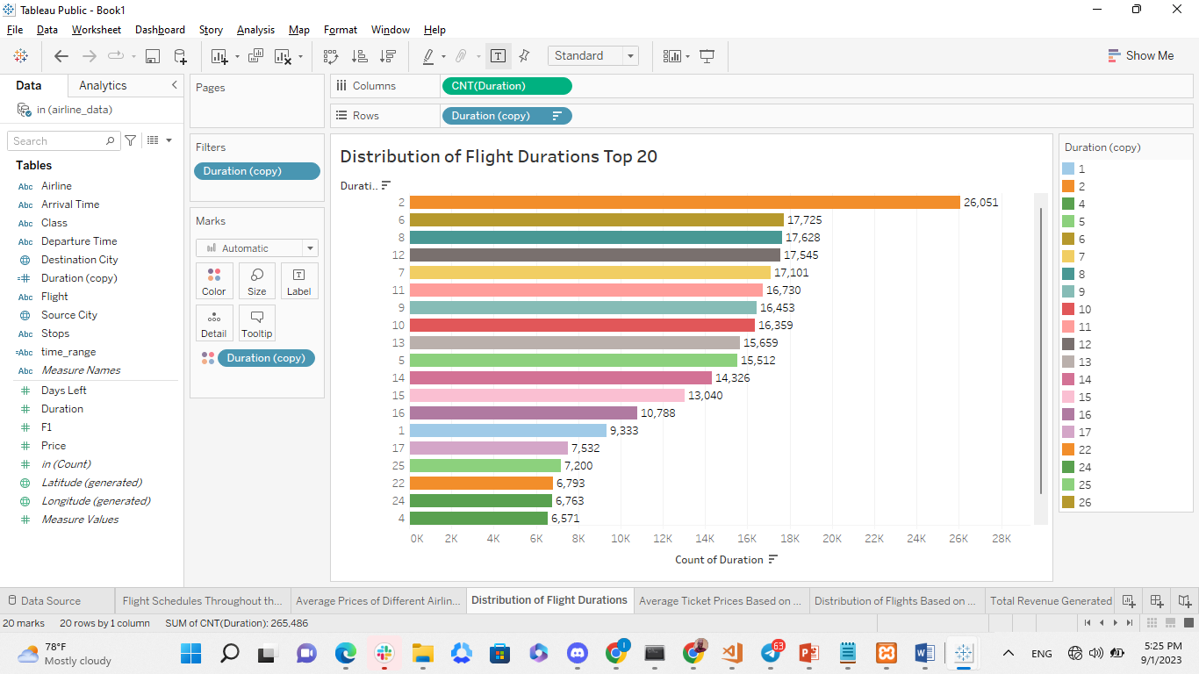

The analysis of flight durations and their corresponding booking numbers reveals a clear passenger preference for shorter journeys, with flight durations of 2 hours, 6 hours, 8 hours, 12 hours, and 7 hours garnering the highest booking numbers. This finding aligns with the common expectation of travelers for efficiency, convenience, and cost-effectiveness. Shorter flights are seen as more efficient and less tiring, making them a popular choice for a variety of travel purposes. They also tend to be more economically attractive, influencing booking decisions, particularly for budget-conscious passengers. Airlines can leverage this insight to optimize their flight schedules, resource allocation, and marketing strategies to cater to the demand for shorter flight options and enhance the overall travel experience for their customers.

1. Distribution of Flights based on number of stops

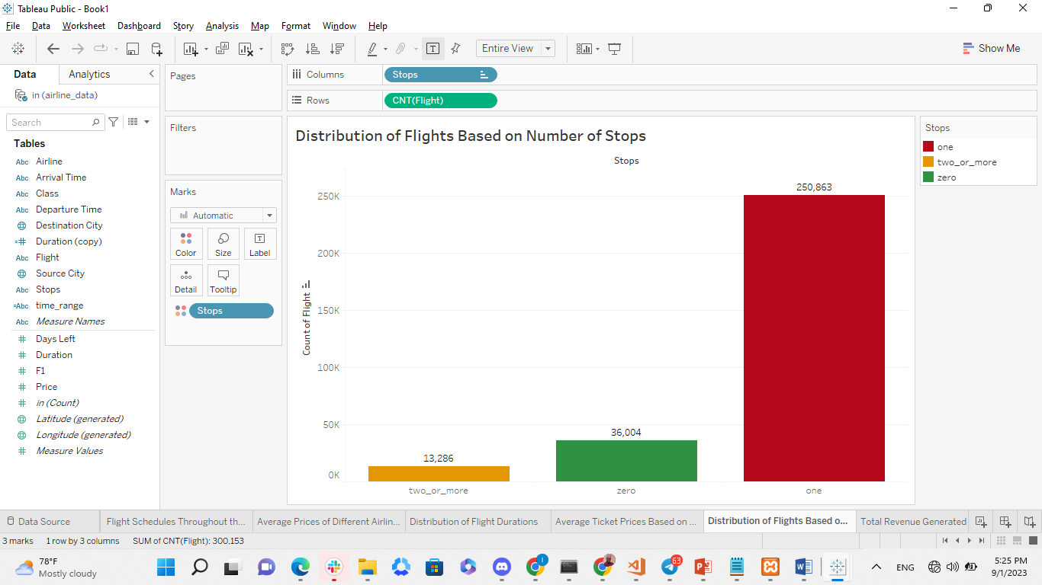

The analysis of flight stops provides valuable insights into passenger preferences and travel patterns. The majority of flights in the dataset, approximately 250,863, are one-stop flights, indicating that many travelers are comfortable with a single layover during their journeys. Non-stop flights, totaling 36,004, are also popular due to their convenience and efficiency. In contrast, flights with two or more stops are less common, with approximately 13,286 instances, suggesting that passengers generally prefer more direct routes. Airlines can use this information to optimize route planning and enhance the travel experience by aligning services with passenger preferences for convenience and efficiency.

1. Total revenue generated by Major Airlines

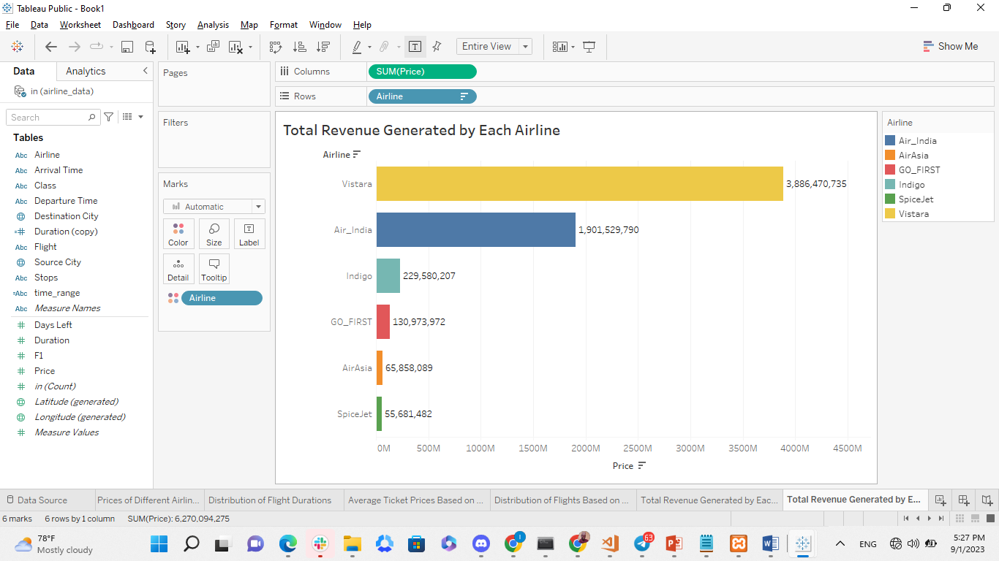

The analysis of revenue generation among major airlines in the dataset unveils notable disparities in financial performance. Leading the pack is Vistara, with an impressive revenue of approximately 3,886,470,735, reflecting its substantial patronage and potentially effective pricing strategies. Air India follows closely as the second-highest revenue generator, contributing 1,901,529,790 to the dataset, underscoring its significant market presence.

Indigo, while not reaching the revenue levels of the top two, maintains a healthy figure of 229,580,207. In contrast, GO_FIRST, AirAsia, and SpiceJet, though contributing to the dataset, report comparatively lower revenue figures. These variations highlight the diverse financial landscapes among airlines, influenced by factors such as their route networks, pricing models, and passenger demand.

1. Average price on time of the day

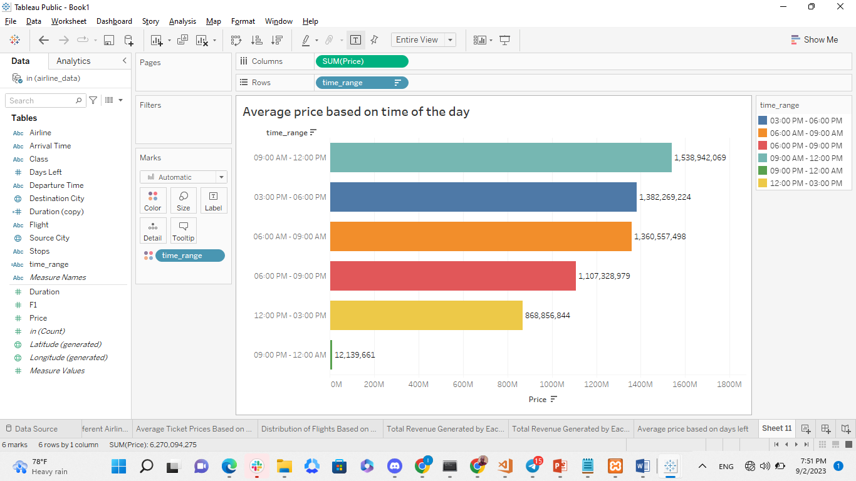

The analysis of flight prices based on the time of day reveals an interesting pattern: flights during the early hours of the day tend to be more expensive compared to those in the afternoon and night. This observation suggests that airlines often apply a pricing strategy where flights departing in the morning, possibly during peak travel hours, command higher ticket prices. In contrast, flights scheduled for the afternoon and night offer more budget-friendly options for passengers.

There could be several factors contributing to this pricing disparity. Morning flights might be in higher demand due to their convenience for business travelers or passengers with tight schedules, allowing airlines to charge a premium during these hours. On the other hand, afternoon and night flights might attract price-sensitive travelers or those seeking more affordable options.

1. Total Revenue generated bases on each Airline with Economy class and Destination City Delhi

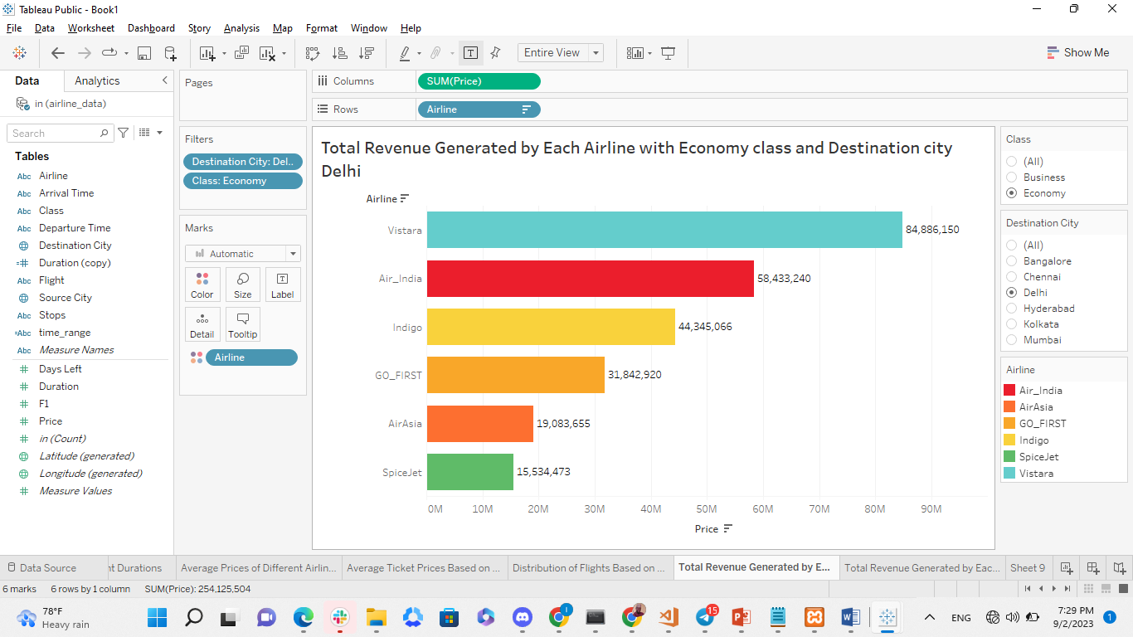

This finding underscores Vistara and Air India's strong financial performance in the economy class, suggesting effective strategies in capturing revenue from passengers with diverse travel profiles and preferences. It also emphasizes the fierce competition within the aviation industry, with airlines continuously vying for passenger patronage and revenue in a highly competitive market. These insights provide valuable guidance for airlines in optimizing their services, pricing models, and marketing efforts to meet the diverse needs of travelers in the economy class on flights to Delhi.

**1.6. Findings summary**

* Vistara operates the highest number of flights, followed by Air India, Indigo, GO_FIRST, AirAsia, and SpiceJet.
* Delhi and Mumbai are the most connected cities, with numerous flights to various destinations.
* Morning flights are the most popular, followed by early morning, evening, night, afternoon, and late-night schedules.
* Vistara and Air India have higher average ticket prices, especially in the business class.
* Most flights have shorter durations, with a peak at 2 hours, followed by 6, 8, 12, and 7 hours.
* Preference for Non-Stop or One-Stop Flights:
* One-stop flights are the most prevalent, followed by non-stop, and two or more stops.
* Vistara leads in revenue generation, followed by Air India, Indigo, GO_FIRST, AirAsia, and SpiceJet.
* Ticket prices tend to rise as the departure date approaches, with higher prices for last-minute bookings.
  1. **Recommendations**
* Implement dynamic pricing models that consider factors such as demand, time left until departure, and seat availability to maximize revenue.
* Offer promotional fares during non-peak hours or for flights with lower occupancy to attract cost-conscious travelers.
* Analyze peak travel hours and adjust flight schedules to meet the demand during those times.
* Consider introducing more red-eye or late-night flights to cater to passengers with flexible schedules.
* Identify underserved routes with high passenger demand and consider expanding services to those destinations.
* Utilize data on popular flight routes to prioritize route expansion efforts.
* Invest in customer service training for airline staff to ensure a positive and empathetic passenger experience.
* Implement technology solutions for streamlined check-in processes and baggage handling to reduce passenger wait times.
* Analyze passenger demographics and preferences to tailor marketing campaigns and services to different customer segments.
* Offer personalized travel packages and loyalty programs to incentivize repeat business.
* Optimize flight crew and aircraft utilization to reduce operational costs.
* Utilize predictive maintenance to minimize aircraft downtime and improve reliability.
* Compete aggressively in the economy class segment by offering competitive fares while maintaining service quality.
* Consider bundling services (e.g., baggage, meals) to provide value to economy class passengers.

**1.8. Conclusion**

In conclusion, the analysis of the airline dataset has yielded several key takeaways that hold significant implications for the airline industry:

* Vistara emerges as the airline with the highest number of flights, highlighting its substantial operational footprint. This underscores the need for optimizing its flight schedules and services to meet passenger demand efficiently.
* Delhi and Mumbai stand out as the primary connectivity hubs, with extensive flight networks to various destinations. Airlines should continue to leverage these hubs while considering strategic route expansions.
* Passenger preferences for flight schedules exhibit clear time-based trends. Morning flights are the most popular, indicating the importance of aligning schedules with passenger needs.
* The analysis reveals that Vistara and Air India command higher average ticket prices, particularly in the business class. This suggests an opportunity for airlines to refine their pricing strategies.
* Most passengers prefer shorter flight durations, emphasizing the importance of efficient and time-effective travel options.
* One-stop flights are the most prevalent choice among passengers, reflecting a willingness to accept layovers for cost savings or convenience.
* Vistara leads in revenue generation, signaling its effectiveness in attracting passengers and optimizing earnings.
* The analysis demonstrates that ticket prices tend to rise as the departure date approaches, highlighting the significance of dynamic pricing strategies.

**1.9 Limitation or Future works**

The analysis of the airline dataset has shed light on various aspects of the airline industry, offering insights into airline operations, pricing dynamics, and passenger preferences. While the findings provide valuable guidance for optimizing flight schedules, pricing strategies, and services, several limitations, including potential data quality issues and limited data scope, must be acknowledged.

To build upon these findings, future research could focus on data enrichment, predictive analytics, customer segmentation, operational optimization, and sustainability assessments.

These avenues for future work have the potential to further refine airline strategies, improve customer experiences, and address emerging industry challenges, ensuring the industry's continued growth and competitiveness.

**References**

Dataset Source: Kaggle as shared in the case study document

Tableau Software

Tableau Public 2021.4