Fixture B — Structured Content [B-001]
This document exercises tables, hyperlinks and images. [B-002]

1. Simple table [B-003]
Feature [B-004] | Priority [B-005] | Owner [B-006]
DOCX import [B-007] | Critical [B-008] | Editor team [B-009]
Autosave [B-010] | Critical [B-011] | Platform team [B-012]
Templates [B-013] | High [B-014] | Design team [B-015]
Paragraph after the simple table. [B-016]

2. Merged cells and alignment [B-017]
Quarter [B-018] | Plan and actual  Actual [B-020] |  | Variance [B-021]
Q1 [B-022] | 100 [B-023] | 96 [B-024] | -4 [B-025]  +11 [B-029]
Q2 [B-026] | 120 [B-027] | 131 [B-028] | -4 [B-025]  +11 [B-029]
Total [B-030] | 220 [B-031] | 227 [B-032] | +7 [B-033]
Paragraph after the merged table. [B-034]

3. Hyperlinks [B-035]
Visit the Prime Word project page for details. [B-036]
A second link: documentation with a query string [B-037]

4. Images [B-038]
An inline image follows, centered, with a caption. [B-039]
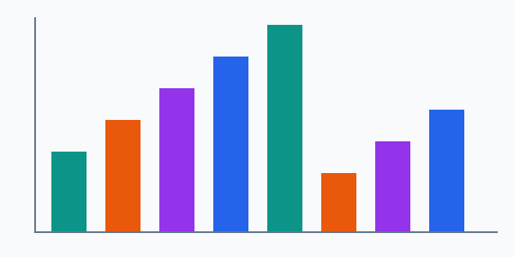
Figure 1: Synthetic chart image [B-040]

5. Image inside a table [B-041]
Thumbnail [B-042] | Description [B-043]
 | A smaller image placed inside a table cell. [B-044]
Closing paragraph of fixture B. [B-045]

