Name: Israel B. Pañamogan Section: ILDV3
Date: 11/1/2026

Activity title:
Design & Animations, Forms & Gestures
Hands-on activities in Flutter using Visual Studio Code

Activity 0 screenshots:
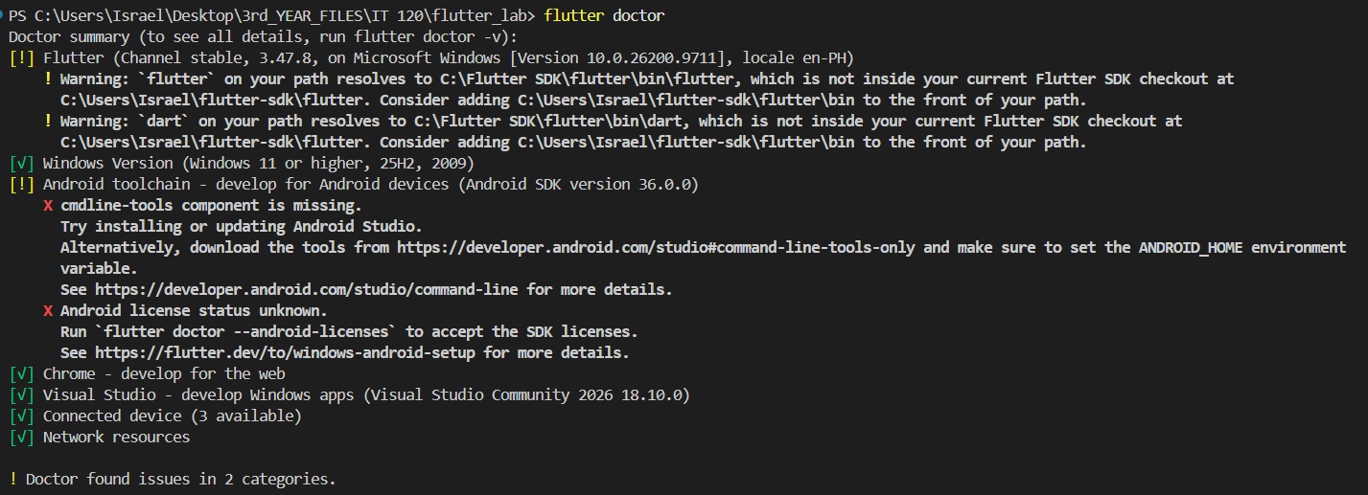
A0-1

A0-2

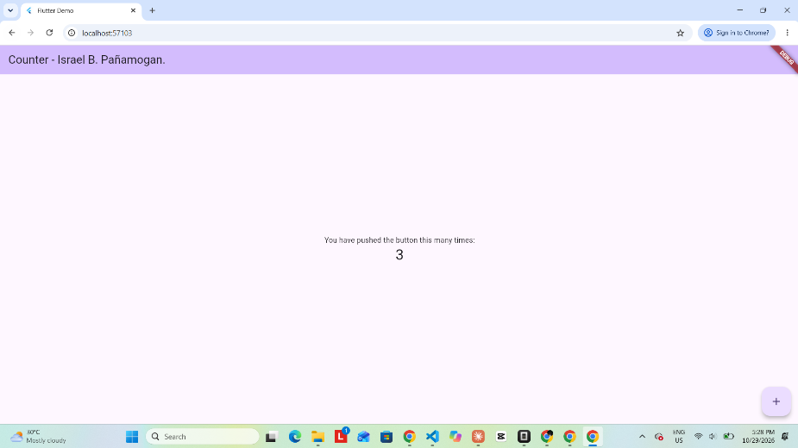

Activity 1 screenshots:
A1-1
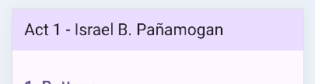

A1-2
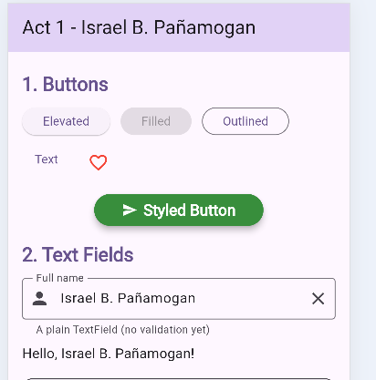

A1-3
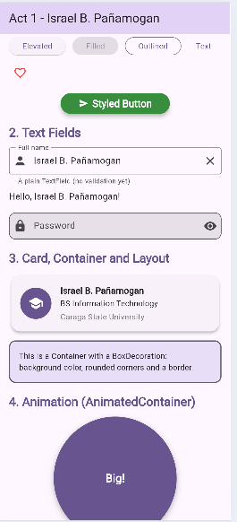

Activity 1 - Designing Buttons and Other Elements
1. Why is ShowcasePage a StatefulWidget and not a StatelessWidget?
- ShowcasePage is a StatefulWidget because its values change while the app is running.

2. What happens when setState() is removed from the heart button, and why?
- The heart icon will not change because Flutter is not told to update the screen.

3. What is the difference between labelText, hintText, and helperText?
- labelText tells what the field is for, hintText shows an example, and helperText gives extra instructions.

4. In Twist Part A, why did the Styled Button not change color? How would you make it follow the theme?
- The button did not change color because its color was set manually. Using Theme.of(context).colorScheme.primary allows it to follow the app's theme.

Activity 2 screenshots:
A2-1
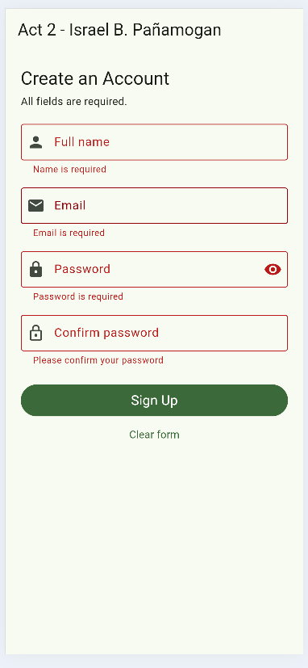

A2-2
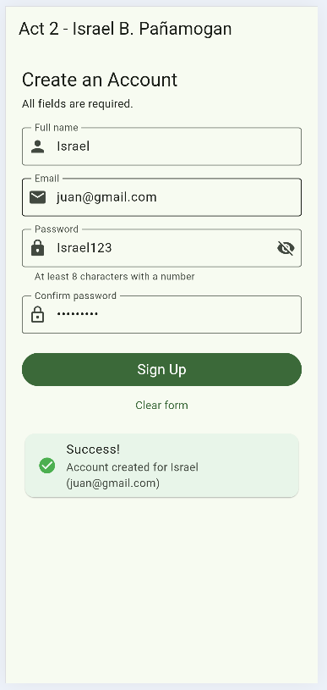

A2-3
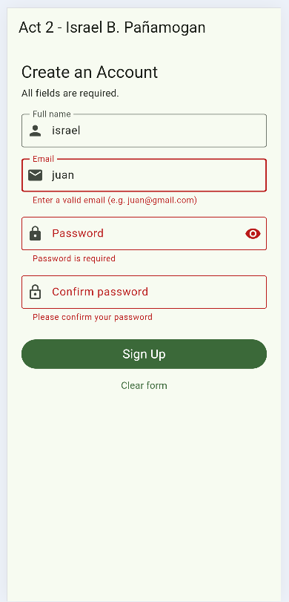

A2-4
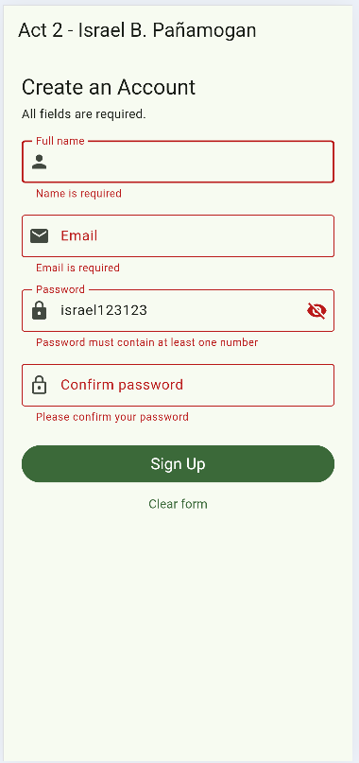

Activity 2 - Form Validation
1. What does a validator return when the input is valid? When it is invalid?
- It returns null if the input is correct and an error message if it is wrong.

2. What does _formKey.currentState!.validate() do, and what does it return?
- It checks all the form fields. It returns true if all are correct and false if there are errors.

3. Why do we use value.trim() before checking?
- It removes extra spaces at the beginning and end of the input.

4. Why does the Confirm Password validator read _passwordController.text?
- It checks if the confirm password matches the original password.

5. Based on Twist Part C, explain how validation protects accurate data entry.
- Validation stops users from entering wrong information, such as an invalid email address.

6. Is validation inside the app enough to keep data secure? Explain in 2 to 3 sentences.
- No. The server must also check the data. Other security measures are needed to keep the data safe.

Activity 3 screenshots:
A3-1
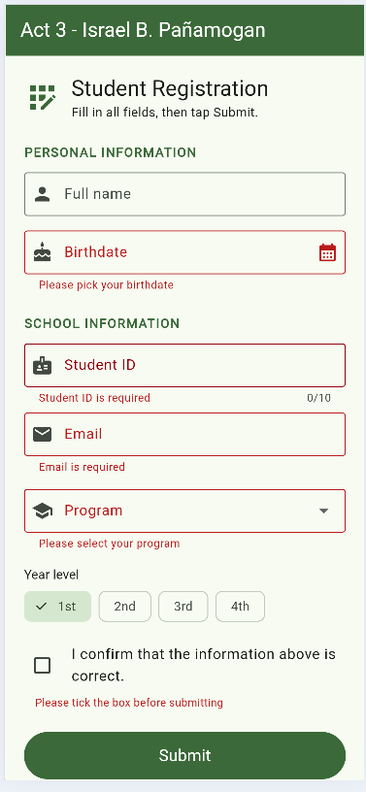

A3-2
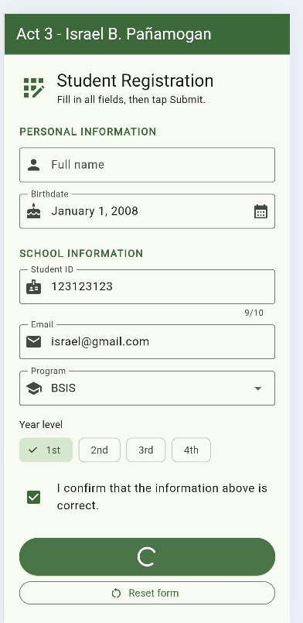

A3-3
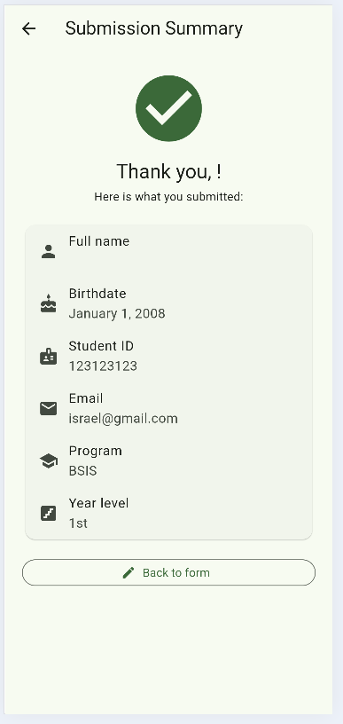

A3-4
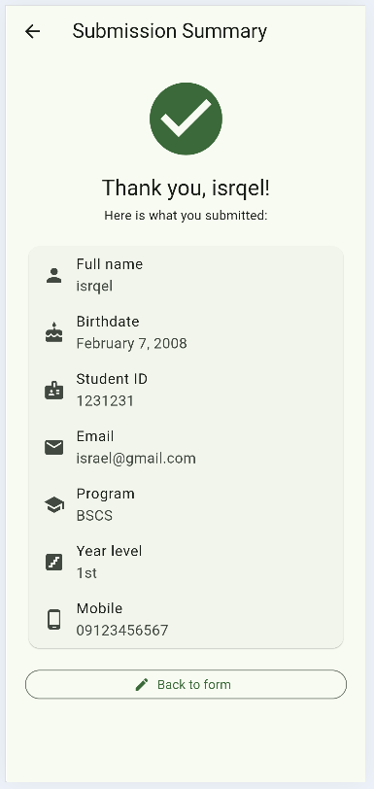

Activity 3 - Form Submission
1. Why is the Birthdate field read-only? How does that improve accuracy?
- It lets users choose their birthdate from a calendar, which helps avoid typing mistakes.

2. What does FilteringTextInputFormatter.digitsOnly prevent?
- It stops users from entering letters and symbols.

3. Explain what happened in Twist Part A when the guard line was removed. Why is that a data-accuracy problem?
- Removing the guard allows users to submit the form more than once. This can create duplicate records.

4. Why do we write if (!mounted) return; after await?
- It stops the code from running if the page is no longer active.

5. How does the submitted data travel from the form page to the summary page?
- The form data is saved in a Registration object and sent to the Summary page using Navigator.push().

Activity 4 screenshots:
A4-1
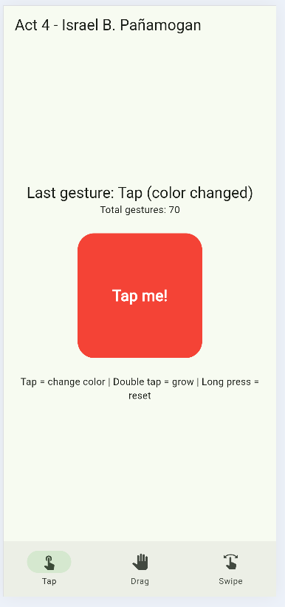

A4-2
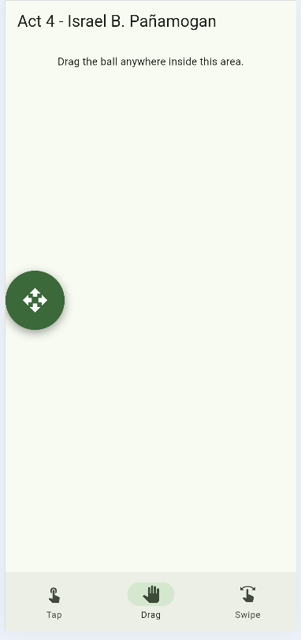

A4-3
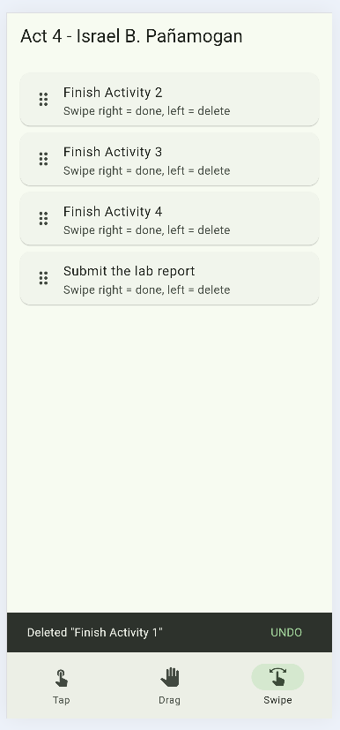

A4-4
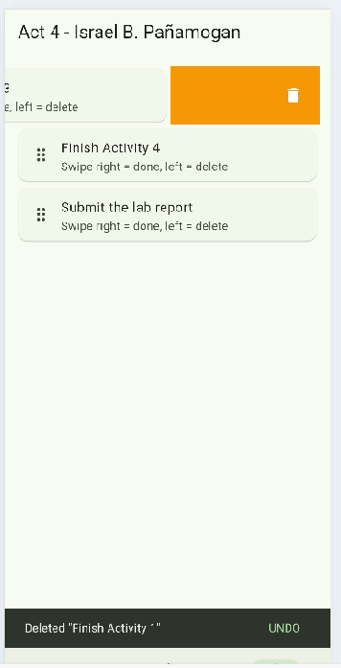

Activity 4 - Flutter Gestures
1. Why did onTap react faster after removing onDoubleTap (Twist A)?
- onTap reacts faster because Flutter no longer waits to check if the user will tap twice.

2. What in details.delta in onPanUpdate?
- It shows how far the pointer moves while dragging.

3. Why does every Dismissible need a unique key?
- A unique key helps Flutter know which item is being removed.

4. What would be lost if we used _pages[_currentTab] instead of IndexedStack?
- Some page data, like the ball's position and task list, may reset when switching tabs.

5. Give one real app feature where you would use a long press, and one where you would use swipe to dismiss.
- A long press can show message options, while a swipe can remove notifications.

Reflection
Throughout this laboratory activity, I learned how to use Flutter to create simple and user-friendly applications. I learned how to design interfaces, validate forms, submit information, and use different gestures. The hardest part for me was understanding how `setState()`, form validation, and asynchronous operations work. I overcame these challenges by following the instructions, studying the code, testing the features, and fixing errors. Overall, this activity helped me improve my Flutter skills and understand how to create interactive applications.

