Activity 9 Summary
In Laboratory Activity No. 9, our group extended the existing Flutter Web project from Activity 8 by implementing a Report Form screen and connecting it to the application's navigation. The form includes Report Title and Description fields with input validation to prevent empty or invalid submissions. Reusable widgets, namely AppButton and AppTextField, were implemented and used in multiple contexts to promote code reusability and maintainability. The application also demonstrates four essential UI states: Loading, Success, Empty, and Error, using simulated asynchronous responses. The updated application was tested to verify its functionality, and both flutter analyze and flutter test completed successfully. The Activity 9 changes were committed and pushed to the existing GitHub repository.

Github repository link: https://github.com/israelpanamogan-a11y/flutter_project

Screenshot_1_Project_Structure
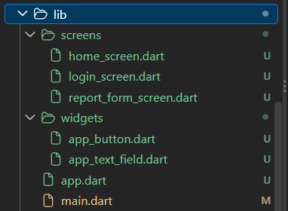

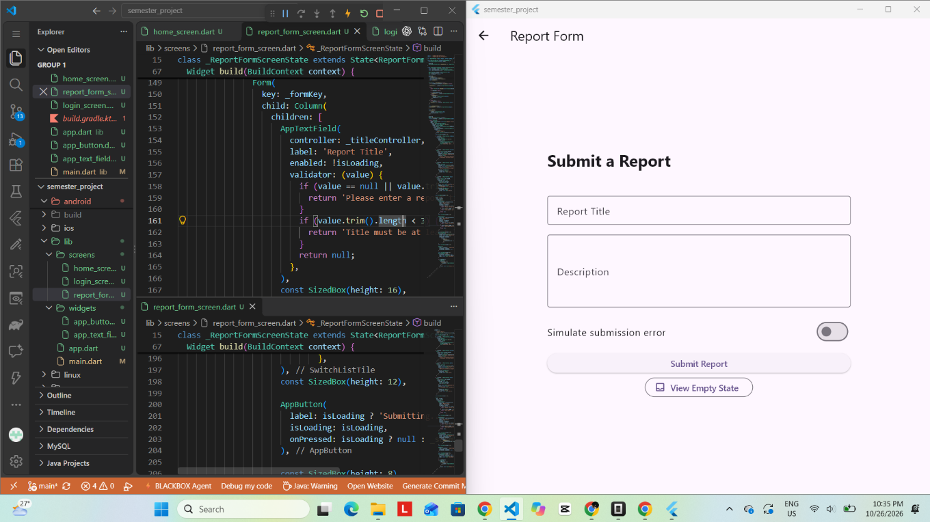
Screenshot_2_Reusable_Widgets

Screenshot_3_Loading_State
The Loading state was triggered by entering valid report details and clicking the Submit Report button, which displayed a progress indicator during the simulated three-second submission process.
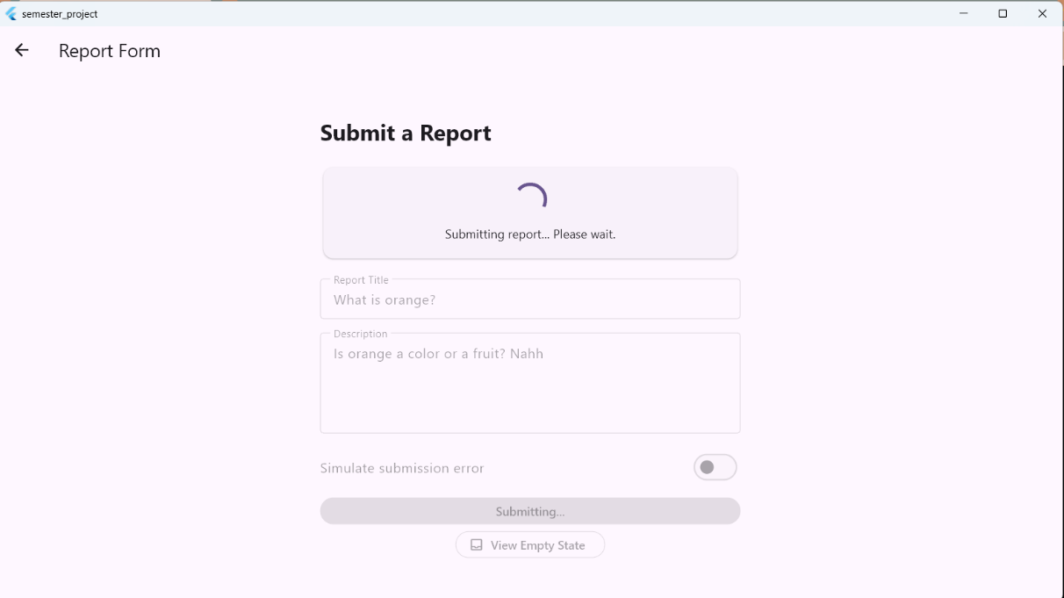

Screenshot_4_Success_State
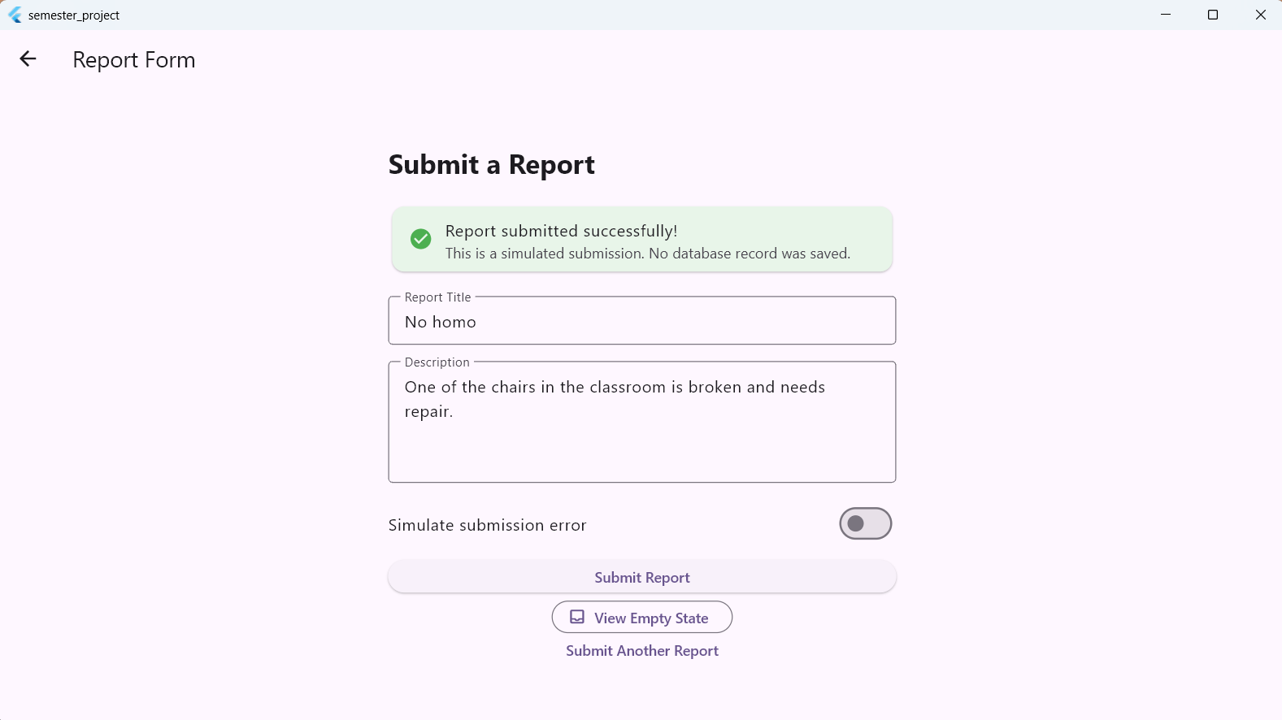
The Success state was triggered by submitting a valid report with the Simulate submission error toggle turned off, resulting in a success confirmation message.

Screenshot_5_Empty_State
The Empty state was triggered by clicking the View Empty State button, which displayed a message indicating that no report records were available.
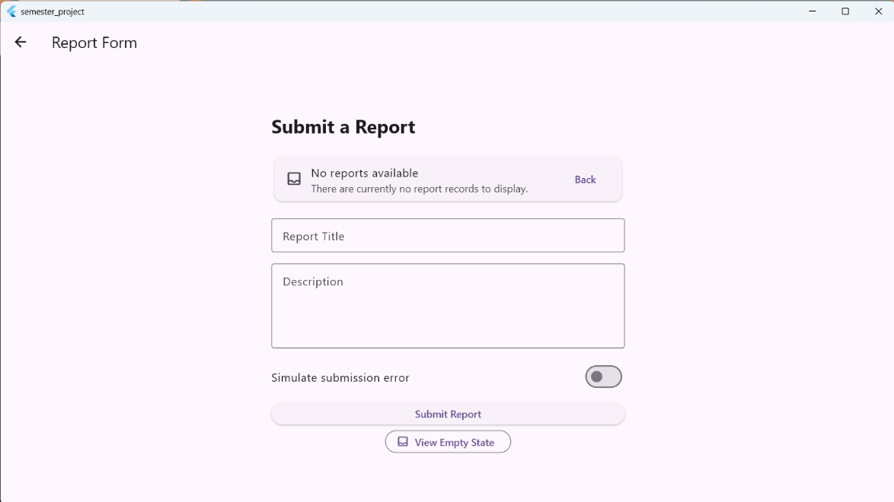

Screenshot_6_Error_State
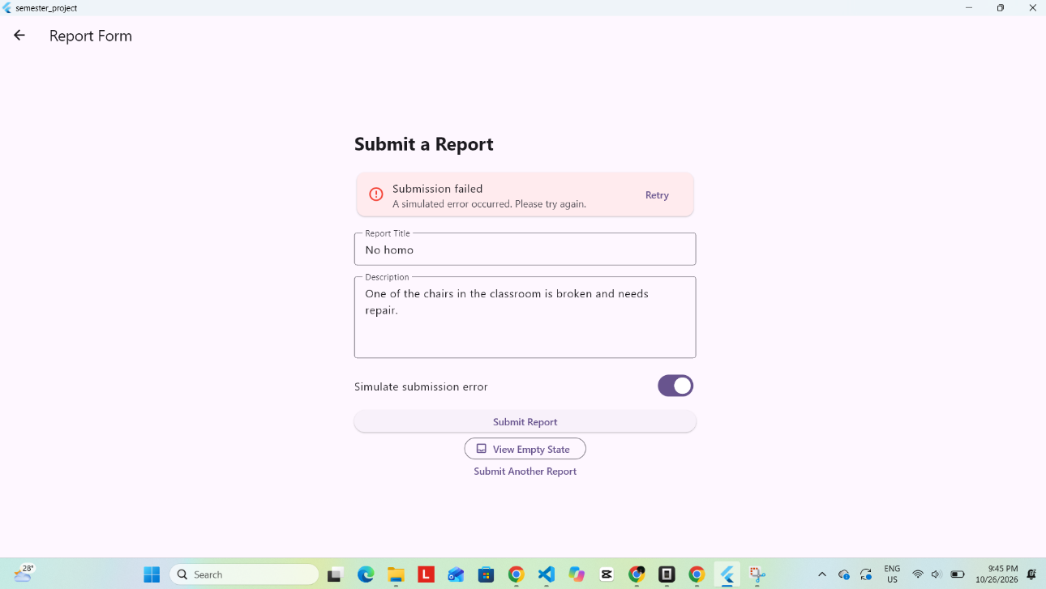
The Error state was triggered by turning on the Simulate submission error toggle, entering valid report details, and clicking Submit Report, which displayed an error message with a Retry option.

1. How does report_form_screen.dart extend your Activity 8 project without replacing its existing Home and Login screens?
- The report_form_screen.dart adds a new Report Form screen to our existing Flutter project. It connects to the Home screen through navigation, while the Home and Login screens remain available. This allows us to add new features without creating a new project.
2. Which shared widget did your group reuse, and what benefit does that provide?
- Our group reused AppButton and AppTextField. AppButton is used in the Report Form and Login screen, while AppTextField is used for the report title and description. These widgets help us reuse code, keep the design consistent, and make the code easier to maintain.

3. How does your report form prevent invalid input and duplicate submissions?
- The form uses validation to make sure the report title and description are not empty and meet the required length. The Submit Report button is disabled while the form is loading. This prevents users from submitting the form multiple times at once.
4. How did you reproduce the Loading, Success, Empty, and Error responses? Which were simulated?
- We reproduced the Loading state by submitting a valid report and showing a progress indicator for three seconds. The Success state appeared after a valid submission with the error toggle turned off. The Empty state appeared when we clicked the View Empty State button. The Error state appeared when we turned on the simulated error toggle and submitted the form. All responses were simulated because no backend was connected.
5. What must be changed when the real REST API and PostgreSQL database are connected later?
- We need to connect the report form to the real REST API and PostgreSQL database. We must replace the simulated delay and responses with actual API requests. The application should send report details to the server, save them in the database, and display the correct Loading, Success, Empty, or Error response based on the actual result.

