University of Washington

iSchool Info 330

# Module 03 Assignment - Enhancing a Database

In this module's assignment, you will learn how work with a database using the SQL language.

## Assignment Videos

Please watch the following Videos:

|  |
| --- |
| Assignment Videos < 120 min (Links are to external sites) |
| [SQL 2012 Basic Queries Lab 1.1 - 18](https://youtu.be/OsZ5Tqn1W0Y?list=PLM-CGnaD3kr0jl13yR3DexukWlUFd0s7Z) |
| [SQL Aggregation queries using Group By, Sum, Count and Having - 10](https://youtu.be/IVMfDpCGwK4) |
| [SQL 2012 Joining Tables lab 1.2 - 13](https://youtu.be/3lSQI79XLUw?list=PLM-CGnaD3kr0jl13yR3DexukWlUFd0s7Z) |
| [TSQL: How To Count NULL (And/Or Blank) Values - 4](https://youtu.be/xIFz7qAGGfw) |
| [SQL Server Programming Part 14 - Transactions - 23](https://youtu.be/is03uRYFgqc) |
| [Functions-01 Using Built In Functions - 33](https://youtu.be/ShQ6Wm1pNks?list=PLfycUyp06LG_ShpiOSTkQmu69sZD2Ng13)  https://youtu.be/[Creating Entity Relationship Diagrams using Draw.io](https://youtu.be/lAtCySGDD48) - 11 |

## Assignment Examples

Read and try out some SQL statements on the W3Schools website. This website has short articles about many subjects and we will use this site throughout the course. In many of these articles you will find a "Try it Yourself" section where you can experiment with the SQL language interactively. You only need to scan though these pages so don't spend a lot of time on each.

This website will become one of your most used "Go To" sites as you progress in your learning. So please check out the following pages this week!

|  |
| --- |
| Examples < 60 min (Links are to external sites) |
| [SQL Syntax](https://www.w3schools.com/sql/sql_syntax.asp) |
| [SQL Select](https://www.w3schools.com/sql/sql_select.asp) |
| [SQL Select Distinct](https://www.w3schools.com/sql/sql_distinct.asp) |
| [SQL Where](https://www.w3schools.com/sql/sql_where.asp) |
| [SQL And, Or, Not](https://www.w3schools.com/sql/sql_and_or.asp) |
| [SQL Order By](https://www.w3schools.com/sql/sql_orderby.asp) |
| [SQL Select Top](https://www.w3schools.com/sql/sql_top.asp) |
| SQL Min and Max |
| SQL Count, Avg, Sum |
| SQL Like |
| SQL Wildcards |
| SQL In |
| SQL Between |
| SQL Aliases |
| SQL Group By |

## Assignment Reading

Since the course does not have an official text you will use various websites for your studies. This is a great way to learn new subjects and practicing it will be something you will use for years to come! Please read the following web pages:

|  |
| --- |
| Reading < 120 min (Links are to external sites) |
| <https://technet.microsoft.com/en-us/library/bb264565(v=sql.90).aspx> |

## Assignment Task

I would like you to practice what you have learned in this module. To do so, you will write a SQL Script answers several requests for data found in the Northwind database.

You use the provide starter file, Assignment03.sql, to get you started.

-- Data Request: 0301

-- Date: 1/1/2020

-- From: Jane Encharge CEO

-- Request: I want a list of customer companies and their contact people

-- Needed By: ASAP

**Hint**: The results will look like this…

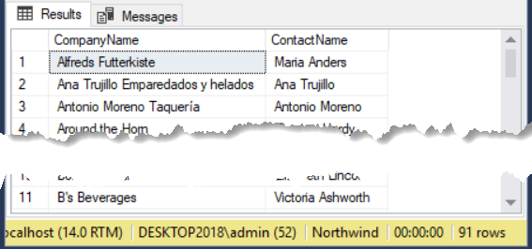

-- Data Request: 0302

-- Date: 1/2/2020

-- From: Jane Encharge CEO

-- Request: I want a list of customer companies and their contact people, but only the ones in US and Canada

-- Needed By: ASAP

**Hint**: The results will look like this…

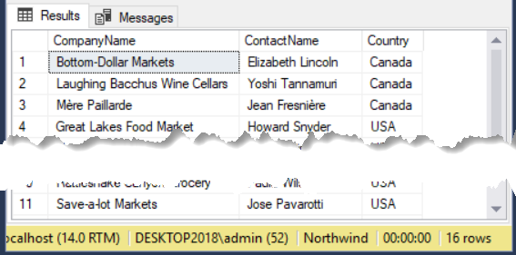

-- Data Request: 0303

-- Date: 1/2/2020

-- From: Jane Encharge CEO

-- Request: I want a list of products, their standard price and their categories. Order the results by Category Name

-- and then Product Name, in alphabetical order

-- Needed By: ASAP

**Hint**: The results will look like this…

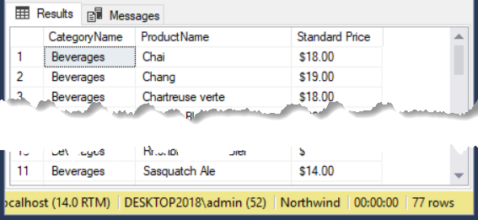

-- Data Request: 0304

-- Date: 1/3/2020

-- From: Jane Encharge CEO

-- Request: I want a list of how many customers we have in the US

-- Needed By: ASAP

**Hint**: The results will look like this…

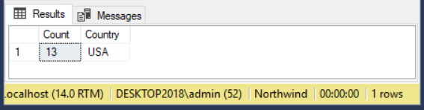

-- Data Request: 0305

-- Date: 1/4/2020

-- From: Jane Encharge CEO

-- Request: I want a list of how many customers we have in the US and Canada, with subtotals for each

-- Needed By: ASAP

**Hint**: The results will look like this…

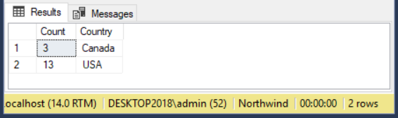

# Grading

Student work will be evaluated on a point system using the following general guidelines found on the Course Syllabus page. Make sure you read and understand this.

**NOTE:**  It is very possible to get a 3.9 or better from this course, but you have to earn it! Do not expect to get 100% of the possible points without extra effort on your part. If you want to excel in this course, you must submit **excellent**work!

# Submit your work

After you have completed your SQL Script into a folder called Assignment03**FirstInitialLastName** and Zip the folder. Upload the Zipped folder to the Canvas web site.

