University of Washington

iSchool Info 330

# Course Final

In this Final, you will **plan, document, and implement a database** used for an application being created by another development team.

## The Application

The purposed application consists of a simple Windows application that **handles scheduling of appointments between patients and doctors**.

This application allows a user to:

* Search for **existing** **patients**
* Add a **new** **patient**
* Search for **doctor**
* Select a **clinic**
* Select an **appointment** date and time

## Application Flow

Users will use the application in this manner (Figure 1).

1. The user **looks up an existing** patient (If a patient cannot be found, a new record can be created).

2. The user **selects a doctor** (or clinic)

3. The user **selects a clinic** (or doctor)

4. The user **selects a date and time** for the appointment

5. User **Creates the appointment** (or updates appointment or delete appointment)

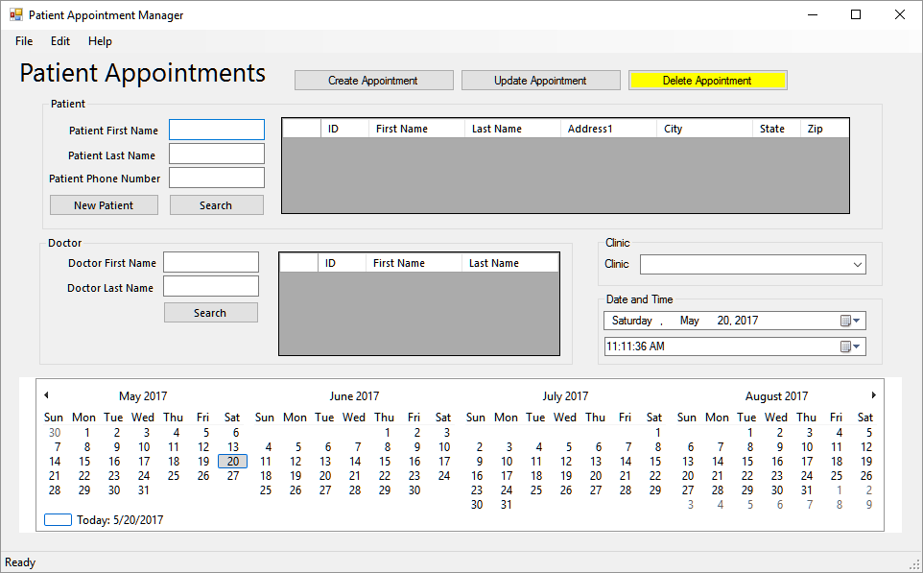

Figure 1: The Patient Appointment Manager

## Database Design

You need to **design a database** based on what you know about an application being built by other developers on your team. This database will be a **prototype**, so it is expected that there to be issues to resolve later, but you will try to get as close to our final design as you can. When you find issues or have questions for the Application team, you note these for discussion once your prototype design is complete.

Please remember to **use normalization, constraints, and abstraction layers**. Each table needs a view showing the table's data and an insert, update, and delete stored procedure. All stored procedures must have explicit transactions, error handling, and of course, test code at the bottom of the script.

## Project Artifacts

You need to turn in the several files including:

* A **developer** Excel **document**
* **An** **Entity Relationship Document**
* **A** **SQL script** that creates the database
* A **SQL Import script** that fills your database with sample data
* An **Excel and Tableau Report**
* A formal **project document** that details the final database design
* A "**lessons learned" document**

Here is an outline of these items and the points associated with them with their submittal.

|  |  |  |  |
| --- | --- | --- | --- |
| **Final Checklist** | |  |  |
| Max Points | Project Component | Est Hours | Actual Hours  **(Fill this in as you work!)** |
|  | **Milestone 1 (Assignment 07: Design)** |  |  |
| 80 | A development documentation using MS Excel | 4 | 2.5 |
| 20 | An ERD | 1 | 0.5 |
|  | **Milestone 2 (Assignment 08: Implementation)** |  |  |
| 100 | A SQL database script (tables, constraints, views, etc.) | 4 | 3 |
|  | **Milestone 3 (Assignment 09: QA and Testing)** |  |  |
| 40 | An Import script of sample data | 2 | 1 |
| 20 | One or more reporting views | 1 | 0.33 (20) |
| 20 | One or more Excel reports | 1 | 0.16 (10) |
| 20 | One or more Tableau reports | 1 | 0.75 (45) |
|  | **Milestone 4 (Assignment 10: Documentation and Release)** |  |  |
| 80 | A formal project document using MS Word | 2 | 2 |
| 20 | Lessons Learned Document | 1 | 1 |
| **400** | **Total** | **17** | **~12** |

Table 1. The checklist for the final

## Milestone 01

In this Milestone, you **design a database** based on what you can guess about the application and its database needs. You will be graded on how well thought out your design is and how well you follow the rules of normalization. There are multiple correct answers, so you have lots of chances to get it "right!" Not guessing the exact design I want you to will not affect the outcome of the final project, so don't be concerned about breaking the final if you do not get everything correct. Just try your best, think things through, **keep it simple, and be ready to defend the reasons for your design** when we ask you a question during the grading process!

### Task 1

I have provided a starter Excel spreadsheet, "***Metadata for Patient Appointment Project.xlsx***." **Fill in the items** needed to describe your database design (Figure 1).

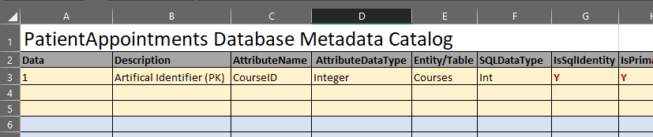

Figure 2: The current metadata in the MetaData.xlsx file

### Task 2

Afterward, **create a Database diagram** for your newly designed database. Here is an **incomplete and possible incorrect** example I created using PowerPoint and Word (Figure 2).

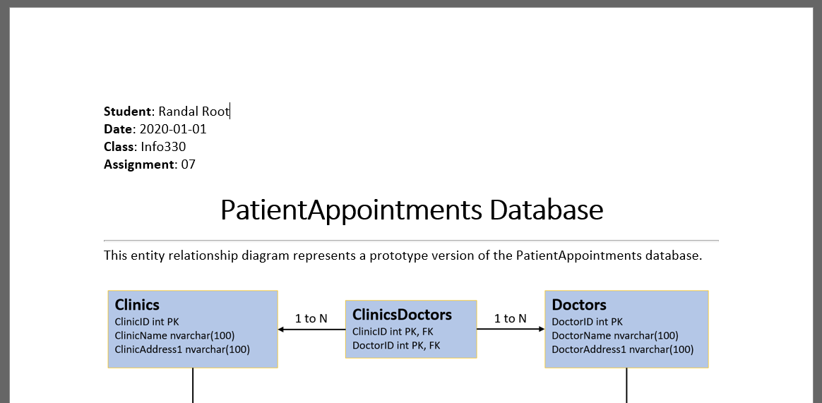

Figure 3: The ERD in a Word document

***Note:*** *Remember that**there are several ways this database can be designed. If your design is like the examples you've seen and fits the rules of normalization, then you have done well.**Design it like you think it should be designed but be prepared to explain why your answer is correct!*

You can use any tool you want to create the diagram, but once it is done, paste an image of it into a document for submission.

### Turing in your work

Put your **Excel metadata spreadsheet and the ERD** into the Milestone 01 folder, Zip the Info330Project-YourNameHere folder, and submit it under Assignment 07.

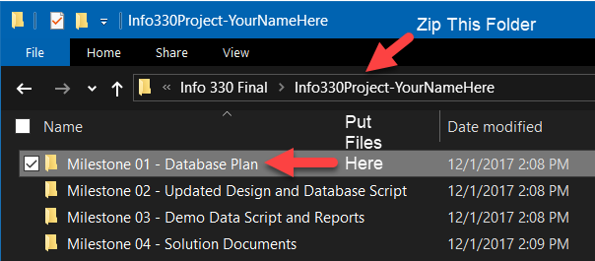

Figure 4. Files and Folders of Milestone 1

## Milestone 02

In this Milestone, you create a prototype database and import some basic data into the new database.

### Task 1

Create a SQL script that implements a database as defined by an updated Excel development document (figure 3). The database will include tables, views, and stored procedures.

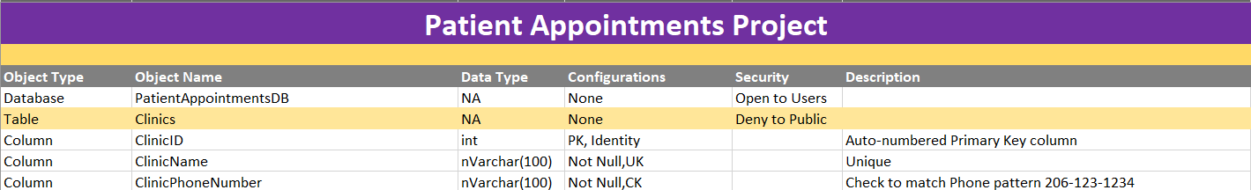

***Figure 5: The Updated Metadata Spreadsheet***

***Note:*** *Remember to use the metadata spreadsheet provided by your instructor and not your original design.*

### Turing in your work

Put the **instructor's updated metadata worksheet** **and** your **SQL Script** into the Milestone 02 folder, Zip the Info330Project-YourNameHere folder, and submit it under Assignment 08.

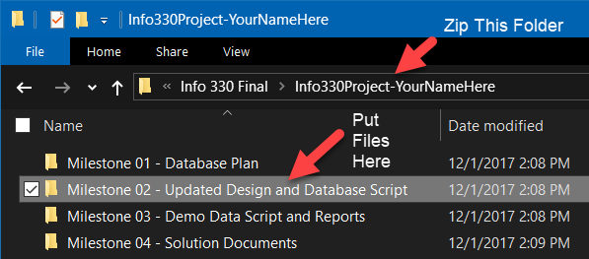

Figure 6. Files and Folders of Milestone 2

## Milestone 03

In this Milestone, you need to import some basic data, create one or more reporting views, and two reports. The reports should include one "table like" display of data and one chart. It must also include a Title and header with your name and the date like Figure 4.

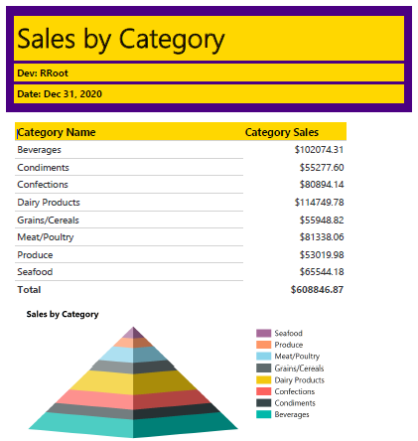

Figure 7: The typical format of a report

### Task 1

You will also need to create a SQL script that fills the database with a new with some simple sample data. You only need a few patients, doctors, and clinics, and you need to import those first and before adding a few appointments.

Add a minimum of:

* 5 clinics
* 10 Doctors
* 10 Patients
* 10 Appointments

You can either "Hard Code" the values, use Mocaroo.com to generate values, or use SQL code to generate values.

### Task 2

Create One or More Reporting Views. You should already have one reporting view in your database, called vAppointmentsByPatientsDoctorsAndClinics that shows data from all the tables, but create smaller one(s) to be used for your reports.

### Task 3

Create an Excel report using data from a view.

### Task 4

Create a Tableau report using data from a view. (See the important note below)

***Important: Tableau, does not let you save a local file to a folder, so capture a screenshot of your tableau report, and paste it into a Word document called, "Tableau Report Example."***

***Note:*** *Your reports should give information to the user. They can be simple, but I want you to think about what you are creating. Something like; which doctors are seeing which patients, which patients have an appointment on which days, which doctors are at which clinics on which dates are all acceptable examples.*

### Turing in your work

Put your **SQL script that imports** the starter data, the **script that creates the reporting views, and the two report documents** into the Milestone 03 folder, Zip the Info330Project-YourNameHere folder, and submit it under Assignment 09.

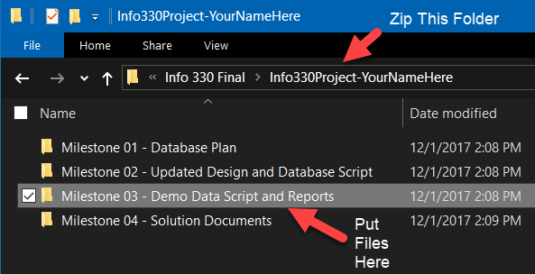

Figure 8. Files and Folders of Milestone 3

## Milestone 04

In this Milestone, you have two tasks to perform. The first is the creation of a formal project development document for your solution that second is a lessons learned document.

### Task 1

I have provided you with a sample of solution development planning (figure 5). You need to **remove the existing entries** and **add your entries**, but it should provide you with a convenient format in which to enter your project's meta-data.

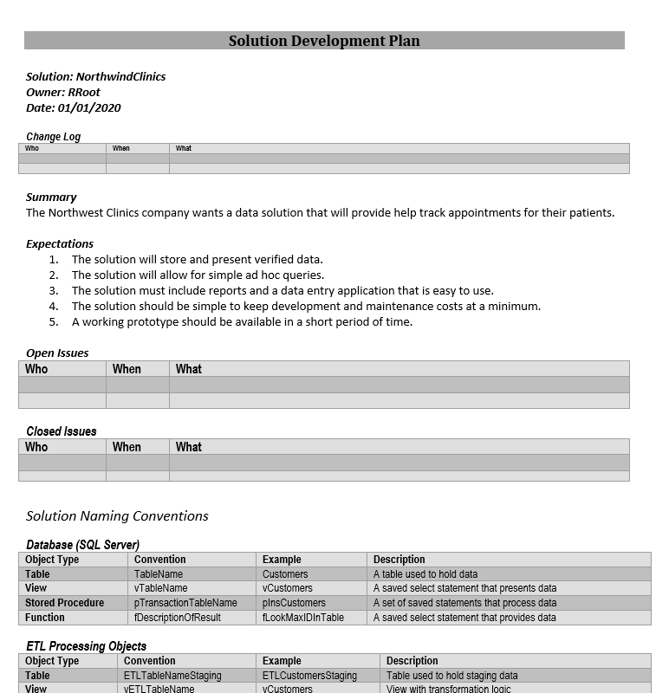

Figure 9: The formal project documentation

### Task 2

The **second task** requires that you create a **document** about the **lessons you have learned throughout this course**. This document can be a **relatively informal overview** of the different things you have learned during the quarter.

Writing this document helps both you and me to understand your progress in the course. You may be surprised to see how the writing process solidifies what you have learned (or at least other students have told me it does!) There is no need to make this an exhaustive coverage of what you did, so make the paper to about a single page of text, and it will be fine.

Next, post what you wrote on the provided discussion board.

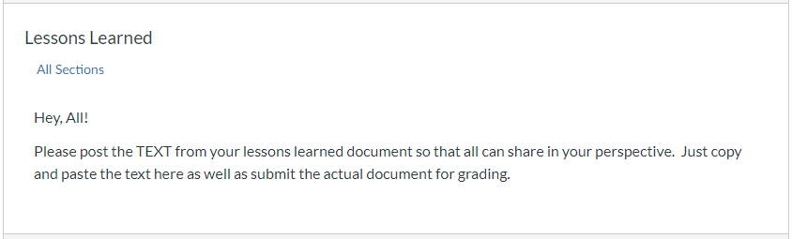

Figure 10: The Lessons Learned Discussion Board

### Turing in your work

Put your formal solution **document, and your lessons learned document** into the Milestone 04 folder, Zip the Info330Project-YourNameHere folder, and submit it under Assignment 10.

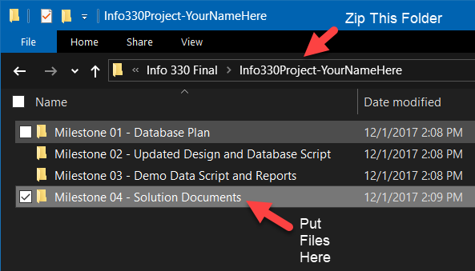

Figure 11. Files and Folders of Milestone 4

# Grading

Student work will be evaluated on a point system using the following general guidelines found on the Course Syllabus page. Make sure you read and understand this.

**NOTE:**  It is very possible to get a 3.9 or better from this course, but you must earn it! Do not expect to get 100% of the possible points without extra effort on your part. If you want to excel in this course, you must submit **excellent**work!