Diagnostic & Laboratory Solutions
Automated Ecosystems for Accurate and Efficient Results
Complete laboratory ecosystems featuring automated chemistry analyzers, hematology systems, and comprehensive IVD solutions tailored for Ethiopian healthcare facilities. | 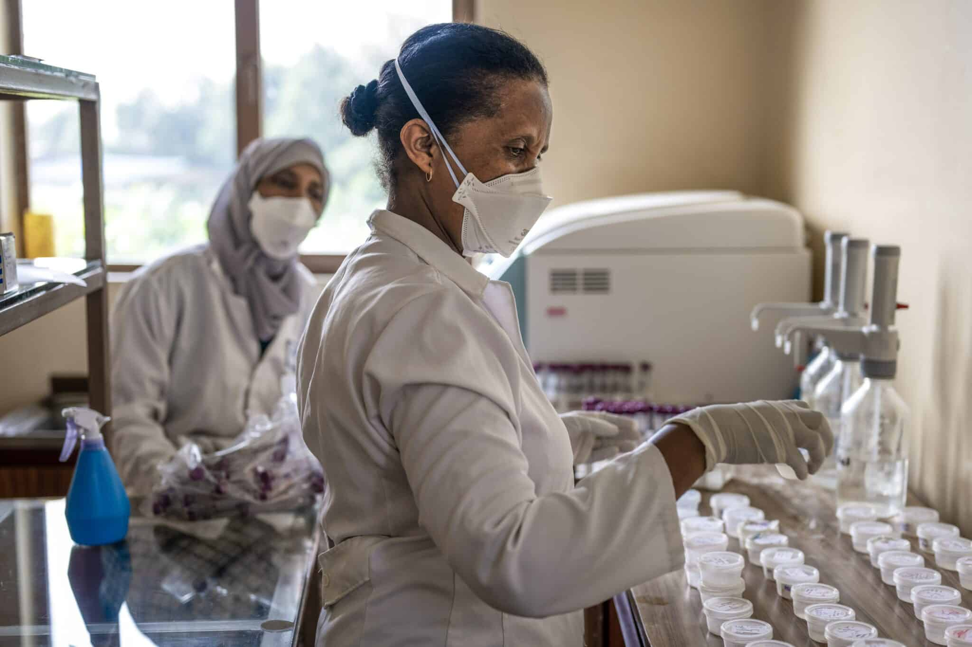
Key Features & Benefits
Key Features  - Mindray BS-240 Chemistry Analyzers  - Mindray BC-5150 Hematology Systems  - High-Precision Digital Microscopes  - Comprehensive Lab Furniture Solutions  - Integrated Quality Control Systems & Reagents | Benefits  - Increase patient throughput with automated workflows  - Reduce diagnostic errors by 85% with reliable results  - Accelerate staff competency with comprehensive training  - Minimize equipment downtime with 24/7 technical support  - Ensure consistent and traceable results

Technical Specifications
Chemistry Analyzer: | Up to 240 tests/hour throughput | Hematology System: | 5-part differentiation, 60 samples/hour
Sample Types: | Serum, plasma, urine, whole blood | Data Management: | LIS/HIS connectivity with HL7 protocol
Reagent System: | Refrigerated reagent positions, barcode reading | Optical System: | Advanced LED illumination microscopes
Installation: | Full setup, calibration, and method validation | Support: | On-site user training and remote diagnostics

