Aisha Rigert

Dr. Baas

COSC 3403-01

19 January 2016

Project Concept Proposal: Visitor Mobile Website

**Overview**

This project is a mobile website or collection of web pages intended to welcome visitors to campus, help their visit run more smoothly by bringing visit resources to their mobile devices, and encourage them to return by providing helpful information about the university and events.

**Problems to Solve**

One problem visitors sometimes encounter is getting lost; thus, having a map tailored to a walking trip on campus would be helpful. Although previewers are given a folder with maps and other information, this requires the party to stay together if they want to access the folder. Having this information accessible on a mobile device gives visitors freedom to split up without fear of getting lost or being without important information. In addition, making last-minute updates to a hard-copy schedule would require reprinting pages and refilling folders; a website would allow the admissions center to easily make changes.

**Equipment**

The website would be targeted toward mobile devices such as smartphones and tablets. Since a website does not require installation, it would be better than an app for one-time use.

**Target Audience**

The website would be directed at visitors, mostly previewing students and their parents. However, it could also be used for visitors to special events such as sponsorship dinners.

**UI Screenshots**

The proposed user interface contains a home page with links to event schedule, dining option, map, activity offering, and help pages. Rough drafts of the pages are shown below.

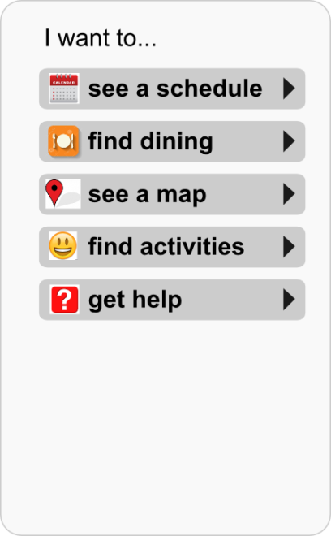 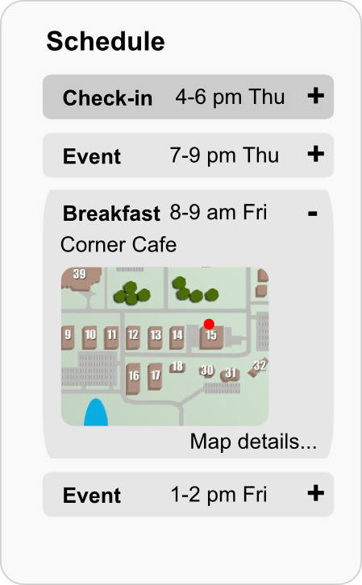 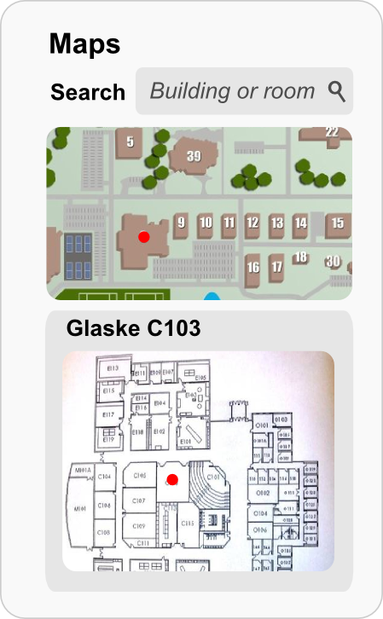

Figure 1. Visitor website home, schedule, and maps pages.

As shown in Figure 1, the home page links to the other main pages of the site. The schedule page shows the schedule for the ongoing visitor event, if applicable. The background color of activities that have already occurred would be darkened. Clicking on an event would expand the detailed view, including the location, a map, and a link to further map details. The maps page would allow the user to search for a building or room and see detailed maps for both the campus and the building.

Figure 2 shows the dining page with various sections expanded. The hours section would provide a summary of which dining options were currently open, as well as a week schedule. The menu section would link to the Bon Appetit website, and the maps section would provide a map summary and a link to the maps page for more details.

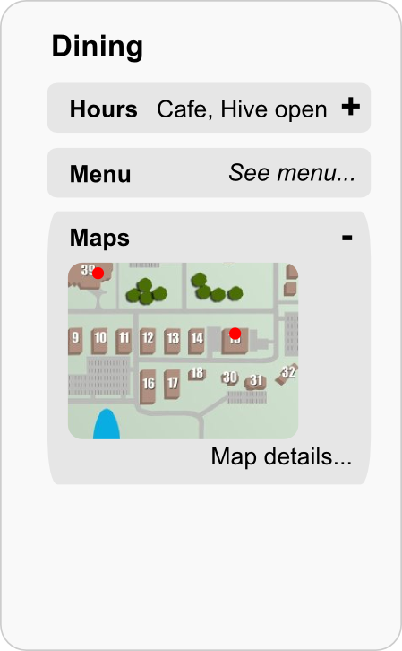 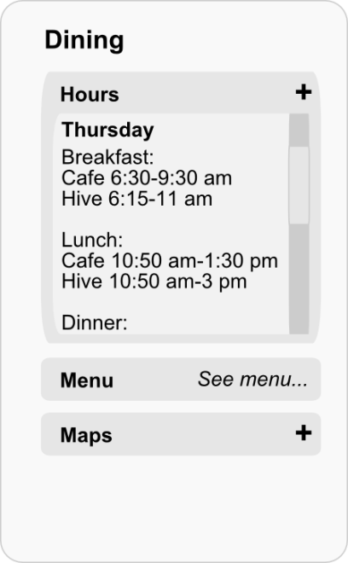

Figure 2. Two views of dining page.

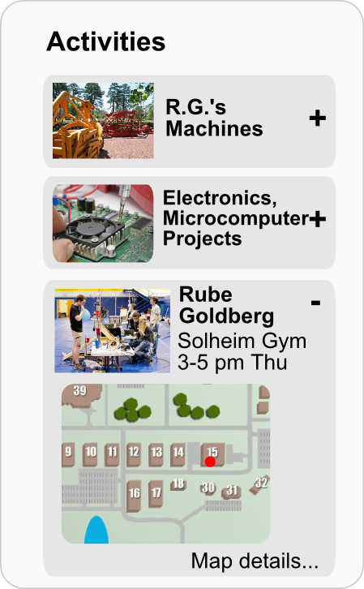 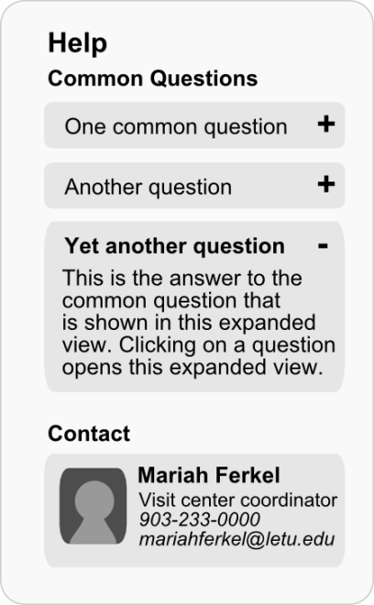

Figure 3. Activities and Help pages.

Figure 3 shows the activities page, in which static activities such as R.G.’s machines or the Digital projects in Glaske would be listed, along with current events such as the Rube Goldberg competition or Belcher shows. Clicking an activity would expand the detailed view. On the Help page, visitors could browse answers to common questions, or if they needed additional help, they could contact admissions center staff.

**Most Difficult Aspect**

I suspect the most difficult aspects of this project for the team will be designing a user-friendly interface, maintaining the site to keep information updated, and promoting the site so it is actually used. This will take cooperation with admissions staff and, ideally, feedback from users of the software.